Introduction to GIS with QGIS

for Environment

Clare Gordon

University of Leeds

March 2022

Table of Contents

Table of Contents 2

1 Introduction to the workbook 3

2 Introduction to GIS with QGIS 6

3 Finding spatial data to use in GIS 43

4 Using spatial data in GIS: Coordinate systems, projections and transformations 69

5 Coordinate systems: practice in projecting data 95

6 Collecting point data with GPS 97

7 Creating data by digitising 123

8 Elevation models 1: the shape of the land 142

9 Elevation models 2: Analysing terrains 176

10 Layout and presentation 204

11 Raster analysis 1 251

12 Raster analysis 2 280

13 Census data for England and Wales 299

14 Vector data analysis 315

15 Environmental decision making 339

16 Making repetition more efficient 374

17 Viewing your data in 3D 418

# Introduction to the workbook

Last Modified: 30 Mar 22, 16:37:36

This workbook contains the exercises for the Introduction to GIS for Environmental Scientists module at University of Leeds.

This workbook is provided in Word format. You can download alternative formats via Minerva, e.g. pdf or epub. Look for the link after the download. These alternative formats are not available directly from Clare.

You are welcome to keep your own notes within your copy of the workbook. An up-to-date version will always be available to you within Minerva. Updates may be made during the module based on questions from students and whether anything appears to be unclear. The date that each chapter was last updated will be just under the chapter heading.

## Contact me

If you find any problems with these instructions, please get in touch with me giving full details of the section and the problem and I will do my best to correct it.

Email me at: [c.e.gordon@leeds.ac.uk](mailto:c.e.gordon@leeds.ac.uk)

Clare Gordon © 2022 The University of Leeds.

To cite the workbook: Gordon, C.E. 2022. *Introduction to GIS with QGIS: for Environment*. Leeds: University of Leeds.



Creative Commons Attribution-NonCommercial-ShareAlike 4.0 International License.

This work is licensed under a [Creative Commons Attribution-NonCommercial-ShareAlike 4.0 International License](https://creativecommons.org/licenses/by-nc-sa/4.0/).

## QGIS software

Details of the software required (QGIS) and how to gain access to it will be given to you in a separate document before the start of the course.

This workbook acknowledges use of QGIS: QGIS Development Team, 2022. [QGIS Geographic Information System](https://www.osgeo.org/projects/qgis/). Open Source Geospatial Foundation Project.

## How to use these exercises

The following conventions are used:

Video clips of techniques are available in Minerva or in the [list of videoclips](https://cgordon-gis.github.io/videoclips.htm). They aren’t fancy, just what you’d see if I gave a demonstration in class, but you may find them useful as a supplement to the written instructions.

They are shown as follows in the worksheets:

 **Spatial bookmarks in GIS**

This video clip can be found in the module area of [Minerva](https://minerva.leeds.ac.uk) or in the [full list of video clips](https://cgordon-gis.github.io/videoclips.htm).

Information boxes point out techniques that you may already know about. They are here as reminders, or as quick tips:

 **Geopackage format**

A **Geopackage** is a form of database specifically designed to store and retrieve spatial data efficiently. It has been relatively recently developed but it’s use as a GIS format has spread very quickly. QGIS encourages the use of geopackages and it is increasingly possible to use them in other GIS software.

For something you should do following previous instructions:

 **Change page size and orientation**

Have a look for each of the tools suggested below and try them out to see what they do. Make notes in the spaces provided.

For a question:

 **Question title**

What do you think of this? Make your own notes either in the document (if you’re using the Word version) or in your own notebook.

For a warning - take note of these, they can often save you time and trouble:

 **Warning**

If you do x it won’t always work! Make sure that you do y.

# Introduction to GIS with QGIS

Last Modified: 06 Nov 22, 16:17:03

The background to GIS and an explanation of what it is will be covered in the lecture segment at the beginning of the class, and the presentation and any other supporting materials will be available in Minerva. The lecture segment should help you to understand **why** you are doing these exercises. If you still aren’t sure, please ask [Clare](mailto:c.e.gordon@leeds.ac.uk).

## Learning outcomes

When you have completed this section of the workbook you should be able to

* demonstrate how to open a map project in QGIS
* select appropriate tools to navigate in a map document
* use layers to organise and display information on a map
* add information to a layout and prepare it for printing or display
* demonstrate different ways of finding help when using GIS

## Introduction to the exercises

As a GIS specialist you have been asked by your local Member of Parliament to produce a map of the proposed High Speed Rail Link showing which Local Nature Reserves and Sites of Special Scientific Interest (SSSIs) will be directly affected by the route. The High Speed Rail Link is planned to run north from London, firstly to Birmingham and then in a second phase (also known as HS2) to Manchester and Leeds. The project is controversial and arguments both for and against can be found on the internet.

For this exercise I have created a basic map of the HS2 route and provided the data so that you can explore the GIS application and get used to basic navigation and functions. In future sessions you’ll be preparing the data and setting up the basics for yourself.

## Obtaining and opening the sample map

The sample map is based on the proposed route of the High Speed rail link from the West Midlands to Leeds and uses data from a number of sources with which you will become familiar during this module.

* Download the HS2_Q.zip file from Minerva and save it to your computer.
* Create a new folder called gis in the location in which you intend to save all your work. **You’ll need a total of about 500 MB of free space to complete the exercises in this chapter.**
* Unzip the downloaded file to that folder.
  + In My Computer right-click on the zip file
  + If you have 7-zip go to 7-zip > Extract Here[1]
  + If you don’t have 7-zip, right-click Extract files... and select the location to save the files, then OK[2]

 **Warning**

Never try to use the contents of a zipped file in GIS without extracting it first - it won’t work. If you are looking for a file in QGIS and can’t find it, always check via My Computer that the file isn’t inside a zip or 7zip archive.

Once you’ve unzipped the file you should have a folder called HS2_Q. Enter that folder and have a look at the contents. They should look something like the following image with two folders called miniscale and vmd-raster_clb, and two files, one called HS2.gpkg and the other HS2.qgz.

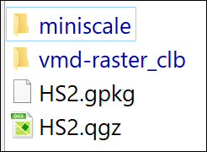

The data inside the folder in the zip file for this project.

## Opening the map project in QGIS

* The simplest way is to double-click on the HS2.qgz file in File Explorer.
* Alternatively, and sometimes more usefully, first open QGIS by searching for it in the Start Menu box (on Windows). If you have a choice between QGIS with GRASS and without, go for the version with GRASS [3].
  + Once QGIS opens go to Project > Open
  + Navigate to where you saved the project files and select HS2.qgz
  + Click Open

The image below shows how the project will look in QGIS when you first open it. Note that yours may look different to mine as buttons and toolbars can vary in location and the colours of the contents of your map will probably be different too. If you are using a different version of QGIS to me you may find that you get a notice at the top warning you about that. If that happens just ignore it or close it, it shouldn’t be a problem for you.

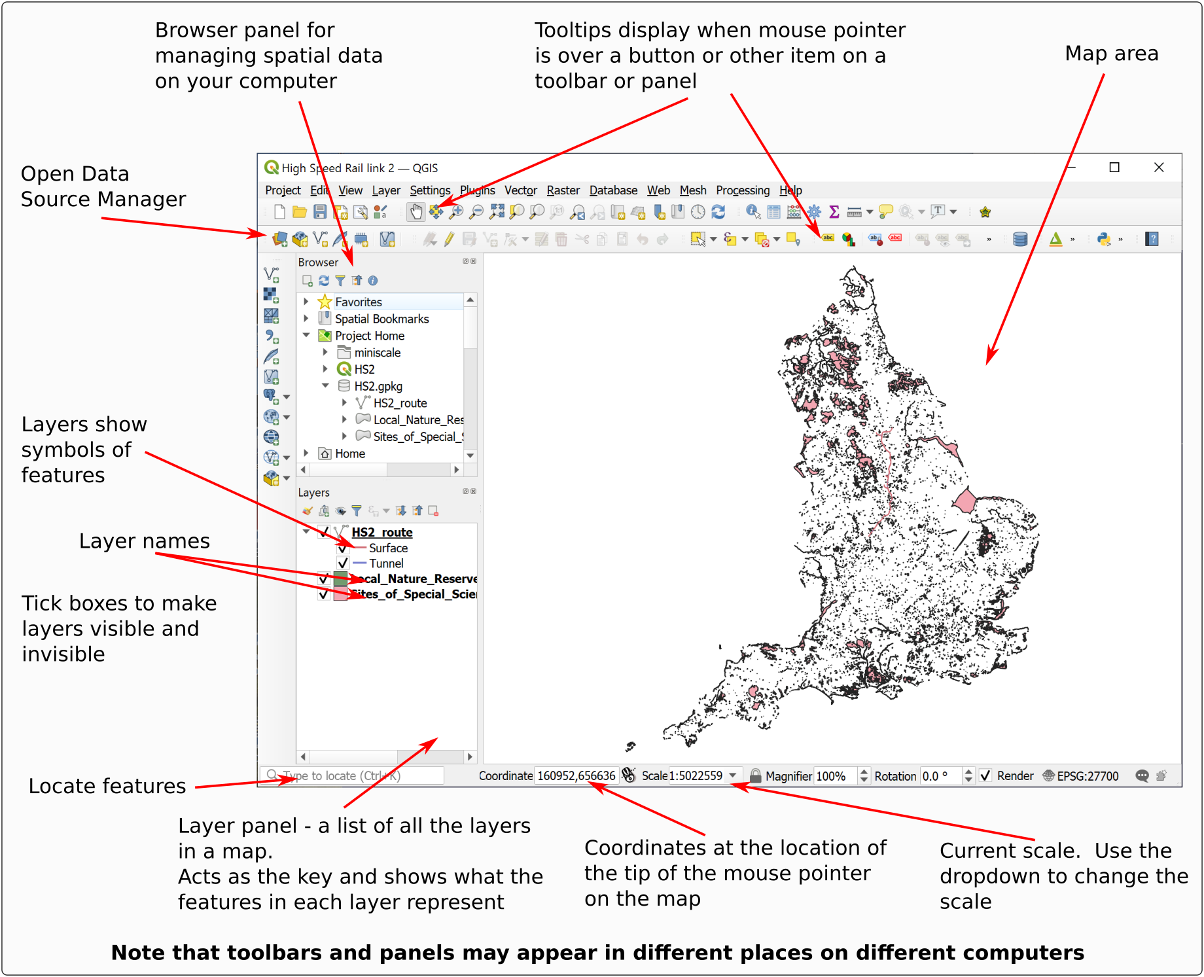

The QGIS window when you open the HS2 project. Your toolbars and buttons may look different to mine.

### The Browser Panel

The browser panel usually appears on the left of your map. In the image above it appears above the Layers panel, but this can vary.

The browser panel allows you to explore spatial data, add data to your map, open projects and view the properties of files. You will find out more about how to use this as you go along, but for now make sure that you know where to find it.

## Navigation in QGIS

Once you have data on a map in QGIS there are various tools which allow you to zoom in and out and move around the map view.

### Zoom to Layer

A lot of the work that you do in GIS will be layer-based. Each file that you add is a layer and will appear in the Layers panel on the left.

Zoom to Layer is an extremely useful command to know and you’ll probably find yourself using it a lot.

* Right-click on the HS2_route layer (sub-heading) in the Layers panel
* Select Zoom to Layer.

Your map should zoom in so that you can see a more close up view of your map which matches the extent of the HS2 route.

### The Map Navigation Toolbar

Tools for zooming in and out and for moving around the map are available on the Map Navigation Toolbar.

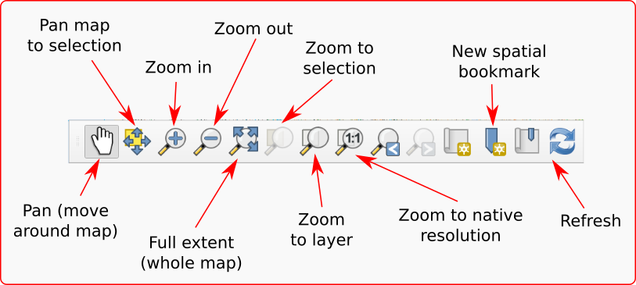

The Map Navigation Toolbar.

If the toolbar isn’t already visible in QGIS go to:

* View > Toolbars
* Put a tick in the box next to Map Navigation Toolbar

 **Trying out the navigation**

Try out the following tools in turn on your map so that you are aware of what they do.

Pan - use the hand cursor to “grab” the map and move it around

Zoom in - click on the button, then on the map, or use the cursor to draw a rectangle over the map defining the area to zoom to. You can also use the middle mouse wheel to zoom in and out of your map.

Zoom out - click on the button, then on the map. You can also use the middle mouse wheel to zoom in and out of your map.

Full extent to see the whole map (you may need to be patient while it loads) - then use Zoom to Layer to get back to the extent of the HS2_route layer.

### Changing the scale

Instead of zooming with the mouse wheel or the tool you can change to a particular scale, e.g. 1:100 000, using the scale box at the bottom of the window to select the scale you want. This box always shows the current scale of the map and you can use the dropdown arrow to select preset scales. You can also type a scale in this box, particularly if the scale you want isn’t in the list.

 **Finding the current scale**

Look at the Scale dropdown at the bottom of the window. What is the current scale of your map?

* Click in the scale box at the bottom of the window and select 1:500000

The map should zoom to the correct scale.

* Click in the scale box again but this time **type** 100000 into the box, replacing the scale that is already there.
* Press Enter

Again, the map should zoom to the correct scale.

## Spatial bookmarks

Spatial bookmarks enable you to go to a view that you have set up earlier.

 **Spatial bookmarks in QGIS**

This video clip can be found in the module area of [Minerva](https://minerva.leeds.ac.uk) or in the [full list of video clips](https://cgordon-gis.github.io/videoclips.htm).

### Using a bookmark to move to a new location

The map of the HS2 rail link has a bookmark set up showing the planned route near Leeds.

* In the Browser find the Spatial bookmarks subheading and drop it down by clicking on the small arrow to the left.
* Drop down the Project Bookmarks subheading
* You should find a bookmark called HS2 Leeds - double-click on that to zoom to the correct location.

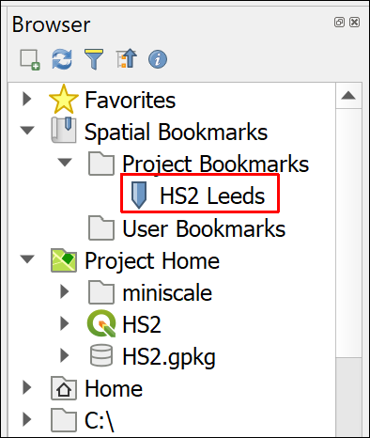

The Browser showing Spatial Bookmarks > Project Bookmarks. Double-click on HS2 Leeds to zoom to the bookmark.

### Creating a spatial bookmark

To set up your own bookmark

* Pan the map (i.e. move it) to a different location
* Either right-click on the Project Bookmarks heading in the Browser or use the keyboard shortcut Ctrl+B to bring up the Bookmark Editor
  + Give your bookmark a name
  + The Extent should be correct, but click on Map Canvas Extent to be sure
  + Check that Saved in is Project Bookmarks
  + Then click on Save

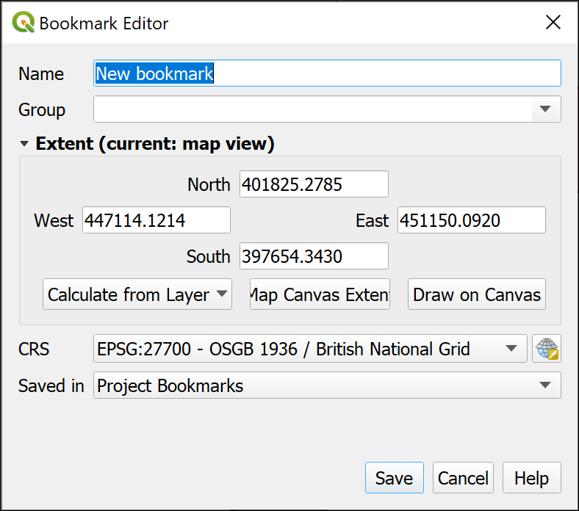

Setting up your own bookmark in the Bookmark Editor.

Once you have saved your bookmark it should appear in the Browser.

 **Check your bookmark**

Pan to a different area of the map and rescale your map. Now double-click on your new bookmark. Does it take you back to the correct view?

### Removing a spatial bookmark

To **remove** a bookmark that you no longer need just right-click on it in the Browser and Delete Spatial Bookmark.

* Delete your new bookmark now. You won’t need it again.

## Working with map layers in QGIS

### What are layers?

Layers are an essential part of any GIS. Each layer is a **reference** to a particular data source on disk.

In the HS2 map project the layers include:

* Local_Nature_Reserves_England
* HS2_route

 **What is the name of the other layer in the HS2 map?**

Layers are controlled from the Layer panel to the left of the main map window.

 **Working with layers in QGIS**

Go to the module area for this module in [Minerva](https://minerva.leeds.ac.uk) or go to the [full list of video clips](https://cgordon-gis.github.io/videoclips.htm).

Watch the video clip on “Working with layers in QGIS”. Then get used to working with layers by following the instructions below.

### Viewing contents of layers

In the Layers panel

* Click on the small arrow next to a layer to open and close the layer contents
* The Layer panel also acts as a key to your map and shows the symbols for map features

 **Looking at layer symbols**

Have a look at the HS2_route layer in the Layer panel. How many different symbols are shown, and what do they look like?

### Renaming layers in the Layers panel

You can make the layer names more useful by changing them in the Layers panel. This also means that names will be clearer when you generate legends prior to printing or exporting maps.

When storing GIS data on disk you usually need to make names **short and with no spaces** for the benefit of the GIS program, this makes them more difficult for you or your audience to read. It’s good practice therefore, to change this in the Layers panel so the names become more “user friendly”.

Note that you are not renaming the original data file by doing this, but just how the name appears in QGIS.

* Select Local_Nature_Reserves_England in the Layers panel. You’ll see that the name includes underscores instead of spaces. To make this more readable press F2 on the keyboard, or right-click on the layer name and select Rename layer.
* Type the new name, e.g. Local Nature Reserves in England and then press Enter

 **Renaming layers**

Repeat this with the other two layers in the map to make them more readable too.

### Making layers visible and invisible

There will be times when you don’t want all the layers to be visible on your map, but you won’t necessarily want to remove them completely. It is simple to make layers visible and invisible.

* Click in the little box next to one of the layers - the tick will disappear and so will that layer in your map
* To make the layer visible click in the little box again.

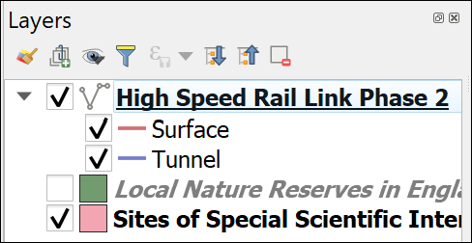

The box is unticked, so the Local Nature Reserves layer no longer appears on the map. Tick it again to make it visible once more.

You’ll notice in layers with multiple symbols that you can turn each symbol off individually too. For example:

* Fold down the HS2 layer if necessary to display the symbols for Surface and Tunnel.
* Untick next to Surface

The line showing the railway on the surface should disappear from your map, but the lines showing tunnels should still be visible.

* Make sure you tick back in the Surface box.

### Add new layers

There are two simple ways to add new layers. Below I’ll show you how to use both with different types of data.

 **Adding new layers to QGIS**

This video clip can be found in the module area of [Minerva](https://minerva.leeds.ac.uk) or in the [full list of video clips](https://cgordon-gis.github.io/videoclips.htm).

But first, a warning…

 **Warning**

While it is possible to add data by dragging and dropping it from your file explorer it really isn’t a good idea to do that. It might look as if it has worked at first, but things can go horribly wrong… Instead use one of the following methods.

#### Refreshing the contents of the Browser

Sometimes you can’t see all your files in the Browser even if you know they are there. This often happens if you have added or unzipped new files after opening the project in QGIS. If this happens don’t panic, you probably just need to **refresh** the Browser.

* At the top of the Browser panel look for the Refresh button and click on it. Remember you can use tool tips to help you find a particular button.

#### Adding layers to QGIS with the Browser

Have another look at the Browser panel on the left of the QGIS window.

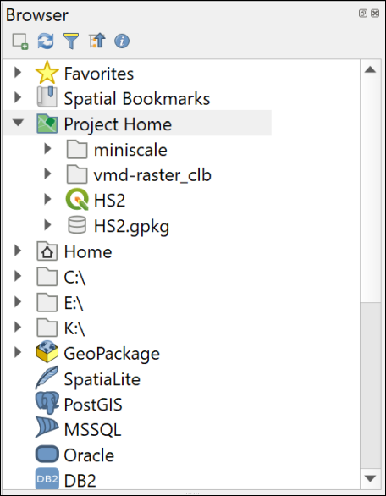

The Browser Panel in QGIS.

If you can’t see the Browser which shows you where files are on your file system, go to:

* View > Panels and tick in the box next to Browser.

Using the Browser you should be able to navigate to the folder in which you saved your downloads.

If you have saved your data in the same folder as the map (which you should do) you should be able to find everything under the Project Home heading. Otherwise you’ll have to browse through your file system.

* If you think your files should be in Project Home but they aren’t, right-click on the Project Home heading and select Set Project Home... to browse to the folder.

We’ll add a background map to the data that we already have on the map.

* Browse to your downloaded files and look for a folder called miniscale
* Have a look in the folder and find a file called miniscale_mono_R22.tif
* Drag and drop that file from the Browser to the Layers panel
* Right-click on the miniscale_mono_R22 layer in the Layers panel and Zoom to Layer

You should now be able to see a map of Great Britain in the main panel.

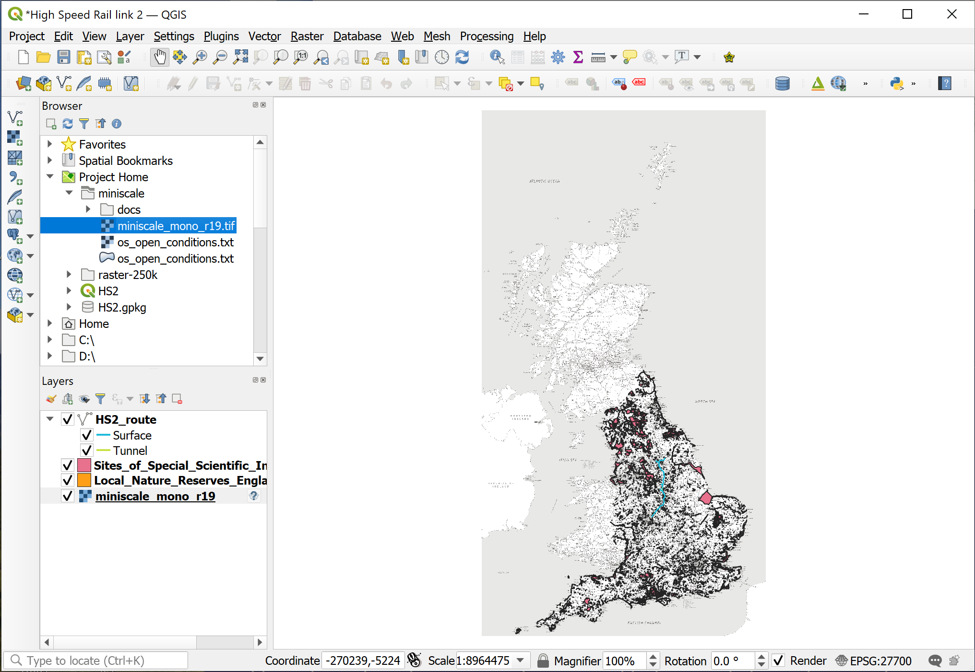

QGIS once you have added the Miniscale layer to your map. Note that the new layer has been moved to the bottom of the list in the Layers panel.

##### Reordering layers for visibility

The new layer was probably added to the top of the list in the Layers panel.

The order of layers in the Layers panel affects how they appear on the map. Layers at the top of the list appear **on top** of the layers lower down. If you can’t see a layer and you’re sure it should be visible one thing to check is that it isn’t covered by another layer.

* To allow the other layers to show as well drag and drop the new Miniscale layer so that it is at the bottom of the list.

Your map should now look something like the image above and your Layers panel like the image below.

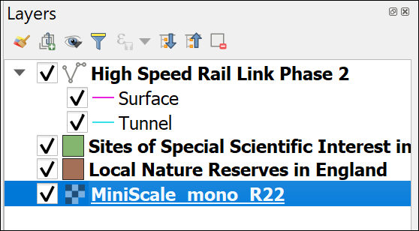

The Layers panel showing the order of the layers. With the background map at the bottom the rest of the layers will show on your map.

#### Adding raster data to a map with the Data Source Manager

Dragging and dropping from the Browser panel is probably the easiest way to add data to your maps but as with so many tasks in GIS there is more than one way to add data to QGIS.

The Miniscale map is fine for a zoomed out view, but if you zoom in you need more detail. We’ll add a more detailed 1:50 000 background map for part of the HS2 route using the alternative way to add data.

To use the Data Source Manager you do need to know what type of data you are adding. In this case it will be raster data.

* On the menu bar go to Layer > Data Source Manager or find the button on the toolbar by looking at the tool tips. Alternatively you can use the keyboard shortcut Ctrl+L to open the Data Source Manager.
* Click on Raster on the left
* Then click on the button with three dots next to the Source box
* Navigate to the vmd-raster_clb folder and select vmd-raster_3833332.tif
* Click on Open
* Then click on Add, then on Close

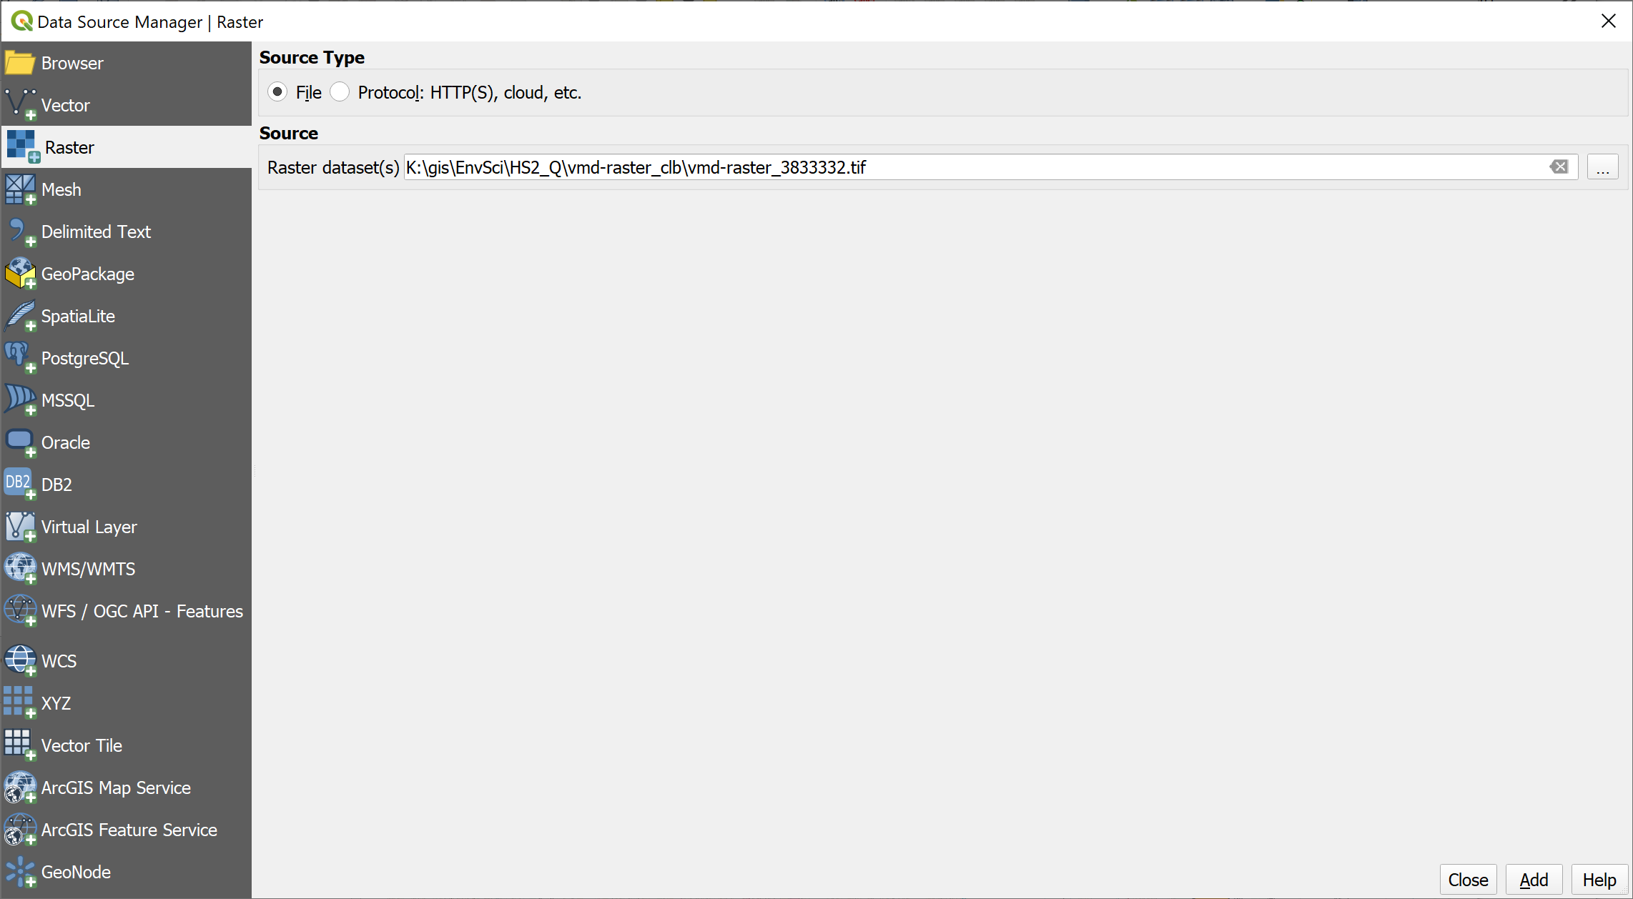

Adding a raster layer via the Data Source Manager.

The new layer will be added to your Layers panel, but you will need to zoom in to see it properly.

* Use Zoom to Layer to zoom to the area of the new map. You should also drag and drop it to just above the Miniscale layer in the Layers panel.

You may need to zoom in further to have a good look at the layer that you’ve just added.

#### Adding vector data to a map

The vector layers on this map are all stored in a Geopackage called HS2.gpkg.

 **Geopackage format**

A **Geopackage** is a form of database specifically designed to store and retrieve spatial data efficiently. It has been relatively recently developed but it’s use as a GIS format has spread very quickly. QGIS encourages the use of geopackages and it is increasingly possible to use them in other GIS software.

During this course you will frequently use geopackages to store your spatial data. If you want more information about the format there is a lot on the [GeoPackage website](http://www.geopackage.org/).

If you look at a geopackage in your file explorer you’ll note that it looks like a single file, though if it is open in QGIS you’ll see a couple of “side-carriage” files with the same name but different extensions. If you look at the geopackage in the Browser in QGIS you’ll see that there is a little arrow next to it and you can see the contents. This is the advantage of using the browser, it is specifically designed to work with spatial data.

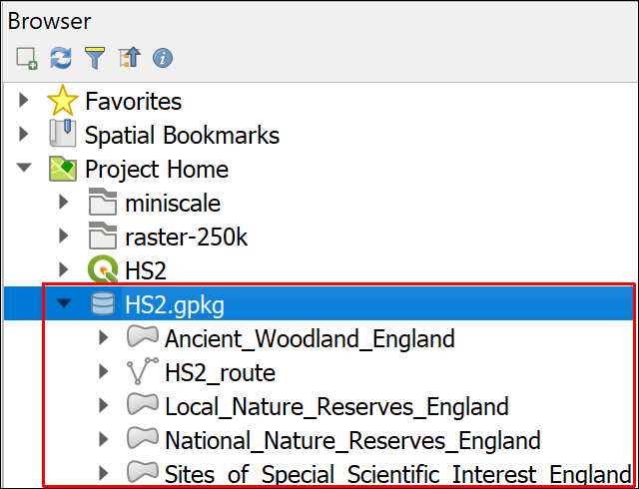

The HS2 geopackage viewed in the Browser. There are five layers within the single geopackage.

* Drop down the little arrow next to HS2.gpkg
* You should be able to see the layers that are stored in the geopackage - as in the image above.
* Select the National_Nature_Reserves_England layer in the Browser and drag and drop it into the Layers panel

You may need to turn other layers off to be able to see the new layer clearly. If you have the vmd-raster layer on your map then there are a couple of National Nature Reserves further to the north east of the area covered by that layer.

You can also add vector layers via the Data Source Manager.

* On the menu bar go to Layer > Data Source Manager or find the button on the toolbar by looking at the tool tips.
* Click on Vector on the left
* Then click on the button with three dots next to the Source box
* Navigate to the HS2.gpkg geopackage and and click on Open then on Add
* You’ll get a choice of vector layers to add - select Ancient_Woodland_England
* Then click on OK, then on Close

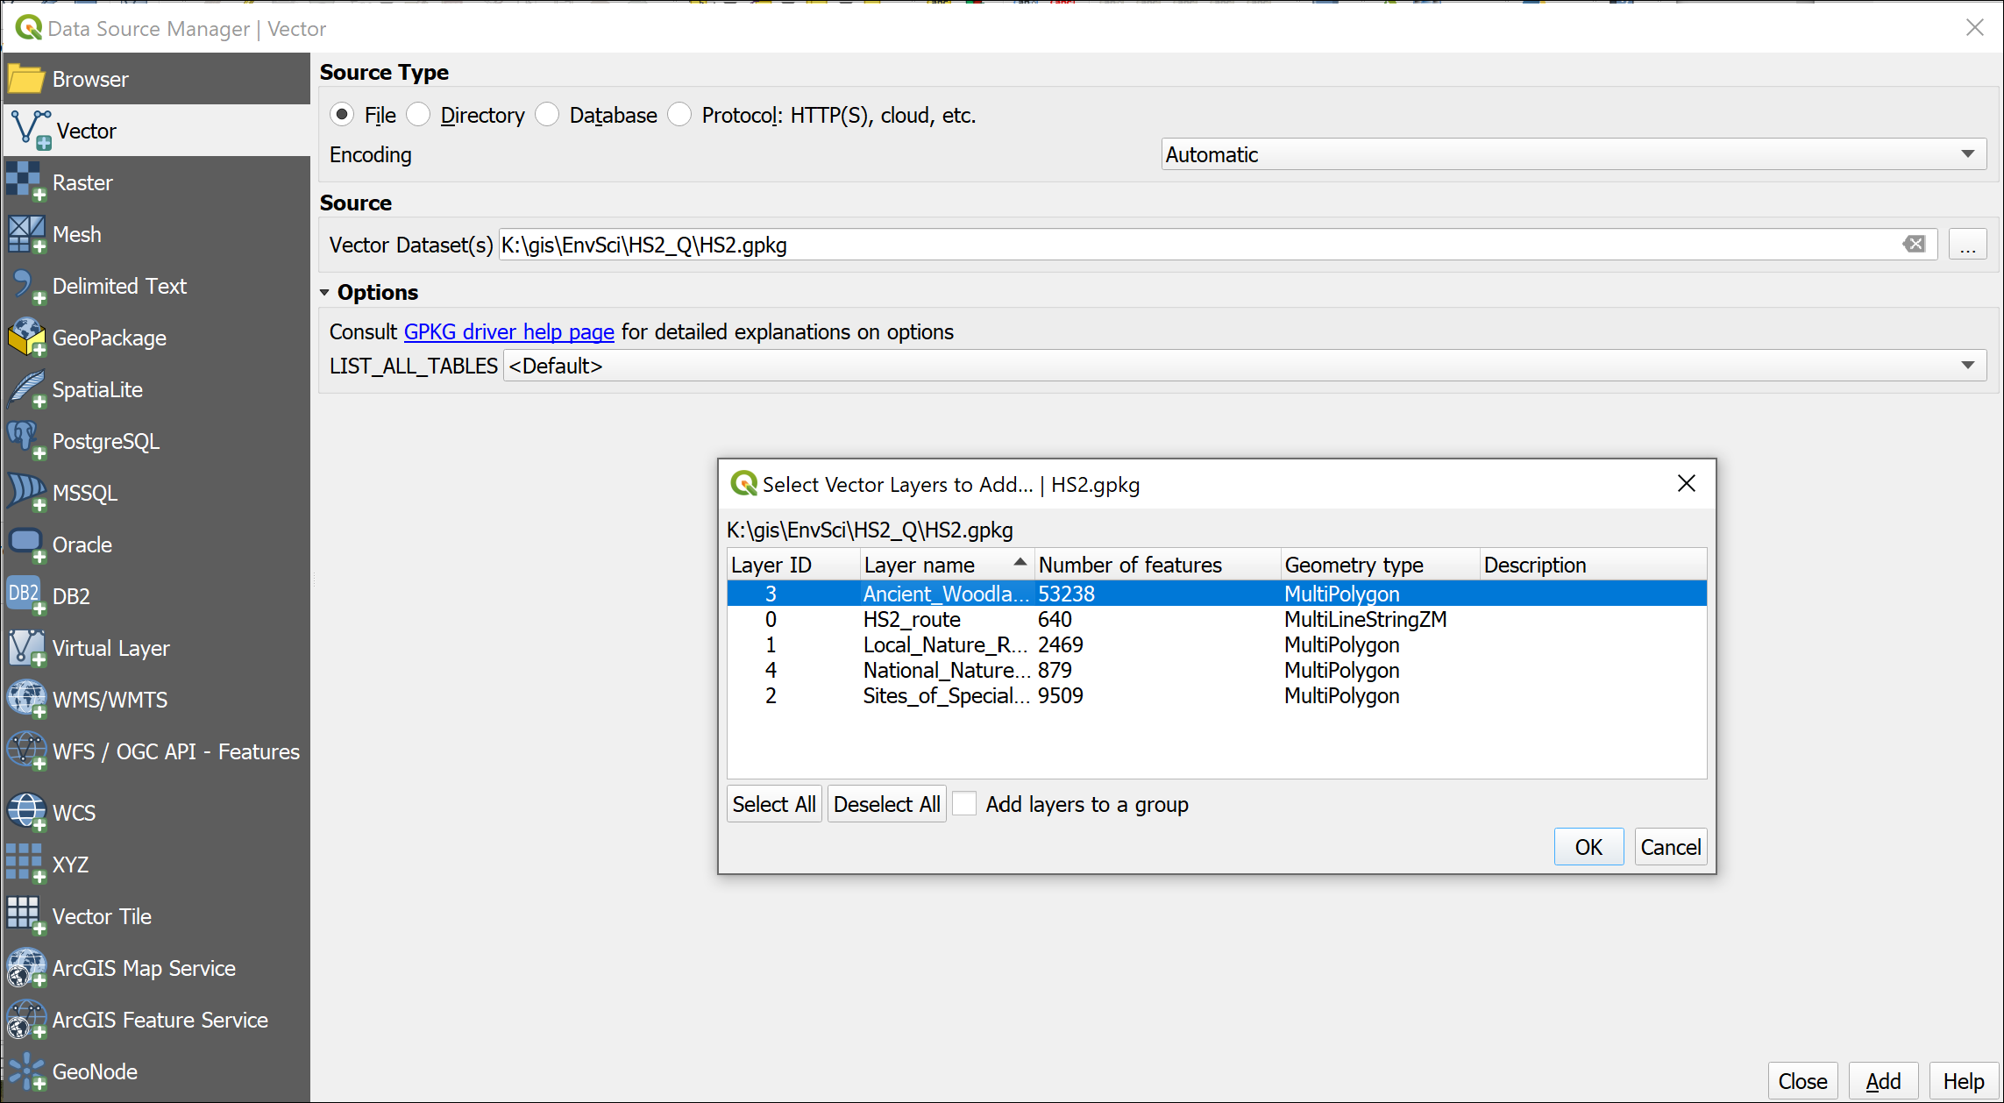

Adding a vector layer from a geopackage via the Data Source Manager.

The new layer will be added to your Layers panel. Again, you may need to make other layers invisible to see the new layer.

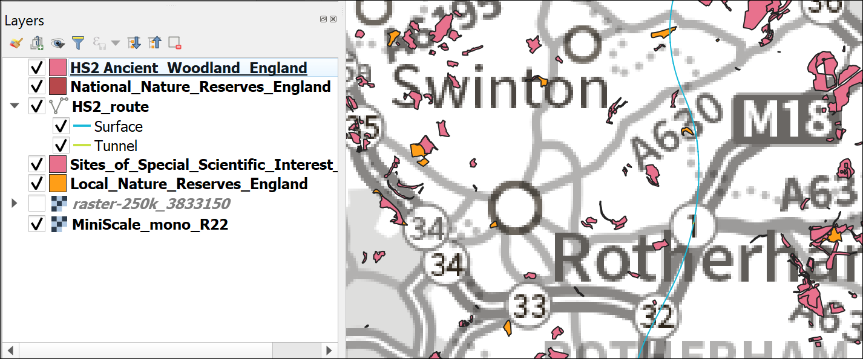

Your map with the new layers. Your colours will probably be different. I’ve turned off the VMD raster layer to show the other layers better.

When you’ve finished looking at your new layer make sure that you make the other layers visible again.

### Removing layers

Your map may be looking rather a mess by now, so let’s clear it up. It’s always a good idea to remove layers that you don’t need as it keeps your Layers panel less confusing.

You won’t need the Miniscale, Ancient Woodland and National Nature Reserve layers for the rest of this exercise, so they can be removed.

 **Removing layers doesn’t delete the data**

Note that removing layers from your map just does that. You are not deleting data from your disk. They still exist but you are removing the **link** between the map and your data.

* Either right-click on the Miniscale layer and Remove layer...
* Or select the layer in the Layers panel and use the keyboard shortcut - Ctrl+D
* You’ll be asked to confirm that you want to remove the layer, click on OK
* Repeat the process with the Ancient Woodland and National Nature Reserve layers. The process is identical for raster and vector layers.

### Grouping layers

The Local Nature Reserves and Sites of Special Scientific Interest are related to each other and could be grouped together to organise the layers panel. Amongst other advantages this would make it easier to turn all the reserve layers on and off together.

* Select both the Local Nature Reserve and SSSI layers in the Layers panel by clicking on them with the Ctrl key held down.
* Right-click and Group Selected
* You’ll then get a chance to give the new group a name - type Nature Reserves as the new group heading. If you can’t type it select the group heading and press F2 or click twice slowly.
* Try making the Nature Reserves group invisible to check that the layers are actually grouped. You should see **all** of the nature reserves and SSSIs disappear from your map. Don’t forget to make them visible again!

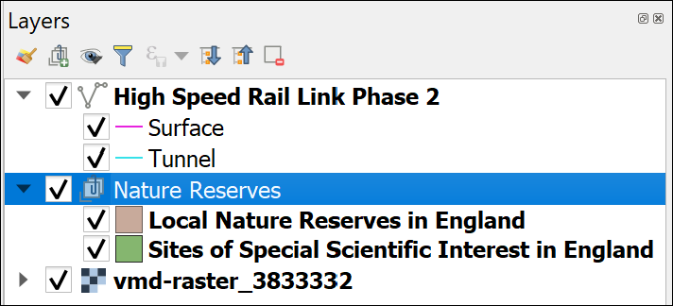

The grouped nature reserves.

## Layers in QGIS and data on disk

I’ve already said above, that “each layer is a reference to a particular data source on disk”. This has implications for how you manage your data, particularly if you are going to be moving your project from one computer to another.

### What happens if you move your data?

If you’ve followed the instructions above you’ll be able to see several layers in your map and in the Layers panel.

What happens if you move these layers outside of QGIS? Let’s have a look.

* Save your map (Ctrl-S or Project > Save) and close QGIS.
* In your system file explorer navigate to where you have saved the files for this project and go into the folder named HS2_Q.
* Create a new folder inside this one and call it Data.
* Move the HS2.gpkg file into the new folder.
* Also move the vmd-raster_clb folder into the new folder.
* Now reopen your map in QGIS.

 **What happens when you open your map?**

What’s the first thing that pops up when you try to open your map?

You will probably get a popup window titled Handle Unavailable Layers which lists the layers that QGIS can no longer find in their original location. (Don’t worry if you don’t!)

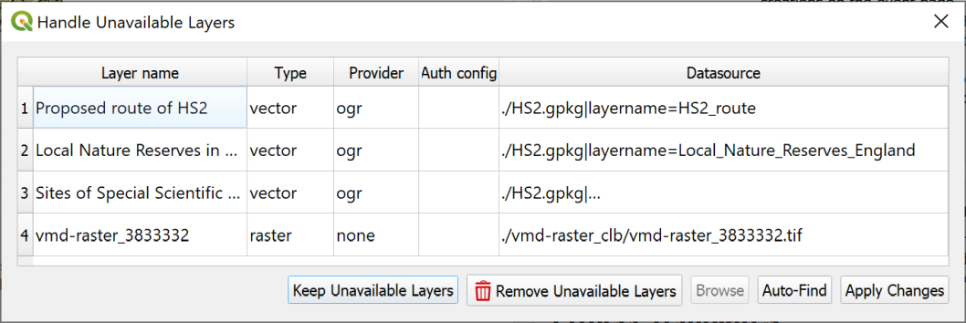

The Handle Unavailable Layers popup.

It is possible to repair the broken links using this dialog, but I find it easier to do so in the main map.

* Click on Keep Unavailable Layers on the popup to close it.

Your map should open but will be blank. Have a look at the Layers panel and you should see small warning triangles on the right next to each missing layer.

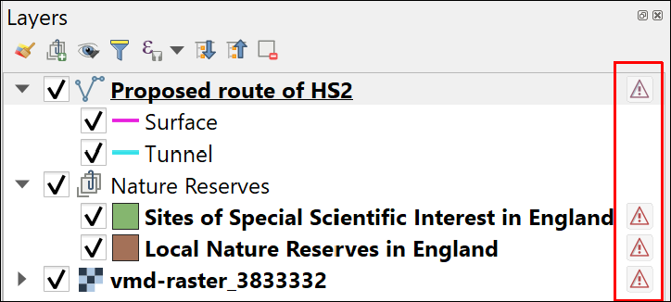

The warning triangles on the right of the layers in the Layers panel. These warn you that the layer is missing.

At this stage, **don’t panic**! As long as you know where the data files are stored on your computer, you can repair the links from QGIS.

### Repairing broken links to data

 **Repairing broken links to data in QGIS**

This video clip can be found in the module area of [Minerva](https://minerva.leeds.ac.uk) or in the [full list of video clips](https://cgordon-gis.github.io/videoclips.htm).

To repair the broken links in the Layers panel:

* click on the warning triangle next to the HS2 route layer.

The Repair Data Source window should open.

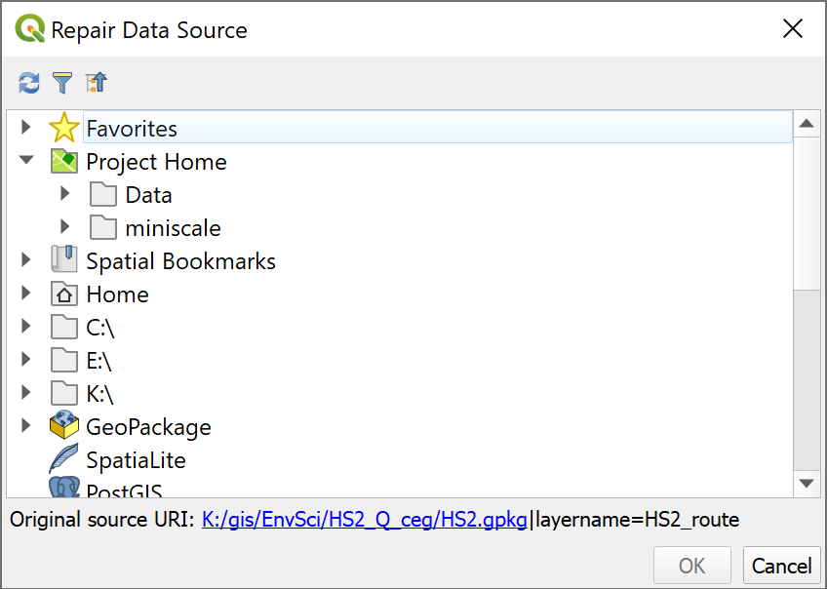

The Repair Data Source window.

* Have a look at the bottom of the window - it shows you the Original source URI: - that’s where QGIS is looking for your layer.
* If you don’t know where your data has gone, use the Original source URI as a starting point to look for it. This will also tell you the name of the data file your are looking for.

Once you do know where your data is located on your computer you can easily repair the link by navigating to the data in the list of locations provided.

* In this case you moved all your data into a folder called “Data”, so navigate to that in the Repair Data Source window and look for the HS2.gpkg file.
* Click on the little arrow next to HS2.gpkg and then click on the correct layer - HS2_route.
* Click OK

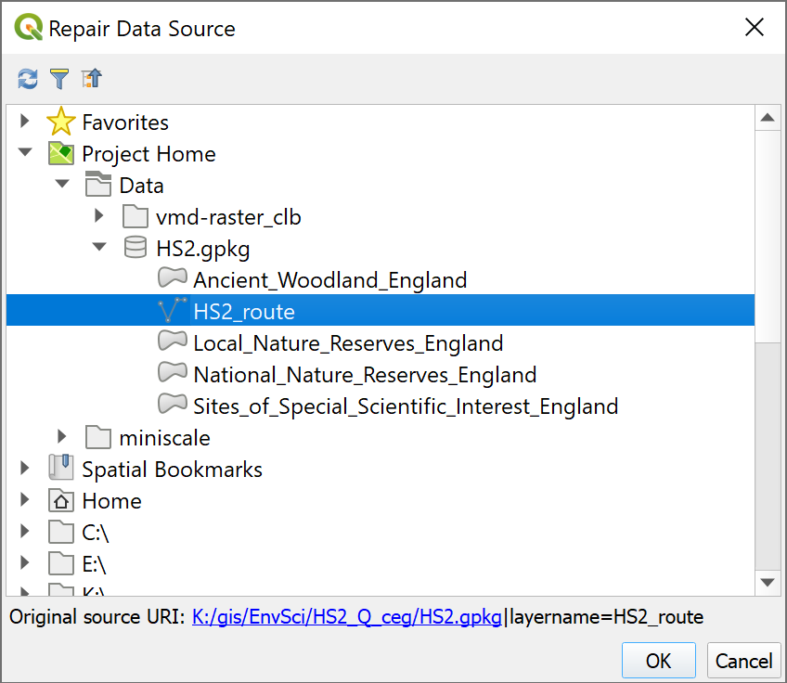

Selecting the correct data source.

Once you click OK you should find that the layer loads as expected and the warning symbol disappears. If you are selecting a layer from a geopackage you may even find that all the layers from the same geopackage load. In this case, hopefully the Sites of Special Scientific Interest and the Local Nature Reserves should also appear on your map.

 **Repair the link for the final layer**

The vector layers in your map should be loaded now. If not, repeat the process to load them.

You also have a raster layer on your map which won’t have loaded along with the vector layers - vmd-raster_3833332. That will still have the warning symbol.

Use the same instructions as above to load the raster layer, but this time you’ll need to look in the vmd-raster_clb folder for the data, instead of inside the geopackage.

Once you’ve done this your map should be complete again and there should be no warning symbols in the Layers panel.

### Avoiding missing file links

If you know where your data files are located, you should be able to fix missing links now, but it would be better to avoid needing to in the first place.

* Check that Save paths are set to Relative
  + Go to Project > Properties and make sure you’re on the top tab - General settings.
  + In the top section look for Save paths and check that it is set to Relative, not Absolute [4].
  + Click on OK.
* When you download data or set up a new project make sure that you start with a single folder for the project and save **everything** for that project into that folder. Be disciplined. If you download something, move it to the project folder straight away or you’ll forget and lose it.
  + When you download the HS2 project, **all** the files are stored in the same folder. This means that if you want to move the project, or save it to another drive, all the data is together. You can move the main folder or zip the whole thing and move that. You don’t need to worry about losing files.

 **Warning**

Please bear in mind that you need to be aware of where you are saving your files and take responsibility for that yourself. If you lose your files, I probably can’t help you to find them again as I don’t know where they are likely to be.

## Make vector layers transparent

Zoom in close to one of the Local Nature Reserves on your map which is on top of the VMD raster layer. You should be able to see that the polygons making up the reserve are symbolised in a solid colour which hides the detail of the base map underneath. We need to make the layer transparent by changing the opacity so that it is still possible to see the detail of the layers below it in the layers panel.

 **Making vector layers transparent in QGIS**

This video clip can be found in the module area of [Minerva](https://minerva.leeds.ac.uk) or in the [full list of video clips](https://cgordon-gis.github.io/videoclips.htm).

* Start by making sure that you have the Local Nature Reserves and vmd-raster layers visible on your map.
* Select the Local Nature Reserves layer in the Layers panel
* Press F7 on your keyboard or click on the Open the Layer Styling Panel button at the top left of the layers panel.

A new panel should open on the right of your map. This controls how your data looks on your map. For now we are only looking at Opacity.

* Click on the Symbology tab in the icons on the left of the panel
* Make sure that the Fill is selected
* You should see the Opacity slider - this controls the transparency. Move the slider to about 60% or type 60% into the box to the right.
* If you have Live update ticked at the bottom of the panel you should see the difference immediately, otherwise you’ll have to click on Apply.

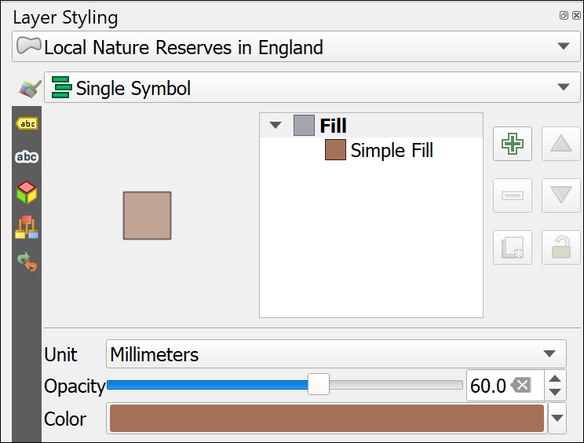

Changing opacity/transparency in the Layer Styling panel.

You should now be able to see the background map through the Local Nature Reserve polygons.

Feel free to try different settings of opacity to see how it works.

 **Warning**

It is also possible to change the transparency by using the Opacity setting in the Layer Rendering section, but if you do that the features won’t always remain transparent when you export your map to pdf.

## Locating features in vector layers

 **Locating features in vector layers in QGIS**

This video clip can be found in the module area of [Minerva](https://minerva.leeds.ac.uk) or in the [full list of video clips](https://cgordon-gis.github.io/videoclips.htm).

The layers in your map at the moment are vector feature classes and are searchable (you’ll find out more about raster and vector data types later).

* Click in the Type to locate box at the lower left of the QGIS window or use Ctrl+K on the keyboard.
* Have a look at the list of options that pops up - it looks a bit confusing to start with but is simple to use.

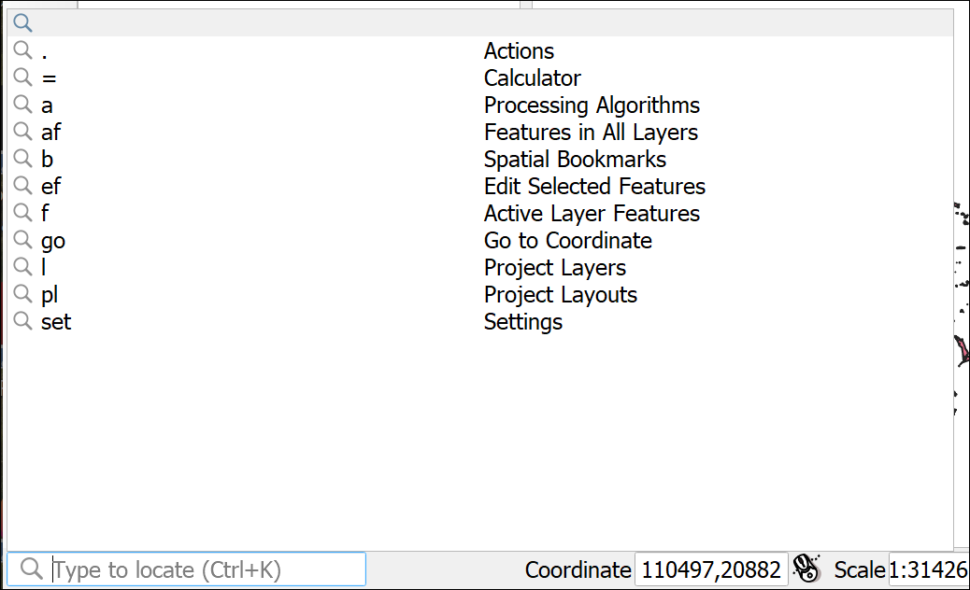

Click in the Type to Locate box to get a list of options.

* Type the following in the box: af Denaby. The af shows that you want to search for Features in all layers.
* As you type a list of results will appear - double-click on Old Denaby Wetlands

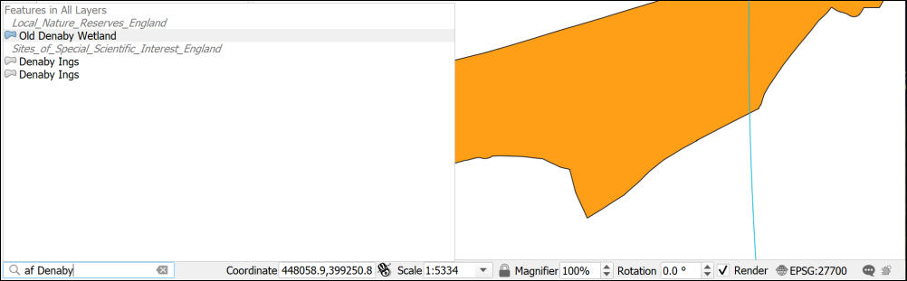

Clicking on one of the Type to Locate results should take you to the feature that you chose. In this case a feature from the Local Nature Reserves layer.

This can be a very useful way of finding things on your map if you are using vector layers.

 **Set a bookmark for Old Denaby Wetlands**

With Denaby at the centre of the map set the scale to 1:50 000

Create a new spatial bookmark for this view under Project Bookmarks and call it Old Denaby Wetland LNR. You’ll need to go back to this view later.

## Identifying features in layers

It can be really useful to be able to click on a layer and find out the values underneath the cursor. To do this you can use the **Identify Features** tool.

 **Using the Identify Features tool in QGIS**

This video clip can be found in the module area of [Minerva](https://minerva.leeds.ac.uk) or in the [full list of video clips](https://cgordon-gis.github.io/videoclips.htm).

* Check that the Attributes toolbar is visible by going to View > Toolbars and checking that there is a tick next to it.

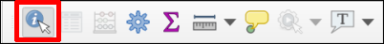

The Attributes Toolbar. The Identify Features button is highlighted.

* Click on the Identify Features button (highlighted in the image above, and remember you can use tooltips if you hover over a button)
* Then click on one of the Local Nature Reserves on your map
* You may get a choice of layers from which to identify a feature, if so, choose the Local Nature Reserves layer
* The Identify Results window should pop up showing a tree view of the value of the feature at the point you clicked on
* If nothing appears then the Mode may be set to Current Layer. In this case check the Mode at the bottom of the window. If it is set to Current layer you can change it to Layer selection, to identify features from a little pop-up window, or Top Down to identify features on all layers at that point. If you change the setting you will then need to click on the map again to get the result.

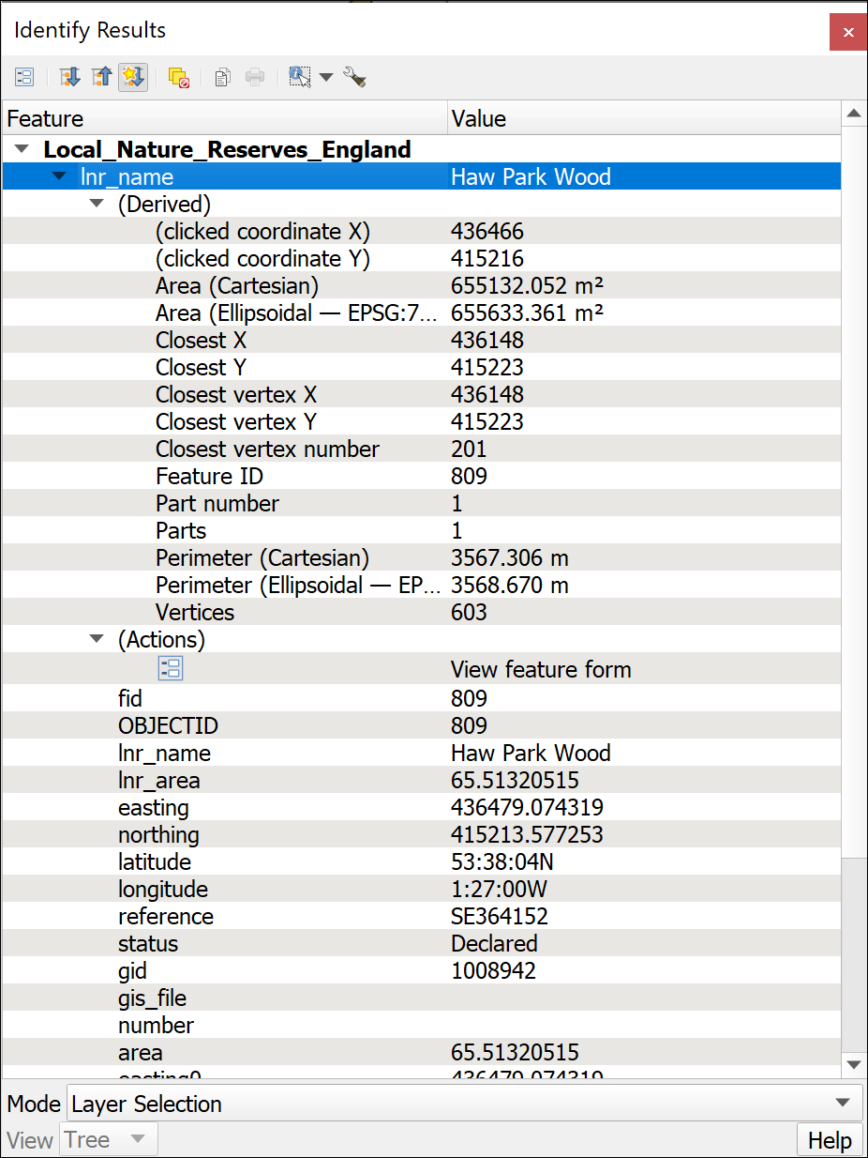

The Identify Results window showing the values for the feature that you clicked on from the local nature reserves layer.

You should be able to see the attributes of the feature, such as its name, but also statistics about it such as the Area.

You can also select to see details of all the layers at the point at which you clicked. This can be very useful if you are trying to compare layers.

## Saving your map

**Save your map projects at regular intervals.** You will be doing a lot of work on them and can lose a lot of time and effort if you have to do your work again because the program has crashed.

* Project > Save or alternatively Ctrl+S (Windows)
* If this is the first time you have saved a project make sure you remember where you save it to and give the file a name which will help you to remember what it is. It’s a good idea to save all your files to the same gis folder and make subfolders for each individual project. The aim is to be able to find your maps and data again if you come back to them weeks or months in the future!

### Back up copies

It is also a good idea to keep back up copies of your project and of the data files. Particularly once you start editing, very occasionally problems can corrupt the whole file, so make a copy of your gis folder in a separate location each time you finish working on them.

One way to do this is to zip the whole of the gis folder, rename it with the date, e.g. GIS_2020-12-03, then upload the zip file to your OneDrive.

## Geospatial analysis tools

Now that you have your data in a GIS, why not take advantage of its power? GIS can do much more than just display maps. It can also create new data by analysing existing data.

### Creating a buffer

By running a buffer tool you can create a new layer which shows the area within a certain distance of the selected features. We’ll use this to show areas within 1 km of the proposed HS2 route.

 **Using the buffer tool in QGIS**

This video clip can be found in the module area of [Minerva](https://minerva.leeds.ac.uk) or in the [full list of video clips](https://cgordon-gis.github.io/videoclips.htm).

* On the menu bar go to Vector > Geoprocessing Tools > Buffer
* Fill in the form as shown in the image below
  + Under Input layer select the Route of the HS2
  + Set Distance to 1000.0 meters (i.e. 1 km)
  + Leave the next four fields as the defaults
  + Tick the box next to Dissolve result
  + The Buffered field is for the output location and name. Click on the three dots button at the end of the line and select Save to Geopackage....
  + Select the HS2.gpkg geopackage, then give the layer a name, such as Buffer1000m so that you know what it shows and click on OK.
* Click Run

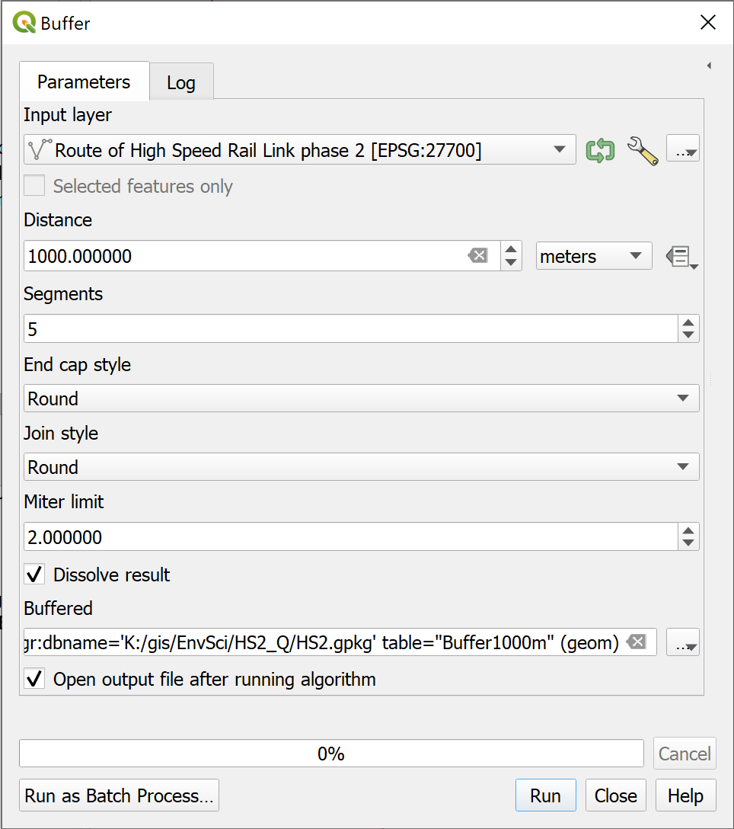

Filling in the Buffer tool.

The tool should run and add a long coloured polygon over the top of the HS2 route.

* Drag and drop the new layer so that it is below the route and nature reserve layers, but above the background layer.
* Make the layer transparent so that the background layer shows through.

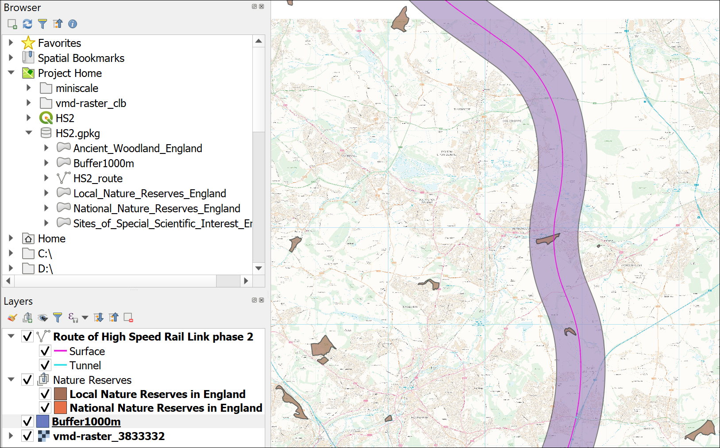

The map showing part of the 1 km buffer around the proposed route of HS2.

### Intersecting two different layers

You can use GIS to select features which are within a certain distance of features in another layer. For example, which Local Nature Reserves will be directly affected by the HS2 line?

We’ll use Select by location to select and export the nature reserves close to where the route is planned to pass. To do this we can use the buffer layer that we created in the previous step.

Make sure that both the buffer and the Local Nature Reserves layer are visible in your map.

 **Select by Location in QGIS**

This video clip can be found in the module area of [Minerva](https://minerva.leeds.ac.uk) or in the [full list of video clips](https://cgordon-gis.github.io/videoclips.htm).

* Find the Selection toolbar - if it isn’t already open go to View > Toolbars > Selection Toolbar
* Click on the button on the right - the tool tip will show you that this is Select by Location

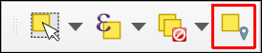

The Selection Toolbar. The Select by Location button is on the right.

* Fill in the Select by Location form as follows:
  + In Select features from select the Local Nature Reserves layer
  + Under Where the features... ensure that only intersect is ticked, but note what the other choices are.
  + In By comparing the features from select your Buffer layer
  + You’ll be creating a new selection rather than a new layer so from the Modify current selection by dropdown choose creating new selection to make sure that you’re not keeping anything from a previous selection.
* Click Run

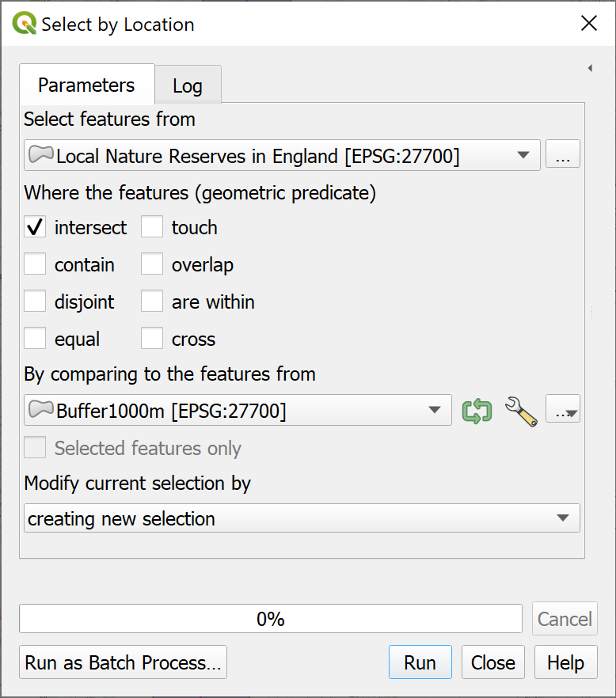

Selecting the local nature reserves which intersect the buffer around the HS2 route.

Close the form and have a look at your map. If you pan up and down the route of the HS2 you should spot that some of the nature reserves are now bright yellow - the selection colour.

#### Saving a selection as a layer

At the moment the selection is only temporary, to make this into a permanent layer do the following:

* Right-click on the Local Nature Reserves layer in the Layers panel
* Select Export > Save selected features as...
* Fill in the form as follows:
  + Format should be Geopackage
  + In the File name field choose your HS2.gpkg geopackage
  + Under Layer name give the layer a name such as LNR_intersect which tells you what it contains
  + Check that Save only selected features is ticked
* Click on OK

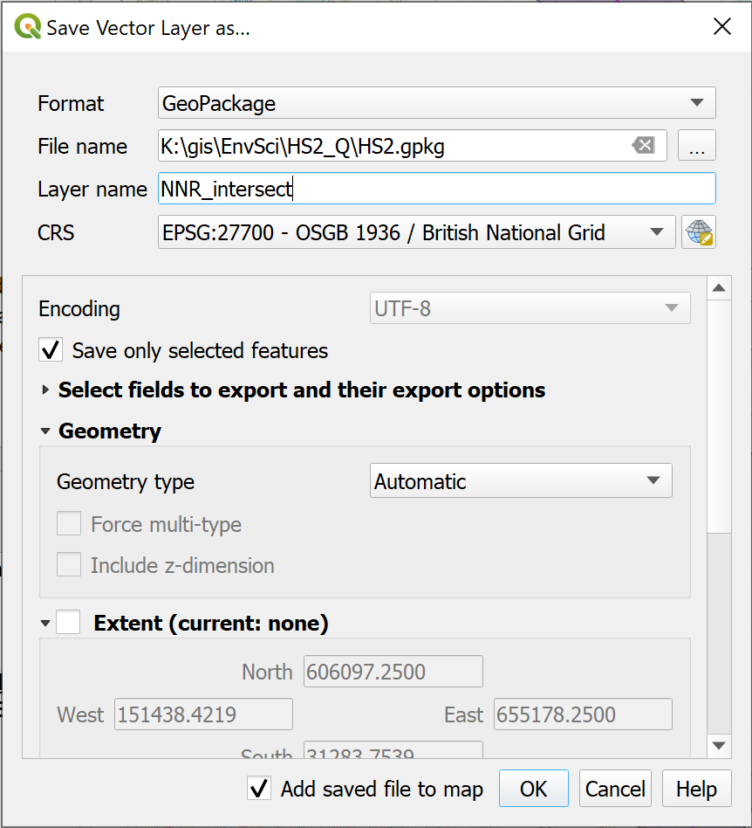

Saving the resulting selection as a new layer.

QGIS should run the tool and add a new layer to your Layers panel. You may need to add the layer yourself from the geopackage.

Check on your map that the layer only contains nature reserves that overlap the buffer.

To check that there is a difference between the original layer and the new one try the following:

* Right-click on each layer in the Layers panel in turn and select Show Feature Count

You should then be able to see how many features there are in the original Local Nature Reserves layer and in the new one.

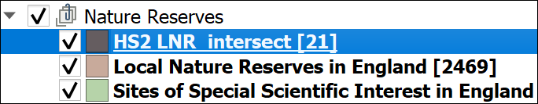

Showing how many features there are in the original layer and in the new layer.

In my case there were 2469 features in the original layer, and only 21 in the new layer.

Now remove the original Local Nature Reserves layer and you should be left with just those reserves which you had selected as intersecting with the buffer.

 **How many SSSIs are directly affected by HS2?**

Repeat the above process to intersect the SSSI layer with the buffer and work out how many SSSIs are directly affected by the route of the HS2.

## Layout - laying out a map for print or export

So far we have been working on the map view. If you print or export the map from here you have little control over it’s appearance. To produce a professional-looking map you need to use a **layout**. The information given here is just a quick introduction, you’ll cover layout and presentation in more detail in a later chapter.

I’ve set up a basic layout for you. To open it:

* In the menu bar click on Project > Layouts > Denaby Local Nature Reserve

The layout should open in a new window and look something like the image below.

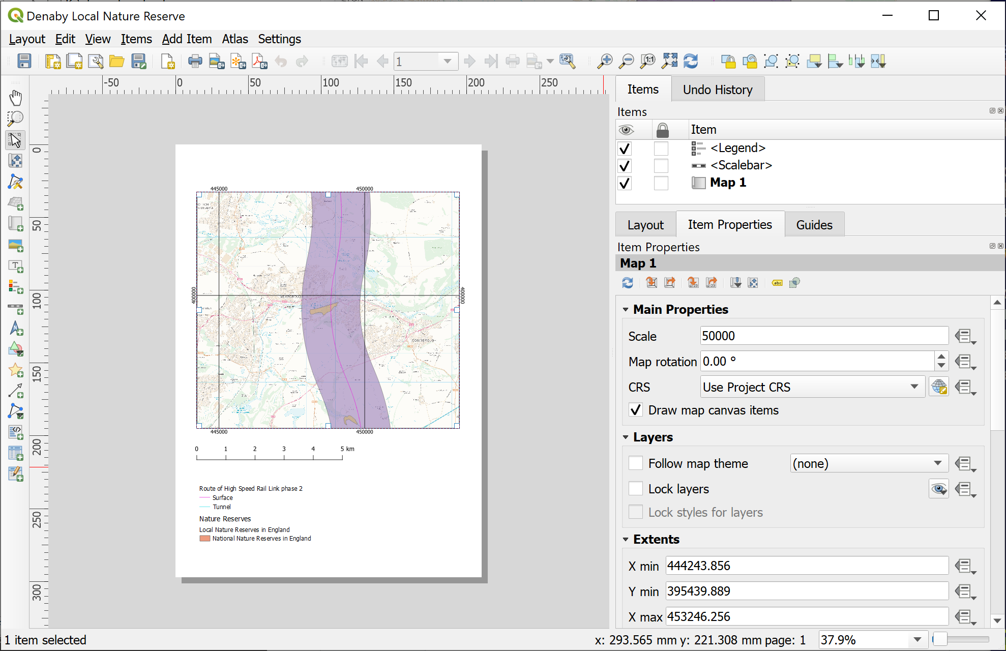

The Layout window showing the Denaby Local Nature Reserve layout.

The main area shows the “page” with the current layout. On the right you’ll see the Item Properties which depend on which item from the layout is selected.

The current layout includes three items, the main map, the scale bar and the key.

* Click on the map frame, i.e. the actual map, to see the Properties, such as the scale.
* The map frame can reflect the layers and view on your main map so go back to that and go to the Old Denaby Local Nature Reserve spatial bookmark that you set up earlier
* Return to the layout and with the map frame selected click on the left-hand button at the top of the Item Properties to Update Map Preview
* Try out some of the tools from the toolbar on the left (yours may be at the top of the map). Remember you’ll see a tool tip if you hover over the button. A lot of these tools add a new map element.

Don’t worry if you make a mess of the map! This chapter is just about learning the basics so explore and see what happens.

### Adding text to a layout

The most obvious thing missing from this layout is probably a title. Let’s add one now.

 **Adding text to a layout in QGIS**

This video clip can be found in the module area of [Minerva](https://minerva.leeds.ac.uk) or in the [full list of video clips](https://cgordon-gis.github.io/videoclips.htm).

* Either find the button for Add Label on the toolbar, or in the menu bar go to Add Item > Add Label
* Click and drag somewhere on the top of the page to create a text box.
* In the properties on the right click in the box which currently says Lorem ipsum
* Type the following text as a title

Denaby Local Nature Reserve and HS2 planned route

* Use the buttons below the box on the Item Properties to change the font and make it larger
* change the Horizontal alignment to Center

Try out some of the other options to make the title clear on your layout.

#### Copyright acknowledgement

Copyright acknowledgement is important! Always check the terms and conditions for any data that you use. Most will tell you the wording that you should use - though it can take a bit of finding sometimes!

The HS2 route and the nature reserves data is under the Open Government Licence[5]. So add the text below to your map.

Contains public sector information licensed under the Open Government Licence v. 3.0.

The background map is from the Digimap service (you’ll find out more about this later in the course). For this you need to add the following acknowledgement:

© Crown copyright and database rights *year*. Ordnance Survey (100025252).

Where *year* is replaced by the current year.

 **Adding copyright information**

Add both of those bits of text in a small font size near the bottom of the layout. You start with the same button you used to add the title above.

To add the © symbol (on Windows) put the number lock on the keypad, hold down the Alt key, type 1 6 9 then let go of the Alt key.

#### Adding your name / ID and the date

You should always add your name to your maps as the Creator. In the case of assessments you can add your Student ID instead.

In addition it is a good idea to add the date. Features “on the ground” will inevitably change and it will be useful to know when your map was created.

 **Adding a name and date**

Using the instructions for adding text add your name and the date to your layout.

### Printing or exporting a map layout

To export the map to pdf or an image

* Go to Layout on the menu bar and select either Export as image... or Export as pdf...
* Choose where to save your export and what to call it
* Click on Save - for now just accept the defaults and click Save again.

Have a look at your exported layout and check that you are happy with it.

To print your layout

* Layout > Print... from the menu bar
* Set up the printer as you would normally and click on Print

## Suggested layout

Your final map could look something like the image below. It is unlikely to look identical as you should make your own decisions about where to place elements and how to display your map.

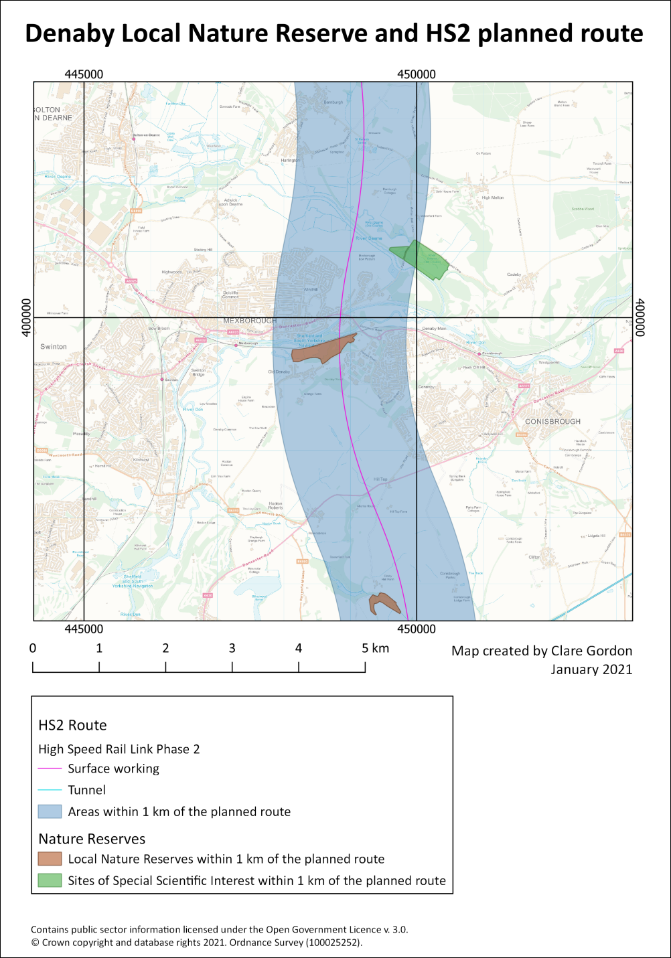

Possible layout for the HS2 map. Your map probably won’t look identical to this as you should make your own decisions about how to lay it out.

 **Getting feedback on your map**

Export your final layout and upload it to your Class Notebook personal GIS portfolio as instructed in class. If it is uploaded before the next class I will give **brief** feedback on your work.

If you have any questions about what you have done you can ask them in the class, in the drop in class or [via email](mailto:c.e.gordon@leeds.ac.uk).

## Finding help for QGIS

There is a lot of help available for QGIS online.

The obvious place to start is the [Documentation section of the QGIS website](https://www.qgis.org/en/docs/index.html). Select the documentation appropriate to the version of QGIS that you are using, e.g. 3.16. The page includes links to:

* User guide / Manual
* QGIS Training manual
* A gentle introduction in GIS

These go into different levels of detail but all are very useful to have bookmarked.

If you go on to [YouTube](https://www.youtube.com/) there are a lot of videos showing techniques in QGIS. Search for QGIS then whatever you are trying to do. Keep an eye on which version of QGIS the clips show as techniques can change with the version. Particular recommendations include videos by the following:

* [Klas Karlsson](https://www.youtube.com/c/KlasKarlsson/videos)
* [Hans van der Kwast](https://www.youtube.com/c/HansvanderKwast/videos)
* [Digital Geography](https://www.youtube.com/c/RiccardoKlinger/videos)

## Further information and recommended reading: Introduction to GIS

Many of the books on the reading list[6] have a general introduction to GIS which explain what it is and how it is used. Specific suggestions include the following:

* Chapter 1: *What is GIS?* in Heywood, I., Cornelius, S. and Carver, S. (2011), pp. 2-30.
* Chapter 1: *Systems, Science, and Study* In Longley, P.A. et al. (2015), pp. 3-37.

### What is GIS? and some example applications

* ESRI UK (who publish proprietary GIS software ArcGIS) have a web page which includes an [Overview of GIS](https://www.esriuk.com/en-gb/what-is-gis/overview) and a [GIS Showcase](https://www.esriuk.com/en-gb/what-is-gis/showcase) which includes examples of how GIS can be used.
* The webpage [GIS for Science](https://www.gisforscience.com/) gives a lot more ideas of how GIS can be used by scientists and is well worth a look.

# Finding spatial data to use in GIS

Last Modified: 02 Sep 22, 16:21:39

The background to finding data will be covered in the lecture segment at the beginning of the class, and the presentation and any other supporting materials will be available in Minerva. The lecture segment should help you to understand **why** you are doing these exercises. If you still aren’t sure, please ask [Clare](mailto:c.e.gordon@leeds.ac.uk).

## Learning outcomes

When you have completed this section of the workbook you should be able to

* find suitable data for GIS projects from a variety of sources
* acknowledge the data that you use in your maps in a suitable fashion

## Introduction

Being able to find, download and prepare your own data is an essential part of using GIS. While the data will be provided for you for many of the exercises in this module, you will find it useful to have some idea of where the data comes from, and what there is available for you to use for your own maps.

While downloading shouldn’t take too long, don’t leave it until the last minute before you have to produce a map. Websites can become unavailable either permanently or temporarily, or computers can crash.

## Digimap

Digimap is a service provided to Higher Education in the U.K. by EDINA at Edinburgh University. Digimap provides a front end to digital maps and data of Great Britain from the Ordnance Survey and British Geological Survey, amongst others. The University of Leeds subscribes to the collections and as a student you have access to maps and data for use as part of your studies.

### Logging in to Digimap

If you have not used Digimap before you will need to register and log in using your University ID, that is the username and password that you use to access University systems such as Minerva.

Full instructions for logging in are on the [Digimap help pages](https://digimap.edina.ac.uk/webhelp/digimapsupport/about.htm#access/access_to_digimap.htm).

* Go to the Digimap Collections page at <https://digimap.edina.ac.uk>

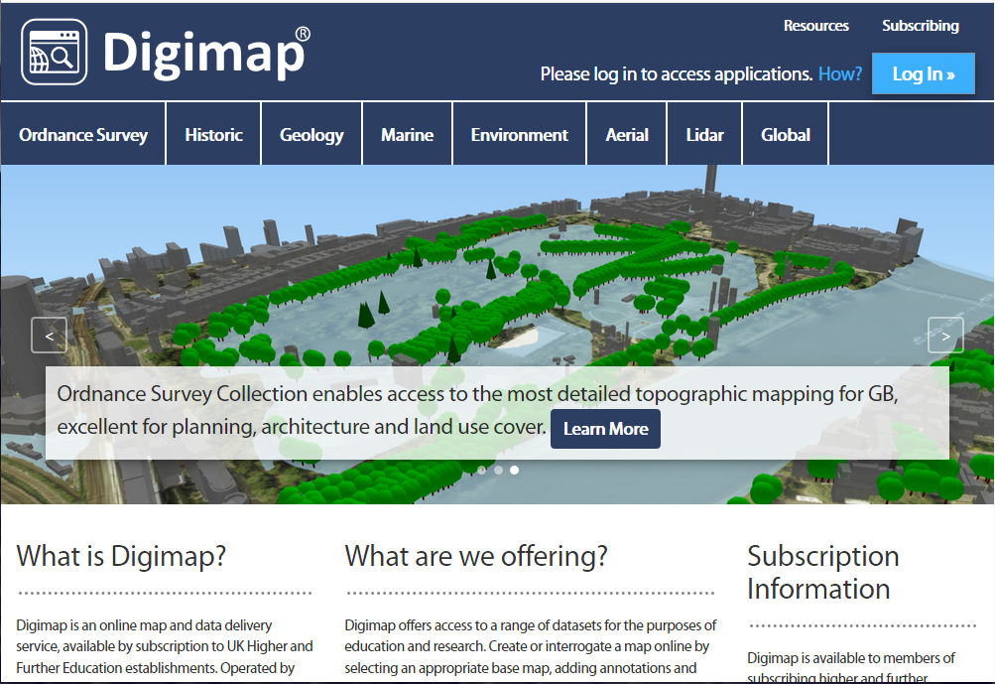

The Digimap initial page - note the “Log in” button at top right.

* Click the Log in button at the top right of the screen
* type Leeds in the box and select University of Leeds from the list of available institutions
* You should get the familiar University of Leeds log in page, so type your **University username and password** into the appropriate boxes and then click the Log in button. If you are already logged in to Minerva you may find that you don’t have to enter your login details again.

If this is the first time that you’ve logged in to Digimap you’ll be asked to register for each collection separately, though you can do all at one go. You won’t need to use all the collections during this module, but it’s worth registering for all that are available to you so that you can explore them for yourself.

* Go through the list of collections, read and accept the conditions for each one, selecting Academic Works (coursework, projects, dissertations etc.) in the Purpose dropdown for each.

Once you submit all those, you should be taken to the Digimap initial page again, as shown below, but this time you should see your name at top right rather than the log in button.

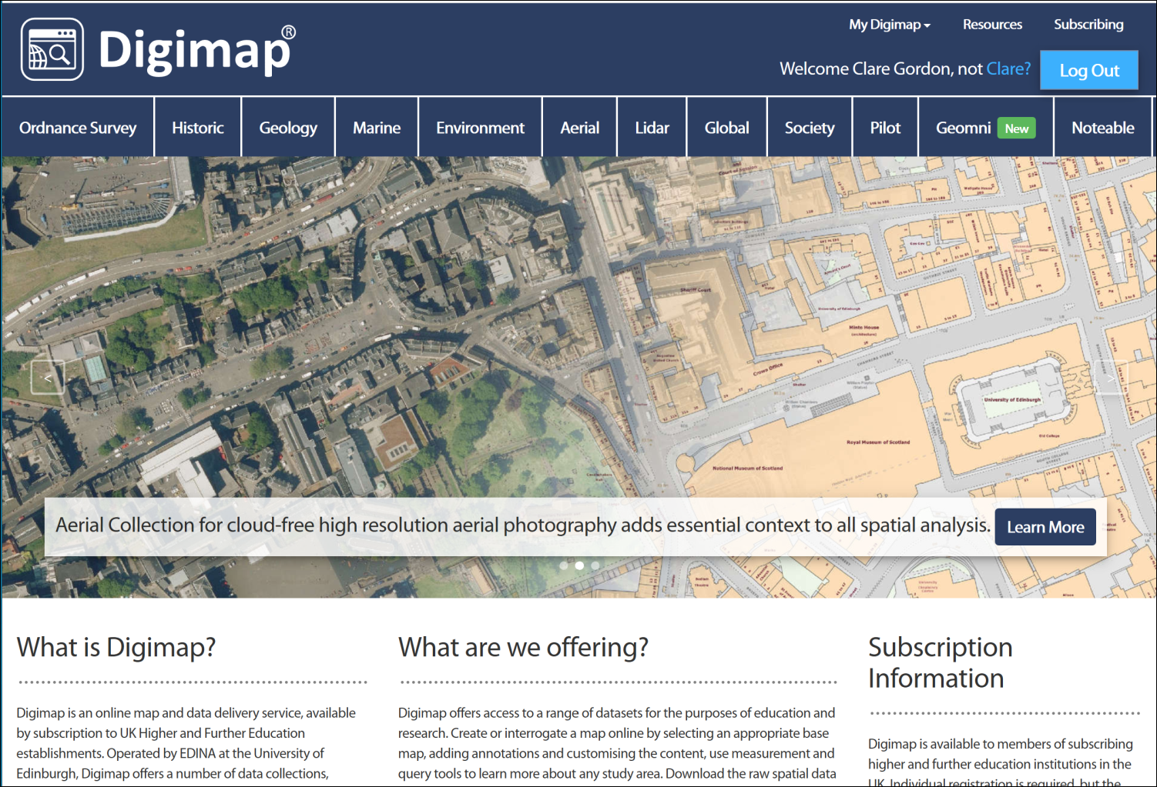

The Digimap main page again, this time with your name at the top right. You can now select a collection from the menu across the top.

The list includes options for a large number of collections. In this workbook we’ll only be looking at the collections that are the most relevant for creating the maps you’ll need during your course, but if you are interested in any of the others feel free to explore them. EDINA have worked to make all the tools similar across each collection, so just have a go!

### Browsing maps on screen

Each Digimap collection provides a **Roam** and a **Download** interface. The Roam interface allows you to view the data from that collection on a map on screen.

 **Using Digimap OS Roam**

As an example click on Ordnance Survey on the menu at the top of the main screen

Then select Roam under View, annotate & print a map on the right.

Have a go at zooming in and out and exploring the map at different scales.

Try searching for a location in the Search box at the top left, for example try searching for Leeds and from the list that appears click on Leeds (Leeds).

In this module we’ll be making most use of the Download interface, but it’s worth knowing what the Roam interface will do too, so have a quick go with a few of the tools on the left before continuing with the next exercise.

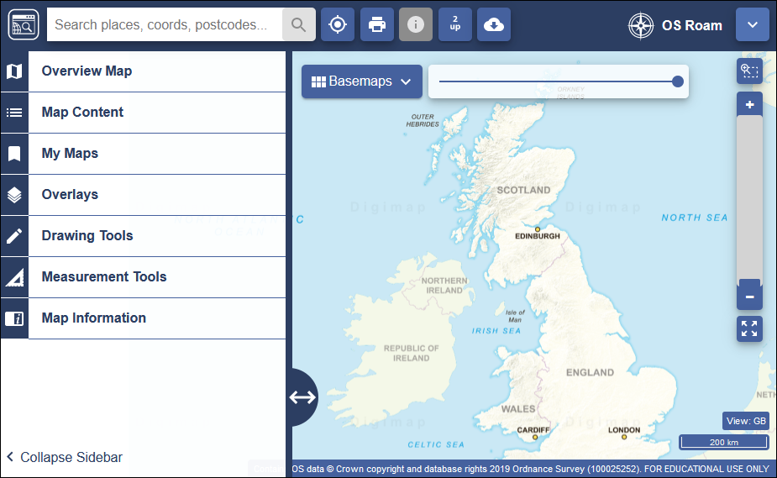

The Digimap Roam interface for Ordnance Survey data.

If you want more information about using the Roam interface have a look at the [Digimap Help Centre](https://digimap.edina.ac.uk/help/) which is linked from Help on the main page.

### Downloading data from Digimap

**Data Download** is the tool for downloading data for use in GIS or CAD software. The format that the data is delivered in will determine whether you will be able to open it directly in a software package or whether you will need to convert it.

We’ll be using data from Digimap in QGIS for various exercises in the rest of this module, so you need to know your way around this section. Instructions for converting, importing and viewing file types that need it will be given later in the workbook.

As an example of the download interface, we’ll download some **Ordnance Survey** data.

* Start from the Digimap main page (you can get back to it by clicking on the icon at the top left of the map - hover over to see a tool tip)
* click on Ordnance Survey in the menu at the top of the page
* from the Ordnance Survey page choose Data Download

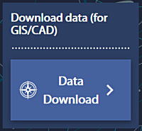

The Data Download link on the Ordnance Survey page.

Data Download takes you to a map that looks very similar to Digimap Roam, but with some important differences.

#### Selecting an area

On the left there is a menu panel with options for selecting an area, with a search box above it.

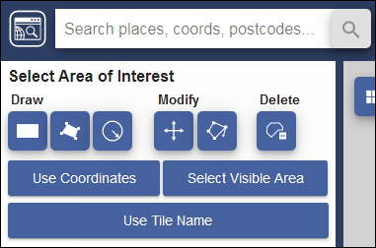

Digimap Download - search for and select an area.

* Click in the Search box and type Otley, then press Enter or click on the magnifying glass to search
* When you get the results click on Otley (Leeds) to zoom to the correct area, then close the search results
* Under Draw click on the rectangle and use the mouse to draw a box around the area shown by an orange box in the image below, clicking to start and finish the box. It doesn’t matter if the box you draw is a bit bigger, but try not to make it any smaller.

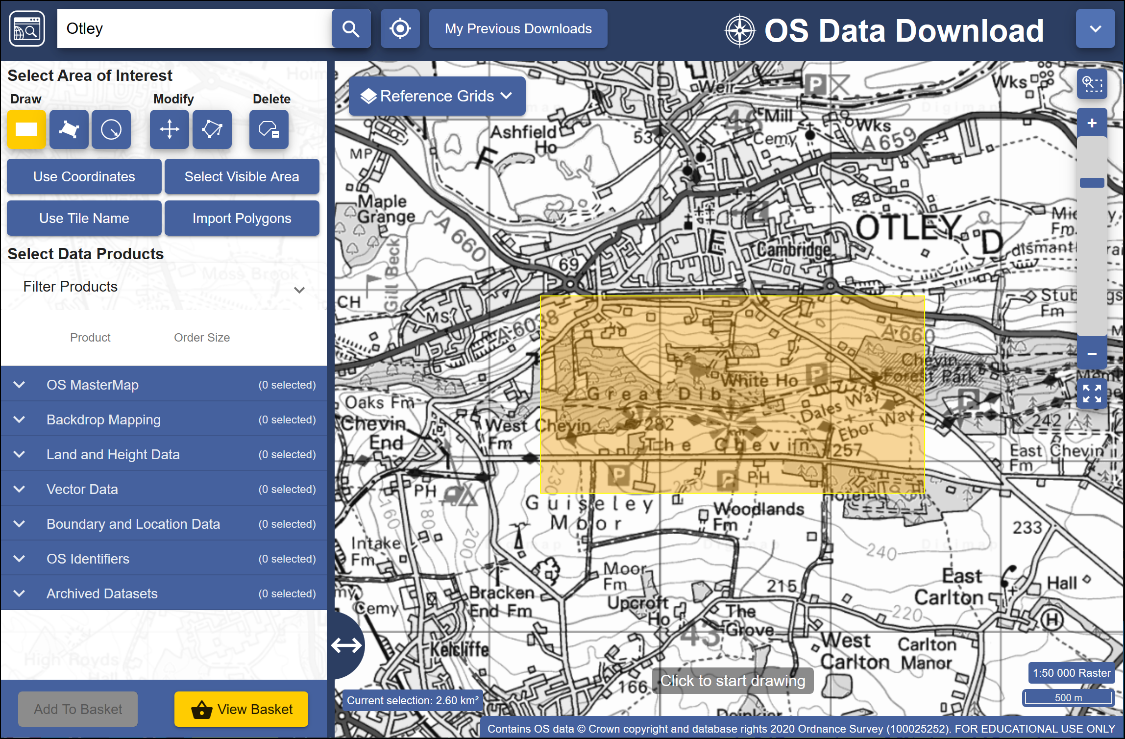

The minimum area to select using the rectangle tool.

 **Area view**

Note that the map you see on the screen only shows the area that you will be downloading data for, **not** the actual data that you’ll be downloading. You’ll select the data in the next section so don’t worry what it looks like for now.

#### Selecting data sets

Now that you have selected an area you have to select the data that you need.

* Back in the panel on the left, under Select Data Products, drop down each of the headings, e.g. Backdrop Mapping, in turn by clicking on the arrow next to them.

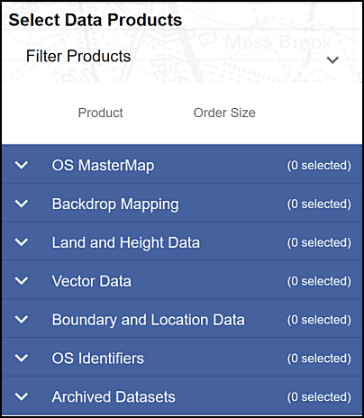

The list of data products - click the arrow next to each subheading to see the full list.

* There are a lot of different data sets here and most of them won’t mean anything to you. For now select the following data sets when you find them, by putting a tick in the box next to them.
  + Backdrop mapping: VectorMap Local Raster
  + Land and Height data: OS Terrain 5 Contours

You can get more information about the data sets by clicking on the arrow next to them. This includes information on licences - which you will need to know later.

The number on the right in brackets under Order Size shows how many tiles your selected area uses out of the maximum downloadable number. If you have chosen a slightly different area to me your number may be different, but you should still be well within the limit.

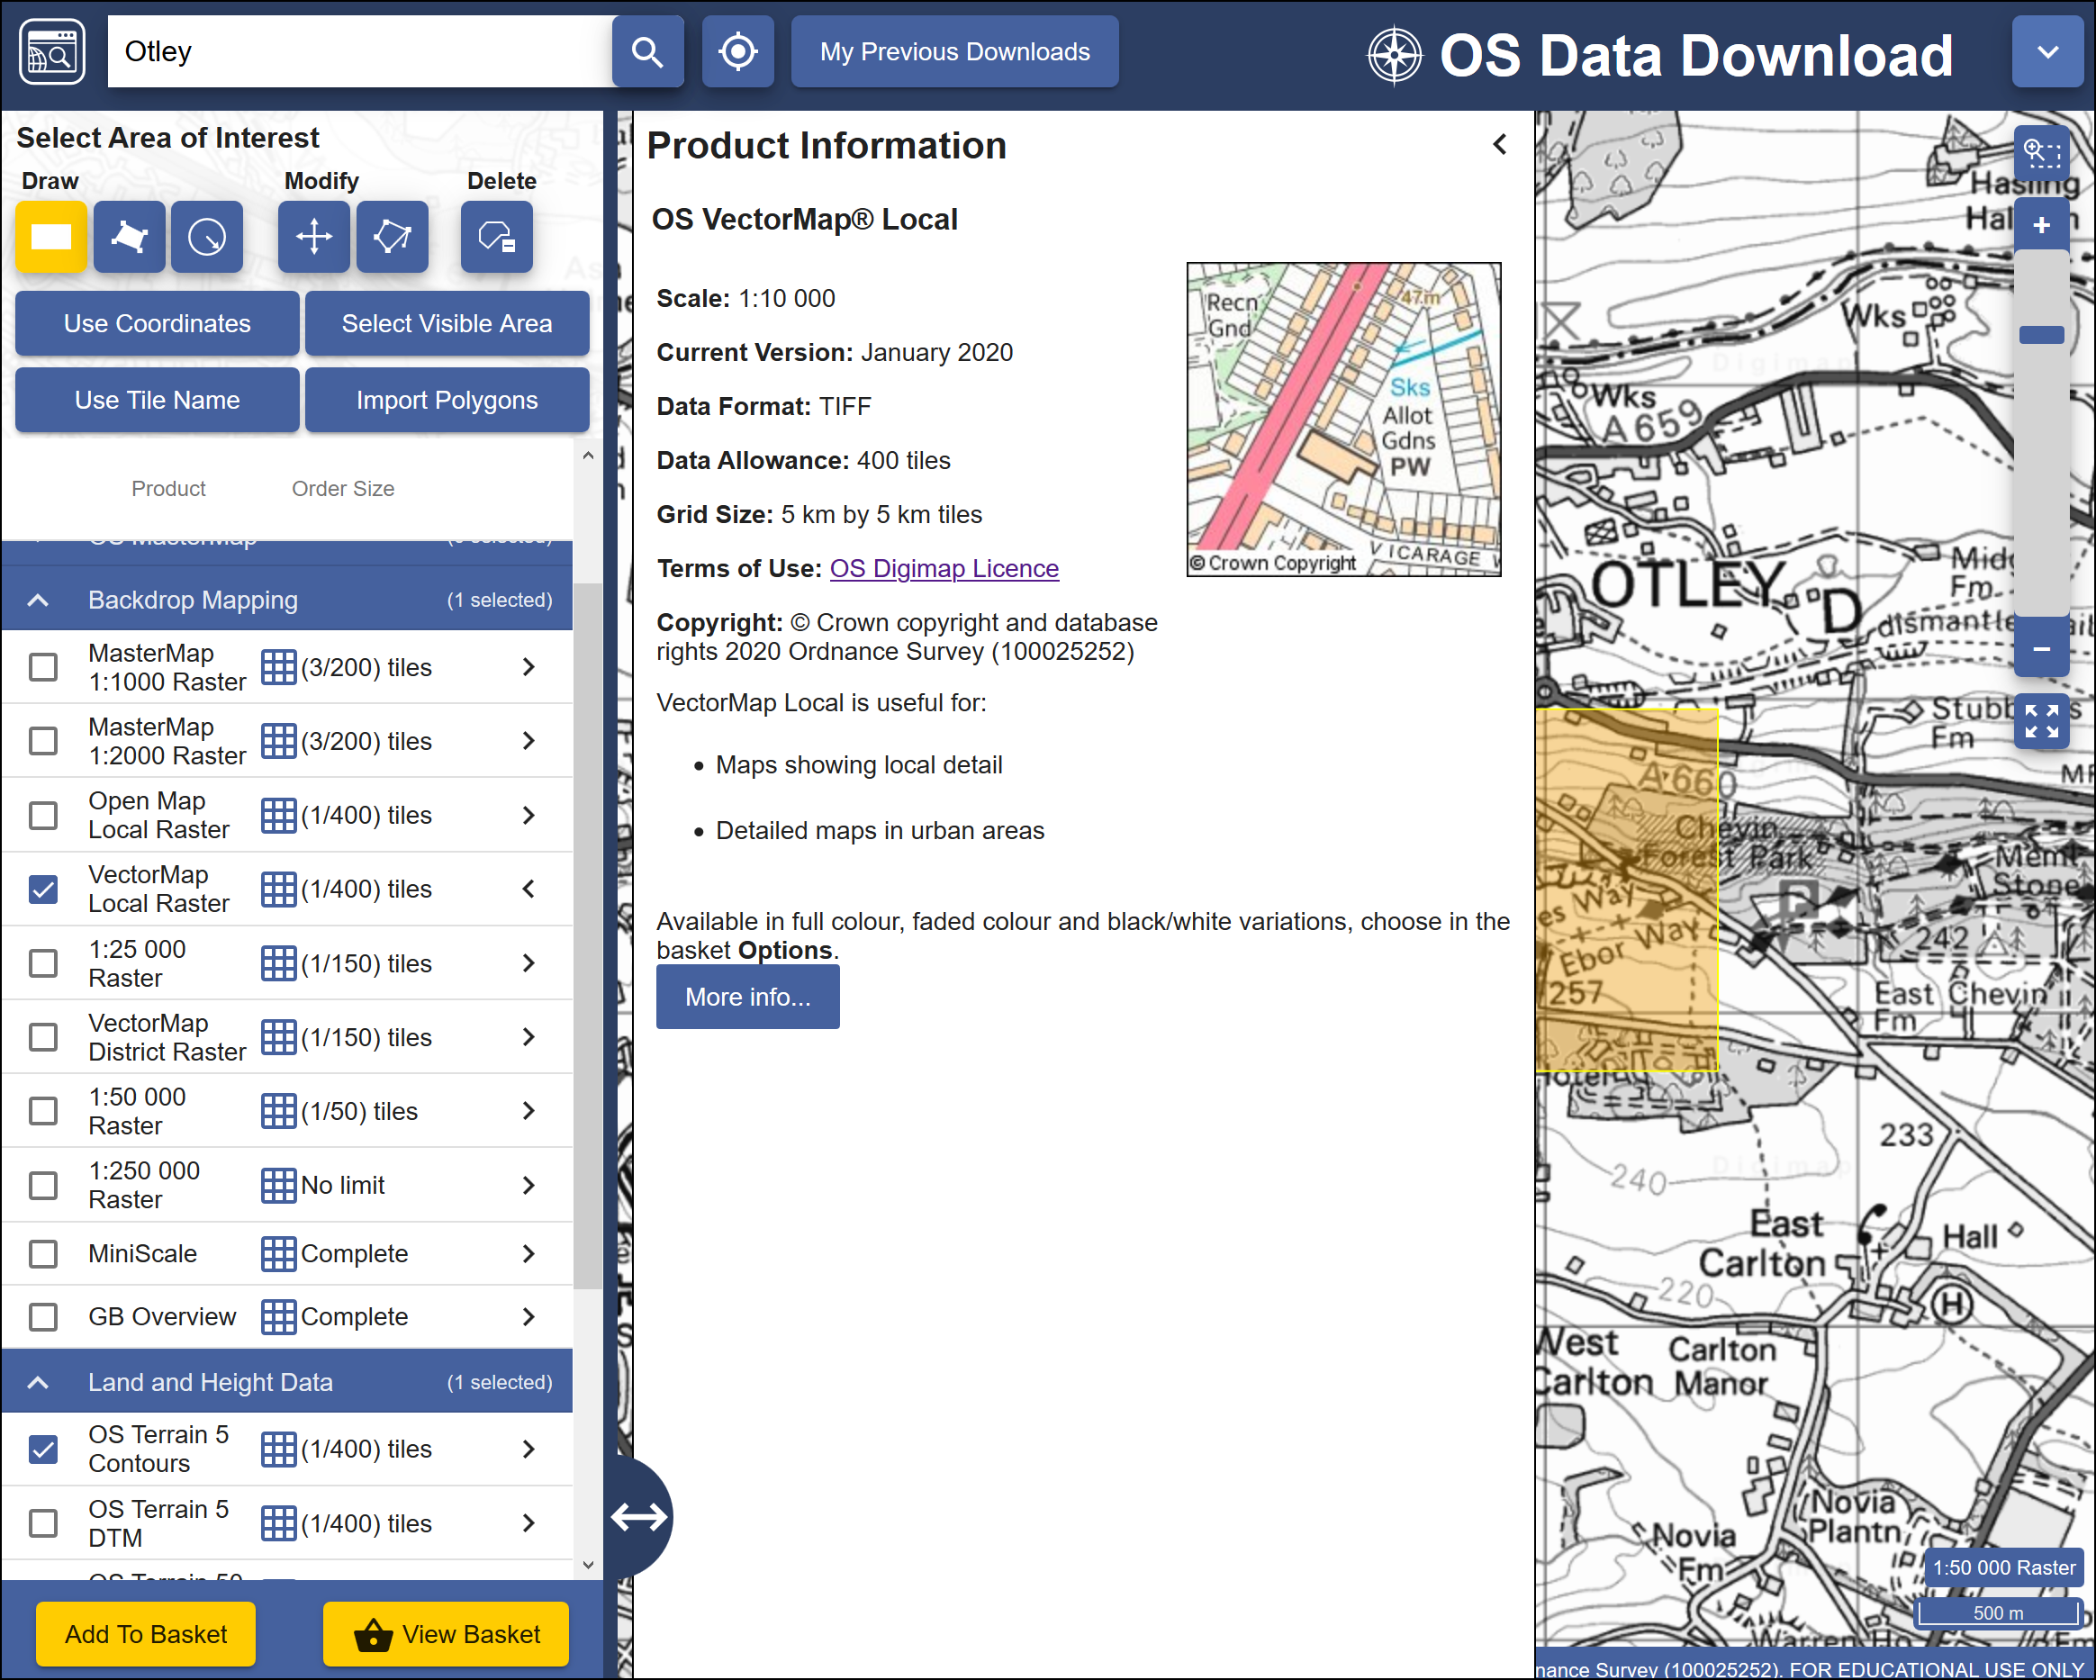

Selecting datasets. The image shows the information for the VectorMap Local Raster dataset and that I am going to download one tile out of the maximum limit of 400.

* When you have selected the data you require click on Add to Basket (Don’t worry, despite the Basket and Checkout you won’t be charged. The University has already paid the subscription.)

Your basket should appear with details of your order.

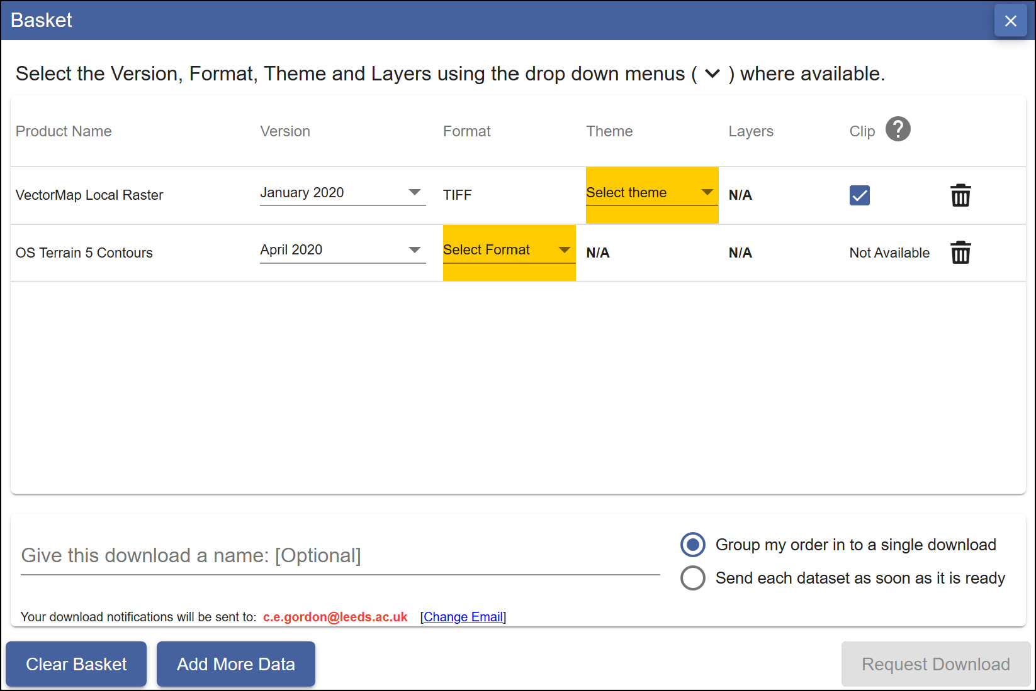

Details of your order in the Basket. Yellow highlights show choices that you need to make before you can request download.

* Some datasets will give you an option to change the format. In this case click on Select Format next to the OS Terrain 5 Contours. The choices are **Shape, GML3** or **DWG**. Choose Shape in this case.
* You may also need to select a theme. For the VectorMap Local Raster there is a choice of themes - pick Black and white for this exercise, though it is worth downloading the others to have a look at them too.
* Some items will have a Clip option. This means that the data will be sent to you clipped to the area outline that you requested. If you are short of disk space this is very useful as it restricts the amount of data you need to download, but otherwise it doesn’t hurt to have extra data around the outside of your study area. I prefer to untick this box and download full map tiles.
* Give the order a name, e.g. OtleyOS (for Ordnance Survey). This will be part of the file name of the zip file that you download, so try to make it short but helpful!
* Click on Request Download

#### Downloading your data.

You’ll receive an email confirming your order, then another with a download link. This can sometimes take a while to arrive, depending on how busy the service is.

Make sure that you are still logged in to Digimap before you click on the download link.



The download link in the email - click on this to download your data, not on any of the other links in your email!

Once you have clicked on the link a browser window should open telling you that your order is ready to download.

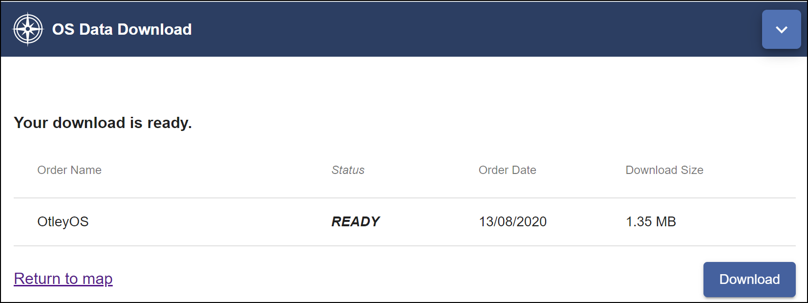

Order ready to download, showing the name and size. Click on the Download button.

* Click on Download
* You’ll download a zip file. **NOTE:** Don’t run or open the file directly from your browser, and make sure that you **DON’T** save your zip file to a **temp** folder where you will probably be unable to unzip it.

 **Warning**

Make sure that you remember where you have saved the zip file.

Now open File Explorer (in Windows) and navigate to the location where you saved the zip file.

* Right-click on the compressed map data file that downloaded and choose to Extract files... - or 7-zip > Extract files... if you have 7-zip available.
* Select where you want to save the extracted files, and make a note of where you save them to

You should end up with a folder for each dataset that you requested plus text files showing citations and contents. The folders will also have the order number as part of their name.

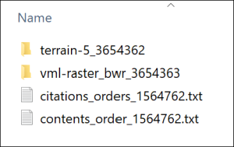

The unzipped Ordnance Survey data showing the folder for each dataset and text files containing citations and contents lists.

#### Viewing your data

In this case the files that you have downloaded are either tiff graphics files or shapefiles.

* Navigate to the data that you downloaded in the file explorer and find the folder called something like vml-raster_bwr_3612556 (your order number will be different).
* You may also need to go into a folder with the OS grid letters - in this case for Otley it will be se
* Open one of the .tif files by double-clicking on it - the file should open in a graphics program, but that depends what you have set up on your computer. Don’t worry if it doesn’t!

You should be able to see that this is basically a “picture” of a map.

* Try opening one of the .shp files from the terrain-5_3612555 folder too. It’s unlikely that you’ll be able to. Just cancel that and don’t try finding software that will open it!

 **Warning**

Both folders will contain files that have similar names to the .shp and .tif files, but different file extensions. These are known as “side-car files”.

They won’t open in any programme but are essential for using the data in GIS programs such as QGIS, so make sure that you always keep these files together.

Both of these formats will open in QGIS in the same way that you added data to your map in the [Introduction to GIS](/introduction/#adding-layers-to-qgis-with-the-browser).

You don’t need to keep the files that you have just downloaded, just remember how you downloaded data from Digimap. You’ll be doing that for future exercises.

### Copyright acknowledgements for Digimap data

Copyright is important. Remember that most data providers ask you to sign up to conditions that include an obligation to add a copyright acknowledgement to your map. Check what that copyright statement is and add it.

When you signed up to use the Digimap collections you agreed to add copyright acknowledgements whenever you created a map with the data. The wording does change from time to time so it’s worth knowing how to check it for yourself.

To find these copyright acknowledgements:

* go back to the main Digimap home page
* go to the Digimap Help Centre (Help at the top of the main Digimap page)
* Click on the link to Copyright and Licensing from the Help page.
* In the list on the left click on the Educational User Licence for the data that you’ve used - in this case the Ordnance Survey Educational User Licence.
* then look for the information under In return, you must: - that gives you the acknowledgement text.

For example, as of November 2021 when you use Ordnance Survey data obtained from Digimap you are expected to add the following text to your maps.

© Crown copyright and database rights *year*. Ordnance Survey (100025252).

Where *year* is replaced by the current year.

 **Adding the copyright symbol to your text**

To add the **copyright symbol** - © - to your text

* check that the Num lock is on on the keyboard
* hold down the Alt key on the keyboard
* then use the number pad to type 0169
* release the Alt key

Remember that you do have to acknowledge each different dataset that you use and will have signed up to that when you registered.

If you are **not** using U.K. Ordnance Survey data this is **not** the correct copyright acknowledgement to use. For example, if you are using data for Spain or the United States, or indeed UK data that you haven’t downloaded from Digimap. You’ll need to find the correct copyright acknowledgement for yourself.

[Advice on **citing** Digimap data](https://digimap.edina.ac.uk/webhelp/resources/citation/services.html), as opposed to the copyright acknowledgement is given in the Digimap Resource Centre.

The [GIS Lounge page on How to cite GIS materials](http://bit.ly/1ZSifnd) gives some information about citing the software as well as the data. Have a look at that and follow the suggestions to cite non-Digimap data.

### Other Digimap collections

In addition to Ordnance Survey Digimap you will also find that you’ll make use of some of the other collections, in particular **Geology Digimap** and **Aerial Digimap**. The Roam and Download interfaces work in a very similar way to the Ordnance Survey collection so you should find that you already know how to use them.

You have access to all of these collections so feel free to have a look at what is available and make use of any of the data or maps in your work.

 **Exploring other Digimap collections**

Go into the Historic Digimap Collection and use Historic Roam to look up either your house, if you are in Great Britain, or the University of Leeds (search for the postcode LS2 9JT) using old maps. Try the 2 up view to see how you can compare old and new mapping of the same area.

### Digimap Collections online help

Digimap help is available from each of the collection pages. Click on the links in the left-hand menu for more information about how to use the services and file formats.

Alternatively use the Help links from within Roam or Download or use the [videos that EDINA have uploaded to YouTube](http://www.youtube.com/user/EDINADigimap)

If you want more detailed information EDINA provide e-learning units which are linked from the [main Digimap home page](https://digimap.edina.ac.uk).

## Data from the web

EDINA Digimap provides a wide range of useful data covering the UK, but you are also likely to need data from outwith the UK, or UK data that isn’t provided by Digimap. It isn’t possible to cover everything in this session, but I will show you a couple of sources which you should find useful. You’ll discover others as you go through the rest of this course.

### Natural Earth Data

Natural Earth is a free, public domain dataset consisting of raster and vector data that will allow you to make maps at general scales. If you want a map of the World, or a general map of a particular country, this is a good starting point.

* Start by going to [Natural Earth](https://www.naturalearthdata.com) in your browser

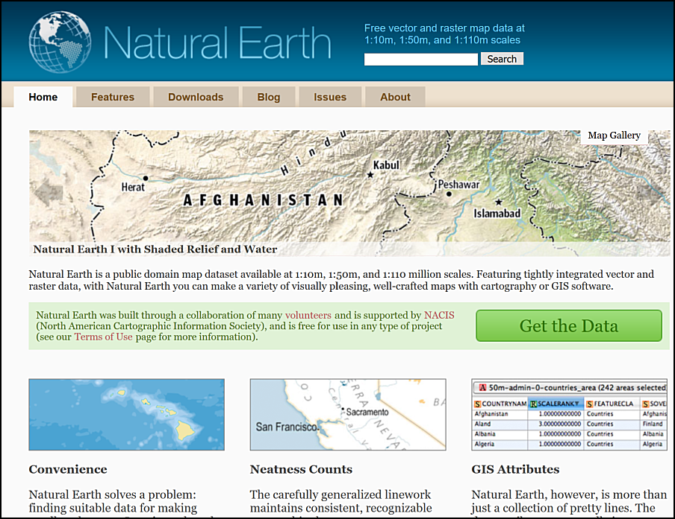

The Natural Earth front page. Free vector and raster map data at three general scales.

The front page gives an overview of the principles behind the data and an idea of the scales at which it is available. You can find more information under the Features tab, including the file formats and the coordinate system - both important for using the data within GIS.

 **Natural Earth data**

Go to the Features page and make a note of the file types of both the raster and vector data provided by Natural Earth and of the coordinate system that the data comes in.

To download data either

* Click the Get the Data green button on the front page
* or click on the Downloads tab at the top of the site
* Choose the scale that you want to download and the type of data that you want, e.g. cultural, physical or raster

For this exercise download the following data:

* Medium scale data, 1:50m > Cultural > Admin 0 - Countries - click on the Download countries button to download a zip file. Make a note of where this file is saved to on your disk.
* Medium scale data, 1:50m > Raster > Natural Earth 1 - click the Download small size button under Natural Earth 1 with Shaded Relief and Water. Again, make a note of where the zip file is saved.

Keep these data layers for later exercises. Make sure you put the zip files into your GIS folder.

Have a look at the summary of the data on the Features page. If you wish, try downloading other datasets. You can try adding them to a blank map in QGIS in the same way that you added data in the Introduction to GIS.

#### Natural Earth data copyright

Finding and acknowledging the copyright of data is very important.

* Return to the [Natural Earth front page](https://www.naturalearthdata.com)
* Look at the text in the box next to the Get the Data button. One of the links there is to the Terms of Use page. Click on that now.

 **Acknowledging Natural Earth data**

Read the Terms of Use of Natural Earth data

How should you acknowledge the Natural Earth data if you use it in one of your maps?

The terms of use do say that “Crediting the authors is unnecessary”, however, it is still a good idea to add the data acknowledgement to your map to avoid any possibility of plagiarism. You can choose whether to use the short or long text listed on the page. Adding the url of the data can also be a very good idea.

### XYZ Tile maps in QGIS

If all you need is background map and you don’t need to be able to make changes to it then QGIS XYZ Tile maps are probably the easiest solution. They make use of [OpenStreetMap (OSM) data](https://www.openstreetmap.org/) - be aware that this is crowd-sourced and quality and coverage vary.

* Open QGIS - you can leave it on the welcome screen or open a new blank map by clicking on the New Project button on the toolbar or pressing Ctrl-N on your keyboard.
* In the Browser panel look for the XYZ tiles heading.
* Double-click on the OpenStreetMap layer to add it to the new map.

You should find that you have a World map and can now zoom in to wherever you want and pan around. Try that now to see the level of detail that you can get. Note that the level of mapping does depend on how actively particular areas have been mapped.

By default the XYZ Tile choices include OpenStreetMap, OCM Landscape and Outdoors. OpenStreetMap doesn’t need an API key and won’t have a watermark across it, the other two do.

To add an api key:

* Sign up for one on [Thunderforest website](https://manage.thunderforest.com/). You can do so for free as Hobby Project (free), but get a limited quota of views. This shouldn’t be a problem if you are just using it as a map background on your desktop.
* Once you have an API key you can see list of urls at bottom of page. Select and copy one of these, e.g. Outdoors. There is a gallery of the [map styles](https://www.thunderforest.com/maps/) you can check.
* In QGIS look for the XYZ Tiles subheading in the Browser panel.
* Right-click on XYZ Tiles and select New connection...
* Give the new layer a Name, e.g. Outdoors (API).
* Next to URL paste in the url that you copied, which should include your personal api key, then click OK.

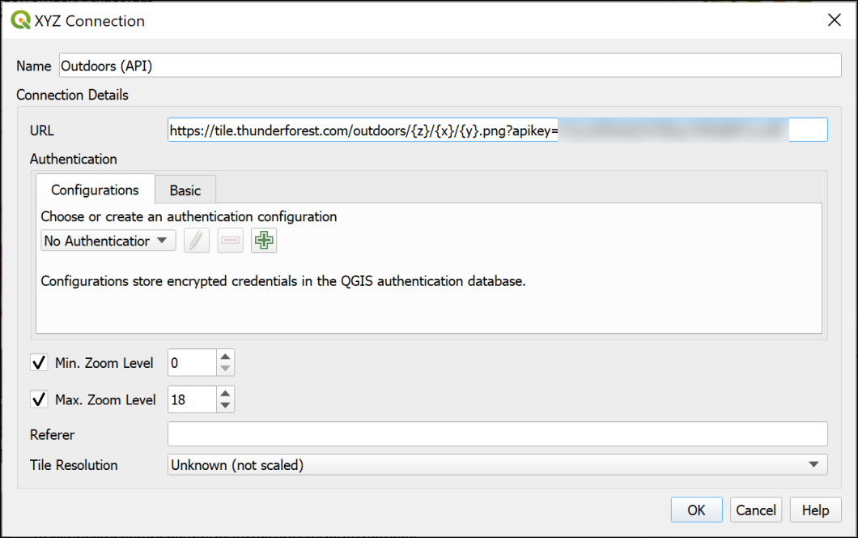

Setting up the XYZ tiles connection using the link from Thunderforest.

* Now you should be able to find the layer in the list of XYZ Tiles and drag and drop it into the Layers panel as you would any other layer to add it to your map.
* If you wish to edit the settings for any of the XYZ Tile layers right-click on them in the Browser and select Edit....

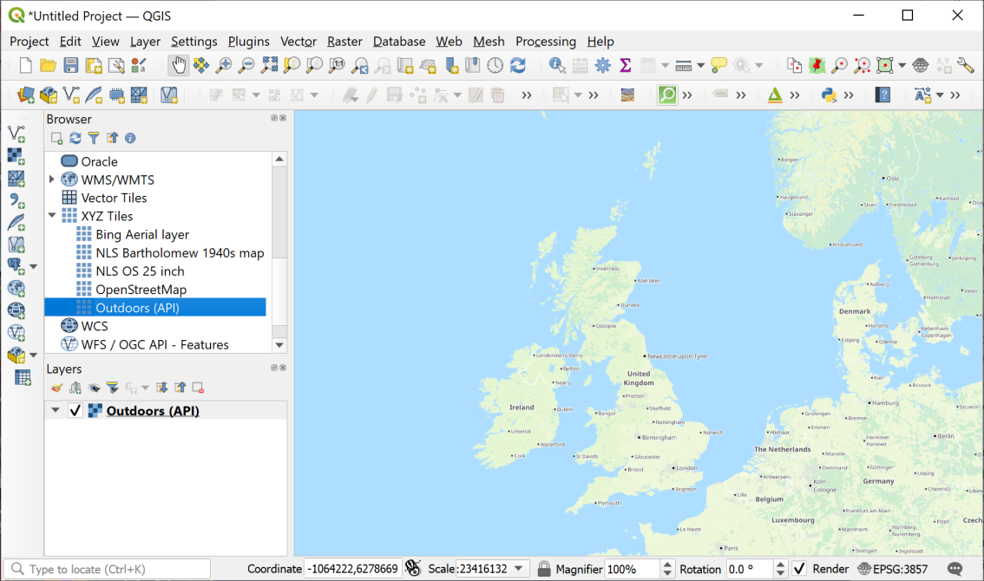

Loading XYZ tiles - the Thunderforest Outdoors layer is displaying in the map window.

#### Adding a Bing Aerial layer

 **Adding an XYZ Tile Layer to QGIS**

This video clip can be found in the module area of [Minerva](https://minerva.leeds.ac.uk) or in the [full list of video clips](https://cgordon-gis.github.io/videoclips.htm).

Tile layers are becoming more widespread, and you may be able to find other data to add to the list. If you do, there should be a URL which you can add in the same way as the Thunderforest urls above.

For example, it is possible to add a Bing aerial layer as XYZ tiles. I found this URL by searching for Bing satellite tile maps qgis then [browsing some help pages](https://gis.stackexchange.com/questions/370594/getting-bing-maps-to-display-in-qgis?rq=1).

* Try adding the following URL to the same map as the OpenStreetMap layer you added above.

http://ecn.t3.tiles.virtualearth.net/tiles/a{q}.jpeg?g=1

If you need to change an entry later simply right-click on it in the Browser panel and click on Edit.

Once you’ve added a layer it should stay in the list in your Browser panel for you to use again in future.

### Finding other data online

These are just a few examples of finding useful data for GIS. Throughout the rest of the workbook you’ll be downloading your own data from Digimap. If you need data from elsewhere, I’ll either give full instructions or provide the data for you, but tell you where I got it from.

If you are looking for data for a particular project it is well worth searching online using your favourite search engine (e.g. Google). Put the words “gis” and “data” into your searches and it should help you to find relevant data.

I have put together a short [list of possible data sources](https://cgordon-gis.github.io/links.htm) which you are welcome to use to find data and maps.

## Optional section: ESRI Living Atlas

This section is optional. You can work through it to find out about some more layers you can add to your maps in QGIS.

If you don’t have time to do this section now, you can come back to it later if you wish to.

The [ESRI Living Atlas](https://livingatlas.arcgis.com/en/home/) is an extensive collection of map layers and maps curated by a company called ESRI. ESRI produce commercial GIS software, ArcGIS, which is similar to QGIS but is not Open Source. Some of the data is only available if you subscribe to ArcGIS Online, but even without subscribing there are a lot of datasets available to use as background layers. This section will give you an idea of what is available and how you can use the layers in your maps in QGIS.

### Finding ESRI Living Atlas layers

The ESRI Living Atlas is online at <https://livingatlas.arcgis.com/en/home/>

The first page gives you an overview of the atlas. It’s worth having a look at this to see what new layers and maps have been added.

Once you’ve done that:

* Click on the Browse tab at the top of the page.

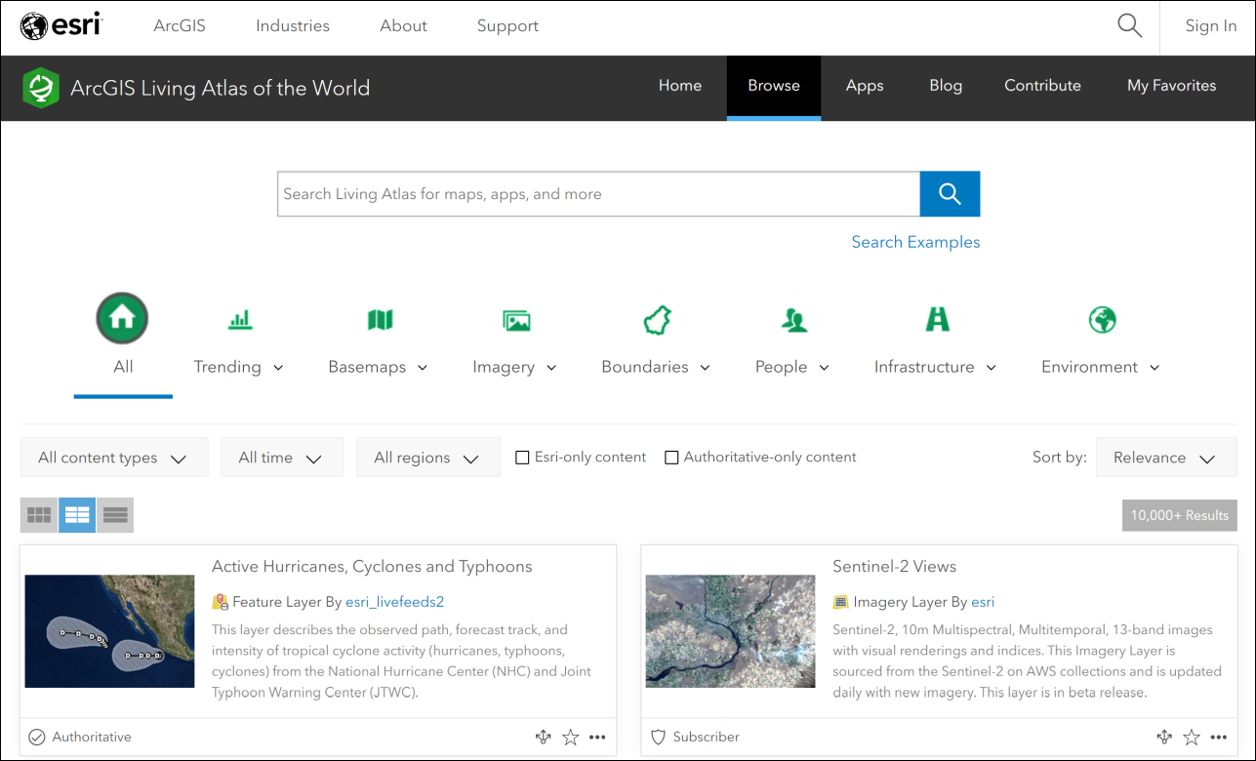

The Browse page for the Living Atlas. Note the search box at the top, and the filters below that. The main part of the page is the full list of maps and layers.

The Browse page allows you to use filters to limit the data, as well as to search.

I’ll start by showing you how to find and add layers to QGIS, then you can do some searches for yourself and see what you can find.

We’ll start by finding a background map of the Oceans and adding it to QGIS. This could be useful if you need to produce a map for a report showing a particular area of the ocean floor with some of your own data on top of it.

* Type World Ocean Base into the search box on the Browse page.

The list of results will appear below the filters. Have a look at the options you are given.

Make sure the option to view the List is selected from the three buttons above the list. You’re given more information in a clearer format if you select this.

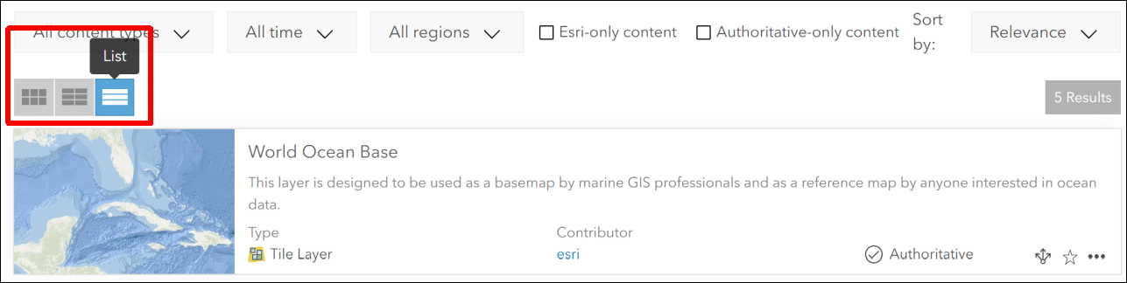

Viewing the results of your search in List format.

 **What types of layers are available?**

Look at the information next to each of your results. You’ll get a summary of what the layer or map shows, but you’ll also be shown the Type and the Contributor.

What types of layers do you have available to you?

Not all of the layer types are suitable for use in QGIS. You will be able to use layers which have the type:

* Feature Layer
* Tile Layer
* Map Image Layer

You should also see the word Authoritative next to some of the layers. This indicates that ESRI have checked the data and consider it to be reliable. Even so, remember that it’s always a good idea to check who is the creator of any data, and which organisation it comes from.

### Seeing full information about ESRI Living Atlas Layers

There should be in your list of results, a Tile Layer called World Ocean Base, for which the contributor is ESRI.

* Click on the title for this Tile Layer.

You’ll be taken to a full page of information about the layer. It’s worth looking at this information as it will give you a better idea of whether this is a good layer to use.

* If you want to check what the layer looks like, click the Open in Map Viewer button at top right. Zoom in and out and pan around to check the map.
* Once you are happy that this is the layer you want to use, return to the page containing the information about the layer.
* Look for the URL field, which is usually at the bottom right of the page.
* Hover over the right-hand side of the URL box and click to copy the URL.

Now you are ready to add the layer to QGIS.

### Adding an ESRI Living Atlas layer to QGIS

Start by opening QGIS. You can add ESRI Living Atlas layers to existing maps, but in this case we’ll start with a blank map.

As usual, there are multiple ways to add the layer to QGIS. You can use either of the following:

#### Via the Browser panel

In the Browser panel, scroll down to find ArcGIS REST Servers heading. Right-click on the heading and choose New Connection....

This will open a dialog box.

* Fill in the Name as World Ocean Base (or something which will remind you what the connection is in future).
* In the URL box paste the URL you copied from the Living Atlas web page.
* You don’t need to fill in any further information.
* Click on OK to add the server connection to QGIS.

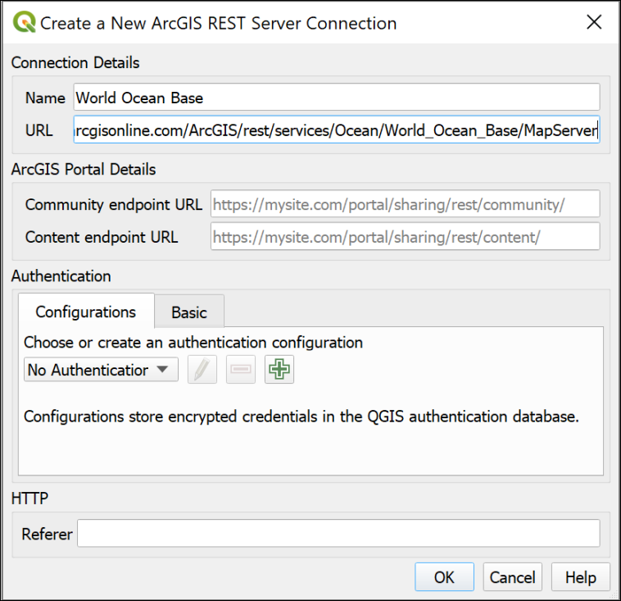

Creating a new ArcGIS REST Server Connection to add a layer from the ESRI Living Atlas.

The new connection should appear under the heading in the Browser panel.

* Drop down the small black arrow next to your new connection. This will show any layers available on the server. For the World Ocean Base there is only one available.
* Double-click on the layer you want to add to your map.

Be patient, some layers can take a while to load, particularly if you have a slow internet connection.

Zoom in and out and have a look at the data you have added.

#### Via the Data Source Manager

* Alternatively, go to Layer > Data Source Manager.

This will open the Data Source Manager.

* Find the ArcGIS REST Server tab on the left and click on it.
* Click on New under the box at the top.

This opens the same form as the method above, so refer to the image under those instructions.

* Fill in the Name as World Ocean Base (or something which will remind you what the connection is in future).
* In the URL box paste the URL you copied from the Living Atlas web page.
* You don’t need to fill in any further information.
* Click on OK to add the server connection to QGIS.
* The name of your new connection should appear on the dropdown at the top.
* Now click on Connect to actually connect to the server.
* Drop down the small black arrow next to your new connection. This will show any layers available on the server. For the World Ocean Base there is only one available.
* Select the layer you want, then click the Add button at the bottom of the window.

You can also Close the Data Source Manager if you wish.

Be patient, some layers can take a while to load, particularly if you have a slow internet connection.

Zoom in and out and have a look at the data you have added.

### Trying out other ESRI Living Atlas layers

Once you have added a layer, you can combine it with other data from other sources to produce your own maps.

* Return to the [Living Atlas browse page](https://livingatlas.arcgis.com/en/browse/#d=3).

Look for another layer to add to your map. Is there a country you are particularly interested in, or a subject you’d like to see on a map?

* Use the Filters at the top of the page to select the country.
* Search for the subject you want to investigate.

Example searches could include:

* Earthquakes
* Land use or Land cover
* Hurricanes
* Traffic
* Imagery (for aerial photography)

You’ll need to look for layers which don’t say Subscriber or Premium, and which are one of the following types:

* Feature Layer
* Tile Layer
* Map Image Layer

In addition, some layers which look as if they will be OK, may not work. This can be because a server somewhere isn’t working and there isn’t much you can do about it, unfortunately.

 **Find a layer and add it to your map in QGIS**

Find a layer showing something you are interested in and add it to the same map as the World Ocean Base.

Zoom in to an area you are interested in, and export the map using the instructions below. Upload your map to your OneNote Class Portfolio to get feedback on it.

#### Exporting your map

It is possible to set up a layout and export that, but I’m not expecting you to spend extra time on this exercise.

Instead, so you have something I can give you feedback on in OneNote:

* Make sure your map looks as you want it to in the map window in QGIS.
* Go to Project > Import/Export > Export Map to Image.
* In the form which appears, click on Map Canvas Extent.
* Untick Append georeference information
* The other settings will be fine for now, so click on Save.
* Give your export a name and choose where to save it.

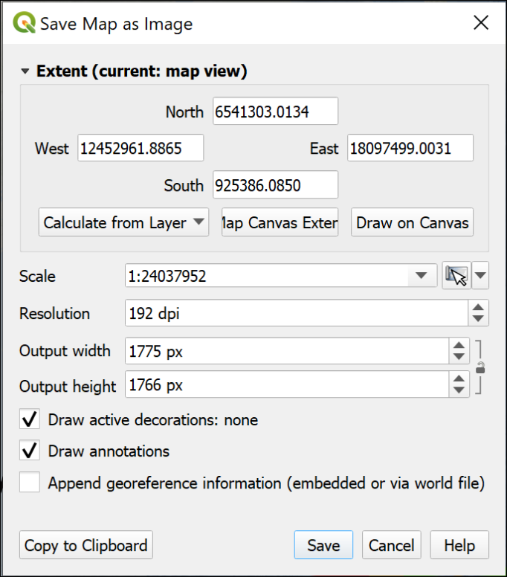

Saving a map as an image directly from map view.

QGIS will export a .png image which you can open in a photo editor, or upload to OneNote.

I’d be interested to know what you think of the ESRI Living Atlas layers, so if you want to add any comments or questions in your portfolio, that is absolutely fine.

# Using spatial data in GIS: Coordinate systems, projections and transformations

Last Modified: 27 Sep 22, 15:37:03

The background to using spatial data in GIS, coordinate systems and projections will be covered in the lecture segment at the beginning of the class, and the presentation and any other supporting materials will be available in Minerva. The lecture segment should help you to understand **why** you are doing these exercises. If you still aren’t sure, please ask [Clare](mailto:c.e.gordon@leeds.ac.uk).

## Learning outcomes for using spatial data in GIS

When you have completed this section of the workbook you should be able to

* describe the main types of data used in GIS
* find out essential information about the data and apply that to your use of the data in GIS
* set the correct coordinate reference system (CRS) for your project and for each layer in your map

## Data to download and prepare

Being able to find, download and prepare your own data is an essential part of using GIS. For the exercises in this chapter, you will need to download several datasets. While these should not take too long to download and prepare, don’t leave it until the last minute. Websites can become unavailable either permanently or temporarily, or computers can crash.

If there are problems with a website, then try again later. If the problems persist please get in touch with me ([c.e.gordon@leeds.ac.uk](mailto:c.e.gordon@leeds.ac.uk)) and I will try to contact the site or find an alternative source of data.

### Data required

Download and prepare the following data. If you can do this before the start of the class you will be able to get started on the exercises as soon as they have been introduced. Full instructions are in the sections below.

 **Summary of data to download**

CoordSystems.zip from Minerva

European River Catchments from the web

SRTM height data for part of Skye, off the West coast of Scotland

### CoordSystems.zip

CoordSystems.zip can be downloaded from Minerva. Please unzip it to your GIS folder. Instructions for using this file will be given in the exercises in this chapter.

You should end up with a folder within your GIS folder which is called CoordSystems_Q. Make sure that you put the rest of the data for this project inside this folder.

### European River Catchments from the web

Inevitably the web is an extremely rich source of spatial data. A lot of government and related bodies make data publicly available online. Sometimes you have to register first even when the data is available without charge, but the European source below allows you to download without registering.

* [European River Catchments data](http://www.eea.europa.eu/data-and-maps/data/european-river-catchments-1)

Download the zip file from the above URL which has the title Zipped shapefile, vector polygon. You may need to tick a box to show what purpose you will be using the data for, select Education.

Unzip the downloaded file to your CoordSystems_Q folder.

You should find that you have a shapefile with a name something like ERC110108v2.shp plus several other files with the same basic name. Make sure that you keep all these together or the data won’t load into GIS.

While you’re on the web page have a look at the Metadata tab. This gives you background information about the data that you’ve downloaded.

#### Shapefile format

**Shapefiles** are a form of vector data storage. We’ll mainly use geopackages for data that we create, but if you download data it is often delivered in shapefile format as that will work in most GIS software.

There are limitations to the format, which is why we’re mainly using geopackages, but the main one to remember is that a single shapefile actually consists of multiple files on disk with extensions such as .shp, .dbf, .prj, .sbn etc. If you’re dealing with shapefiles make sure that you keep all those files together or you won’t be able to open the data in GIS.

### SRTM data via Earth Explorer

SRTM stands for Shuttle Radar Topography Mission and is data collected from the space shuttle *Endeavour*. You can find out more detailed information on the [USGS webpages](https://on.doi.gov/2V1Af4x).

If you are working in the UK then you will have more detailed height data available to you via Digimap and Open Government sources, but SRTM data is possibly the best height data easily available for many countries, e.g. Turkey. One limitation is that it is not available above 60 degrees north and below 60 degrees south - so it doesn’t cover most of the Shetland Islands to the north, for example.

#### Obtaining SRTM data

You could [download the original data](http://www2.jpl.nasa.gov/srtm/) but we’ll be using the postprocessed data (this has data voids filled, and accuracy improved in some areas). This is available from the [Earth Explorer website](http://earthexplorer.usgs.gov).

* Navigate to [Earth Explorer](http://earthexplorer.usgs.gov) and if this is your first visit click on Register to set a username and password. (**don’t use your University login details**, but don’t forget to make a note of the ones that you do set up! You’ll probably need to use them again in future.)
* If you have already registered click on Log in and enter your username and password.
* Once you have the viewer open use the map to navigate to the area that you require data for - in this case look for Skye off the NW Coast of Scotland. The image below shows the general area, but zoom in closer than this so that the island of Skye fills the whole of the map area.

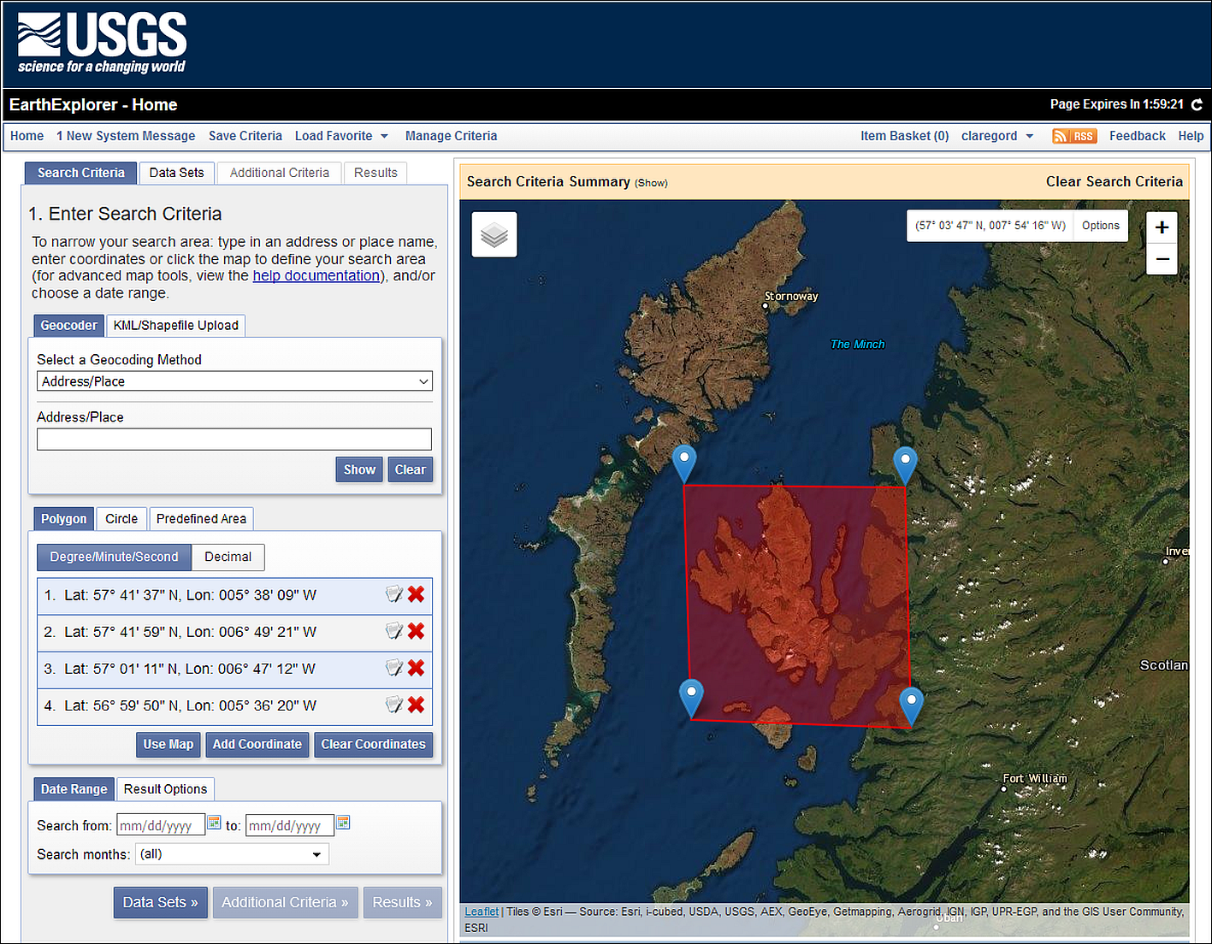

Selecting data in Earth Explorer - the area to enter to search for data for Skye.

* On the Address / Place tab click on Use Map to select the area. You can change the area by moving the markers if necessary. The image above shows the map with Skye selected.
* Now click on the Data Sets button to move to the next tab.
* Go to Digital Elevation > SRTM - this should give you four choices. Click on the i buttons to see more information about the products. It’s worth having a look at what other data is available to you through this interface too. There is a lot there.
* For this exercise select SRTM 1 Arc-Second Global by putting a tick in the box next to it.

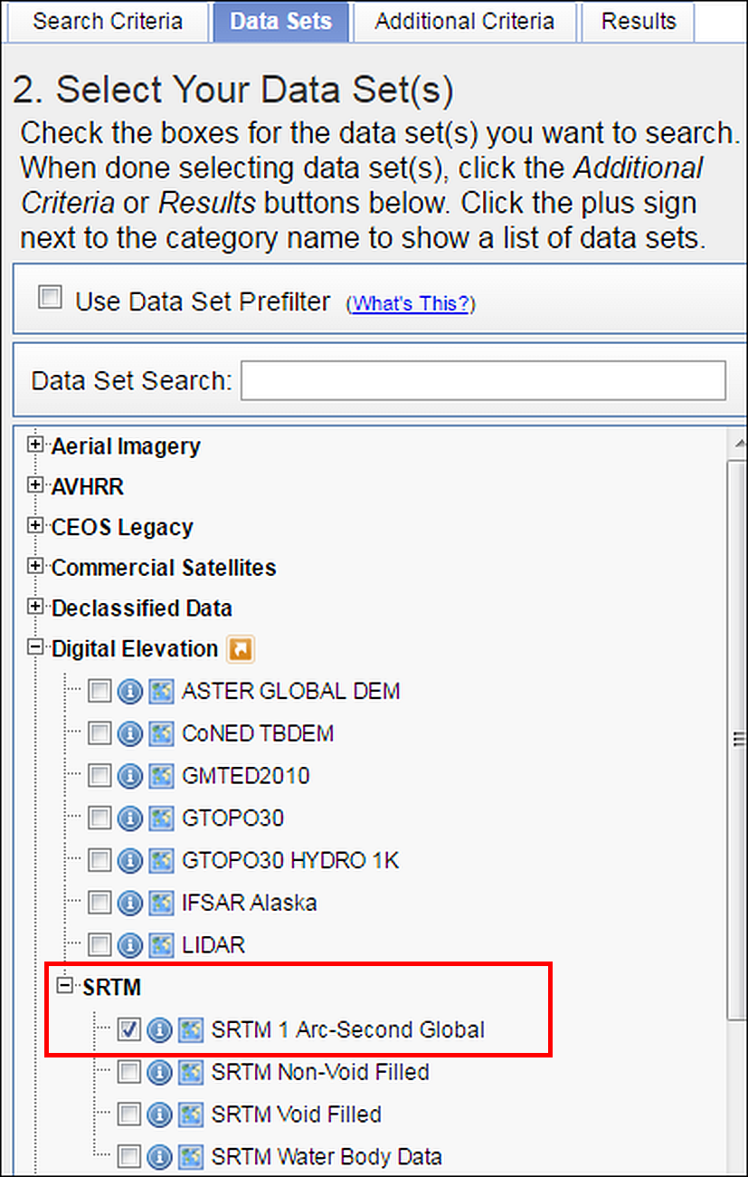

Selecting data in Earth Explorer - Digital Elevation data choices. Select SRTM 1 Arc-Second Global - outlined in red.

* Click on the Results button - you may need to scroll down to see it.

Now Earth Explorer should give you a list of your selected data covering your chosen area, but you’ll need to explore a bit further to see exactly which tiles to download.

* The image below shows the results of a search for SRTM 3 for Skye. To see the coverage for a tile of data click on the “footprint” icon under it.

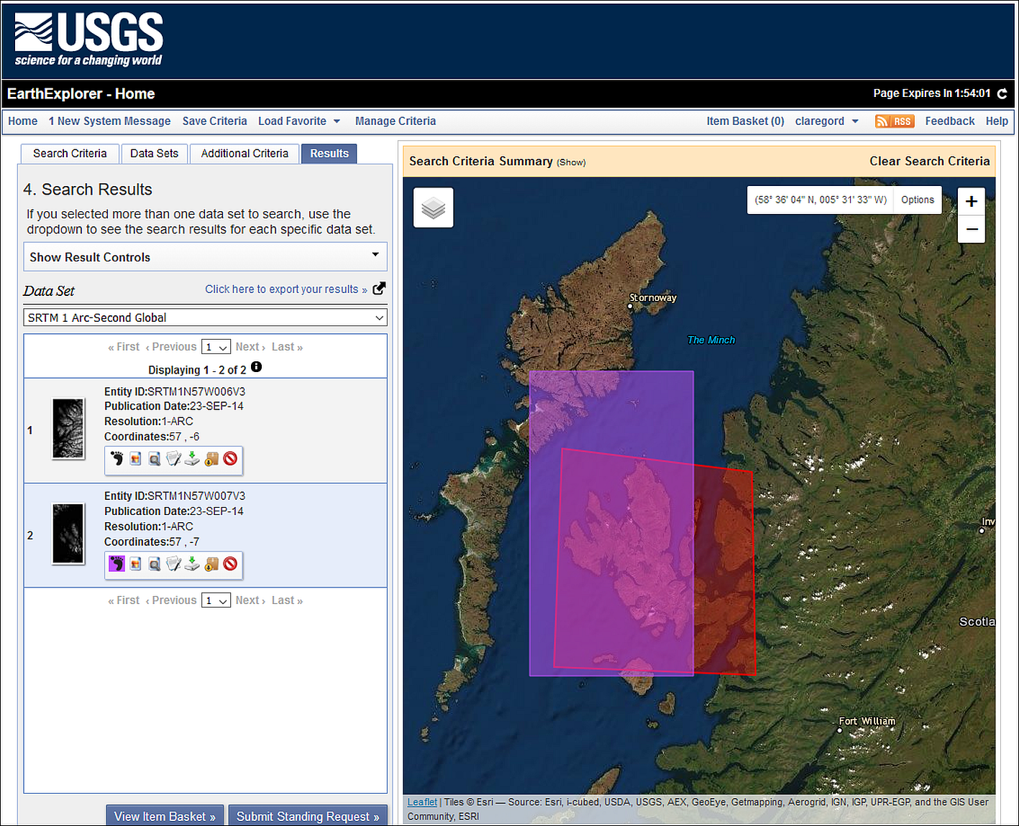

The SRTM results screen - showing the footprint of the SRTM tile to download for the Isle of Skye.

* To download a file, click on the fifth icon (a green arrow) - it has a tool tip which says Download Options if you hover over it.
* From the choices that appear click on the Download button next to the GeoTIFF option and then wait for the download to complete. You may need to accept/allow popups for this webpage for this to happen.
* If you want multiple tiles you’ll need to click on each one separately.

 **Download SRTM tile**

Download one tile of SRTM data covering the western part of the Isle of Skye and save it to use in the exercises in this chapter.

If you need to do multiple searches then click on Clear Search Criteria above the map. This doesn’t always work, if it doesn’t you have to close the browser completely and start again from scratch.

## Using coordinate systems: Setting up your project

For this exercise you will be using the data that you downloaded above and exploring what you need to do when your layers have different projections to each other - a situation that is very likely to happen. This exercise should show the importance of understanding coordinate systems and how they work in GIS.

* You should already have a folder called CoordSystems_Q under your gis folder from when you unzipped the Minerva download. If you haven’t, create that now and move the unzipped miniscale data to that location.
* Check that you have copied all the data for these exercises into that folder and check that it is all unzipped.

### Adding layers to a blank map

We’ll start by looking at what happens if you add data to a map project without thinking about coordinate systems first. You’ll have a few goes at adding these data layers in different orders.

#### First time

Start by adding the layers in the following order:

* Open a blank map in QGIS and browse to your CoordSystems_Q folder in the Browser panel.
* From there find the miniscale folder and add miniscale_mono_r19.tif to the map by dragging and dropping it into the Layers panel.
* Next find the European River Catchments layer - ERC110108v2.shp in the browser and add that to the Layers panel. You may not see anything change on your map, don’t worry about that at this stage.
* Finally find the srtm layer n57_w007_1arc_v3.tif and add that to the Layers panel.

 **Look at the layers on your map**

You should be able to see the first layer that you added but where are the other two layers? Zoom to layer on each of them in turn and see what they look like, and how they appear in relation to the other layers.

Can you see all the layers at once?

When you zoom to the SRTM or ERC layers you may see a large grey shape - zoom way out and investigate that further.

Use the cursor to hover over the bottom left-hand corner of the miniscale layer - what coordinates show at the bottom of the map?

Have a look at the bottom right of the map window. Use the mouse to look at the tooltips and find the button that shows the CRS. Make a note of what it says at the moment.

#### Second time

Let’s try adding the layers to a blank map in a different order:

* Click on the New Project button at the top left of the QGIS window, or Ctrl-N on your keyboard. If asked Discard the current project.
* Go to the Browser panel again and this time add the ERC110108v2.shp file first.
* Next add the srtm layer n57_w007_1arc_v3.tif
* Finally this time add the miniscale layer miniscale_mono_r19.tif

 **Look at the layers on your map**

You should be able to see the first layer that you added but where are the other two layers? Zoom to layer on each of them in turn and see what they look like, and how they appear in relation to the other layers.

Can you see all the layers at once?

Use the cursor to hover over the bottom left-hand corner of the miniscale layer - what coordinates show at the bottom of the map?

Have a look at the bottom right of the map window. Use the mouse to look at the tooltips and find the button that shows the CRS. Make a note of what it says at the moment.

#### Third time

There are three layers, so let’s try again and see what happens this time:

* Click on the New Project button at the top left of the QGIS window, or Ctrl-N on your keyboard. If asked Discard the current project.
* Go to the Browser panel again and this time add the srtm layer n57_w007_1arc_v3.tif first.
* Next add the miniscale layer miniscale_mono_r19.tif
* Finally this time add the European River Catchments layer ERC110108v2.shp

 **Look at the layers on your map**

You should be able to see the first layer that you added but where are the other two layers? Zoom to layer on each of them in turn and see what they look like, and how they appear in relation to the other layers.

Can you see all the layers at once?

When you zoom to the SRTM or ERC layers you may see a large grey shape - zoom way out and investigate that further.

Have a look at the bottom right of the map window. Use the mouse to look at the tooltips and find the button that shows the CRS. Make a note of what it says at the moment.

### What have you observed?

You should see that each time the result is different. In particular the miniscale map doesn’t appear in the same geographic location as the other two maps.

You should also notice that when the European River Catchments layer is added first the CRS button at the bottom right of the window shows a different code.

* When the miniscale is added first the code will either be EPSG:4326 or No projection, depending on how the default is set on your copy of QGIS.
* When the European River Catchments layer is added first the code will be IGNF:ETRS89LAEA
* When the SRTM layer is added first the code will be EPSG:4326.

This is because the map is set to the coordinate system of the first layer to be added, or, if the layer does not have a coordinate system defined, to the default which is usually either EPSG:4326 or No Projection.

If you’ve noted the coordinates of the miniscale layer each time you should notice that they are low numbers close to 0,0. Because the miniscale has no projection set, QGIS is placing it with the lower-left corner at 0,0 and this will vary depending on the “origin” of the current project CRS.

### On-the-fly projection

The different results that you have observed are because if you have already set a project CRS either by adding a layer or through the properties, QGIS then tries to project subsequent layers “on-the-fly”. Whilst this is very useful, the result is not always successful and the layers are not all visible together or, if they are, may not line up exactly on top of each other.

Even if all the layers line up, if the coordinate systems are not all set to the same crs then you’ll have trouble editing data, measuring distance and area, or running analysis tools.

The important lessons here are:

* Make sure that you know the coordinate systems of your data
* Make sure that you know what coordinate system you want your map to appear in
* Make sure that all the coordinate systems match.

We’ll spend the rest of the time in this chapter looking at how you can do the above.

## Working with coordinate systems

When setting up a new project you’ll need to start by checking and setting the coordinate reference system (CRS) for your project and for each of your layers. There are also other layer properties that you’ll need to check, for example, is your data layer raster or vector?

* If QGIS isn’t already open, open it now
* Click on the New Project button at the top left of the QGIS window, or go to Project > New or use Ctrl-N on your keyboard. Discard the current project if there is one.

### Deciding on the correct CRS

The first step is to think about what CRS you need to set for your project. It can depend on what area you are working in, for example if you are working in the UK then it will usually be the British National Grid, if you are in Spain then it will probably be a version of UTM. If you are creating a map of a whole continent or the World, then the use of the map will affect which CRS you choose.

In this case we’ll create a map of the Isle of Skye in the UK, so we’ll use British National Grid.

Let’s find out more about that CRS.

* Go to the [epsg.io](http://epsg.io/) website. You can use this site to find out more about coordinate systems for different areas of the World.
* Use the search box to look for Britain.
* The first result should be OSGB 1936 / British National Grid - United Kingdom Ordnance Survey which is the most common/likely for the area you’ve searched for - click on that link

The page for this gives more information about the CRS.

* One very useful feature is the map showing the area covered by that projection. Remember from the lecture that different projections or coordinate reference systems work best for different areas and this map showing the extent of the one you have chosen should help.
* Make a note of the EPSG code at the top of the page - EPSG:27700. This helps when finding the correct projection in your GIS.
* Have a look at the Attributes further down the page, in particular the Unit, but also the area of use.

 **Looking up EPSG:4326**

EPSG:4326 is a default CRS in QGIS. Click to search [epsg.io](http://epsg.io/) again, but this time search for 4326. There only appears to be one result for this, so click on the entry in the list to go to that page and have a look at the details for that.

What is the name of the CRS?

What is the area covered?

What are the units?

### Setting up a new project from scratch

Now that you know the CRS you want your project to be set to let’s go ahead and set up a new project.

 **Checking and setting the CRS of your project in QGIS**

This video clip can be found in the module area of [Minerva](https://minerva.leeds.ac.uk) or in the [full list of video clips](https://cgordon-gis.github.io/videoclips.htm).

* If QGIS isn’t already open, open it now.
* Click on New Empty Project under the Project Templates or go to Project > New or Ctrl-N on your keyboard.
* Look at the bottom right of the QGIS window. There will probably be an EPSG code there and that will usually be EPSG:4326 by default. You’ve found out a bit more about that CRS above and should know now that it is called WGS 84 - you’ll come across this frequently.

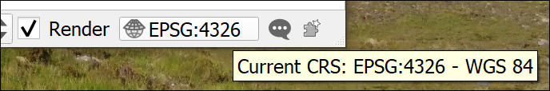

The current CRS button showing that the initial project CRS is set to WGS 84.

You may find that your CRS isn’t set by default, in that case the button will look as follows and say No Projection if you hover over it.

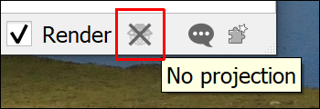

The CRS button showing that there is no CRS set.

* Whichever version your QGIS is showing, click on the button now. This is the quickest way to get to the CRS window of the Project Properties.
* If No CRS is ticked, untick it now.
* In the Filter box type the EPSG number for the CRS you selected for this project - British National Grid - 27700. You could type British National Grid instead, but the code is often the quickest and most reliable way to find the right CRS.
* In the list that appears under Predefined Coordinate Reference Systems click on OSGB 1936 / British National Grid

Note that British National Grid is under the list of Projected Coordinate Systems. This means that it is a grid that will allow measurements in metres or similar, rather than degrees. If you want to use a map for measurements of distance or area it needs to be in a projected CRS, or **projection**.

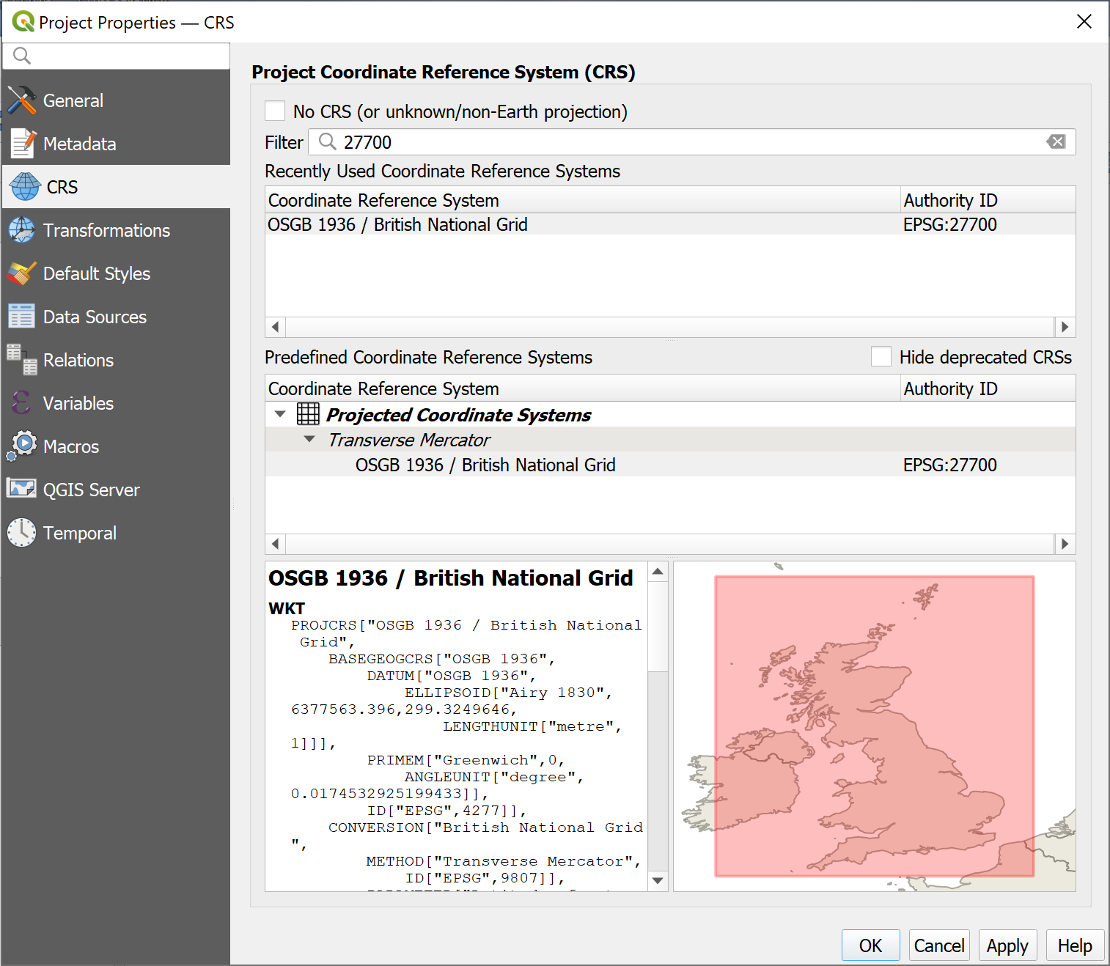

The CRS tab of the Project Properties showing the project CRS being set to British National Grid, EPSG:2700

* To set the CRS and close the properties, click on OK
* Have a look at the Current CRS button again, that should now have changed to say EPSG:27700.

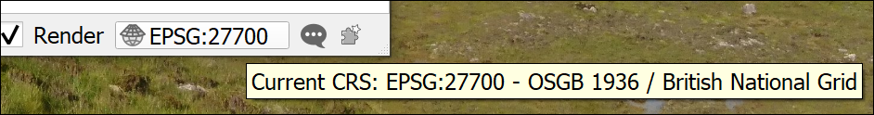

The Current CRS button now shows that the project CRS is set to British National Grid.

At this point Save your map

* Project > Save or Ctrl-S.
* Browse to the project folder and give the project file a name such as CoordSystems. QGIS will automatically give it a .qgz extension.
* Save

Once you’ve saved your file you should be able to see the Project Home folder in the Browser panel and use that to browse to your files.

If you can’t, right-click on Project Home > Set Project Home..., browse to the folder where you saved your qgz file and Select Folder.

### Checking the layer properties

Now that the project CRS is set, we can start looking at the properties of the data layers.

You are going to be creating a map of an area of Britain with the spatial reference of British National Grid so need to check whether all the layers are set to that.

Note that you will need to know whether your data is raster or vector. This will be covered in the lecture for this week so if you need a reminder you can look back at the presentation or recording.

If you are still unsure there are lots of helpful articles and videos on the web. Try the following or search for GIS raster and vector:

* [Ordnance Survey Raster and vector data](https://www.ordnancesurvey.co.uk/business-government/tools-support/gis/raster-vector)
* [Spatial Vision Raster and vector data in GIS](https://spatialvision.com.au/blog-raster-and-vector-data-in-gis/)

 **Checking the layer CRS in QGIS**

This video clip can be found in the module area of [Minerva](https://minerva.leeds.ac.uk) or in the [full list of video clips](https://cgordon-gis.github.io/videoclips.htm).

To find the properties for each layer do the following then make a note of the details. If you’re not sure, just have a go. It doesn’t matter if you are wrong!

* In the Browser panel right-click on the ERC110108v2.shp file and select Layer properties...
* Check that you are on the Metadata tab and look for and make a note of the following details:

 **Properties to check**

Is the data vector or raster?

For raster data, what is the data type and GDAL driver?

For vector data, what is the Storage?

What is the CRS? Is it Geographic or Projected?

Repeat for the other two layers, the Miniscale mono and the SRTM (if you have more than one tile of SRTM data just use one of them, it doesn’t matter which). If there is no text next to CRS just write down Unknown.

Notice that you should come up with a different CRS for each layer. This is a common problem when working with spatial data from multiple sources and is an important reason why you should check your data!

Your notes should show something like the following:

| **Layer** | **Vector / raster** | **CRS** | **Projected / geographic** | **Data type** | **Storage or Driver** |
| --- | --- | --- | --- | --- | --- |
| European River Centrelines | Vector | IGNF:ETRS89LAEA - ETRS89 Lambert Azimutal Equal Area | Projected |  | ESRI Shapefile |
| Miniscale Mono | Raster | Unknown |  | Byte - Eight bit unsigned integer | GeoTIFF |
| SRTM tile | Raster | EPSG:4326 - WGS 84 | Geographic | Int 16 - Sixteen bit signed integer | GeoTIFF |

Now that we have this information, we can start to add our data to the project.

### Setting the CRS of a layer where it is not already set

* Add the Miniscale layer to your map, this should be the first layer added to the project with the CRS set to epsg:27700.

When you add the miniscale layer to your map you should find that it doesn’t cause any obvious problem, but it does have a small globe with a question mark next to it in the Layers panel.

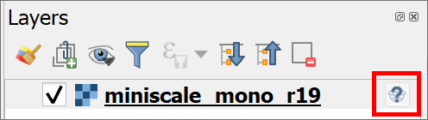

The miniscale layer in the Layers panel showing the symbol which tells you that this layer has no CRS set.

When you checked the layer properties for the miniscale layer you should have found that the CRS is not set.

At this stage you need to do some detective work to find out what the CRS for the layer **should** be. That usually involves looking at any documentation that came with the data, or going to the website from which you downloaded it.

In this case the miniscale layer is Ordnance Survey data downloaded from Digimap and I can tell you that it should be set to British National Grid EPSG:27700, which in this case is the same as the project. Note that you can’t just set the CRS for the miniscale layer to whatever you want at this stage, you have to set it to the original CRS or the one that **should** have been set.

* Go to the layer properties by right-clicking on the layer in the layers panel and going to Properties then to the Source tab.
* Under Assigned Coordinate Reference System you can see that it says invalid projection. To set the CRS temporarily drop this down and select the correct projection - British National Grid. You can also click on the three dots button at the end of the line and select the CRS that way.
* Click on OK to apply it temporarily.

The above looks as if it works fine but is only a temporary solution. If you add the miniscale to a blank map it will need to have the CRS set again, it isn’t part of the data.

To set the CRS of the raster data permanently you need to assign the projection.

 **Assigning a projection in QGIS**

This video clip can be found in the module area of [Minerva](https://minerva.leeds.ac.uk) or in the [full list of video clips](https://cgordon-gis.github.io/videoclips.htm).

To assign the CRS to the original projection do the following:

* On the menu bar click on Raster > Projections > Assign projection.
* For the Input layer select the miniscale_mono_r19 layer
* Under Desired CRS select British National Grid or click on the button at the end of the line and select it that way.
* Click on Run
* Once the tool has run click on Close and the no projection symbol should disappear from the Layers panel.

You don’t need to enter an output name because this tool assigns the CRS to the existing file.

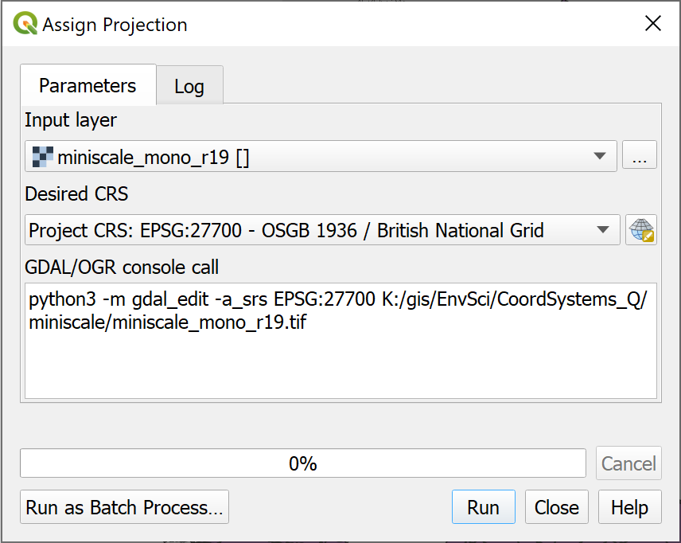

Filling in the form to assign a projection to a layer.

If you add the miniscale layer to a new blank map now you should find that it has kept the British National Grid CRS.

 **Sometimes an unknown CRS doesn’t matter**

To confuse things slightly, sometimes it doesn’t matter if a layer doesn’t have a CRS, or if the CRS is different to that of your project.

Think of the use you’ll be making of the layer. If it is simply a background layer and is in effect a “picture” that just sits behind your other data, but which isn’t used for analysis, then you simply need to check that you’ve set the project CRS correctly and leave QGIS to use “on-the-fly” projection.

If you have added a tile layer or a layer from QuickMapServices **don’t try to change the CRS**. It won’t work and can cause problems with other layers on your map. Again, these layers are there as background layers and can’t usually be used for analysis anyway.

### Transformations

Let’s see what happens with a vector layer with a different projection.

* Add the European River Centrelines layer to the same map.

You should find that a new window opens which looks something like the image below.

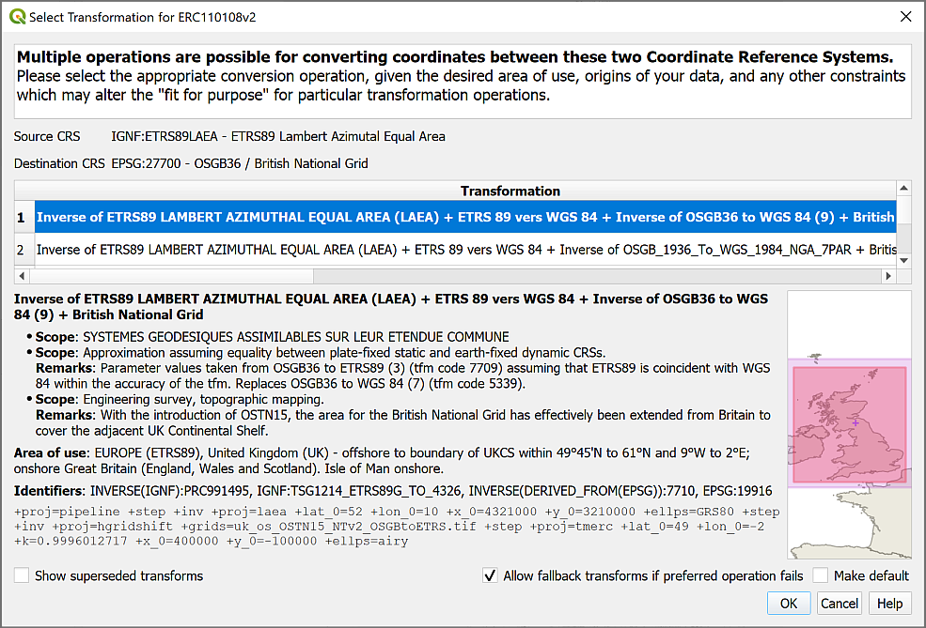

The Transformations selection window for the European River Catchments layer.

This indicates that the layer has a different CRS to the project CRS. QGIS is trying to project the layer into the project CRS on-the-fly but needs to know which mathematical method, or **transformation**, to use to do so, so it is asking you which **transformation** you prefer for your map.

It’s usually OK to select the suggested transformation.

* Click on OK now to accept the suggested transformation.

You may see a yellow band at the top of the map warning you that QGIS “Used a ballpark transform from IGNF:ETRS89LAEA to EPSG:27700”.



The warning about using a ballpark transform. Don’t worry about this, it’s a warning not an error!

You’ll get used to seeing these (with a variety of CRS mentioned). They are warnings, not errors, you are fine to ignore them! They actually mean that there should be a more accurate transformation available. Usually for your needs the default that is used is fine.

It’s important to note that once again this “on-the-fly” transformation is only a temporary solution. This means that the map looks fine, but if you want to do any measurements or analysis you may well run into problems. We’ll look at more permanent ways to **reproject** and **transform** data in the next couple of sections.

### Reprojecting a vector layer

The process of changing the CRS of a layer to a different CRS is called **reprojection**. Reprojection works slightly differently depending on whether a layer is vector or raster.

 **Reprojecting a feature class in QGIS**

This video clip can be found in the module area of [Minerva](https://minerva.leeds.ac.uk) or in the [full list of video clips](https://cgordon-gis.github.io/videoclips.htm).

We’ll start with the European River Catchments, which is a **vector** layer.

The current CRS is ETRS89 Lambert Azimutal Equal Area and we need to convert this to British National Grid permanently.

As with so many tasks in GIS there are two ways to do this. The simplest is to Export the layer to a new layer.

* Right-click on the layer in the Layers panel
* Export > Save features as...
* As this is a vector layer we’ll save it to a geopackage, so select that under Format
* Browse to the project folder to save the geopackage and give it a name, e.g. CoordSystems
* Then give the new layer a name, e.g. ERC_BNG to indicate that it is in British National Grid (note not spaces, and the only symbol allowed is an underscore).
* Next to CRS either dropdown and select the Project CRS if it is British National Grid, or click on the button at the end of the line to select that.
* Check that Add saved file to map is ticked
* Then click on OK

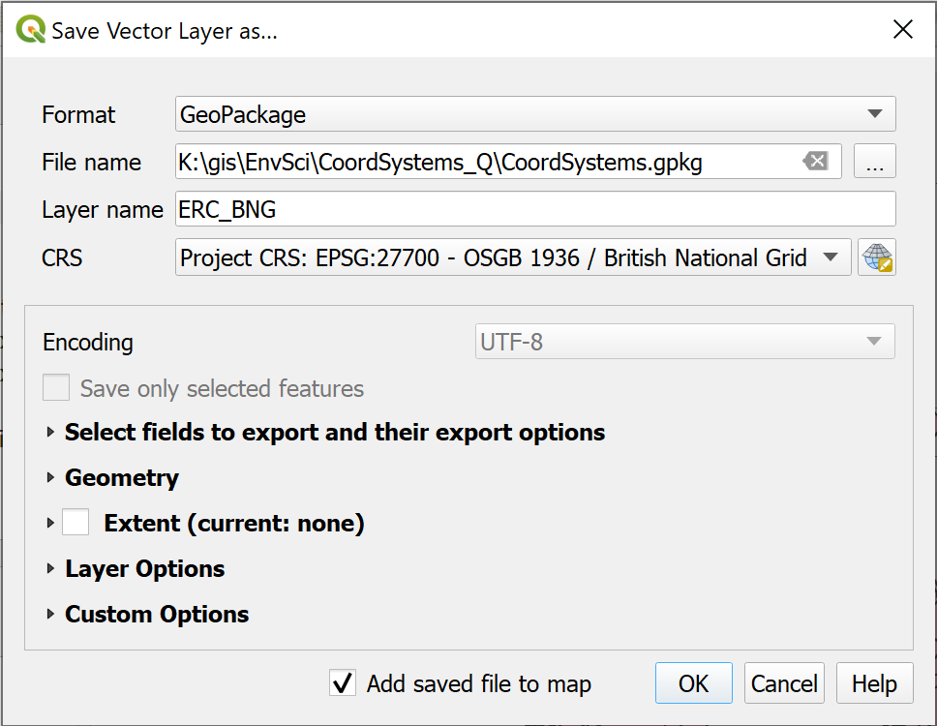

Changing the CRS of a vector layer by exporting to a new feature class.

You can now remove the original layer from your map to keep the map tidy.

The alternative way of reprojecting the vector layer is as follows:

* On the menu bar go to Vector > Data Management Tools > Reproject Layer
* Fill in the Input Layer and the Target CRS and click on the three dots button next to Reprojected to save to a new file.
* Run and then Close to see the reprojected layer.

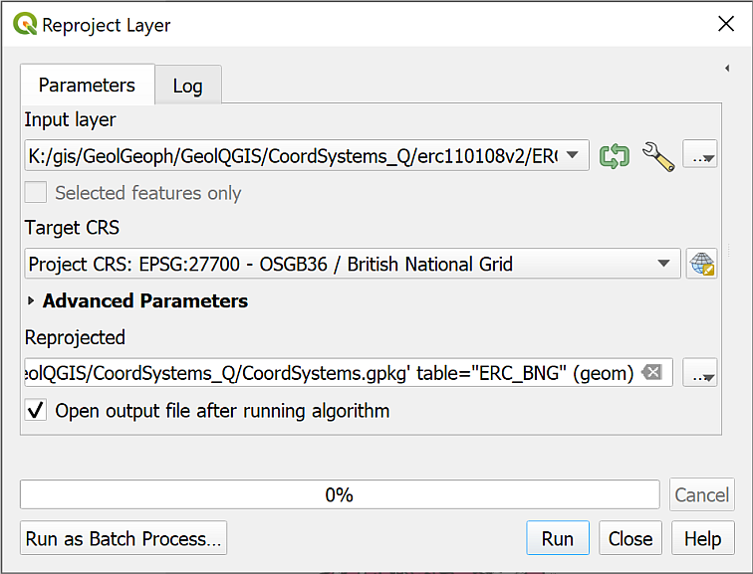

Using the tool to reproject a vector layer.

You probably won’t notice much difference in the data on the map either way, but if you look at the layer properties source tag of the new layer you should be able to see that the CRS has been changed.

If you add the new layer to a blank map it will still be projected to British National Grid, showing that the change is permanent.

### Reprojecting a raster layer

The previous section shows how to reproject **vector** data, now let’s reproject **raster** data using the SRTM data that you downloaded as an example.

Once again there are two ways to reproject a raster. It is possible to right-click on the layer in the Layers panel and Export > Save as... a new file, but the more reliable method in this case is to use the Warp tool.

 **Reprojecting a raster layer in QGIS**

This video clip can be found in the module area of [Minerva](https://minerva.leeds.ac.uk) or in the [full list of video clips](https://cgordon-gis.github.io/videoclips.htm).

* Start by adding the SRTM layer to your map. Accept the transformation if you are given a choice.
* In the menu bar go to Raster > Projections > Warp (Reproject)
* The Input Layer is the SRTM layer n57_w007_1arc_v3 - you can select it in the dropdown if it is in your map, or browse for it using the three dots button at the end of the line
* The Source CRS is optional, but feel free to set it to EPSG:4326. The result tends to be more reliable if you can set this.
* The Target CRS is the CRS you are reprojecting to - set this to Project CRS: EPSG:27700 using the dropdown, or again, browse using the button at the end of the line
* Go down to Reprojected and click on the three dots button at the end of the line. Choose Save to file...
* Browse to where you want to save the output file. I often create a folder called output in the project folder and use that to save all the raster files that I generate.
* Give the output file a name that reminds you what it is, e.g. SRTM_n57_w007_BNG to show what data it is, where it covers, and what the CRS is. The Save as type should be set to TIF files (*.tif)
* Save then Run the tool

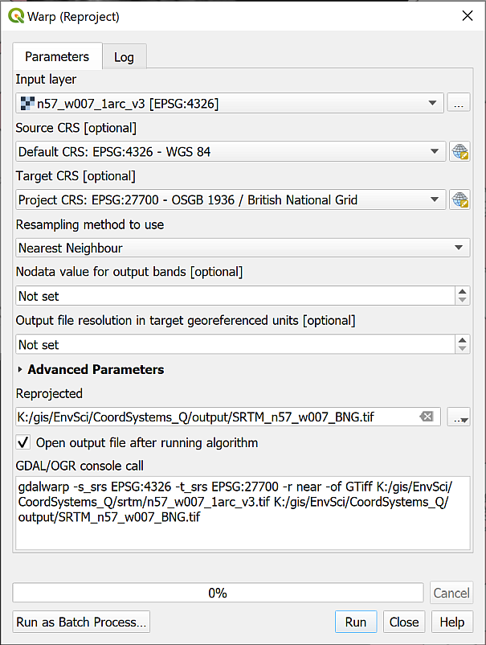

Filling in the Warp tool to reproject a raster file to British National Grid.

The new layer should be added to your map and to the Layers panel. If it isn’t, drag it there from the Browser now.

If you look at the Layer properties of the new layer now (right-click on the layer in the Layers panel and select Properties then look at the Information tab) you should see that the CRS is set to EPSG:27700 - OSGB 1936 / British National Grid - Projected.

You can now remove the original layer from your map to keep the map tidy.

Once again, if you add this layer to a blank map the CRS should already be set to British National Grid.

## Creating a new map in British National Grid

Hopefully if you look at the properties for each of the projected layers now they will all be in British National Grid.

Try opening a new blank map - you should be getting used to this by now! Then add all three of the newly projected layers to the map. It shouldn’t matter which order you add them.

Do all of them appear in the correct location in relation to each other? Remember that you can change the order in the Layers panel if one layer is blocking the others.

QGIS sets the project CRS to that of the layer which is added first, so has that been correctly set to EPSG:27700?

## Summary of defining projections and projecting data

This summary of the main points of this section of the workbook should help you to remember what you need to do each time that you obtain a new dataset or start a new map. Read it through, and then remember where to find it so that you can refer back to it. If you don’t follow these steps then you can give yourself a major headache when trying to load data for a project.

In addition to the text summary there is a step-by-step diagram at the end of this section which you can use as a quick reference each time you have data to load into GIS.

 **Summary of defining projections and projecting data in QGIS.**

This video clip can be found in the module area of [Minerva](https://minerva.leeds.ac.uk) or in the [full list of video clips](https://cgordon-gis.github.io/videoclips.htm).

The next chapter of this workbook gives you another exercise to practice projecting and transforming your data as this will be an important area to understand before you move onto further analysis. The chapter is optional, but if you are not completely sure about what you have just been doing it will be worth working through it.

### What do you want to set as the CRS of your map?

Start by deciding what CRS to use for your map. Remember that this depends on the area you are working in and the use of your map. Go to the [epsg.io](http://epsg.io/) website for more information on a particular CRS or to find out what CRS is best for a particular area.

### Check the current CRS of your data

Once you know which CRS you want to use for your map have a look at your data.

Always start by checking the **current** CRS of your data. You won’t be able to do much without this information. Suggestions for finding this information include:

1. Check the file / layer properties or the metadata using the Browser
2. If that doesn’t help, e.g. if there is no CRS set, look at any documentation that came with the data (sometimes there is a text or pdf file in the folder with the data).
3. If that still doesn’t help, check with whoever or where ever you got the data from, e.g. the web page if you downloaded the data from the web.
4. If you still haven’t found the answer you may need to make an educated guess based on what you do know about the data then experiment…

### Projecting your data on-the-fly

It is possible to project your data on-the-fly to the CRS of your project, but if you are using your data for further analysis you **must** project it to a new layer using the appropriate tools shown below.

### Define the projection

If no CRS has been set you first need to set it to it’s original CRS which you should have worked out in the previous section. You cannot **change** the coordinate system by setting it. You need to set the correct CRS first then use the vector or raster reprojection tools if you need to change it.

### Reproject the layer and transform it

If / when your data is not in the CRS that you want to use for your map then you need to Reproject the layer. Remember that you use a different tool depending on whether you are reprojecting vector data or reprojecting raster data.

If you haven’t already set the transformation for your project you may be asked to do so at this stage.

### Projection all correct

If your data is projected and is in the same projection as your map then there is no problem and you can just use it as it is.

### Quick reference diagram for defining projections and projecting data

This is the above information in diagram form.

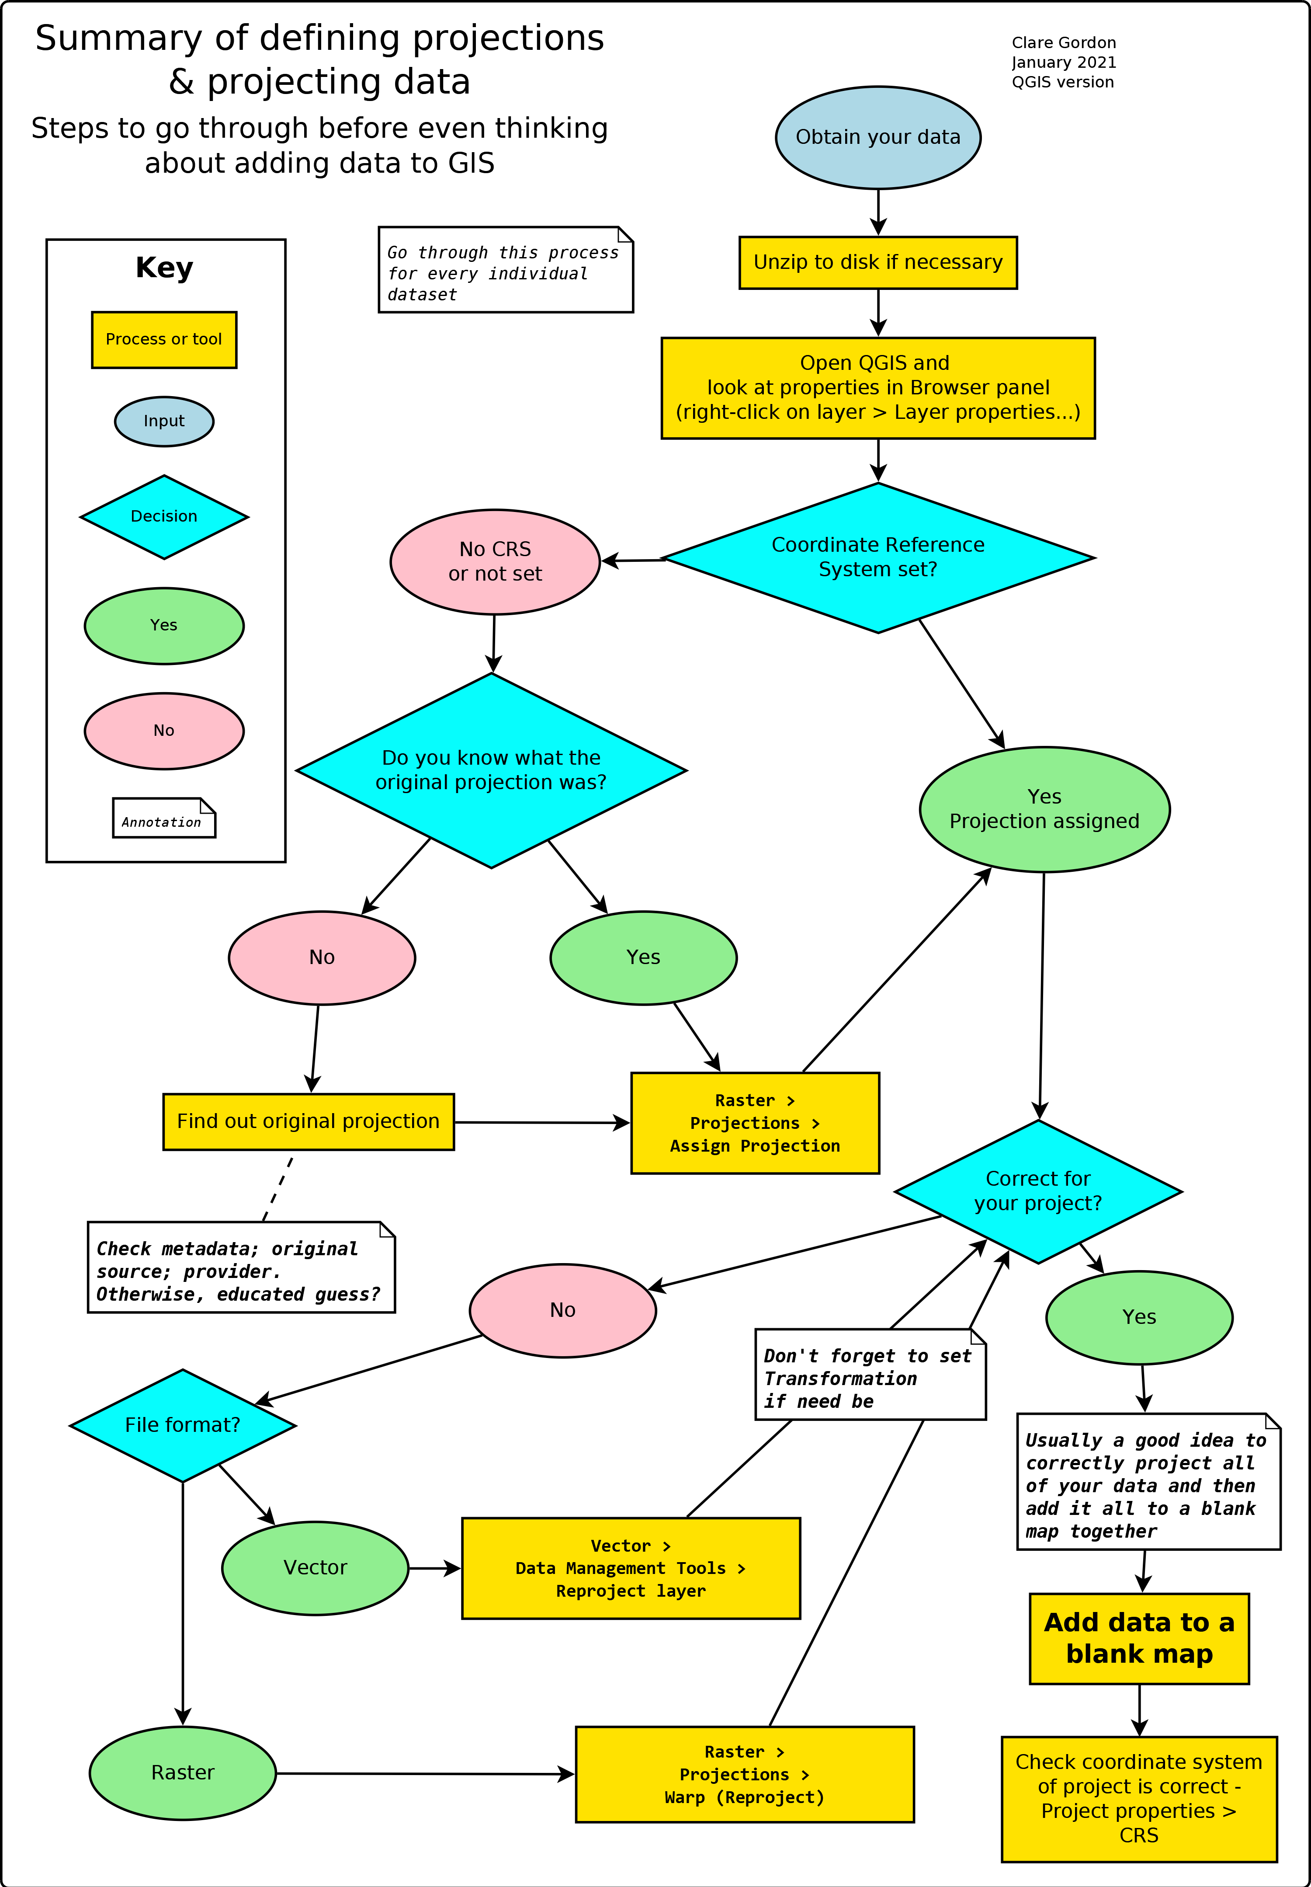

Summary showing the decision process and actions necessary to prepare data for GIS.

## Recommended reading: Coordinate Reference Systems

Many of the books on the reading list[7] include basic information about coordinate reference systems and projections. Specific suggestions include the following:

For background information try the following chapter:

* Chapter 4, *Georeferencing* in Longley, P.A. et al. (2015), pp. 77-98 covers latitude and longitude (from p.86), projections and coordinate systems (from p.88) and gps (from p.94).

If you want to find out more about coordinate systems and projections in general then the definitive guide is the USGS Professional Paper 1395 by John P. Snyder (1987) called [Map Projections: A working manual](https://doi.org/10.3133/pp1395). This is downloadable as a pdf.

The QGIS User Guide includes a section on [Working with Projections](https://docs.qgis.org/3.16/en/docs/user_manual/working_with_projections/working_with_projections.html) that should help you with QGIS in particular.

It is possible to add custom projections to QGIS and you can see how to do this on Anita Graser’s web page [Beautiful Global Projections - adding custom projections to QGIS](https://anitagraser.com/2012/03/18/beautiful-global-projections-adding-custom-projections-to-qgis/).

For some general information about the how and why of coordinate systems look at [I Hate Coordinate Systems!](https://ihatecoordinatesystems.com). This site gives some brief ideas for what to do if you are having problems with coordinate systems for your data.

# Coordinate systems: practice in projecting data

Last Modified: 19 Sep 21, 09:17:01

## Introduction

This is an optional exercise. It is designed to give you more practice in working with coordinate systems and projections, a skill you will need for future assessments as well as the exercises in this workbook. This chapter will not be covered in the practical sessions and you do not have to do it, but if you want to work through it and need help with the exercises you can work on it in any of the classes or email me at any time. I would suggest that if you feel you are getting behind, you leave this chapter for now and come back to it later if you need to.

Often the most challenging part of a GIS project is finding the data that you need and adding it to a map so that it all fits together. In the first assessment you will need to put together several different data sets and then do further analysis. If the data sets don’t all have the correct coordinate system before you do the further analysis, then you will struggle to carry it out successfully.

## What do you need to do?

This exercise is designed to give you practice in projecting data by adding the included data sets to a map.

You should aim to project / reproject all layers to British National Grid so that they all appear in the same position on the map. Once you have processed all the layers provided you should open a new map and add your layers to that. The final map should have the CRS set to British National Grid.

Refer to the instructions in the previous chapter. Remember that there is a summary and diagram at the end of the chapter.

Be aware that even if the layers appear to be on top of each other you still need to check their projection - don’t just rely on QGIS applying on-the-fly projection. That causes problems if you are carrying out further analysis on your data.

## Data provided

The data for this exercise is available as ProjectionsUK.zip in Minerva. Download the zip file and unzip it to your GIS folder.

Files within each folder give more details of where the data was obtained from.

* Copernicus grassland layer for the area surrounding the Bristol Channel
* Corine land cover layer for the area surrounding the Bristol Channel
* getmapping_rgb_25cm - two tiles of aerial photography for the north of Weston-super-Mare
* OS_OpenMap_Local_Raster - two tiles of raster mapping for the north of Weston-super-Mare
* OS_OpenMap_Local_Vector - vector layers for the tidal boundary, tidal water and foreshore of the Bristol Channel
* Sentinel - real-colour data from the European Sentinel satellite
* SPOT - data from the SPOT Earth Observation Satellite

## Target projection

You should end up with a map and layers **ALL** projected to:

EPSG:27700 British National Grid

Work through each layer in turn checking the current crs and assigning or reprojecting as necesary.

## Checking the final result

Add all your British National Grid layers to a new blank map.

All the layers should now lie on top of each other. In addition check that the project CRS is set to EPSG:27700 British National Grid.

## Conclusion

If you’ve worked through all the layers and everything appears to have worked, then congratulations. If you were working on a project or assessment you would be ready to move on to the analysis.

# Collecting point data with GPS

Last Modified: 03 Nov 22, 16:58:02

The background to creating point data with gps will be covered in the lecture segment at the beginning of the class, and the presentation and any other supporting materials will be available in Minerva. The lecture segment should help you to understand **why** you are doing these exercises. If you still aren’t sure, please ask [Clare](mailto:c.e.gordon@leeds.ac.uk).

## Learning outcomes

When you have completed this section of the workbook you should be able to

* Explain what a geopackage consists of and why it is used to store GIS data
* Collect your own spatial data for use in GIS
* Symbolise data on a map so that it displays clearly and informatively to your audience

## Introduction

The previous chapter should have given you some idea of the variety of data that is available for you to use, but there is nothing to replace going out and collecting your own data and it is very likely that you will be using GPS when you’re doing fieldwork at some point.

When you are collecting your own data you may well find yourself using a GPS receiver, or collecting GPS data on a mobile device. If you do, you are likely to need to know how to add data from gpx files to QGIS. This section covers the things you need to be aware of when collecting data, and how to import the data into QGIS for use on your maps.

If you are new to GPS and would like to find out more about the background and technology there is a beginners guide at:

* [Garmin](http://www8.garmin.com/aboutGPS/index.html)

## Considerations when collecting data with GPS

### Setting up the GPS

It is possible to collect data via GPS with a dedicated GPS receiver, or by using an app on a smartphone.

Given the possible variety, I can’t give instructions for downloading data. You’ll need to look at the instructions for your own device.

There are however, a few things you should check before you start collecting data.

* Check the coordinate reference system (CRS) or projection. If you are using GPS as a supplement to a paper map (which you should be…), set the CRS to the same as the map. In the UK that is usually British National Grid or OSGB 1936/OSGB36. For other countries, look at the maps you are using. This will then allow you to check location on the GPS against location on the map.
* GPS units usually store data as WGS 1984 (EPSG:4326), and this will be the CRS of the data you download. If you are using an app on a smartphone, check the CRS of the output.

### Data accuracy

The general advice is to turn on your GPS well in advance of starting to work, and leave it on for the whole of the working day. This gives it a chance to find and track the maximum number of satellites. Even under ideal conditions, when your receiver has found several satellites, due to the nature of the system, accuracy still won’t be 100%. Your device should allow you to see the current level of accuracy, usually a measurement in metres. Be aware of this when using the readings and keep a note of it.

It is particularly worth noting that GPS can give an *illusion* of extreme accuracy. The readings tend to show figures with lots of decimal places, which could lead you to assume that a reading is accurate to 1 m or less. This is extremely unlikely to be the case!

For this reason, it is still important to know how to locate yourself accurately on a paper map without the use of GPS, and most navigation experts will say that with practice you can be far more reliable and accurate than a GPS unit. Not least, you should have the intelligence to recognise when the point you are standing at is at the top of a cliff, not off it!

#### Elevation

Don’t use elevation measurements from your GPS. For various reasons, obtaining accurate height readings with GPS is much more difficult than obtaining accurate horizontal readings. The Ordnance Survey web site has an explanation of how best to do this, but it involves specific equipment and readings taken over at least 24 hours.

## Data to download

* Download the file GPS_data_ChanCourt_2020.zip from this weeks folder in Minerva.
* Save the file to your disk and unzip it.

The zip file should contain the following items

* a folder called mastermap
* several files which make up a single shapefile called LocationBNG.shp - make sure that you keep all these files together
* Waypoints_26-FEB-14.gpx - waypoints which I collected back in 2014 and luckily still have. This is the file downloaded from gps unit. If you are able to collect your own data you won’t need to use this.
* Waypoints_type_26-FEB-14_map.pdf - a map showing the location and type of all the waypoints that I collected.

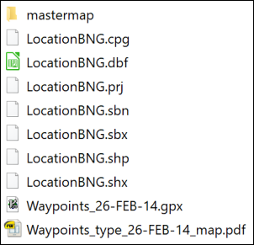

The contents of the zip file. Note that your icons will probably look different to mine as you’ll have different software available.

## Starting a new project in QGIS

You can just open QGIS and start adding data, but it will help you later if you take more care at this stage.

* Open QGIS
* Go to Project > Save and navigate to the folder in which you would like to save your project. This could be a folder called gis with a subfolder called ChancellorsCourt - note that there should not be any spaces in the folder name.
* Give your project a name, e.g. ChanCourt - short and no spaces.
* Save

Having done that you should have a file in your folder called ChanCourt.qgz.

* Go to Project > Properties in the menu in QGIS and click on the General heading on the left
* The Project file should already be filled in
* Set Project home to the folder in which you saved the qgz file
* Set the Project title to something like Chancellors Court, University of Leeds - basically a description of what your map is going to show.
* Check that Save paths is set to relative
* Click OK

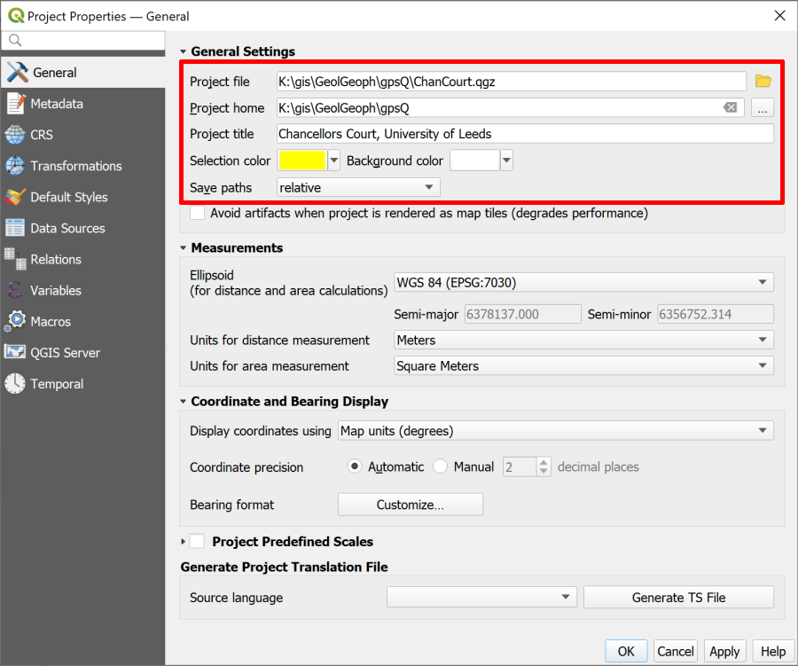

The general tab of the Project Properties showing the settings you should fill in.

**Save paths** is probably the most important project setting as it can save you from having data go missing if you move your project to another computer. By setting this to **relative**, as long as you move the whole folder, your data and your map will stay linked.

## Using the Browser to find information about a layer

Now that you have the **Project home** set it is possible to use that heading in the Browser to find everything associated with this project (assuming all your files are in that folder).

* Go to the Browser (if it isn’t already open go to View > Panels and put a tick next to Browser).
* Click on the little arrow next to Project Home to see the contents of the folder. You should see all the files that you unzipped earlier.

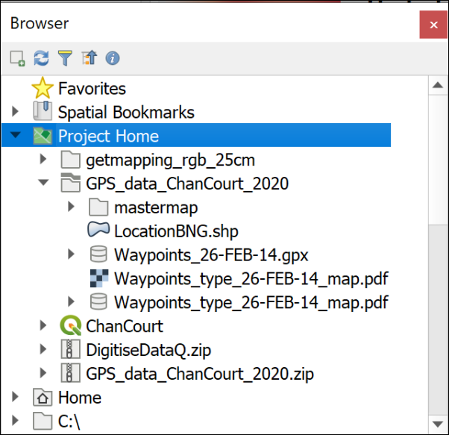

The Browser panel showing the files and folders for this project listed under Project Home.

One of the benefits of the browser is being able to have a look at the details of your data before you add it to a map.

If you are in version 3.16 or above of QGIS

* click on the little arrow next to Waypoints_26-FEB-14.gpx

You should see that the file includes several **layers**. For this exercise the only one we want is waypoints

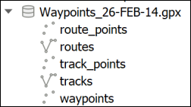

The layers within the gpx file as seen in version 3.16 of QGIS.

* Right-click on the waypoints layer and go to Layer Properties
* Use the three tabs at the top of the layer properties - Metadata[8], Preview and Attributes - to have a look at your file.

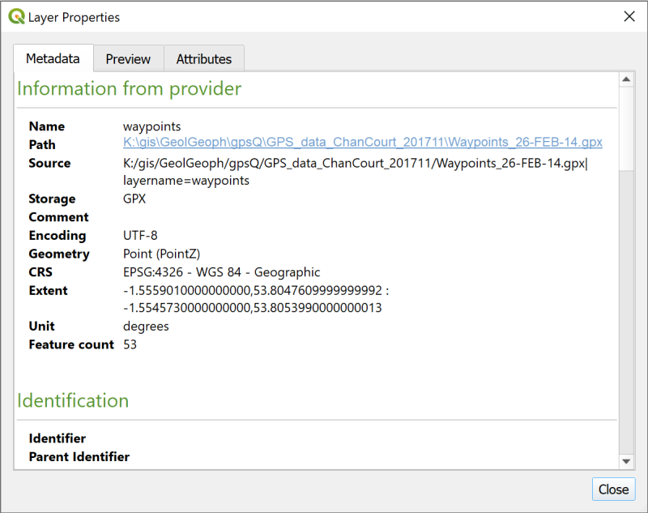

The layer properties showing metadata about the layer you right-clicked on.

The Metadata tab tells you quite a lot, but the Preview tab can confirm that your data looks correct, and the Attributes tab will let you see the table of data that you have.

 **Make a note of the CRS**

One particularly important piece of information is the CRS, or Coordinate Reference System. You’ll need to know this later.

Make a note of the text next to the CRS subheading in the Metadata then close the Layer Properties.

## Adding a gpx layer to a map

 **Adding a gpx layer to a map in QGIS**

This video clip can be found in the module area of [Minerva](https://minerva.leeds.ac.uk) or in the [full list of video clips](https://cgordon-gis.github.io/videoclips.htm).

* Drag and drop the waypoints layer from the Browser to the Layers panel.

You should now have a map showing small circles for each of the waypoints which looks something like the image below. (Your colours may be different.)

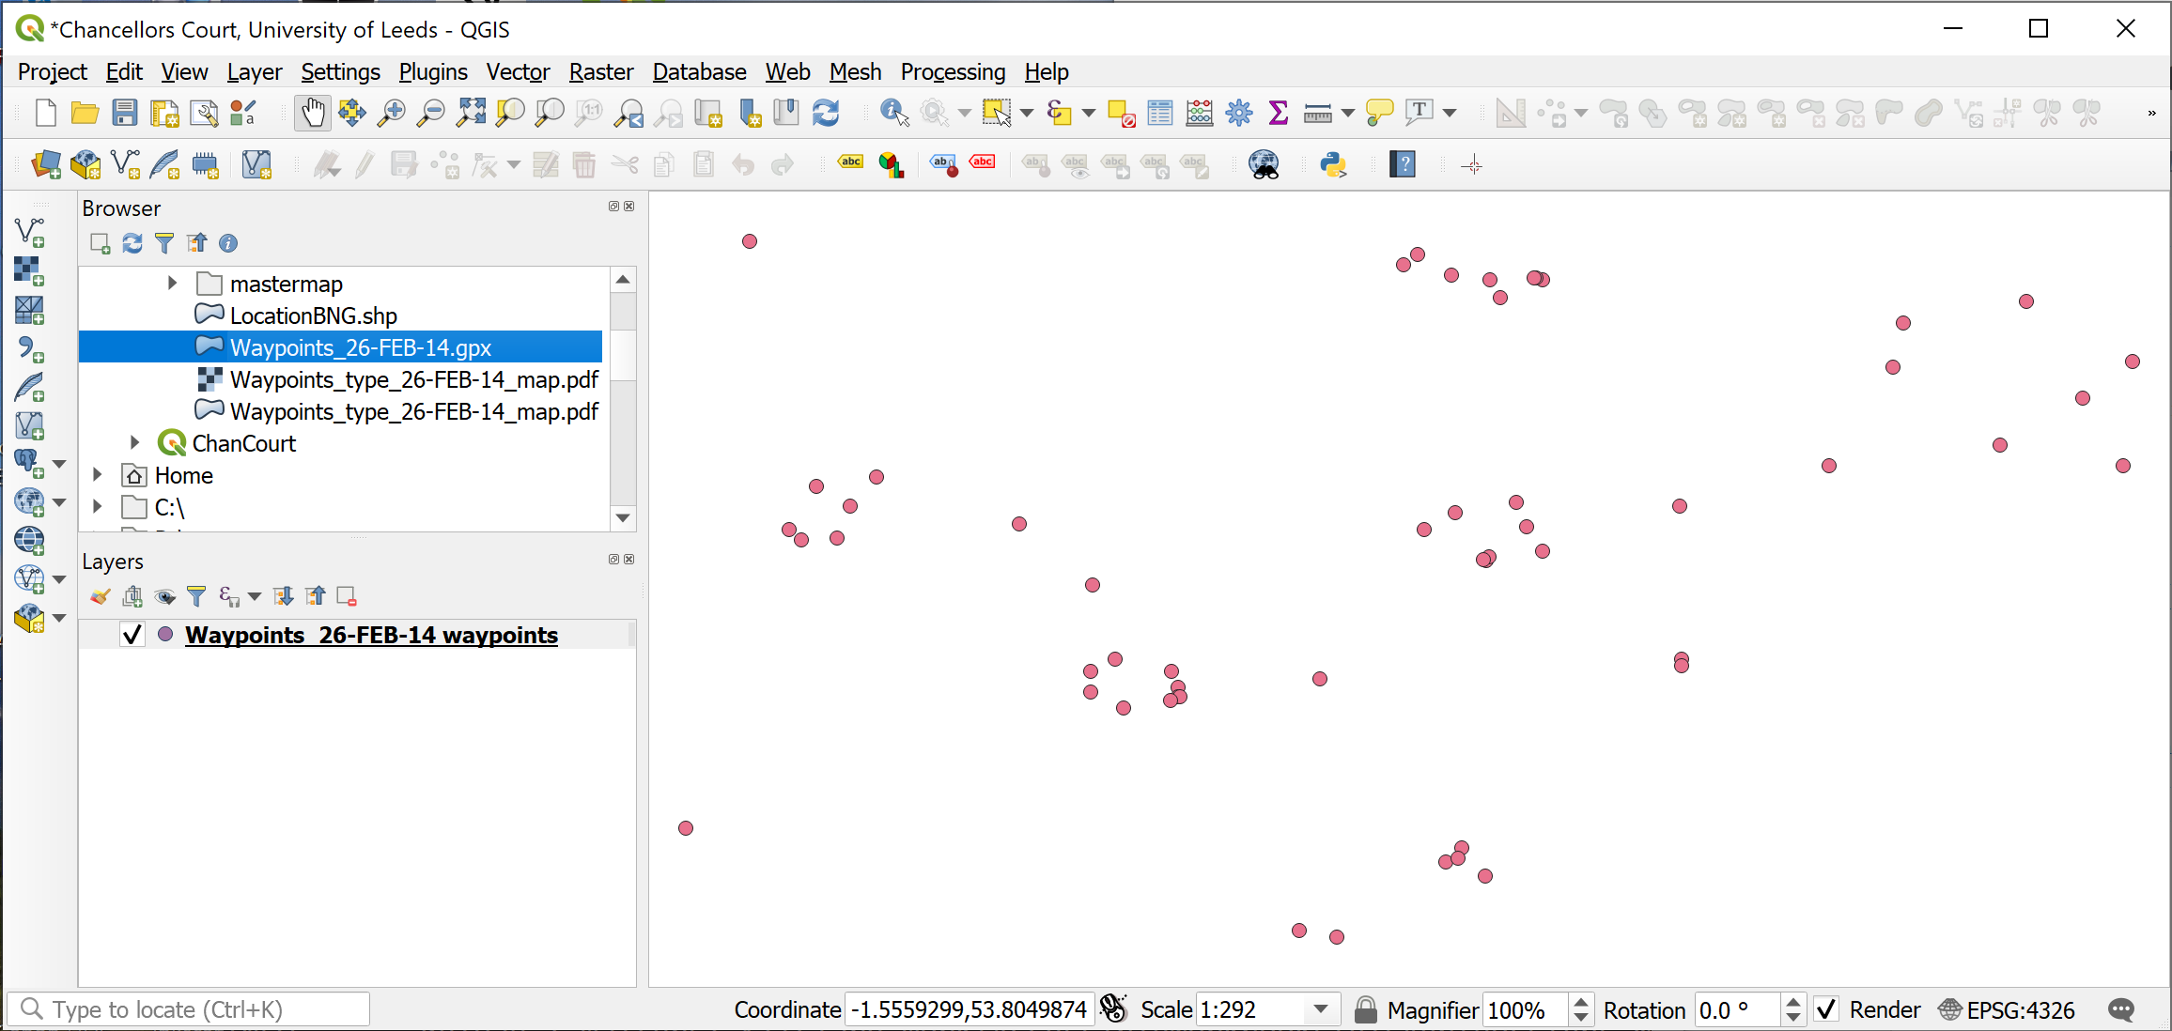

The map once you have added the Waypoints. Your colours may be different to these.

### Exporting gpx layer to a geopackage

As the layer is stored at the moment this is not a proper GIS layer, it is still the gpx file. If you are going to use these points for further analysis or measurements you need to **export** them to a GIS format, such as a layer in a Geopackage.

 **Geopackage format**

A geopackage is a form of database designed to store spatial data. It has been relatively recently developed but it’s use as a GIS format has spread very quickly. QGIS encourages the use of geopackages and it is increasingly possible to use them in other GIS software.

You will store vector data in a geopackage as multiple layers.

If you want more information about the format there is a lot on the [GeoPackage website](http://www.geopackage.org/).

To export the waypoints to a geopackage layer:

* In the Layers panel right-click on the waypoints layer
* Export > Save Features As...
* Fill in the panel that opens as follows:
  + Format = GeoPackage
  + Click on the ... button at the end of the File name box, navigate to the folder in which you want to store your geopackage - preferably the same folder as your .qgz file, then give your geopackage a name, e.g. University.gpkg. The location tends to be a good idea here.
  + Save
  + In the Layer name box give your layer a name such as Waypoints - it needs to be a name that will tell you what data this layer contains.
  + Check that the CRS field is the same as the CRS you made a note of earlier - in this case that should be EPSG:4326 - WGS 84
  + Check the bottom of the form to make sure that Add saved file to map is ticked.
* Click OK to create the geopackage and add the new layer to your map.

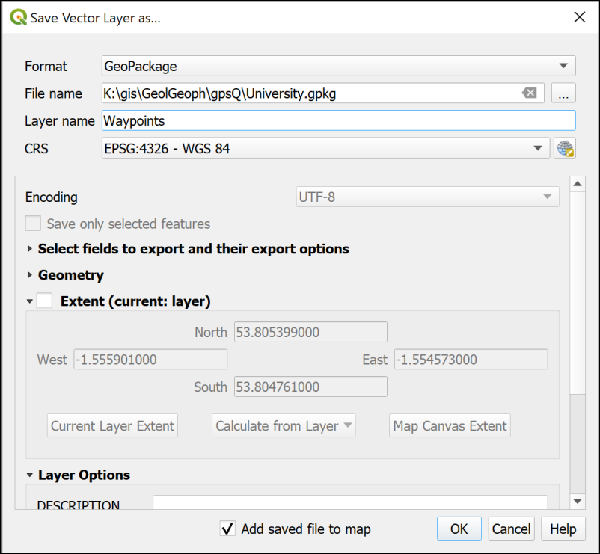

Filling in the form to save your waypoints as a vector layer in a geopackage.

Your map won’t look much different, though the dots may have changed colour.

The new GeoPackage should have appeared in the Browser in the folder you saved it to. Have a look at that now and drop down the arrow next to the .gpkg file to check that the Waypoints layer is there.

#### Refresh the browser

If you can’t see the new geopackage in the browser, or it doesn’t appear to have any contents, you may just need to **refresh** the Browser.

* Select the Project Home heading
* In the row of buttons at the top of the browser click on the second button from the left - the tool tip should show you that this is the Refresh button.

 **Components of a GeoPackage**

If you have a look at the same .gpkg file in your file explorer outside of QGIS you’ll probably see three files with the same name but slightly different extensions - .gpkg, .gpkg-shm and .gpkg-wal. The last two are temporary files which appear when the geopackage is open in QGIS. Once you close QGIS you’ll only see the .gpkg file.

The geopackage itself is a single file and without appropriate software, such as QGIS, you can’t open it and see the contents.

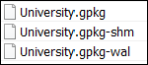

The components of a geopackage viewed in a file explorer when the file is open in QGIS.

To keep the Layers panel tidy right click on the original waypoints layer and Remove layer... but don’t delete the .gpx file or it’s contents from the Browser - you may need them again later.

## Installing QGIS plugin to display a background map

At the moment you have your waypoints on a map but can’t check where they are located because the background is just plain white.

In the chapter on finding data I showed you how to use XYZ Tiles to show a background map. Those are useful but limited. Here I’ll introduce you to another way to obtain background maps.

One of the strengths of QGIS is that it has a wide variety of plugins that you can install to carry out extra tasks. One of these plugins allows you to add maps from the web as background maps so we’ll install that now.

 **Installing plugins in QGIS**

This video clip can be found in the module area of [Minerva](https://minerva.leeds.ac.uk) or in the [full list of video clips](https://cgordon-gis.github.io/videoclips.htm).

* In the menu go to Plugins > Manage And Install Plugins...
* When it opens click on the Installed heading on the left to see the plugins that are already installed.
* If you click on a plugin you’ll be able to see a bit about it in the panel on the right.

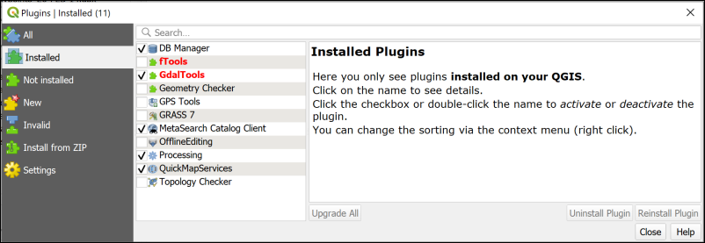

The plugin manager showing the core plugins that are installed when you install QGIS.

To install a new plugin:

* Click on Not installed on the left
* Type QuickMapServices into the search box at the top
* From the list that appears click on QuickMapServices and have a look at the description
* This plugin will do what you want it to do so click on Install Plugin

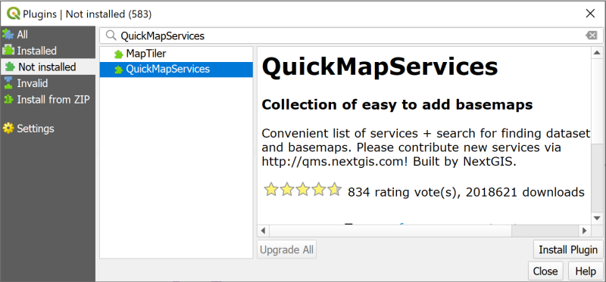

Installing the QuickMapServices plugin.

Once it has installed you should get a message at the top telling you it has been successful and QuickMap Services should now be in the list of Installed plugins.

* You can Close the plugin manager now.

Once the plugin is installed you will have new menu items and toolbar buttons available to you.

* On the menu go to Web > QuickMapServices.
* You should have a very long list of choices available. Go to OSM > OSM Standard.

OSM stands for [OpenStreetMap](https://www.openstreetmap.org/) which is a crowd-sourced map of the World. It can be very useful for quick maps, but isn’t always completely reliable and some areas don’t have much data.

 **Warning: do not try to reproject QMS layers**

Please note that you should not try to reproject the layers from QuickMapServices. These are being loaded over the web (like streaming) and you are not able to alter them. You will only be using them as background maps, not for analysis, so not being able to reproject them is not a problem. QGIS will use on-the-fly transformation to display them correctly.

We have found that some people who have tried to reproject these layers have then had problems with the CRS of the other layers in their project.

Now that you’ve added the OSM Standard basemap you should be able to see the details of Chancellors Court at the University with your waypoints shown on top. If you can’t see your waypoints check that they are above the basemap in the Layers pane.

* Zoom to 1:500 to see the buildings around Chancellors Court too.
* If your points are not appearing over Chancellors Court then there may have been something wrong with the CRS when you imported them. Try importing them again and be careful with the settings.

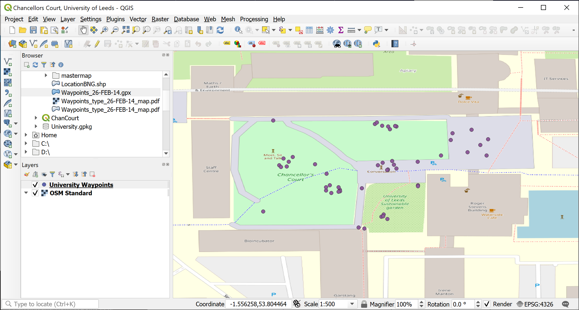

Your map, showing your waypoints on top of the OSM Standard basemap from QuickMapServices.

 **Other QuickMapServices basemaps**

Have a look at some of the other basemaps from QuickMapServices. Not all will cover this area, and some need a licence key, but there are plenty of choices. You will need to switch off other basemaps in the Layers when you add new ones so that you can see them. For example, try

Bing Map

Bing Satellite

OSM Cycle map

OpenStreetMap monochrome

If you can’t find any of the layers above, try the following:

* Under Web > QuickMapServices choose Search QMS
* It should open a panel on the right of your window
* Type Monochrome (or whichever layer you are looking for) in the search box
* Hopefully the correct layer will appear as an option
* Click on the Add button next to the heading

Hopefully the correct layer should appear on your map. You can close the panel now.

Finish with the OpenStreetMap monochrome basemap on your map with all the other basemap layers removed. The monochrome (black and white) background map will make your data easier to see. I sometimes have trouble with these layers not drawing properly, so if you have that problem just choose another layer, or use OpenStreetMap from the XYZ Tiles instead.

Don’t forget to Save your map regularly.

## Adding extra data to feature classes

The layer that you have saved to a Geopackage is known in GIS terms as a feature class. This contains your features and data for each one which are called attributes.

 **Working with attribute tables in QGIS**

This video clip can be found in the module area of [Minerva](https://minerva.leeds.ac.uk) or in the [full list of video clips](https://cgordon-gis.github.io/videoclips.htm).

* In the Layers panel right-click on your waypoints layer and select Open Attribute Table.

The attribute table is the GIS equivalent of a spreadsheet and contains features and their attributes.

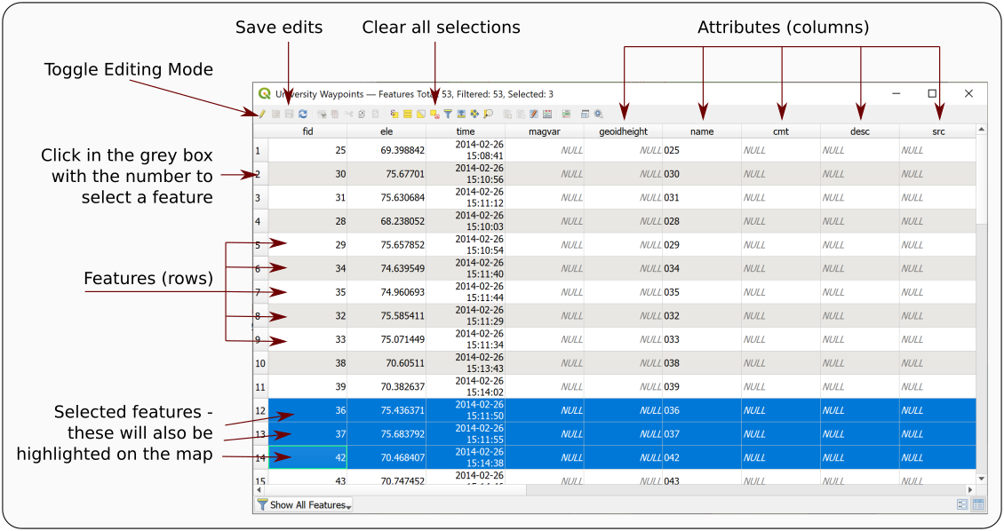

The attribute table annotated with some of the terminology.

Amongst many other attributes there should be one for name which should include the label or name of each waypoint as stored by the GPS unit. In this case the name field holds a number which matches the numbers of the points on the Waypoints_type_26-FEB-14_map.pdf file which you downloaded from Minerva.

* Open the file Waypoints_type_26-FEB-14_map.pdf from the downloaded data and have a look at the information there

Labels on the map show the name field followed by a description of the type of feature, e.g. Rock, Sign post, Planter.

Somehow we need to get that extra information in to the attribute table and unfortunately that has to be done manually!

* Have another look at the waypoints attribute table. There is a field there called desc for description. This seems to be a sensible field in which to put the new information.

To start adding attributes to a table you need to start **editing** the feature class.

* On the attribute table window click on the Toggle Editing Mode button at top left (see the annotated picture of the attribute table above, and remember that tool tips are visible if you hover over buttons). If you’re not sure whether a layer is editable have a look at the Layers panel - any layer toggled for editing will have a little pencil symbol on the left.
* Click in the space under desc for the point with the name 001 - the word NULL should be selected
* Look at the pdf map and find point 001 (it’s at the top left of Chancellors Court) - what is the description of it?
* If you have trouble finding it try selecting the feature in the attribute table by clicking on the number in the grey space on the left. The point will then be highlighted on your map in QGIS
* The description for point 001 should be Sign post so type that in to the attribute table.
* Click on the Save edits button on the attribute table toolbar to write your edits to the feature class in the geopackage.

Continue doing this for some more of the points. Don’t worry if you can’t find some of them on the map - just leave those blank (NULL). Try to do a minimum of about 20 of the points. There are rather a lot there and you don’t need to do all of them on this occasion!

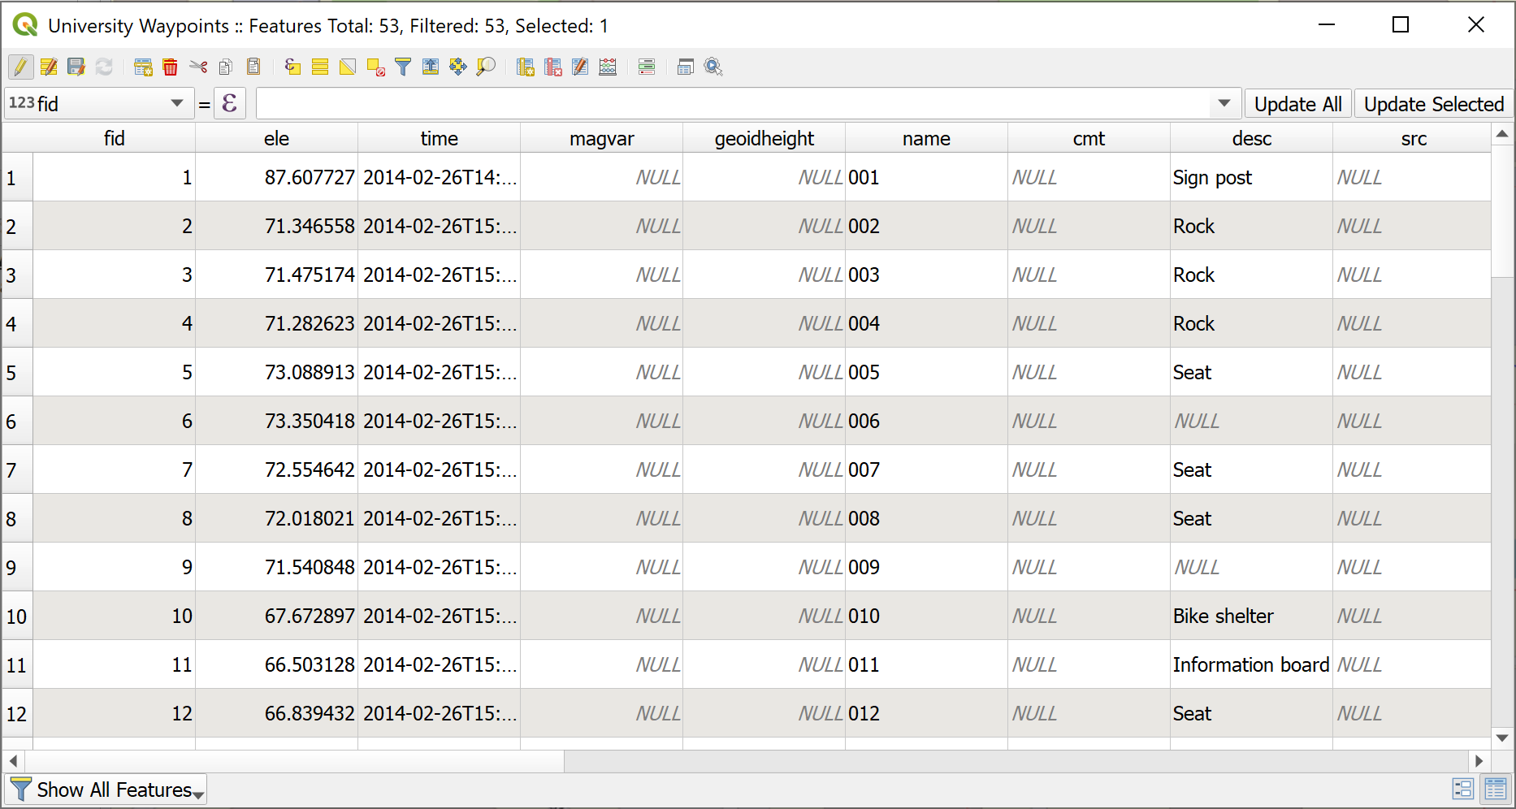

The attribute table in edit mode with the desc fields filled in. Note some are still NULL.

* Once you’ve input the descriptions (and saved your edits) click on the Toggle Editing Mode button again to stop editing
* then close the attribute table by clicking on the cross in the top right.

### Sorting the attribute table

Sometimes the table doesn’t open in the order you expect it to. Before you start entering data check that the numbers in the name field run from 001 upwards. If they don’t you can Sort the table correctly by doing the following:

* Right-click on the column heading in the attribute table and select Sort...
* This opens the Configure Attribute Table Sort Order dialog
  + Put a tick next to Defined sort order in attribute table
  + The name field should already be added to the box on the left, if it isn’t delete anything that is in that box, then go to Fields and Values in the central box and double-click on name
  + Check that Sort ascending is ticked Then click on OK

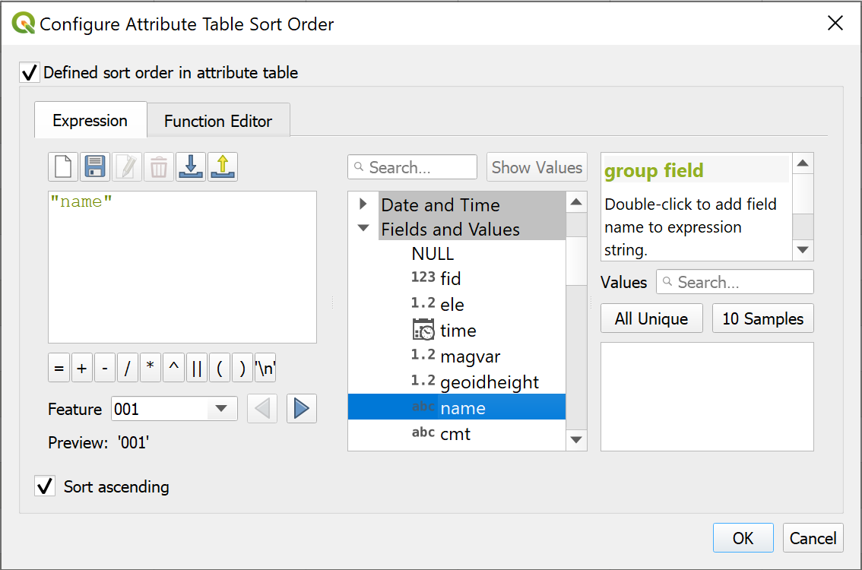

Configuring the sort order of the waypoints table - setting the sort field to name.

## Styling the point layer

Now that you have the description in your attribute table you can style your point layer, initially as a single symbol but then with different symbols for different types of feature.

### Styling a layer as a single symbol

The default styling is for single symbols.

 **Styling a layer as a single symbol in QGIS**

This video clip can be found in the module area of [Minerva](https://minerva.leeds.ac.uk) or in the [full list of video clips](https://cgordon-gis.github.io/videoclips.htm).

* Select the waypoints layer in the Layers panel and click on the Open the Layer Styling panel button - at the top of the Layers panel on the left or use the F7 keyboard short cut.
* The layer styling panel should open on the right of the map window and gives you choices for the way your layer looks.

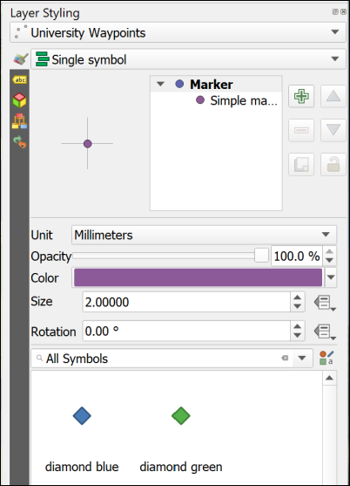

The Layer Styling panel showing single symbols.

In this view you can click on any of the symbols in the gallery and the symbols on your map will change to match them. Try this now by picking any symbol from the gallery.

The section at the top allows you to change the size, opacity and colour of the symbols. Again, try changing the choices there and see what they do. You get more choices if you click on the Simple marker symbol layer.

### Styling a layer as categories

So far you have a single coloured symbol representing every point. Your map would be much more informative if each type of feature had it’s own symbol.

 **Styling a layer as categories in QGIS**

This video clip can be found in the module area of [Minerva](https://minerva.leeds.ac.uk) or in the [full list of video clips](https://cgordon-gis.github.io/videoclips.htm).

* At the top of the Layer Styling panel click on the dropdown that says Single symbol and change it to Categorized
* Now drop down the list next to Value and select the field that you want to categorize your symbols on - in this case desc
* Lower down the panel click on the button that says Classify

Your descriptions should appear as a list and the symbols on your map should change to a variety of random colours.

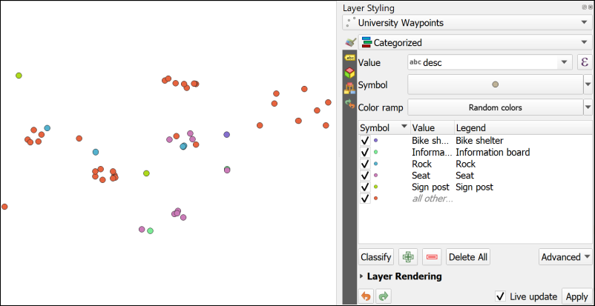

The Layer Styling on the right is set to Categorized and the desc field has been added as the Value. The different types of item have been added to the list by clicking on Classify. Note the different colours on the map.

Note that the attributes that you left as NULL in the attribute table have all been styled as a symbol listed as *all other...*. It would be good to get rid of that as it isn’t adding any useful information to the map.

* In the Layer Styling panel untick the box on the left of the *all other...* category. Alternatively you can click on this and then on the Delete button at the bottom of the panel to get rid of the symbol completely.

The NULL symbols should all disappear from the map.

Note that the Layers panel on the left now acts as a key to your waypoints layer.

### Changing to svg markers

You can change the symbols by double-clicking on each symbol in turn and selecting different ones from the Gallery.

At the moment all your symbols are Simple markers. It is easy to change them to SVG markers and have a wider range of symbols to choose from.

 **Styling points with svg markers in QGIS**

This video clip can be found in the module area of [Minerva](https://minerva.leeds.ac.uk) or in the [full list of video clips](https://cgordon-gis.github.io/videoclips.htm).

* Double click on the first symbol in your list in the Layer Styling panel (in my example it is Bike shelter)
* In the box at the top click where it says Simple marker
* Below that change the Symbol layer type to SVG marker

SVG stands for Scaleable Vector Graphics and is basically what it says. In the context of QGIS it gives you a much greater range of pictorial symbols with which to style your map.

* Have a look at the SVG Image gallery at the bottom of the panel and select an appropriate symbol.
* You can use the settings above the change the size, colour, rotation etc.
* The symbols should appear on your map automatically, but if they don’t click on Apply
* When you’ve finished click on the back arrow at the top of the panel to get back to the list.

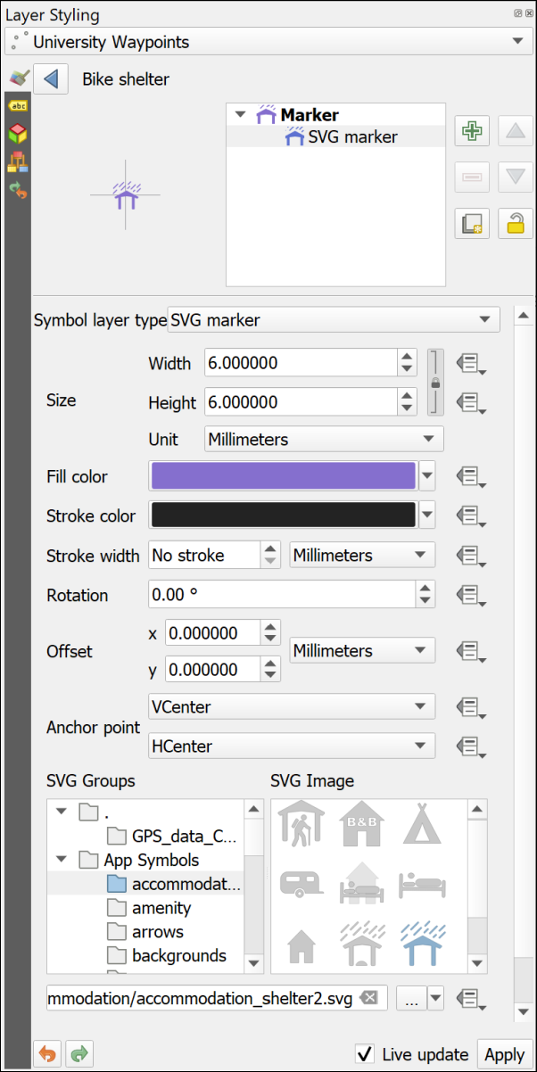

Choosing SVG markers to style your points.

 **Choose symbols for your points**

Continue in the same way to select appropriate symbols for the rest of the categories of point.

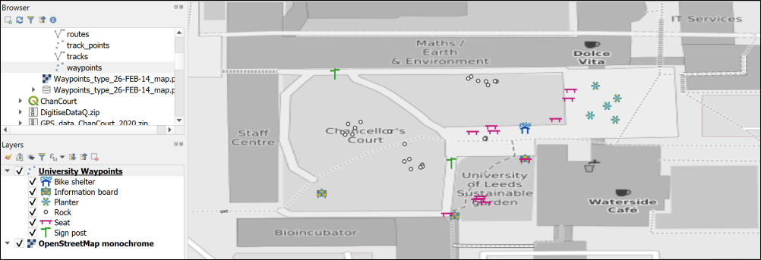

Symbols on the map - yours will probably look different as you’ll have made different choices.

Once you’ve finished setting the symbols for the waypoints, save your map and close it.

## Changing the coordinate system (CRS) of data

The GPS data that you have collected is in the WGS 84 geographic coordinate system. Remember that you checked this earlier. QGIS sets the project CRS to that of the first layer that you add to the map. So, in this case the map CRS is also WGS 84.

Often you will need to use data in a local projected coordinate system. The obvious example is if you are using Ordnance Survey maps from Digimap in the same project. This is the example we will use now, but the same situation can arise if you are, for example, creating a map of Spain or Eire[9].

 **Checking and setting the crs of your project in QGIS**

This video clip can be found in the module area of [Minerva](https://minerva.leeds.ac.uk) or in the [full list of video clips](https://cgordon-gis.github.io/videoclips.htm).

We’ll set up a map project in British National Grid and add the gps data to that.

* If QGIS is not already open, open it from the start menu, but don’t open a map. If you already have a map open click on the New Project button, or use the keyboard shortcut Ctrl+N to open a new blank map.
* Use the browser panel to drag the LocationBNG.shp shapefile that you will have downloaded from Minerva to the Layers panel. It should appear in your map area. Remember that the first layer that you add to a map automatically sets the coordinate system.
* You may get a window like the one below asking about Transforms, just click OK on this for now. This is to do with ways of “transforming” data from one CRS to another.

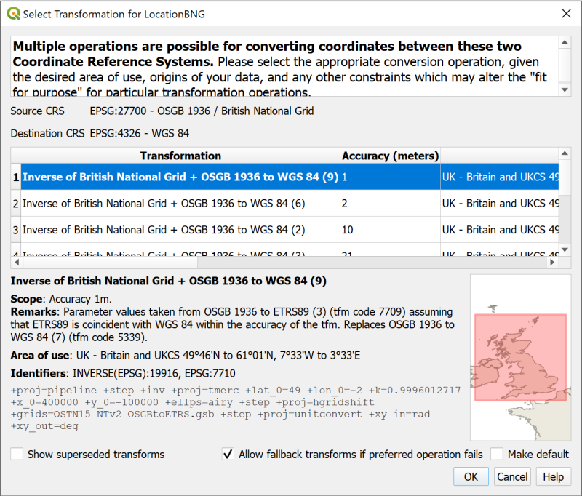

The Transform selection window. Just click OK for now.

You should find that you have a map with two polygons in a random colour. If you look at the bottom right of the map window you should be able to see the text EPSG:27700. This is the code for British National Grid and confirms that your map is in the correct CRS.

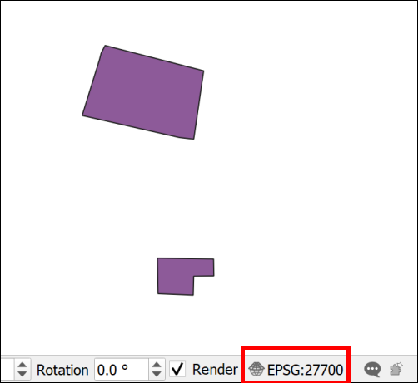

The two polygons on your map and the EPSG code - 27700.

* Save your map to the same folder as the previous map. Call it something like UniversityBNG.qgz - BNG = British National Grid.
* Add the OSM monochrome base map to your map again. You already have the plugin installed so don’t need to do that again.
* Style the LocationBNG polygon layer so that it has an outline but no fill. You should be able to see the base map through it. Styling a polygon layer is very similar to styling points so you should be able to use the previous instructions again.

Now it should be possible to see that both polygons cover parts of the University, but the one that is relevant for this map is the one to the south which covers Chancellors Court.

* Zoom in to the polygon to the south.
* Now add the Waypoints layer from your geopackage (not from the original gpx file) to the Layers panel from the Browser.

They should appear in the correct place, even though they have a CRS of WGS 84 and the map is in British National Grid. You can check this in the layer properties if you want to.

QGIS is projecting the layer “on the fly” using a transformation. This is very convenient, and if you are just going to look at the map that is fine. But if you need to do any analysis or measure anything then you really need to get this layer projected in to British National Grid as well.

 **Reprojecting a feature class in QGIS**

This video clip can be found in the module area of [Minerva](https://minerva.leeds.ac.uk) or in the [full list of video clips](https://cgordon-gis.github.io/videoclips.htm).

To project the layer permanently

* Right click on the Waypoints layer in the Layers panel or in the Browser
* Export > Save features as...
* Fill in the Save Vector Layer as... dialog as follows
  + The Format should be GeoPackage
  + Click on the three dots button next to File name and browse to your existing Geopackage.
  + Give the output a Layer name which will remind you what it contains, e.g. WaypointsBNG
  + Drop down the CRS and select Project CRS: EPSG:27700 - OSGB 1936 / British National Grid.
* Finish by clicking OK

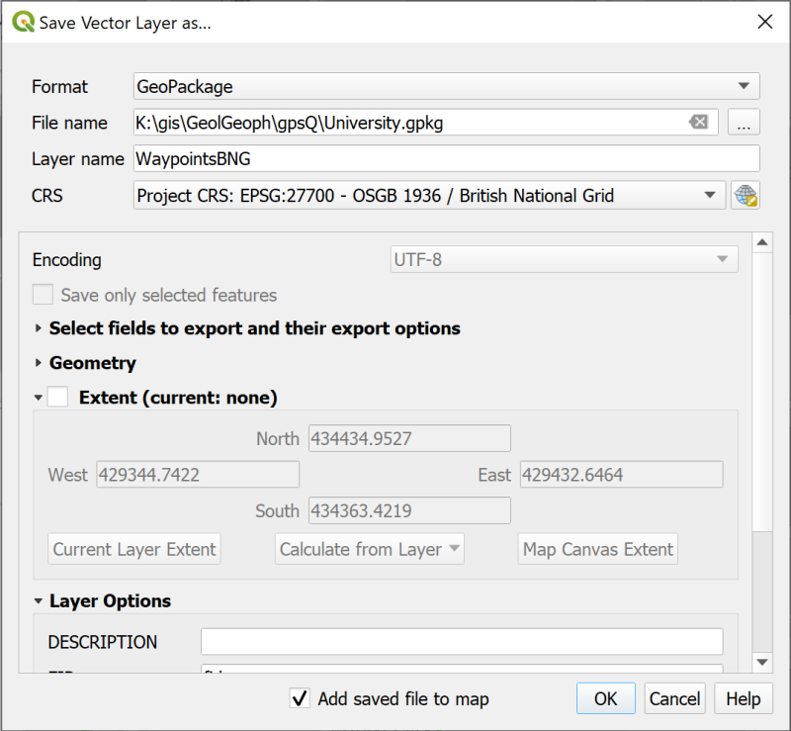

Filling in the Save Vector Layer as… dialog to save your waypoints as a new feature class with a projected CRS of British National Grid.

Your map probably won’t look much different but the new layer should have been added to the Layers panel. If it hasn’t drag it over from the Browser.

 **Checking the layer CRS in QGIS**

This video clip can be found in the module area of [Minerva](https://minerva.leeds.ac.uk) or in the [full list of video clips](https://cgordon-gis.github.io/videoclips.htm).

* Check the new CRS by right-clicking on the new layer and going to Properties
* Look at the Information tab.
* The CRS heading should say EPSG:27700 - OSGB 1936 / British National Grid - Projected. If it doesn’t you may have to try again and check everything carefully as you go along.
* [Remove the original waypoints layer](/introduction/#removing-layers) from your Layers panel and Save your map.

Now you have a map in British National Grid which shows your waypoints and which, because all layers match the map CRS, can be used for analysis.

* Make sure you have both of your maps of Chancellors Court open in QGIS - you should find that it is possible to have QGIS open twice.
* If you compare your two maps you should be able to see that the different CRS gives a very different idea of the “shape” of Chancellors Court.

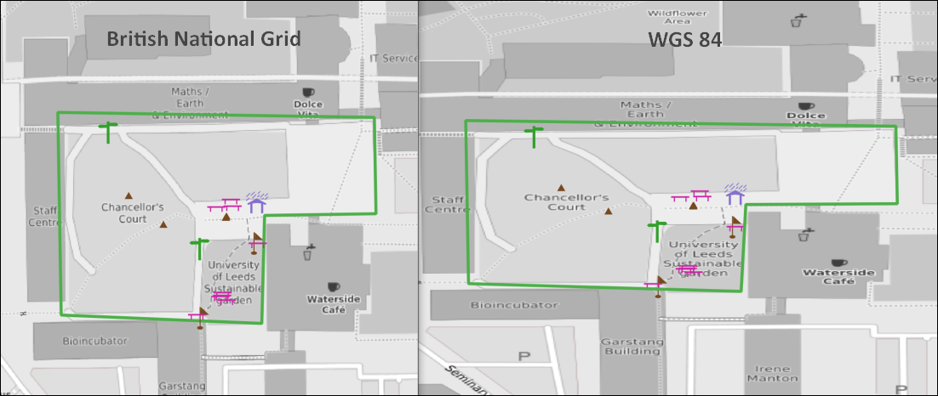

Comparing British National Grid (left) and WGS 84 (right).

This is because the projected CRS, British National Grid, is designed to be best to display maps of Britain on a cartesian grid whereas the geographic CRS, WGS 84, is designed to display maps of the whole world in latitude and longitude. This means that the mathematics behind each CRS is rather different.

### Copying styles

If you want to style the point symbols on your BNG map so that they are the same as the WGS 84 map try the following short cut:

* In the WGS 84 map right-click on the waypoints layer and select Styles > Copy Style > All style categories
* In the British National Grid map right-click on the waypoints layer and select Styles > Paste style > All style categories

Your styles should be copied across and your map is ready to go!

## The final map

Set the symbols on your map so that you are happy with them and zoom out so that a bit more of the University is visible.

Set up a basic layout, export it as an image and upload it to your GIS Portfolio. If you upload it within a week of the class I will give you feedback on your work.

Alternatively just export your map as an image without creating a layout:

* When you are happy with your map go to Project > Import / Export > Export Map to Image
* In the Save Map as Image dialog set the extent by clicking on the Map Canvas Extent button
* Click on Save

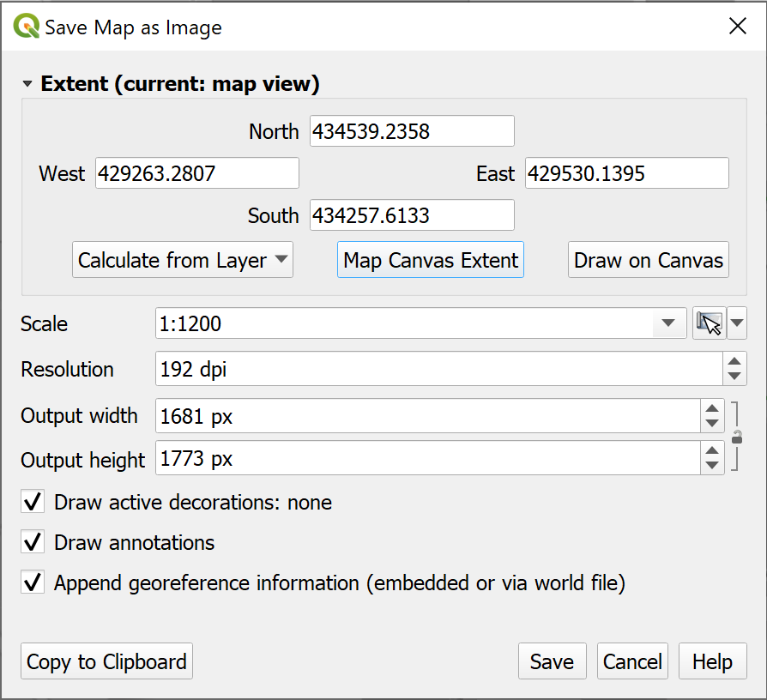

Saving your map as an image.

In a later chapter you’ll find out how to create a full map layout with a key, scale bar, measured grid etc and print or export that properly, but for now this is fine.

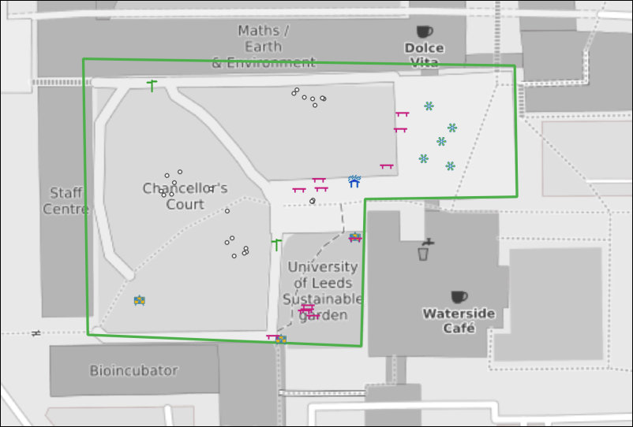

The final map exported as an image. Yours will probably look different to this as you’ll have made your own decisions about symbols and colours.

 **Keep this project for the next chapter**

In the next chapter you will be creating data in QGIS by digitising. We will use the area of Chancellors Court again, so keep this project for that.

## Further information and suggested reading

Some of the books in the reading list[10] have information GPS and its use for collecting data. Suggestions include the following:

* Chapter 2, *Spatial data* in Heywood, I., Cornelius, S. and Carver, S. (2011), pp.65-67 cover GPS.
* Chapter 2, *Collecting Field data more efficiently with GIS and GPS technologies* in Tian, Bai (2016), pp. 57-90 looks in detail at how GPS can be used for collecting data and includes a few case studies.

The **QGIS Documentation** has a chapter on Working with GPS data which covers much more than we have been able to cover here.

* [Working with GPS data for v. 3.10 of QGIS](https://docs.qgis.org/3.10/en/docs/user_manual/working_with_gps/index.html?highlight=gps)
* [Working with GPS data for v. 3.16 of QGIS](https://docs.qgis.org/3.16/en/docs/user_manual/working_with_gps/index.html?highlight=gps)

# Creating data by digitising

Last Modified: 17 Nov 22, 15:42:54

The background to creating data for GIS will be covered in the lecture segment this week, and the presentation and any other supporting materials will be available in Minerva. The lecture segment should help you to understand **why** you are doing these exercises. If you still aren’t sure, please ask [Clare](mailto:c.e.gordon@leeds.ac.uk).

## Learning outcomes

When you have completed this section of the workbook you should be able to

* Set up storage for GIS data
* Use the tools in GIS to draw (digitise) your own data
* discuss the problems that can affect data for GIS
* suggest ways in which to minimize error and uncertainty in spatial data

## Introduction

Digitising or tracing data manually in GIS involves having a background map which shows the locations that you wish to digitise, and then using the editing tools to draw vector polygons, lines and points. In this set of exercises, you will produce a map of Chancellors Court in the University showing the outlines of the buildings, the paths, and the trees. You will already have a layer from the previous chapter which contains features such as sign posts, benches and rocks.

Even if you don’t actually need to digitise a whole map it is extremely useful to know how to set up your own feature classes and how to add features by editing. Sometimes you just need to outline your study area or add a point to show where something specific is, or as input to one of the tools provided in GIS.

This is a very brief overview of the tools for digitising in QGIS as we are limited for time.

**Vector and raster**

If you feel that you are not clear about the difference between **raster** and **vector** GIS data it would be worth having a look at the video “[Learn more about raster and vector map data](https://youtu.be/hbOGp51nYGI)” by the Ordnance Survey.

As you deal with more GIS data you’ll start to find it easier to spot which formats are raster and which are vector, but you need to be thinking about it already.

## Obtaining the data

If you have already followed the GPS chapter and have a British National Grid version of the map of Chancellors Court then you can use that map again. This chapter will use features in the same area.

If you no longer have this project, or if you have not followed the GPS chapter, you can start a new project from scratch instead. You won’t have the gps points on the map when you have finished, but that doesn’t matter.

You will also need to

* download the DigitiseDataQ.zip file from Minerva
* If you already have a Chancellors Court map unzip the file to the same folder.
* Otherwise unzip the data to a new folder within your GIS folder.

You should end up with a folder called getmapping_rgb_25cm which contains aerial imagery of the University[11]. The jpg file within that folder contains the image and the other files with it, which have a similar name, contain information that will locate it correctly within GIS.

You should also have a geopackage called StudyArea.gpkg which contains an outline for the area of Chancellors Court.

## Open the map project

* Start by opening either your existing Chancellors Court map or a new blank map.
* From the files you downloaded and unzipped add se2934_rgb_250_01.jpg to your map using the Browser. (You may need to look in sub folders to find the file.) Remember if you can’t find the folder or the file that you’ve just added you can refresh the Browse panel.
* If you need help to find Chancellors Court add the StudyArea feature class to your map and Zoom to Layer.
* If necessary turn off the waypoints, location and OSM Monochrome layers so they don’t get in the way.

You should have an aerial view of Chancellors Court on your map. You will use this as a basis to digitise the buildings, paths and trees.

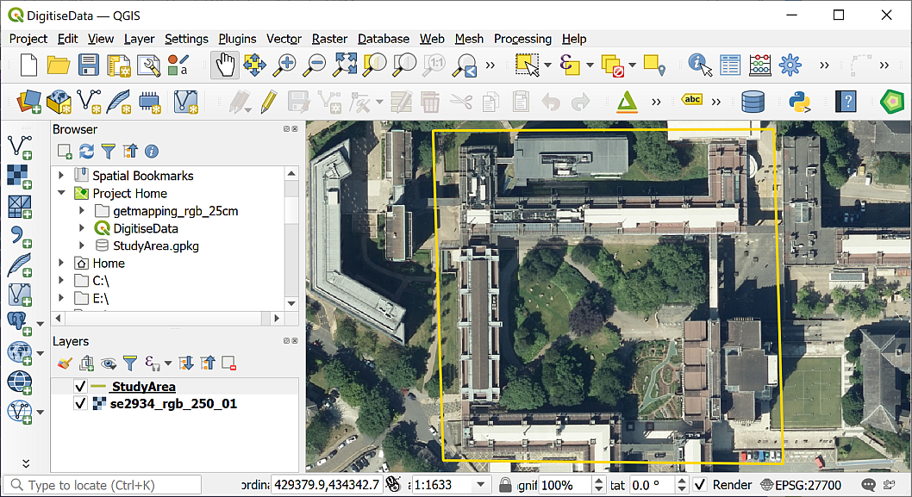

The aerial image open in QGIS showing the area of Chancellors Court.

## Setting up geopackage feature classes to store your data

The first thing you need to do is set up the storage for the data that you are about to create. You should already have a GeoPackage in your project, and if you do you can use that to store this new data too.

 **Creating feature classes in a geopackage**

This video clip can be found in the module area of [Minerva](https://minerva.leeds.ac.uk) or in the [full list of video clips](https://cgordon-gis.github.io/videoclips.htm).

### Creating a new geopackage and adding a feature class

If you are going to use an existing geopackage go straight to the next section - Adding a new feature class to an existing geopackage.

If you don’t already have a geopackage or want to create a new one:

* In the Browser right-click on the folder in which you want to store the new geopackage or geopackage layer. It’s a good idea to use the Project Home folder if you have already saved your map but at least put it in the same folder as the rest of your project data.
* New > GeoPackage
* Give your new Geopackage a name in the Database field - don’t delete the path to it, just change the name. I tend to name the geopackage with the location, e.g. in this case University.gpkg
* Fill in Table name with a name which will remind you what that table contains - in this case call it Buildings
* Choose a Geometry type - in this case Polygon (note that once this is set for a feature class you can’t change it later)
* There is a drop down for the CRS (unlabelled) either drop that down and select Project CRS: EPSG:27700 - OSGB 1936 / British National Grid or use the button at the end of the line to search for the appropriate CRS.
* If you want to add any fields to contain attributes you can do so now - it is also possible to add fields later
  + Under New Field type in a Name - in this case Label
  + Choose a Type - for this layer choose Text data
  + Then type a Maximum length - for now type in 250 - this is the maximum number of characters your label will be.
  + Then click on the Add to Fields List button to add the new field to the list. You can then add more fields if you need to, but we don’t at the moment.
* Once you’ve added all the fields click on OK to create the new feature class.

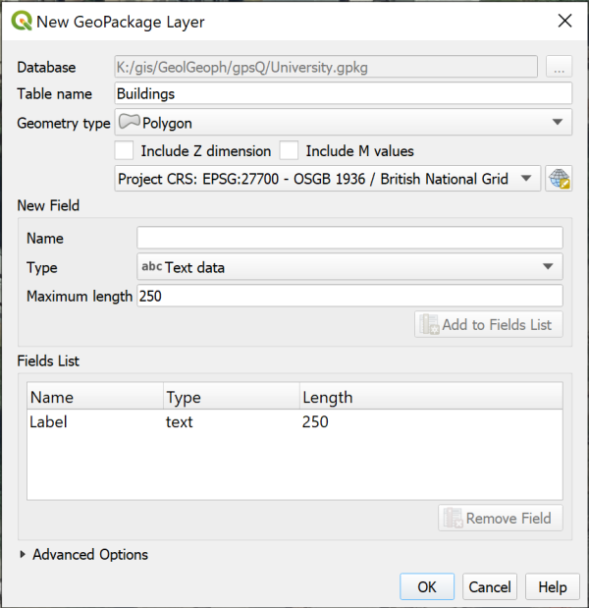

Creating a new layer in a new GeoPackage.

The new feature class should be created in your GeoPackage and added to your map.

If the new layer isn’t added to your map drag it there from the Browser now.

If you can’t see the new layer in the geopackage you may need to select the top-level folder and then click on the Refresh button at the top of the Browser.

### Adding a new feature class to an existing geopackage

If you already have a geopackage (if you followed my instructions above you’ll have a geopackage called University.gpkg)

* Right-click on your geopackage in the Browser panel
* Select New Table
* If you get an error message saying Cannot Create New Tables
  + click OK to get rid of it,
  + then right-click on the geopackage again and this time select Add Connection.
  + You won’t see any difference at this point, but now right-click and select New Table again.
* The New Table dialog should open.
  + Give your new table a name, in this case call it Paths
  + Click on Add field and give it the name Label, Type should be string (choose from the dropdown box) and Length = 250 - that’s the maximum length of text you’ll be able to type into the table for that field.
  + Set the Geometry Type to LineString. Note that it’s important to set this correctly as it can’t be changed later.
  + Under CRS select the required coordinate system - in this case British National Grid
  + Tick to Create spatial index - this makes the storage and retrieval of your data more efficient
* Click on OK to create the new table.

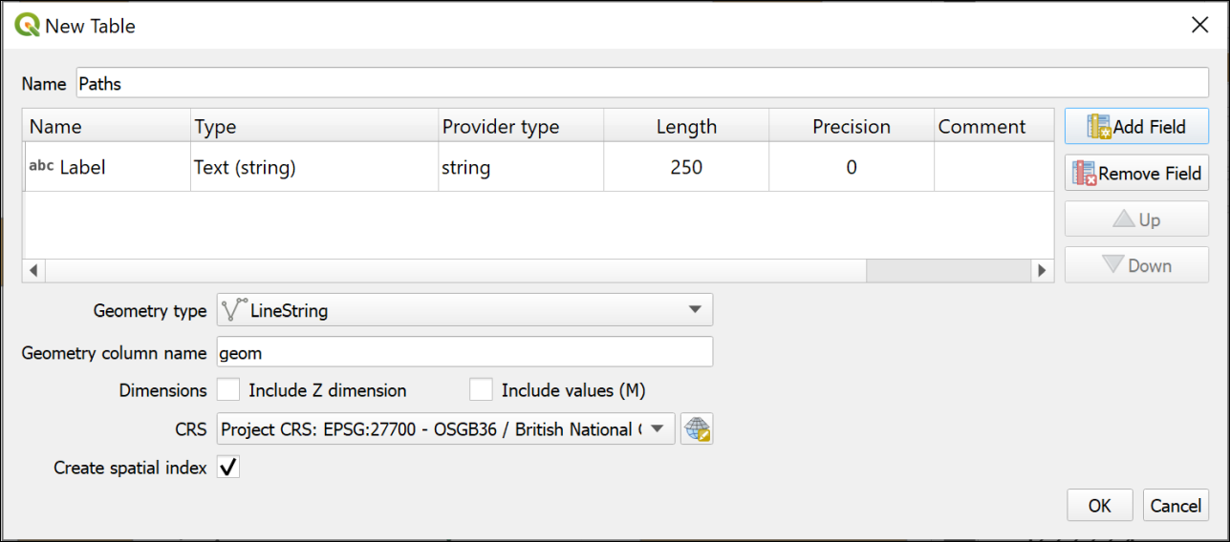

The window to create a new table in an existing geopackage.

If the table isn’t added to your map automatically, drag it to the Layers panel from the Browser now.

If you can’t see the new layer in the geopackage you may need to select the top-level folder and then click on the Refresh button at the top of the Browser.

### Setting up further feature classes

For this exercise you will need a polygon feature class, a point feature class and a line feature class.

 **Feature classes to create**

Use the appropriate instructions above to create a total of three feature classes in the same geopackage. Note that the **Geometry type** is different each time and remember that you must set this correctly or you have to create the feature classes again.

Create a Polygon feature class called Buildings. This should have a new text field called Label with a length of 250.

Create a Line feature class called Paths. This doesn’t need any new fields.

Create a Point feature class called Trees. Again, this doesn’t need any new fields.

Have a look at the new layers in your geopackage using the Browser. Note that the icons next to the layers show you what the Geometry type is.

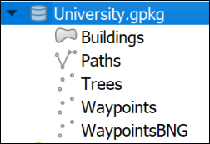

This is how your new geopackage layers should look in the browser. Note that the icons show the Geometry type of each layer. The geopackage example here also includes the waypoint layers from the GPS chapter don’t worry if you don’t have those.

## Digitising in QGIS

You should already have an aerial view as a background for your map. For these exercises you will be **digitising** polygons, lines and points by tracing over features on this view.

Before starting to digitise check that you have the Digitising Toolbar open.

* View > Toolbars
* Check that there is a tick next to Digitising Toolbar

The toolbar should look something like this image at the moment. The only button available is Toggle Editing.



The Digitising Toolbar before you start digitising.

### Digitising polygons

The Buildings feature class has a geometry type of Polygon, so this will hold closed shapes. We’ll start by digitising polygons, but lines and points are actually very similar.

 **Digitising in QGIS Part 1: Starting and finishing, and creating polygon features.**

This video clip can be found in the module area of [Minerva](https://minerva.leeds.ac.uk) or in the [full list of video clips](https://cgordon-gis.github.io/videoclips.htm).

* Start by selecting the Buildings layer in the Layers panel
* Either right-click on the layer and click on Toggle Editing or click the Toggle Editing button on the Digitising toolbar.

You should have more buttons available on the Digitising toolbar now.



The Digitising Toolbar once you have toggled editing with more buttons available.

* The button that I’ve highlighted is Add Polygon Feature. Click on this so that you are ready to start tracing.

We’ll digitise the School of Earth and Environment (SEE) building by drawing around the outline on the aerial photograph. SEE is the building to the north of Chancellors Court[12].

* Left-click on one corner of the SEE building, then on the next. Keep left-clicking until you have outlined the building. You can zoom in and out and pan as necessary (to pan easily hold down the mouse wheel and drag the map).
* As you progress around the shape you should see it as a transparent red with a stronger outline.

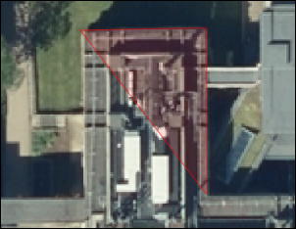

Starting to digitise the School of Earth and Environment. Note the transparent red area outlined in stronger red, this shows where you have already digitised.

* Each click creates a vertex or node.
* If you want to delete the previous vertex that you placed, because it’s not right, just press the Delete or Backspace keys on your keyboard.
* If you’re not happy with the whole shape clicking on Esc will get rid of it completely.
* When you have placed a vertex on each corner of the building right-click to finish editing.

Depending on the settings in your installation of QGIS you should find that a Features Attributes window opens. This gives you an opportunity to add attributes to your table.

If the window doesn’t appear you can still open the attribute table for the layer (right-click on the layer in the Layers panel) and add attributes that way.

* The buildings feature class has a Label attribute. Fill that in now with the name of the building - School of Earth and Environment.
* The fid (or Feature ID) is generated automatically so don’t touch that.
* Click OK.
* To save your new feature to the geopackage make sure that you click on the Save Layer Edits button on the Digitising toolbar

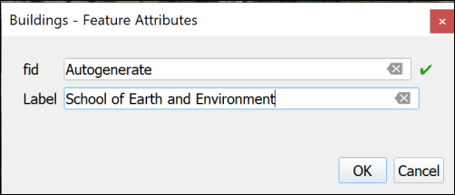

Adding attributes to your new feature. fid is generated automatically so don’t touch that!

Your new feature should appear as a solid colour on your map.

Continue on to digitise the buildings to the east, west and south of Chancellors Court. The map below shows the names of the buildings for you to add.

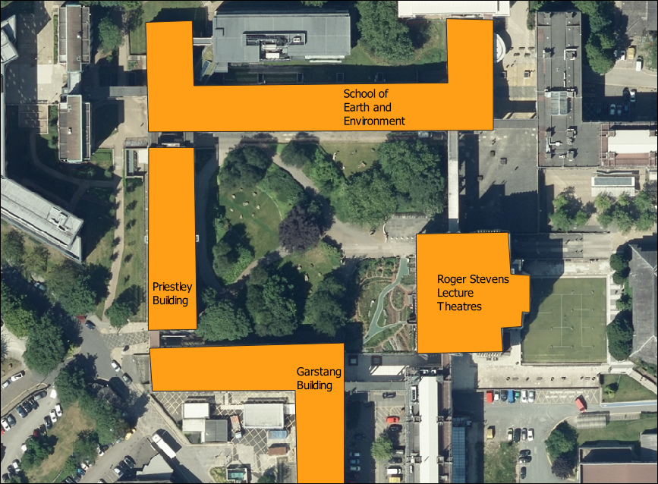

Buildings around Chancellors Court and their names.

* When you have finished digitising and have saved your edits click on the Toggle Editing button again to finish.

#### Styling your layer

At the moment the buildings are a solid, random colour. Let’s change the colour to something that’s more usual for showing buildings on a map.

 **Styling a vector layer as a single symbol in QGIS**

This video clip can be found in the module area of [Minerva](https://minerva.leeds.ac.uk) or in the [full list of video clips](https://cgordon-gis.github.io/videoclips.htm).

* Open the Layer Styling panel by selecting the buildings layer then either clicking F7 on your keyboard, or clicking on the button at the top left of the Layers panel - the tool tip is “Open the Layer Styling Panel”.
* You can select a style from the Gallery that opens - one is called “Topo Building”, or click on the bar next to Color and select your own colour.
* Check Live update is ticked at the bottom of the panel so that your styles are automatically applied to your map.
* You can also click on Simple Fill at the top and experiment with the settings there.

#### Transparency

It can be useful to make your layers transparent. As you draw your building polygons you’ll gradually be covering up the layers underneath and it can be useful to see through the top layers.

 **Making vector layers transparent in QGIS**

This video clip can be found in the module area of [Minerva](https://minerva.leeds.ac.uk) or in the [full list of video clips](https://cgordon-gis.github.io/videoclips.htm).

* Click on the Buildings layer in the Layers pane
* Then click on the button at top left of the Layers pane to Open the Layer Styling Panel or press F7 on your keyboard.
* The layer styling panel should open to the right of your map.
* Click on the Symbology tab in the icons on the left of the panel
* Make sure that the Fill is selected
* Use the Opacity slider to change the opacity or transparency of your layer. For example, slide it to about 70%

 **Warning**

It is also possible to change the transparency by using the Opacity setting in the Layer Rendering section, but if you do that the features may not remain transparent when you export your map to pdf.

Set the opacity so that you can see through your building polgons to the aerial imagery below.

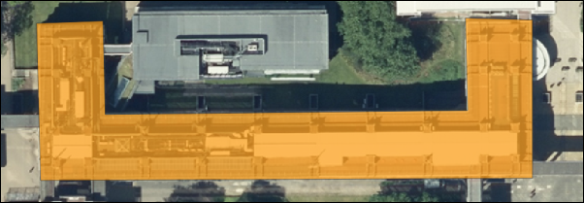

The SEE building with 70% opacity set.

#### Data quality

 **Think about data quality issues**

Stop and think about the digitising you have just done. Can you think of any potential issues with the data that you have created in this way?

What scale did you digitise at? What effect will this have on the amount of detail that you included? What recommendation would you make about viewing the data on the map?

How accurate were you when you were placing the vertices on the corners of the buildings?

How clear were the edges of the building that you were digitising? What did you do when the edges were unclear, e.g. because of overlapping trees. What about shadows?

### Editing features

If you want to edit a polygon, line or point to change it once you have created it you can.

 **Editing features in QGIS.**

This video clip can be found in the module area of [Minerva](https://minerva.leeds.ac.uk) or in the [full list of video clips](https://cgordon-gis.github.io/videoclips.htm).

* Select the buildings layer and click Toggle Edit on the toolbar (if you aren’t already editing)
* Click on the Vertex tool on the digitising toolbar.
* Then right-click on the feature that you want to edit. The feature’s vertices will become visible as small red circles or squares.
* Left-click on one of the vertices and you will be able to move it around.
* When the vertex is in the position that you want it just left-click again.
* When you’ve finished editing right-click on the feature again to stop using the vertex tool. Your feature should appear as transparent red again.
* Don’t forget to click on Save Layer Edits
* When you have done all your edits click Toggle Edit again to stop editing.

#### Moving vertices by typing coordinates

Alternatively you can type coordinates into the Vertex editor to ensure that a particular vertex is in the correct location.

This is most useful if you have surveyed a feature and know exactly where the vertices should be placed.

* Click Toggle Edit on the toolbar (if you aren’t already editing)
* Click on the Vertex tool on the digitising toolbar.
* Then right-click on the feature that you want to edit. The feature’s vertices will become visible as small red circles or squares.
* The Vertex Editor should open on the left of the map window. This will show the x and y coordinates for each vertex on the selected feature.

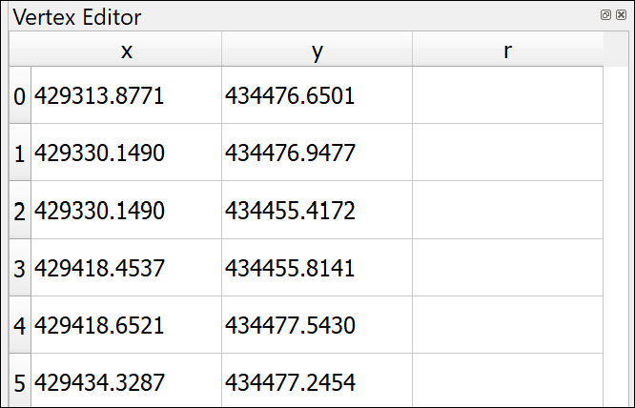

The vertex editor. It is now possible to type in new x and y coordinates for each vertex of the selected feature.

* To edit the coordinates just double-click on the coordinate that you wish to change.
* When you’ve finished editing right-click on the feature again to stop using the vertex tool.
* Don’t forget to click on Save Layer Edits
* When you have done all your edits click Toggle Edit again to stop editing.

### Deleting features

If you want to delete a feature completely you can.

* Click Toggle Edit on the toolbar (if you aren’t already editing)
* Look for Select Features by area or single click button on the toolbars (highlighted on the image of the Attributes toolbar below)



The Attributes toolbar with Select Features by area or single click highlighted.

* Click on the feature that you want to delete - it should become highlighted in bright yellow
* Press Delete on your keyboard
* Don’t forget to click on Save Layer Edits
* When you have done all your edits click Toggle Edit again to stop editing.

### Labelling features

As you added features to your buildings feature class you also added the Label attribute. You can now use this to label the building features on your map.

This section shows you how to label polygon features. The same techniques apply to labelling lines and points.

 **Labelling features in QGIS.**

This video clip can be found in the module area of [Minerva](https://minerva.leeds.ac.uk) or in the [full list of video clips](https://cgordon-gis.github.io/videoclips.htm).

* Click on the Buildings layer in the Layers pane
* Then click on the button at top left of the Layers pane to Open the Layer Styling Panel or press F7 if it isn’t already open.
* The layer styling panel should open to the right of your map.
* Click on the Label tab on the left of the panel. At the moment it will just say No labels.
* Drop down where it says No labels and select Single labels

At this stage QGIS usually just labels your features with the first field in the feature class, which at the moment is fid. This isn’t very useful so the first thing you need to do is select the correct field.

* Next to Value drop down the choices and select the Label field.

Immediately the building names that you added should appear on your map on top of the correct buildings.

The default fonts, colours and placements are not always what you want. In fact, usually just accepting the defaults is not a good idea.

* Use the settings on the first of the tabs (Text) to change the font, font size and colour

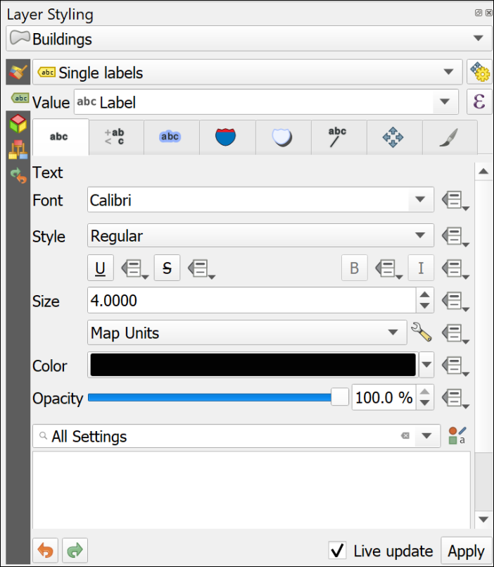

The text panel of the Layer Styling panel. Change fonts properties here.

* Click on the Placement tab and select Horizontal from the Mode dropdown list. This should move your labels to within the polygon shapes as far as possible.

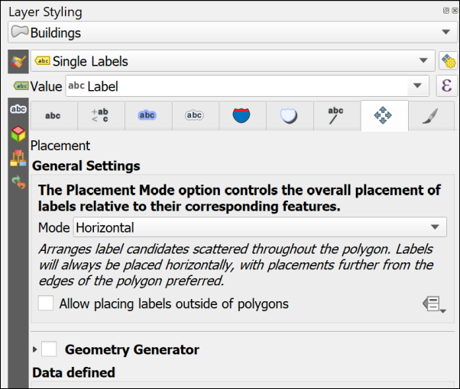

The Placement panel of the Layer Styling panel. Change placement properties here.

Feel free to try out the properties in the other tabs too. There are lots of choices to help you make your labels clear and informative.

One useful one is on the Formatting tab where it is possible to set a maximum number of characters to wrap the labels onto multiple lines.

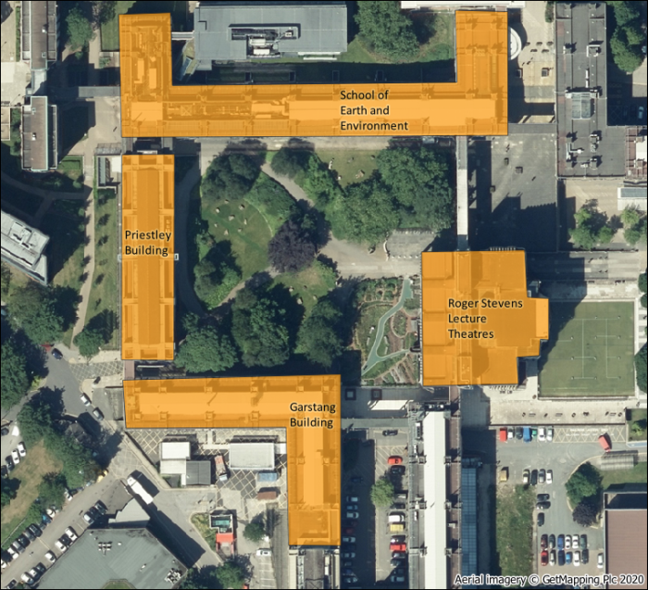

The labelled buildings. Yours will look different as you will have made your own choices.

#### More information about labelling

Labelling is a big area and I’ve only shown you the basics here. If you want to find out more try some of the following suggestions.

The books in the [Principles of Cartography section of the module reading list](http://lib5.leeds.ac.uk/rlists/broker/?bbModuleId=202122_30556_SOEE2650&bbListId=_8986148_1&s=l#Principles_of_cartography_or_How_to_draw_a_better_map_) will all have sections on labelling, but try the following in particular.

* The QGIS User Guide includes a section on [Setting a label](https://docs.qgis.org/3.16/en/docs/user_manual/style_library/label_settings.html?highlight=label) which includes all the basic settings.
* Darkes and Spence (2017) has a section on Text on maps (pages 56-59) which includes information on type sizes and styles and text placement.
* Peterson (2021). Chapter 4 (p. 79 onwards) goes into more detail and is a readable guide.

### Digitising Line features

Digitising line features is very similar to digitising polygons, except that you don’t have to finish where you started.

You should already have a Paths layer in your Layer panel. If you haven’t then drag it across from the geopackage.

Some of the paths on this map are curved rather than straight. The easiest way of drawing curved lines in QGIS is to click more often. On tight curves you do have to click a lot to make the line look curved. There are more advanced editing tools which would help, but this is only a quick overview so you can explore them if you want to, but this way of drawing is fine for now.

* Select the Paths layer, toggle editing and click on the Add line feature button
* Add lines for the paths across Chancellors Court. You don’t need to add any labels for this layer.
* Save your edits and toggle editing off.
* Style your paths in a similar way to how you styled the buildings - this time the gallery will have some suggested line styles and you can choose colours and line widths from the other panels.

#### Data quality

 **Think about data quality**

Again, think about the problems that you encounter as you edit. Do you draw the edges of the paths, or just the centre line? How can you be sure of what happens underneath trees? How easy is it to be accurate with the drawing tools? Think about the implications for future use of the map at different scales.

### Digitising Point features

Digitising point features is very similar to digitising polygons, except that you only have to click once for each point.

You should already have a Trees layer in your Layer panel. If you haven’t then drag it across from the geopackage.

* Select the Trees layer, toggle editing and click on the Add point feature button
* Add a point for each tree in Chancellors Court. You don’t need to add any labels for this layer.
* Save your edits and toggle editing off.
* Style your trees in a similar way to how you styled the buildings - this time the gallery will have some suggested point styles and you can choose colours and shapes from the other panels.

#### Data quality

 **Think about data quality**

Again, think about the problems that you encounter as you edit. How easy is it to decide where you should add a point to represent a tree? How easy is it to be accurate with the drawing tools? Think about the implications for future use of the map at different scales.

## Finally

Finish digitising the buildings around Chancellors Court, the paths across it, and the trees. Check that all the layers that you have created - the points, lines and polygons, have been symbolised appropriately and are labelled where necessary.

* Turn off the Aerial image by unticking the box next to it in the Layers panel
* If you have them, turn the symbolised waypoints layer back on
* Make sure that all the features on your digitised layers are visible in the map window.

Try creating a layout which shows your map of Chancellors Court.

In a later chapter you’ll find out how to create a full map layout with a key, scale bar, measured grid etc and print or export that properly, but for now just experiment and see what you have come up with.

When you have created a map export it to either an image or pdf and upload it to your GIS Portfolio in the Class Notebook. If you upload it within a week of the class I will provide brief feedback on your work.

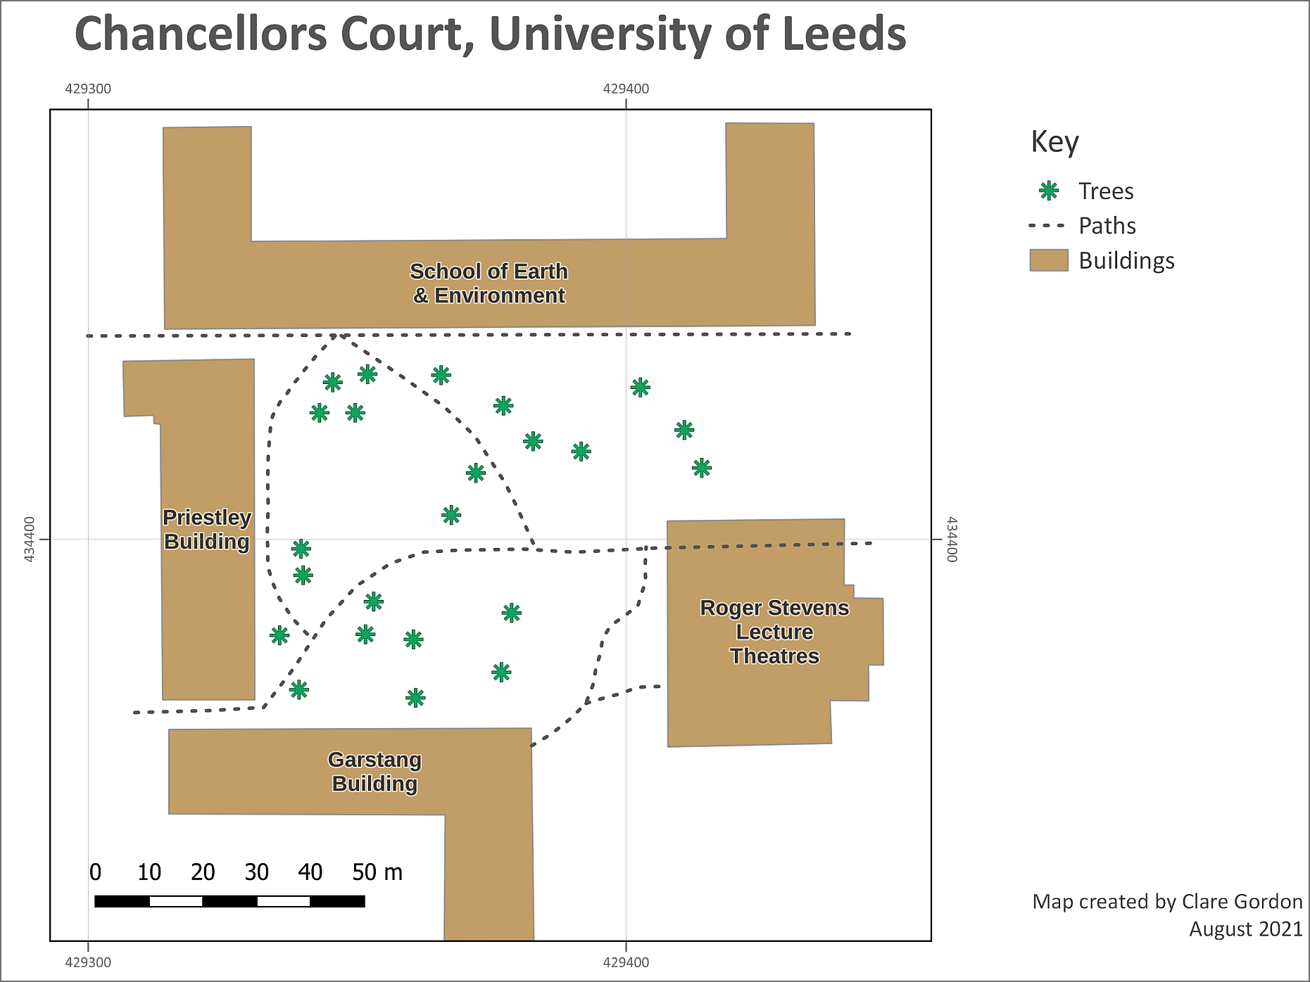

The final map exported as an image. Yours will probably look different to this as you’ll have made your own decisions about symbols and colours, and about which features to include. You may also have included the features from GPS if you have done that exercise.

## Further information and suggested reading

Many of the books in the reading list[13] have a general introduction to inputting data to GIS. Suggestions include the following:

* Chapter 5, *Data input and editing* in Heywood, I., Cornelius, S. and Carver, S. (2011), pp.135-173 covers the background to a variety of ways of inputting data to GIS and discusses data quality issues.
* Chapter 8, *Data Collection* in Longley, P.A. et al. (2015), pp.173 onwards. Again this chapter covers the background to a variety of ways of collecting data and inputting it to GIS. Section 8.3.2 from page 183 covers Vector Data Capture, or digitising.

The **QGIS Documentation** has a chapter on the techniques of [Editing](https://docs.qgis.org/3.22/en/docs/user_manual/working_with_vector/editing_geometry_attributes.html) which covers much more than we have been able to cover here.

The information about Digitising an existing layer covers the topics in this chapter, but there is plenty more there.

* [Digitising an existing layer for v. 3.22 of QGIS](https://docs.qgis.org/3.22/en/docs/user_manual/working_with_vector/editing_geometry_attributes.html#digitizing-an-existing-layer)

There are a lot of videos on [YouTube](https://www.youtube.com/) which may help you. Try searching for Digitising QGIS.

# Elevation models 1: the shape of the land

Last Modified: 16 Mar 22, 17:02:02

The background to elevation models and terrain analysis will be covered in the lecture segment at the beginning of the class, and the presentation and any other supporting materials will be available in Minerva. The lecture segment should help you to understand **why** you are doing these exercises. If you still aren’t sure, please ask [Clare](mailto:c.e.gordon@leeds.ac.uk).

## Learning outcomes

When you have completed this section of the workbook you should be able to

* describe and identify raster formats of height data used in GIS and show an awareness of vector formats
* convert downloaded height data to an appropriate format to use in GIS
* use raster models to analyse surfaces
* describe appropriate applications of height data in environmental projects

## Raster elevation models: DEM/DTM

Raster elevation models are based on pixels or grids and can include various file formats, such as ascii or tiff. They have the advantages of being easy to store and manipulate and integrate easily with other raster formats. They are the best solution for continuous surfaces as they give a smoother and more natural appearance to terrains. The main disadvantage is that the grid size is set and it isn’t possible to vary it to reflect different complexity of relief.

You will use raster elevation models for the rest of the exercises in this chapter.

 **Vector vs raster**

If you feel that you are still not clear about the difference between raster and vector GIS data it would be worth having a look at the video “[Learn more about raster and vector map data](https://youtu.be/hbOGp51nYGI)” by the Ordnance Survey.

## Data for the elevation model exercises

 **Warning**

Being able to find, download and prepare your own data is an essential part of using GIS. For the exercises in this chapter you will need to download several datasets. While these should not take too long to download and prepare, don’t leave it until the last minute. Websites can become unavailable either permanently or temporarily, or computers can crash.

If there are problems with a website then try again later. If the problems persist please get in touch with me ([c.e.gordon@leeds.ac.uk](mailto:c.e.gordon@leeds.ac.uk)) and I will try to contact the site or find an alternative source of data.

### Data required

Download the following U.K. data from the web before the class. Instructions on how to find the downloads are below the summary box.

 **Summary of data required**

**Height data** will be a DTM file - or Digital Terrain Model (sometimes alternatively called a DEM, or Digital Elevation Model). This can be downloaded from Digimap.

Tiff file for **background mapping**. You’ll also download this from Digimap.

Shapefile of **National Park boundaries** from Natural England.

An Excel file containing points and data for **hill summits in the UK** from the Database of British and Irish Hills.

Create a new folder for this project with **no spaces or unusual characters in the name** and unzip all the downloaded data to that folder.

#### Data to download from Digimap

In Digimap OS Download select data by drawing a box around the Lake District - the image below shows the approximate area.

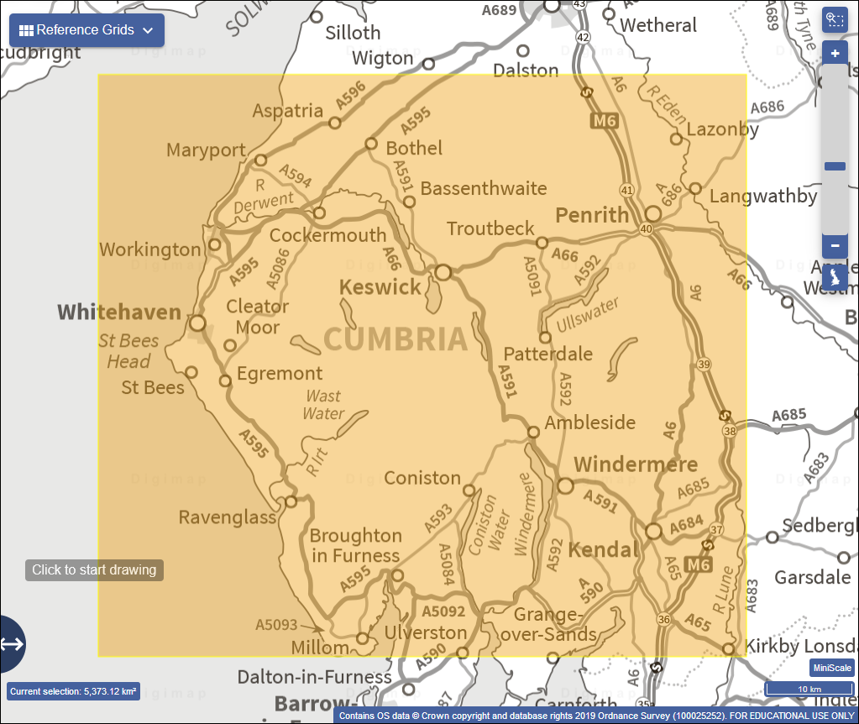

The area for which to download data for the Lake District exercises. Use OS Download to obtain this data.

Download the following layers:

* From the Backdrop mapping section download 1:50 000 Raster in tiff format
* From the Land and Height Data section download OS Terrain 50 DTM in ASC format. **Note: Please ensure that you download the correct layer - the Terrain 5 data is far too detailed for this size of area.**

#### Database of British and Irish Hills

Start by having a look at the [Database of British and Irish Hills](http://www.hills-database.co.uk/) home page. Check how the data has been collected, and what information is included in the database.

Download a zip file containing the Excel 2007+ file for British Hills from the Downloads page and unzip it to your project folder.

#### National Park Boundaries

Go to the [Natural England GIS](https://naturalengland-defra.opendata.arcgis.com/) web page.

* On that page enter National Parks in the box that says Dataset name/leave blank
* From the list of results click on National Parks (England)
* You’ll get a page which shows what the dataset looks like and which also has a Download link on the left-hand side of the map (hover over the blue bar and you’ll get tips which tell you what each button shows). Click on that and select to download shapefile format.
* It’s also a good idea to look for licence information - in this case you’ll find that by clicking on the More info button on the blue bar on the left. There is a link to View license details at the bottom of the information panel.
* You’ll download a zip file which you’ll need to unzip to your project folder.

Once you have all the data below unzipped to your project folder you are ready to start on the exercises.

## Preparing the DTM data

 **Which files need to be merged?**

Note that you do only need to merge the DTM files by following the instructions below. The other raster files that you downloaded for this exercise (1:50 000 raster) are simply background images and will not be used for further analysis. They are basically there as a picture. If you do try to mosaic these expect to end up with a very odd result! With experience you will become used to the different file formats and purposes in GIS.

The DTM files that you have downloaded are raster files in ascii text format with a file extension of .asc. [14]

Try opening one of the .asc files in a text editor [15], but don’t change anything! The image below shows the **NY03.asc** tile from the OS Terrain 50 DTM dataset.

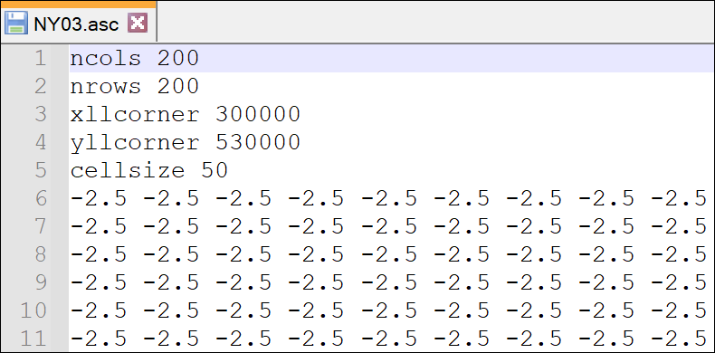

Ascii format DTM file shown in a text editor (Notepad++). The numbers in your file will more than likely be different to the ones shown here unless you have opened the same tile of data.

Note that dtm or dem data may also be delivered as .tif or .jpg tiles amongst other possible formats. You can mosaic those in exactly the same way, but won’t be able to open them in a text editor. If you want to preview them just add them to a blank map.

The five heading rows in the ascii file give QGIS information about the data contained in the rest of the file

1. number of columns - in this case 200
2. number of rows - in this case 200
3. *x* coordinate of the lower left corner in the dataset CRS - in this case 300000 on the British National Grid
4. *y* coordinate of the lower left corner in the the dataset CRS - in this case 530000 on the British National Grid
5. actual size of each cell in map units - in this case 50 metres

This is then followed by a screen full of numbers which are effectively in rows and columns, each number refers to the measurement or value at that particular grid point or cell in the file. When you view the file in GIS each of those points will be coloured according to that measurement.

### Checking the layer properties in the Browser

It’s a good idea to check the properties of your data in the Browser before you start processing it. You’ll have all the information that you need then.

 **Checking layer properties in the Browser in QGIS.**

This video clip can be found in the module area of [Minerva](https://minerva.leeds.ac.uk) or in the [full list of video clips](https://cgordon-gis.github.io/videoclips.htm).

* Open QGIS if it isn’t already open and find your dtm layers in the Browser panel
* Right-click on one of the .asc files and click on Layer Properties to open the properties window.

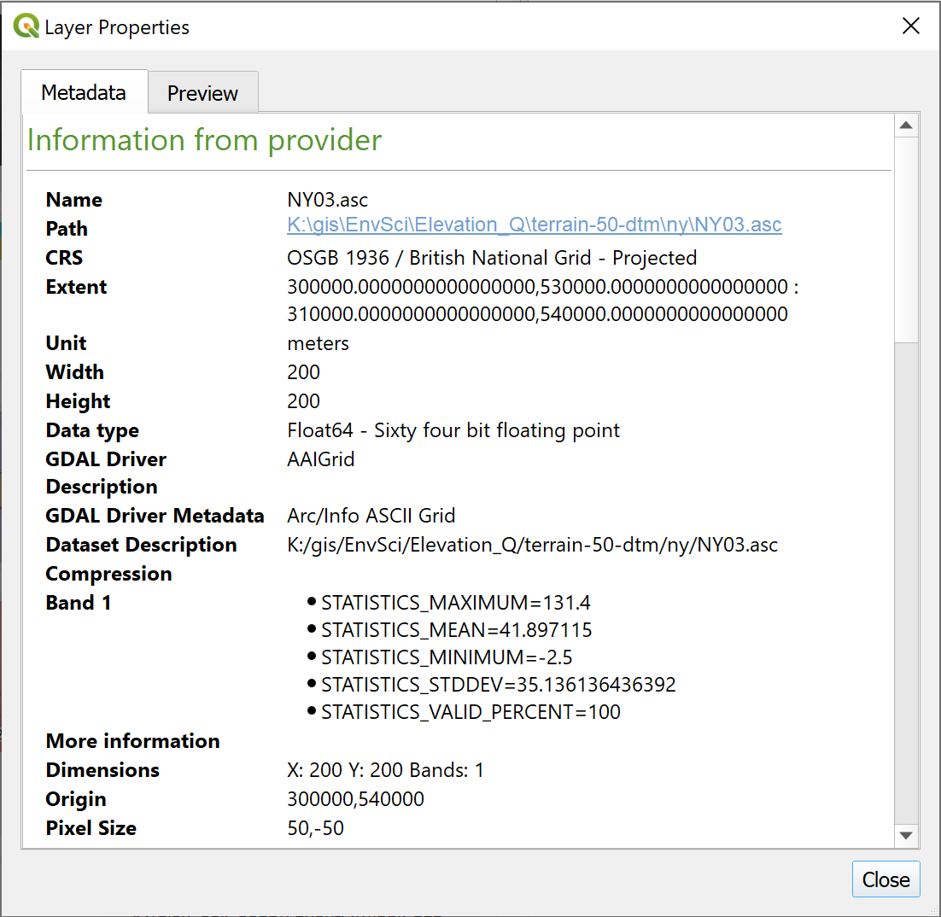

Checking the properties of NY03.asc from the QGIS Browser panel.

From the Metadata tab make a note of the following properties:

* CRS
* Unit
* Width and Height
* Data type
* Pixel size

For some projects you will also find the information under Band 1 very useful as this shows statistics such as the highest and lowest values and the mean.

The Layer Properties also has a Preview tab which can be very useful for getting a quick idea of what your data looks like.

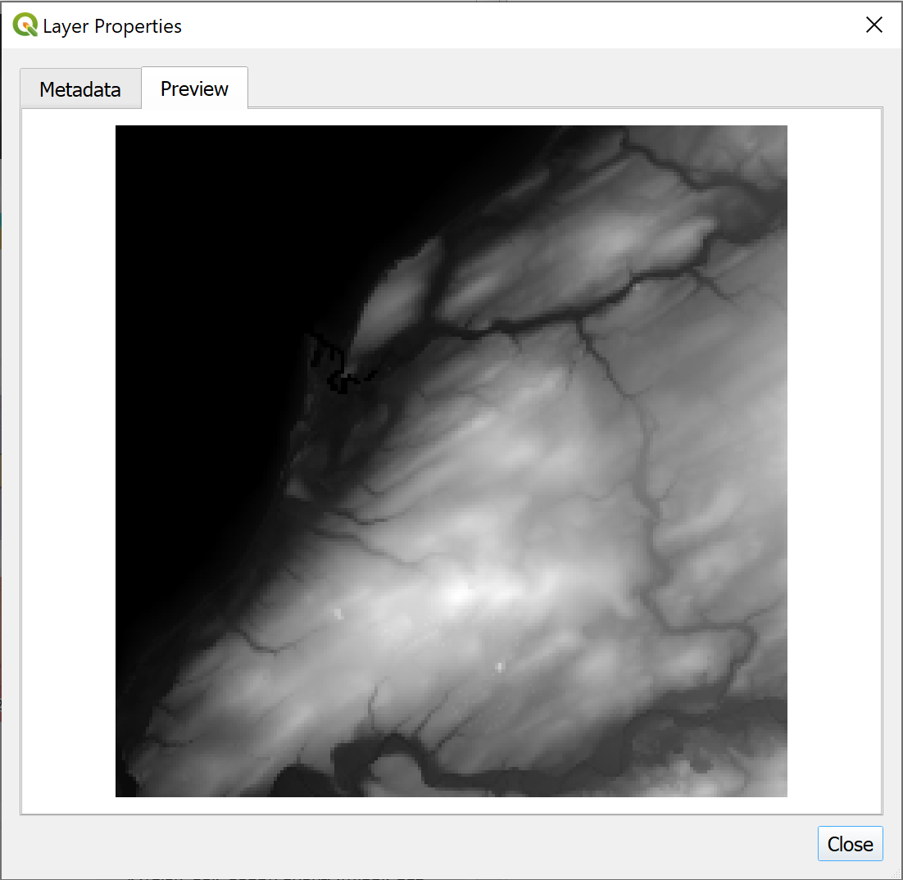

Viewing a quick preview of the tile of data in the layer properties.

* When you’ve finished looking at the properties Close the panel.

### Producing “seamless” datasets from more than one tile of data

Often data is provided as tiles, each covering a small part of the total area. That is what you have here. Before you can use this data for further analysis you will need to **merge** the tiles into one “seamless” dataset. This will make it possible to use the files as a continuous surface in maps and 3D scenes.

Note that this only applies where each tile contains data for a small part of the area. If the raster data tiles that you have all cover the same area then merging them will not work.

This will work with various formats of data, including tiff and asc.

 **Creating a seamless mosaic from multiple DEM tiles in QGIS.**

This video clip can be found in the module area of [Minerva](https://minerva.leeds.ac.uk) or in the [full list of video clips](https://cgordon-gis.github.io/videoclips.htm).

* If QGIS isn’t already open, open it now
* In the menu bar go to Raster > Miscellaneous > Merge
  + Click on the three dots button at the end of the Input Layers line
  + Then click on the Add File(s) button
  + Navigate to where you saved the DEM tiles (probably in a folder called terrain-50-dtm or similar) and add all the .asc files in the folder. You’ll need to go into subfolders, such as nx, ny and sd to find the .asc files. These refer to the 100 km grid squares so you will probably have multiple subfolders to include files from. You can select more than one file at once by using the Ctrl key.
  + Once you have all the files added click OK to go back to the form
  + The Output data type needs to match the data type of the input - you should have found that from the Layer Properties. For the Terrain 50 DTM it will be Float64
  + Click on the three dots button at the end of the Merged field and click on Save to file...
  + choose where to save the output, and give it a name which means something to you. For example, save it in a folder called output under the project folder and call it something like T50_dtm - remember no spaces and apart from the underscore, no odd characters.
  + Check that Open output file after running algorithm is ticked
* Click on Run

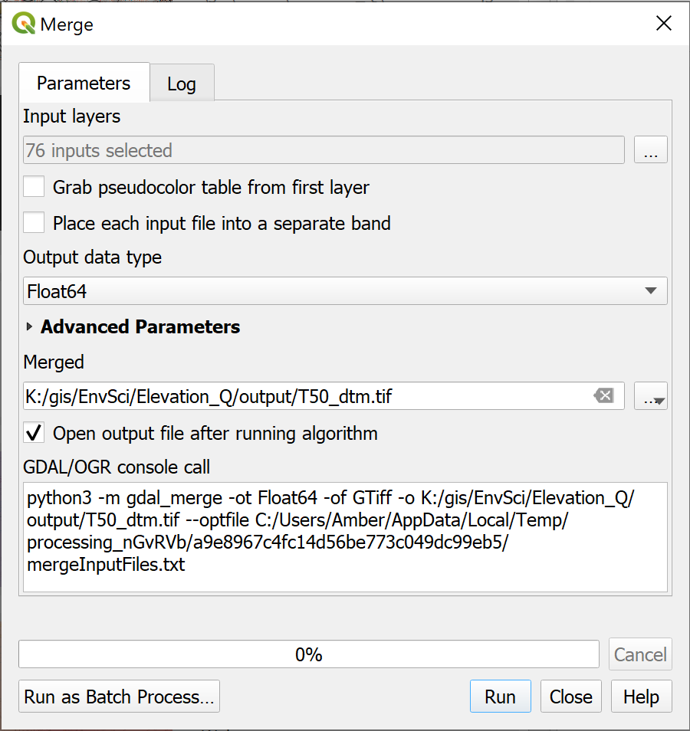

Filling in the form to Merge multiple raster tiles. Note that the details for your data may be different to those shown here, in particular check the data type - this is crucial to running the tool successfully. Remember to include all your input rasters - they may be split across multiple folders.

If the tool runs successfully you should find that you have a map with a greyscale height map of the Lake District.

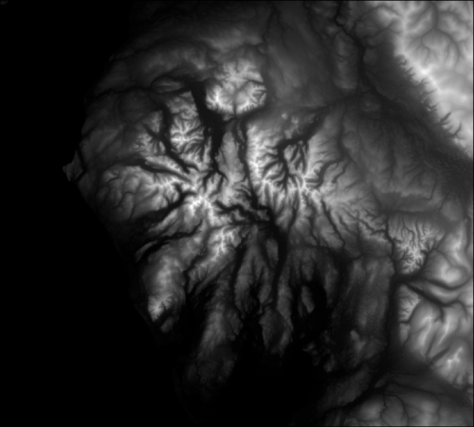

The output map made by merging all the individual tiles of data. note that yours may not look identical to this one as it may cover a different area.

### Setting the CRS of your data

It isn’t possible to set the CRS as part of the Merge command so once you’ve run that tool the first thing you should do is check the layer CRS.

#### Assigning the correct CRS

When I did that with the Terrain 50 dtm data I found that the layer CRS was OSGB 1936 / British National Grid - Projected. When I added the layer to a blank map the project CRS shown in the bottom right of the map was Unknown CRS.

So the Terrain 50 data is in British National Grid, but not a version that QGIS recognises.

If your data has the same problem, or doesn’t have a CRS, the way to deal with this is to assign the correct version of British National Grid using the version that starts with EPSG:27700.

Once you’ve assigned the correct CRS, if you have already added the layer to your map, you’ll need to set the Project CRS correctly using the Project properties.

#### Changing the CRS

If you need to change the CRS of your data, for example if you have height data in EPSG:4326 WGS 1984 and want your final map to be in EPSG:27700 British National Grid then reproject your merged layer into the new CRS.

## Displaying height data

In the previous section you merged multiple dtm tiles to make a single layer. You can now start using this data to create a map.

* Open QGIS if it isn’t already open
* Add your merged layer to a new blank map and check that the project CRS is set correctly
* Save your map as a .qgz file in your project folder

You should now have a map with a black and white elevation model of the Lake District. If you look at the symbology by opening the Layer Styling panel you will see that the layer is using Singleband gray styling. We can change this to make the elevation more obvious.

 **Styling a DTM in QGIS.**

This video clip can be found in the module area of [Minerva](https://minerva.leeds.ac.uk) or in the [full list of video clips](https://cgordon-gis.github.io/videoclips.htm).

* In the Layer Styling panel drop down where it says Singleband gray and select Singleband pseudocolor. The choices in the styling panel will change.
* Drop down the Min / Max Value Settings subheading and make sure that Min / max is selected, then set Accuracy to Actual (slower)
* Interpolation should be Linear
* Then click on the down arrow next to the Color ramp. You have a small choice of colour ramps here, but to find a bigger selection click on Create new color ramp...
* In the Color ramp type select Catalog: cpt-city and click OK to get a much bigger selection.
* Have a look at the colour ramps that are available, but then click on the Topography sub heading
* Select either cd-a or sd-a then on OK
* Your map will probably look a bit strange at this point, but now click on the Classify button
* It is a good idea to add the Label unit suffix to appear in the legend - in this case the height is in metres so type a space then m in the box
* You can really clean up your legend by setting Label precision to 0, but do think about the effect this might have on accuracy.

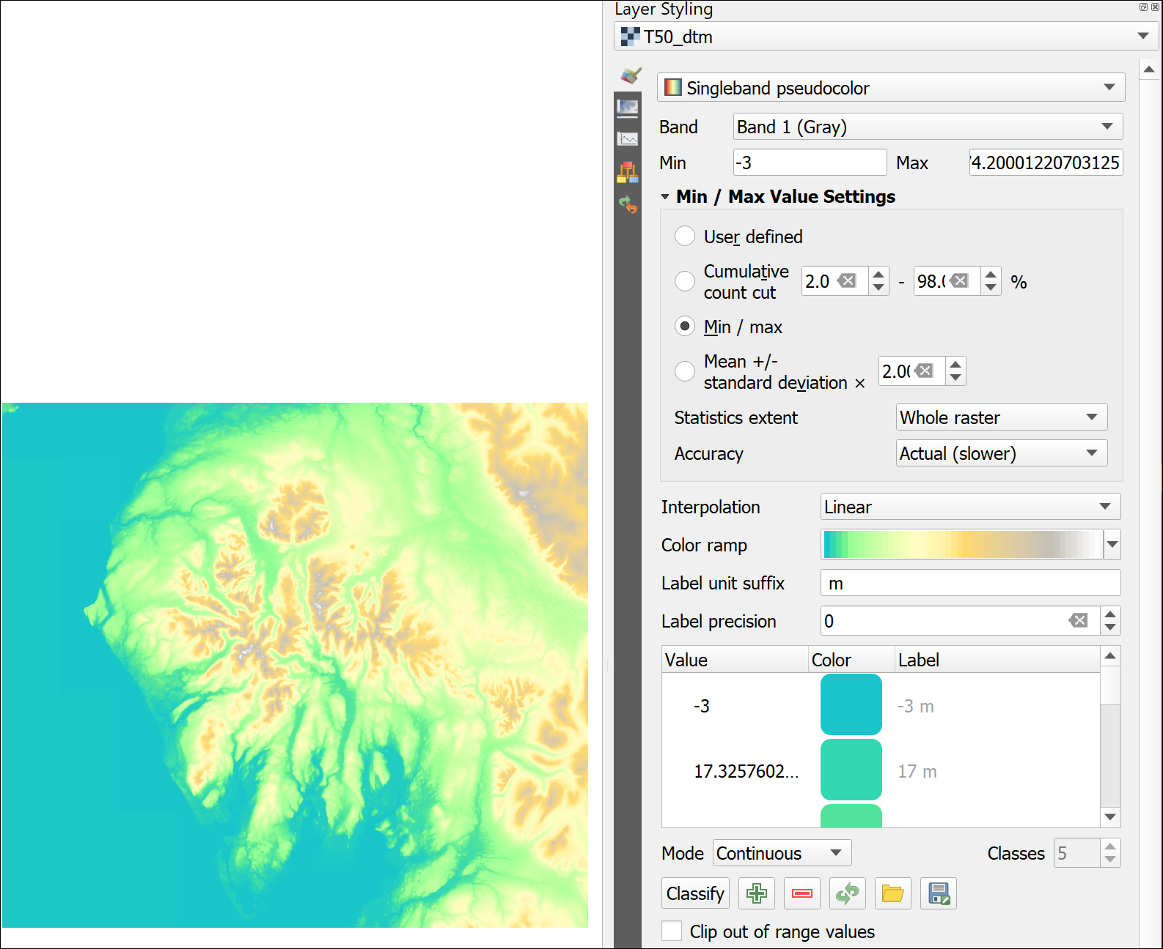

The settings and resulting map for an elevation colour ramp.

You can try out some of the other colour ramps or settings and see what effect those have on your map.

If you were using this map for a report or similar you would want to ensure that the tidal water areas were a darker blue and it was more obvious where the edge of the land was. You could do this by altering the colour ramp, or by using a vector tidal water layer over the raster height map.

### Hillshade

The DTM as it is now gives you a reasonable idea of the topography of the area when you look at it, but if you want a clearer view for including in a layer or want to give an idea of the topography on top of another map then you can create a **hillshade** layer.

 **Hillshade, slope and aspect in QGIS.**

This video clip can be found in the module area of [Minerva](https://minerva.leeds.ac.uk) or in the [full list of video clips](https://cgordon-gis.github.io/videoclips.htm).

* Make sure that your merged DTM layer is open in a map in QGIS
* On the menu bar go to Raster > Analysis > Hillshade...
* In the form that opens set the Input layer to your dtm layer
* Leave most of the parameters as the default - you can experiment with these when you’ve seen what the tool will do
* Click on the three dots button at the end of the Hillshade line and click on Save to file....
* Browse to the folder you want to save the output to and give it a name that will tell you what the layer shows, e.g. T50_hsh (short, with no spaces and no odd characters except an underscore).
* Click on Run

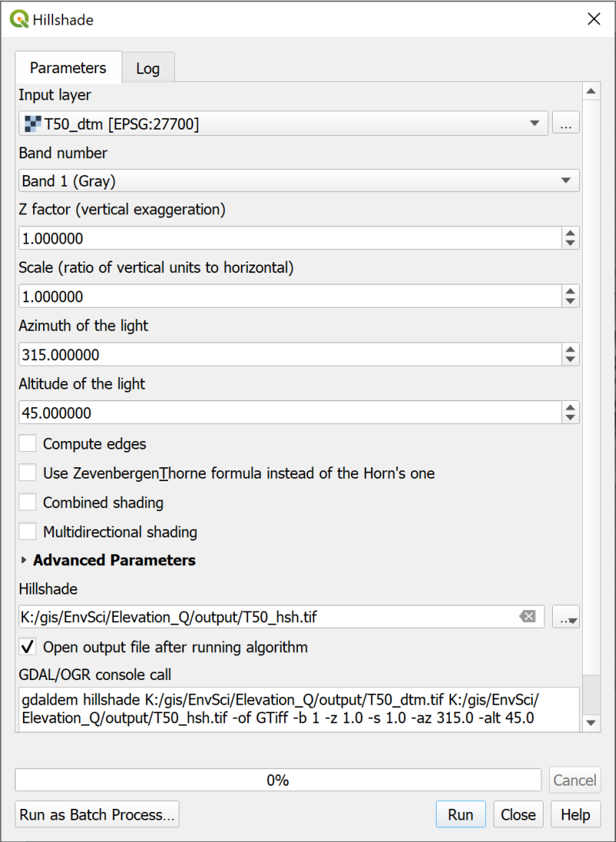

Filling in the hillshade form.

The layer that’s added to your map should look something like the one below - though your area may be different.

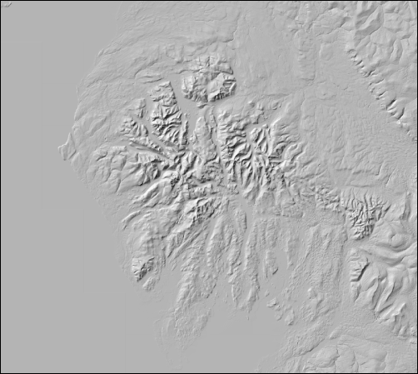

The resulting hillshade layer.

This can be a useful way of checking that your elevation layer (dtm) is correct. Sometimes a hillshade shows if there is something wrong more clearly than if you just look at the dtm. In this case the resulting layer looks absolutely fine.

Zoom in and out and pan around the hillshade layer. The resolution of this data is 50 m horizontally, which means that each pixel is 50 x 50 m, so it does start looking pixellated rather quickly. For this size of area that is fine - if you use data that is too detailed you will be dealing with very large datasets.

Have a look at the Layers panel too. Notice that the hillshade values run from 1 to 255. This is a greyscale raster layer with 255 colours. It is in effect a picture which shows what the shadows on the surface of the land could look like.

### Creating a colour relief image

You won’t be using the hillshade layer in further analysis but can improve the look of the DTM by using it.

 **Creating a colour relief image in QGIS**

This video clip can be found in the module area of [Minerva](https://minerva.leeds.ac.uk) or in the [full list of video clips](https://cgordon-gis.github.io/videoclips.htm).

* Move the hillshade layer to below the dtm in the Layers panel
* Select the dtm and open the Layer styling panel
* Go down to the Layer Rendering section and drop down the Blending mode box.
* You have several choices there, try some of them to see what effect they have on your map.
* When you’ve experimented leave the Blending mode as Multiply

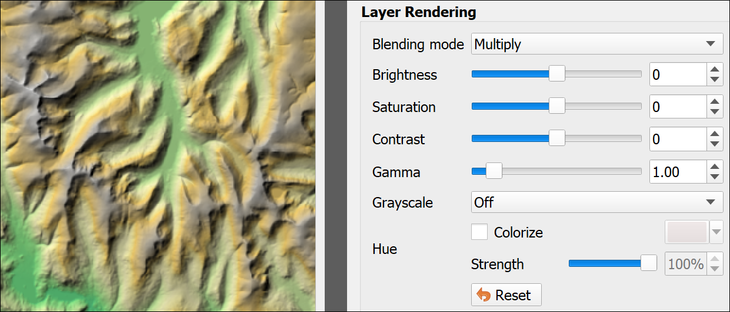

Setting the Blending Mode to Multiply on the DTM so that the hillshade emphasises the relief.

Blending modes “mix” the colours of the layers to produce different effects. In the case of multiply the greyscale of the hillshade emphasises the relief of the DTM very effectively. You can find more ideas for using blending modes in a [blog article by HelenMakesMaps](https://www.helenmakesmaps.com/post/how-to-use-blending-modes-in-mapping) [16]. The map shown in the image above is the same as the one shown next to the Layer Styling panel in the section on Displaying height data.

## Adding raster background data

As well as the height data you should have downloaded a 1:50 000 raster tif layer from Digimap. This is background data. You can open it in an image viewer and would be able to see a map that looks identical to the paper maps that you can buy. We’ll use this as a background layer for the other data - it’s detailed enough to see hill names etc.

* In the Browser find the 1:50 000 raster data that you downloaded and unzipped and just drag and drop it into the Layers panel. You should have files to add from multiple folders.
* You may want to group the layers as there are rather a lot of them. You can then “fold” the group and it won’t get in the way!
* Make sure that this group is above the dtm in the Layers panel. You can make the dtm invisible now if you wish to.
* The raster layers will have the symbol next to them in the Layers panel which indicates that the CRS is not set correctly. You could reproject all of them, but as these are not going to be directly involved in analysis, but are just a background layer, and as they appear to be in the correct location, you don’t need to worry about reprojecting them this time.

### Using QuickMapServices background maps

You could if you like use one of the QuickMapServices background maps instead of the OS data.

These are very useful backgrounds, but I found that it slowed my map down and didn’t always draw correctly. Feel free to try some of the layers out, but if your map starts slowing down too much you may just have to remove them from the Layers panel.

 **Warning**

If you do use one of these layers, please remember not to try reprojecting it to match the rest of the data in your map. This layer will only be used for display, and allowing QGIS to apply on-the-fly transformation is absolutely fine. Trying to reproject QMS layers may just cause problems with the CRS of layers that you do want to use for analysis.

## Deriving new layers from height data

Once you have a height layer in QGIS you can start to use it to derive other datasets. We’ll look at a few examples here and see how they can be used for display and analysis.

For this section let’s assume that you are setting up a study of a particular plant which prefers to grow on south facing slopes (that is, have a south-facing aspect). For safety reasons during fieldwork the study area should not be more than a 15 degree slope. We’ll use the QGIS **slope** and **aspect** tools to generate two separate raster files showing possible areas.

### Slope

The slope tool returns a raster where each pixel shows the rate of maximum change in z-value (height) from each cell.

 **Hillshade, slope and aspect in QGIS.**

This video clip can be found in the module area of [Minerva](https://minerva.leeds.ac.uk) or in the [full list of video clips](https://cgordon-gis.github.io/videoclips.htm).

* From the menu bar go to Raster > Analysis > Slope...
* The Input layer should be your DTM - double-check that you haven’t used the hillshade by mistake.
* Click on the three dots button at the end of the Slope line and click on Save to file....
* Browse to the folder you want to save the output to and give it a name that will tell you what the layer shows, e.g. T50_slope (short, with no spaces and no odd characters except an underscore).
* Click on Run

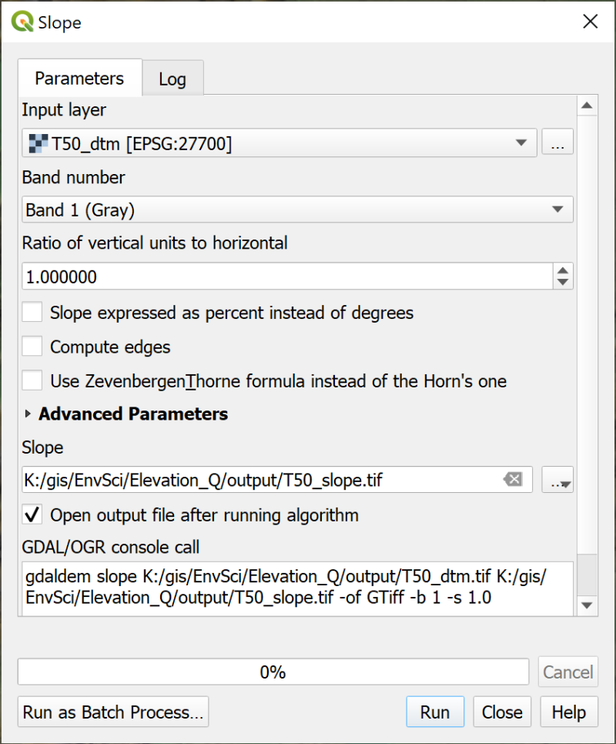

Filling in the form for the Slope tool.

The result will look rather strange, but is a raster file with each pixel having a degree measurement. As usual, zoom and pan to have a good look at the result. Have a look at the layer in the Layers panel. That will show you that the darkest colours are the flattest areas and the whitest are the highest slopes. Does that help you to make sense of it?

Try using the Identify Features tool to look at the values in this layer in more detail.

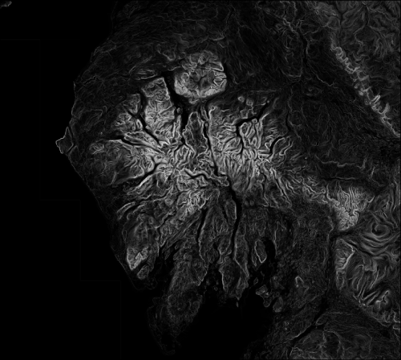

The output of the slope tool. The black areas are the flattest, the white are the steepest.

### Reclassifying a raster

The layer doesn’t show you clearly which areas have a slope of 15 degrees or less, but you can **reclassify** the layer to show this.

 **Reclassifying rasters in QGIS: by changing symbology.**

This video clip can be found in the module area of [Minerva](https://minerva.leeds.ac.uk) or in the [full list of video clips](https://cgordon-gis.github.io/videoclips.htm).

* Select your slope layer in the Layers panel and open the Layer Styling Panel.
* Change the dropdown on the Symbology tab from Singleband gray to Singleband pseudocolor - the layer will probably disappear from the map at this stage
* Change the Interpolation setting to Discrete
* Click on the Classify button below to ensure some classes appear - it doesn’t matter what those are at the moment as we’ll be changing them.
* Change the Mode to Equal Interval - this then allows you to change the number of Classes to 2. We’re trying to set values for either below 15 or above 15 so that gives us two classes.

Have a look at the values for the classes that QGIS has chosen. You can change these manually.

* Under the Value <= heading double-click on the first number and change it to the value for the **top** of the class you want to create. In this case we’re looking for values less than or equal to 15, so enter 15.
* The second band is set to infinity. You can leave that as it is in this case.

Now that you have set up the two classes you can edit the colour patches so that areas with a slope of above 15 degrees are transparent.

* Double-click on the colour patch next to inf
* Set the Opacity slider from the bottom of the colour choices to 0
* Then use the back arrow at the top of the panel to return to the original dialog
* By double clicking on the colour patch next to 15 you can change the colour of that class if you wish and make it partly opaque / transparent.

I found that values below 15 also include flat lakes and the sea, so to get rid of those I clicked on the plus button to create another class and set the class bands as below

* <= 0.2
* 15
* inf

Then I made the <= 2.0 and inf classes transparent. This made a clearer map with this data.

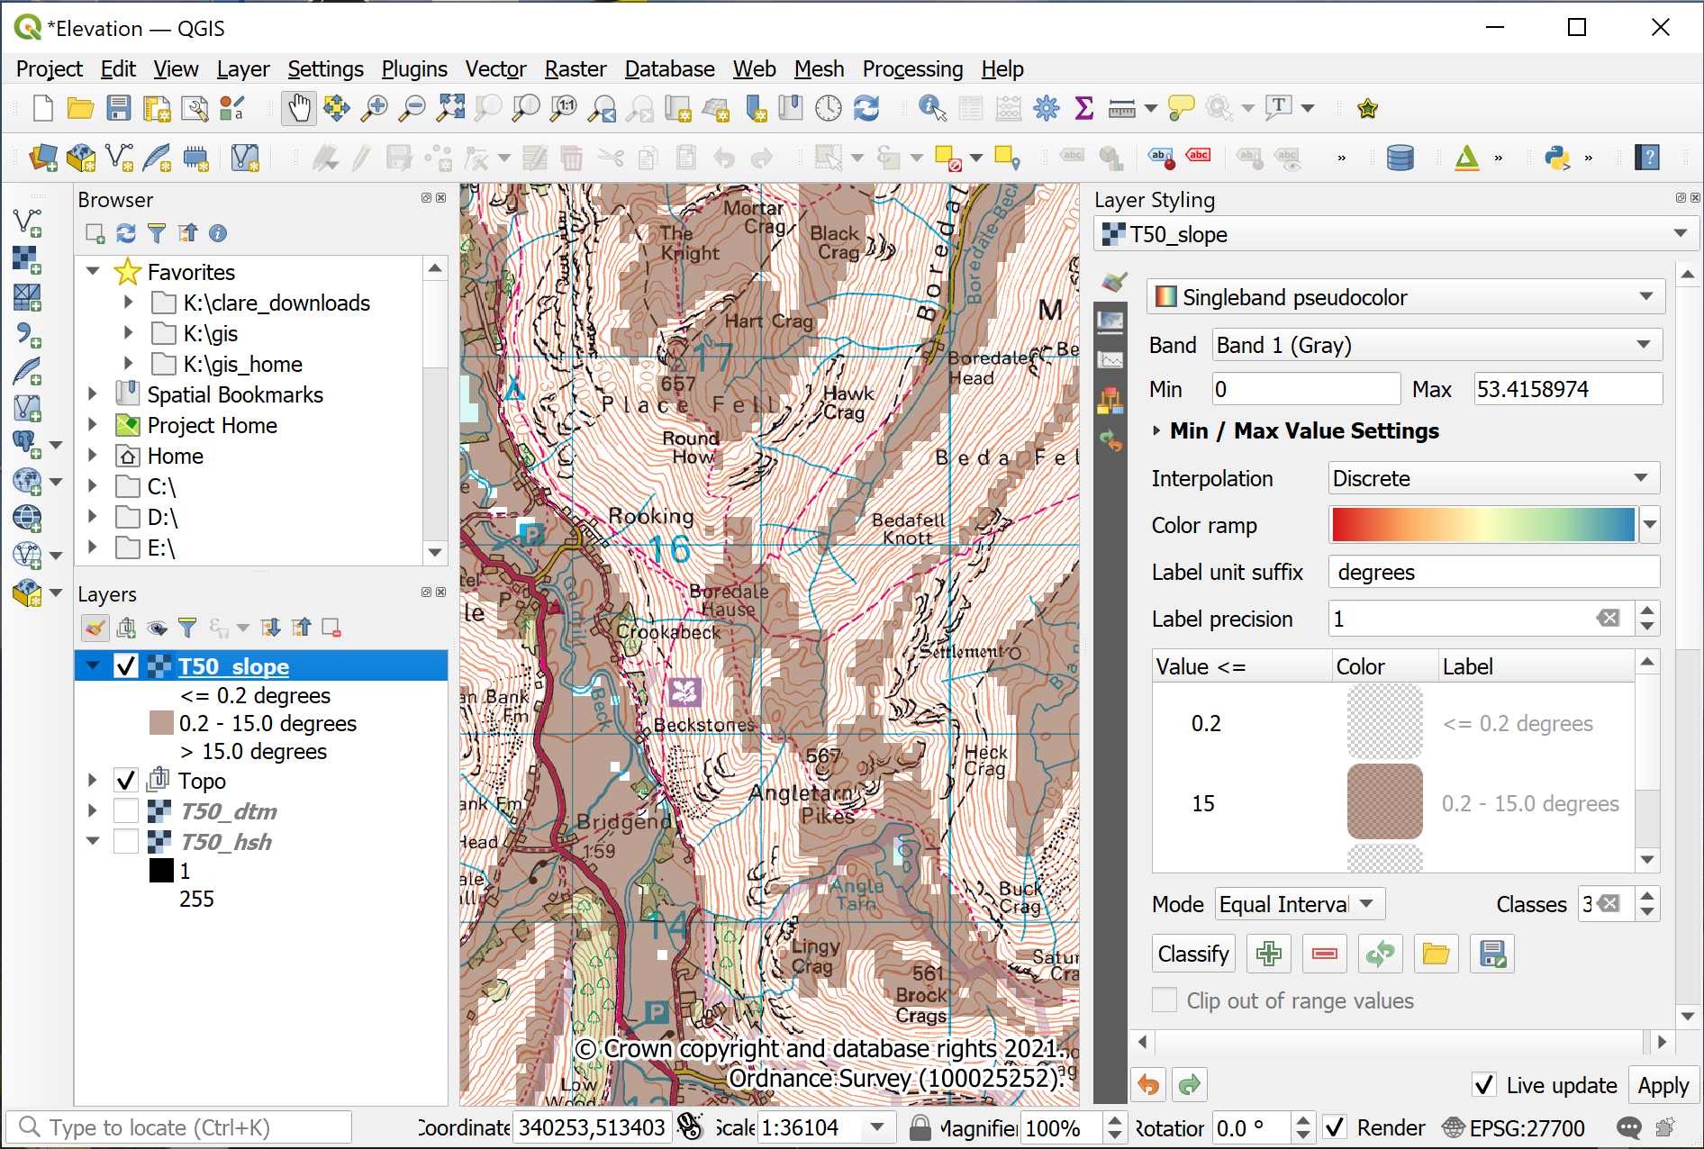

The slope raster, showing the settings in the Layer Styling panel and how the layer looks on the map and in the Layers Panel. The areas of the map with a slope of 15 degrees or less are shown in brown.

 **Checking the slope layer**

Zoom in to your map and check that the slope layer is correctly classified. The areas with the densest contour lines should be clear and the areas where contours are further apart should be shown in the slope raster colour.

If it doesn’t look right can you alter the classes so that it does?

### Aspect

The Aspect tool works in a very similar way to slope, but this time you’ll finish with a raster coloured according to the direction that the slope faces - from north, round 360 degrees back to north. Remember that you are particularly looking for south-facing slopes.

 **Hillshade, slope and aspect in QGIS.**

This video clip can be found in the module area of [Minerva](https://minerva.leeds.ac.uk) or in the [full list of video clips](https://cgordon-gis.github.io/videoclips.htm).

* Raster > Analysis > Aspect...
* Fill in the Input layer, being very careful not to select the slope or hillshade rather than the dtm!
* As usual for output, browse to where you want to save the output, then give it a name which will remind you what the layer shows.

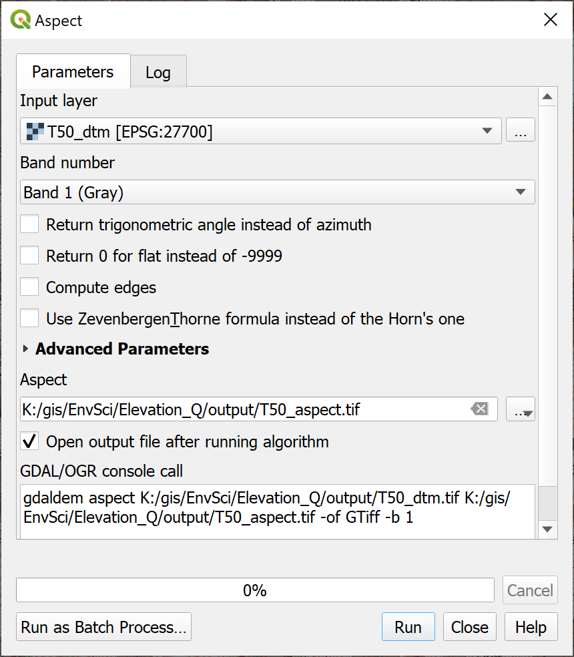

Filling in the form to generate an aspect raster from the dtm.

Again, the result will look rather strange, but have a closer look at it.

* North = zero degrees on the compass and is coloured black
* Then there is a colour gradient clockwise around the compass points to white at 360 degrees.

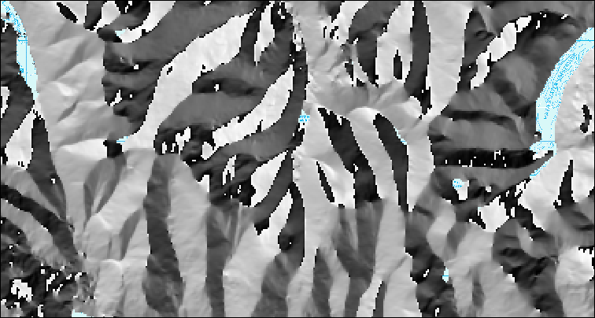

Part of the aspect raster covering the Lake District.

 **Reclassifying the aspect raster**

Have a look at the result and have a go at symbolising it by reclassifying the raster so that only the slopes that face generally south are coloured. Leave all the others transparent.

You don’t need to be too exact, but you could assume that suitable slopes are those between 160 and 200 degrees.

## Adding xy point data to a map

For the next set of exercises it will be useful to have a layer showing the hill summits in the Lake District. In the data preparation section you should have downloaded an xlsx (Excel) file containing a list of summits of British and Irish hills. This spreadsheet file is a form of xyz file in that for each record it includes *x* and *y* location data in the form of eastings and northings of the British National Grid. This means it can be imported into QGIS and mapped.

Start by opening the unzipped .xlsx file of the Database of British and Irish Hills in a spreadsheet program such as Excel, LibreOffice or OpenOffice Calc, Google Sheets or Pages. You’ll probably need to import it.

To be able to use this data in QGIS you will need to make some minor changes.

* If you want to save processing time you can delete a lot of the columns as you’ll only need a few of them. If you do this, make sure that you **keep** the following:
  + Number
  + Name
  + Metres
  + Xcoord
  + Ycoord
* The column headings need to be short - 8 characters or less - and to have no punctuation or spaces. If you have deleted all except the columns above this isn’t a problem, but if you still have fields such as Parent (SMC) or Section name you’ll need to rename them.

Now Save or Export the spreadsheet file to your disk (the command will depend on the app you are using) - it won’t work if you keep it in Google Drive or OneDrive. I usually make sure I give the resulting file a new name so that I can go back to the original if necessary.

### Installing a QGIS plugin

One of the strengths of QGIS is that it has a wide variety of plugins that you can install to carry out extra tasks. It’s worth having a look at the list of plugins available to you in the plugin manager.

 **Installing plugins in QGIS**

This video clip can be found in the module area of [Minerva](https://minerva.leeds.ac.uk) or in the [full list of video clips](https://cgordon-gis.github.io/videoclips.htm).

* In the menu bar go to Plugins > Manage And Install Plugins...
* When it opens click on the Installed heading on the left to see the plugins that are already installed.
* If you click on a plugin you’ll be able to see a bit about it in the panel on the right.



The plugin manager showing the core plugins that are installed when you install QGIS. Your list will probably be different to mine.

To install a new plugin:

* Click on Not installed on the left
* Type Spreadsheet into the search box at the top
* From the list that appears click on Spreadsheet Layers and have a look at the description
* This plugin will do what you want it to do so click on Install Plugin

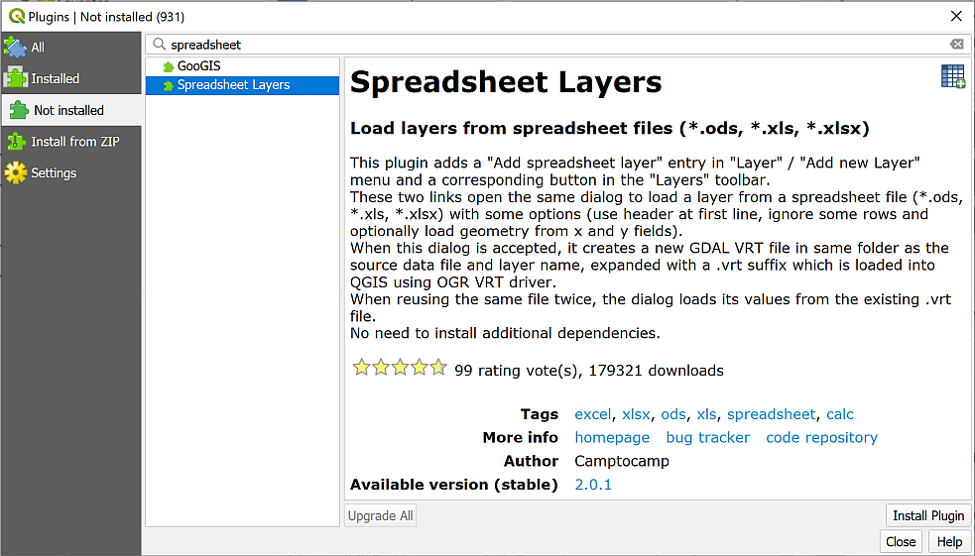

Installing the Spreadsheet Layers plugin.

Once it has installed you should get a message at the top telling you it has been successful, and Spreadsheet Layers should now be in the list of Installed plugins.

* You can Close the plugin manager now.
* If you can’t see the Manage Layers toolbar (see image below) make it visible by going to View > Toolbars and putting a tick in the box next to Manage Layers toolbar. It will probably open vertically to the left of your Layers and Browser panels.
* You should gain a new button in the Manage Layers toolbar - hover over it to see the tooltip which should say “Add spreadsheet layer”.



The Manage Layers toolbar showing the new button for Add spreadsheet layer.

### Converting a spreadsheet to a feature class

Before you can use the data from a spreadsheet file (e.g. csv or excel) in QGIS you need to import it then save it as a feature class.

If you add the file to QGIS as it is you won’t be able to view it on a map - though you can see the grid references these currently don’t mean anything to QGIS. To be able to view the data on a map you need to convert the table to a feature class. As part of this process you’ll be telling QGIS where to find the grid reference of each point so that it can place it on the map.

* If your Lake District map isn’t already open in QGIS, open it now.
* Tidy up your layers by removing the slope and aspect layers that you created in the previous section.

 **Importing points from csv or spreadsheet to QGIS with the Spreadsheet Layers plugin**

This video clip can be found in the module area of [Minerva](https://minerva.leeds.ac.uk) or in the [full list of video clips](https://cgordon-gis.github.io/videoclips.htm).

To convert the spreadsheet so that you can use it in QGIS:

* Click on the Add spreadsheet layer button to open the dialog. Start filling it in by browsing for your spreadsheet file using the button to the right of File Name.
* Check that Sheet is set to the spreadsheet which holds the hill data - in this case hills.
* Type a new name for your output layer next to Layer name, e.g. Hills. It needs to be something which will tell you what the layer shows so that you can remember later.
* Make sure that there is a tick in the box next to Geometry and select the x and y fields as appropriate - in this case x = Xcoord and y = Ycoord.
* Set the Reference system to the correct CRS. This time it will be the same as the current project - EPSG:27700 - OSGB36 / British National Grid.
* Check the data types in the preview pane. You shouldn’t need to change any of these this time.
* Check that the table previewed below the form looks correct - the data should look the same as it did in the spreadsheet you are importing.
* Then click OK.

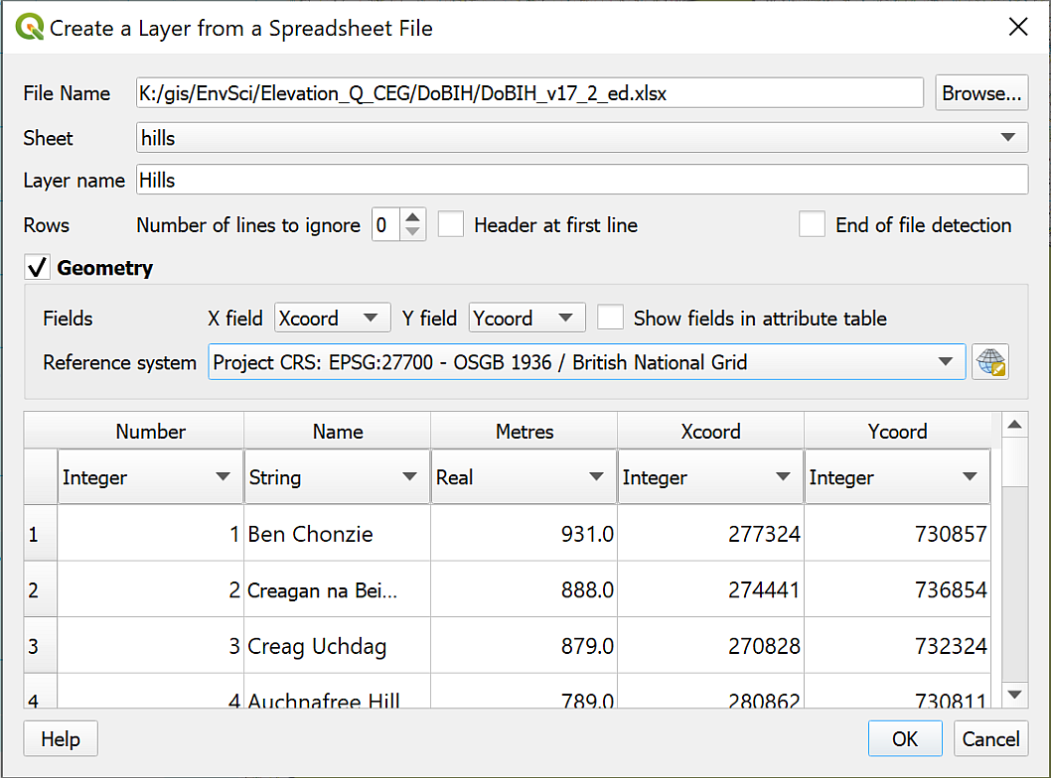

Creating a layer from a spreadsheet.

Lots of points should appear on your map. If you Zoom to layer you should be able to see that these cover the whole of the UK, plus a few outliers to the north.

So far these points will have been saved as a virtual format file with an extension of .vrt, not in a proper GIS format so we’ll need to export the data to a geopackage.

We are only interested in summits within the Lake District National Park, so it makes sense to limit our analysis accordingly as this will save time and storage. It’s possible to do this in the same operation as exporting the points to a GIS format.

### Selecting data in the attribute table

We’ll need to start by selecting the points that we wish to keep.

* You should have downloaded and unzipped a shapefile containing the boundaries of National Parks in England from the Natural England web page.
* Add the National Park shapefile to your map and zoom to layer.

This shapefile contains polygons for all UK National Parks so it will be a good idea to extract the Lake District National Park and remove the rest from the map. It will save confusion later.

* Start by clearing any previous selections - on the tool bar Deselect Features from all Layers
* Right-click on the layer containing the National Parks in the Layers panel and open the Attribute Table
* In the attribute table click on the little grey box on the left-hand side of the row for the LAKE DISTRICT to select it
* The Lake District National Park polygon should be picked out in the attribute table and also on the map.
* Close the attribute table - the polygon on the map should stay selected

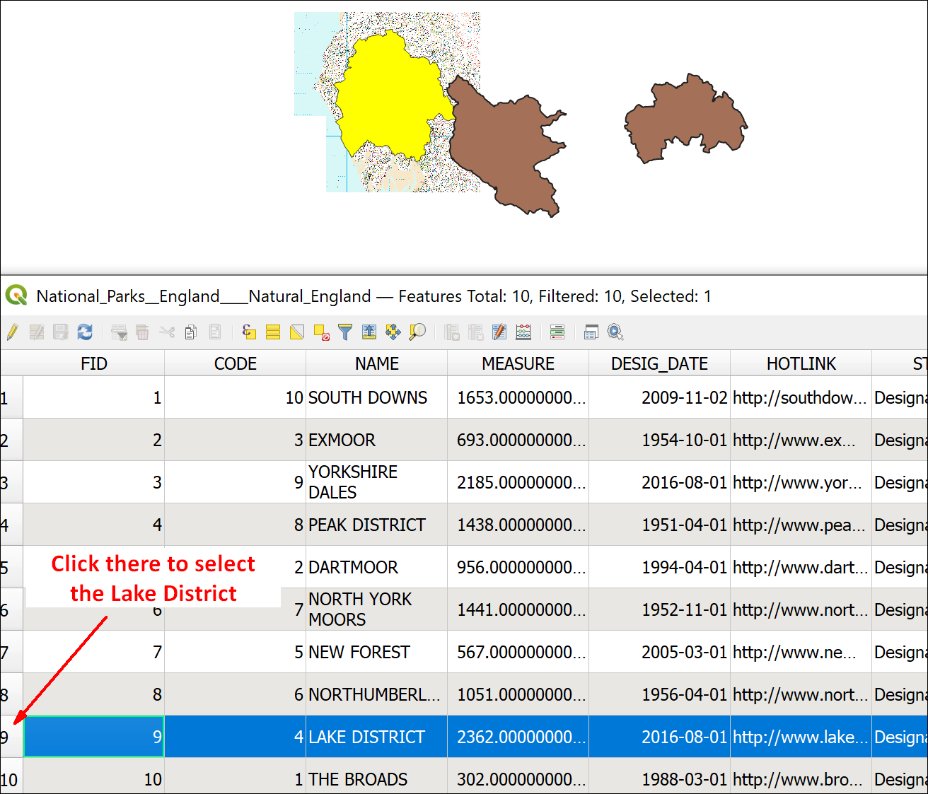

Selecting the Lake District polygon in the attribute table - note how it is highlighted on the map too.

#### Saving a selection to a new feature class

Now that you have the Lake District selected you can export it to a new feature class.

* Right-click on the layer that contains the selected features - the National parks layer in this case
* Export > Save selected features as...
  + Set the Format to GeoPackage
  + Next to File name browse to where you want to save your data then give the new geopackage a name, such as LakeDistrict for the area you are working in.
  + Next to Layer name give your new layer a name that will tell you what that data is
  + Check the CRS is British National Grid
  + Check that Save only selected features is ticked
  + Check that Add saved file to map is ticked
* Then click OK

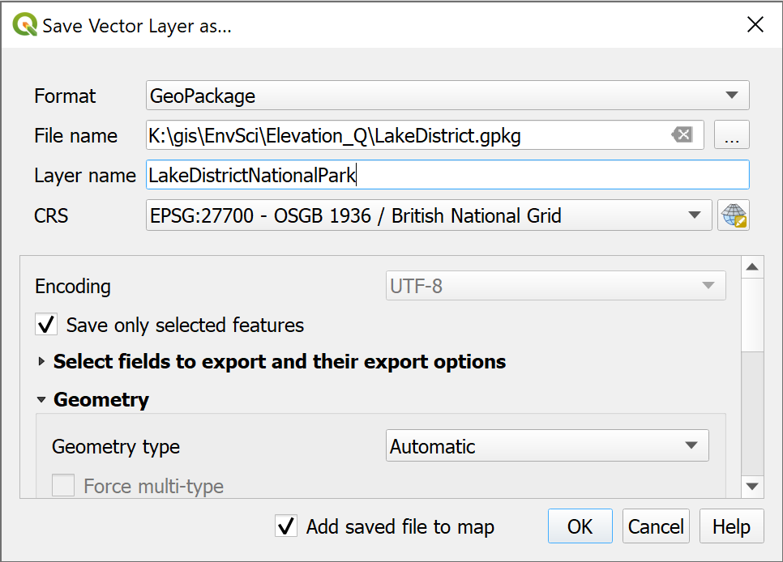

Saving the selected features to a new feature class in a geopackage.

You should get a new feature class added to your map and Layers panel which only contains the polygon for the Lake District National Park. You can remove the National Parks layer from the Layers panel now.

* Zoom to layer on the Lake District National Park
* Style the layer so that the national park has a visible outline, but no fill.

### Select by location

Now you are set up to be able to restrict the summit points to only those within the Lake District National Park.

To restrict the points you need to use Select to Location as you did in the introductory chapter.

 **Select by Location in QGIS.**

This video clip can be found in the module area of [Minerva](https://minerva.leeds.ac.uk) or in the [full list of video clips](https://cgordon-gis.github.io/videoclips.htm).

* Start by clearing any previous selections - on the tool bar Deselect Features from all Layers
* Either click on Select by Location on the toolbar, or go to Vector > Research Tools > Select by Location.
  + Drop down Select features from and select your Hill summits features
  + For Where the features check that intersect is ticked
  + By comparing to the features from should be the feature class containing the Lake District National Park.
  + Set Modify current selection by to creating new selection
* Click on Run then Close

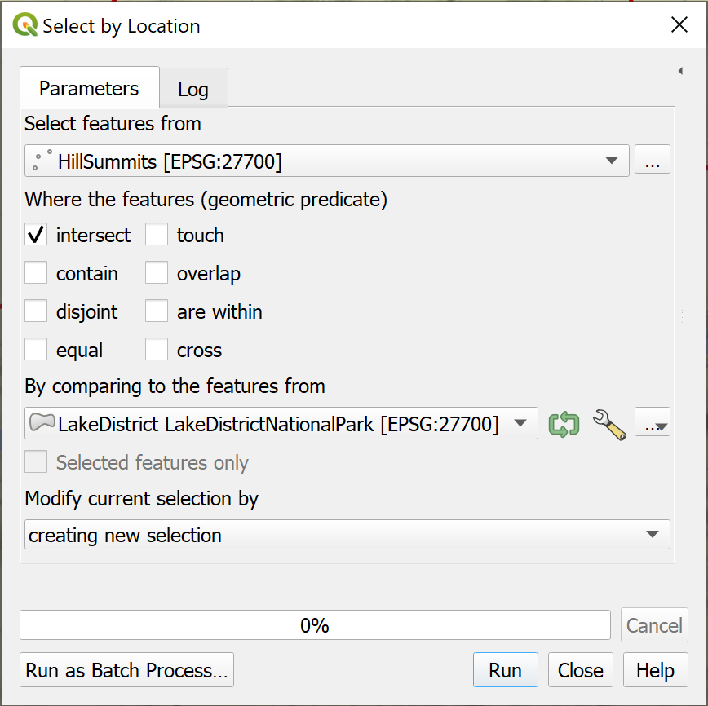

Using Select by Location to select summits within the Lake District National Park.

The tool should run and select just those points within the feature that you used as input. If you look at your map you should be able to see that the points within the Lake District National Park are highlighted (in yellow usually) and those outwith are not.

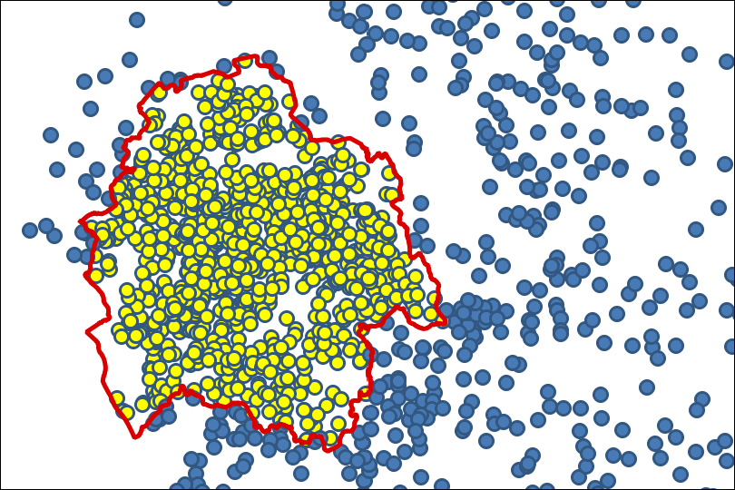

Summits within the National Park are yellow, showing that they are selected. Summits outside of the National Park are the default layer colour, showing that they aren’t selected.

We now need to turn that selection into a feature class as at the moment it is only temporary.

* Right-click on your hill summits layer in the Layers panel
* Export > Save selected features as...
* Save your features as a new layer within the geopackage that you created when saving the National Park outline.
* Remove the summits layer that covers the whole of the UK - keeping your Layers panel tidy will save confusion later.

## The Lake District map so far

At this stage you should have a map open in QGIS showing the outline of the Lake District and within that the points showing the summits. You may also have a background layer.

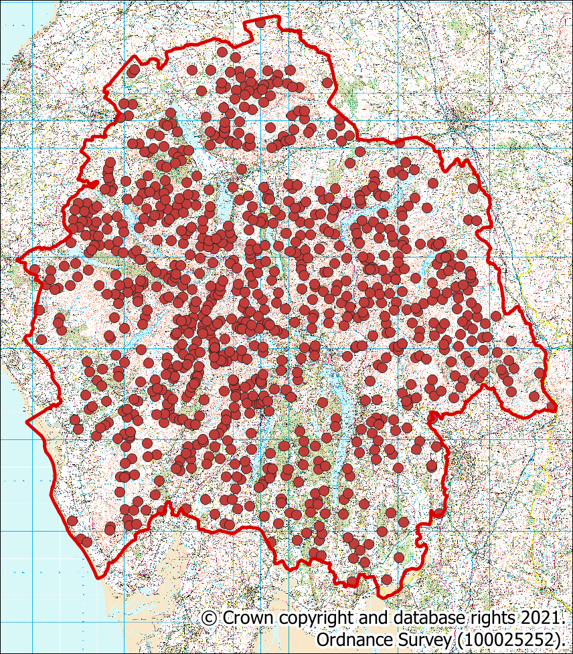

The map showing an outline of the Lake District National Park and all the hill summits within it. Your colours will probably be different to the ones shown here.

You should be realising by now that a lot of work in GIS is preparation of the data rather than actual analysis. This is something you need to remember when you are doing your own projects in the future!

 **Save your map**

Save your map at this stage. You’ll need it and the data that you have prepared for the exercises in the next chapter.

## Further information and suggested reading for elevation

Many of the books in the reading list[17] have general information about elevation data. Suggestions include the following:

* Chapter 3, *Spatial data modelling* in Heywood, I., Cornelius, S. and Carver, S. (2011), pp.89-95 covers the background to modelling surfaces, which includes dtm.

For technical information that refers specifically to QGIS try the following:

* The **QGIS Documentation** has a chapter on [Working with Raster Data](https://docs.qgis.org/3.16/en/docs/user_manual/working_with_raster/index.html) which should help you with some of the techniques that have been covered in this chapter.
* [QGIS Tutorials and Tips](https://www.qgistutorials.com/en/index.html) - this is a series of tutorials which cover some of the techniques you’ve been using in these exercises. It’s worth browsing the list, but particularly relevant to this chapter would be [Raster Mosaicing and Clipping](https://www.qgistutorials.com/en/docs/3/raster_mosaicing_and_clipping.html). Not all the tutorials refer to the current version of QGIS, so do keep an eye on that.

# Elevation models 2: Analysing terrains

Last Modified: 16 Mar 22, 17:02:26

The background to elevation models and terrain analysis will be covered in the lecture segment at the beginning of the class, and the presentation and any other supporting materials will be available in Minerva. The lecture segment should help you to understand **why** you are doing these exercises. If you still aren’t sure, please ask [Clare](mailto:c.e.gordon@leeds.ac.uk).

## Learning outcomes

When you have completed this section of the workbook you should be able to

* describe and identify raster formats of height data used in GIS and show an awareness of vector formats
* convert downloaded height data to an appropriate format to use in GIS
* use raster models to analyse surfaces
* describe appropriate applications of height data in environmental projects

## Introduction

In the previous chapter you prepared SRTM data to use for terrain analysis, looked at the properties of that data, and used it to generate some simple derived layers for slope and aspect. In this chapter we’ll look at more detail in how you can use height data in analysis within GIS.

## Data to prepare

You should have all the data that you prepared in the previous chapter already in a map in QGIS.

* If you don’t have your map of the Lake District open in QGIS already, open it now.

## Restricting processing extent

We did a lot of data preparation in the previous chapter, but before we start running more complex analysis it would be good to do one further bit of preparation.

When doing analysis in GIS it makes sense to limit the size of the area on which those analyses will take place. If you are working with a very large dataset this can make an enormous difference to the amount of time and computer processing power that you need. For example, you may have a dataset covering the whole of the Atlantic, but actually only need to analyse data for a small area to the west of the U.K.

In some cases **not** limiting the processing extent can actually lead to incorrect results, for example if you are trying to work out the area of a particular outcome.

There are two main ways to restrict the processing area for data in QGIS.

* The first is to clip your original data to the area that you actually need to use.
* The second is to restrict the extent within the tools that you are running. Many of the tools in QGIS allow you to do this, but not all, so we’ll look at the first method here.

### Clipping the DTM to the study area

To do this you need a vector polygon layer which covers the extent that you wish to analyse.

In some projects you may need to create this by setting up a new feature class and digitising the outline of your study area.

In this project you already have a vector polygon layer which will restrict the extent correctly.

 **Restricting extent**

Which layer in your map is a polygon layer which covers the area you will need to analyse for the Lake District?

Hopefully you realised that it is the layer which contains the **outline of the Lake District National Park**.

Set your Layers panel so that the following layers are visible and all the rest are invisible.

* Lake District National Park outline
* Terrain 50 merged DTM

You should be able to see that the DTM has a larger extent than the National Park. Note, you’ll probably have downloaded a slightly different area to me for the DTM, that doesn’t matter as long as you have at least the extent of the National Park.

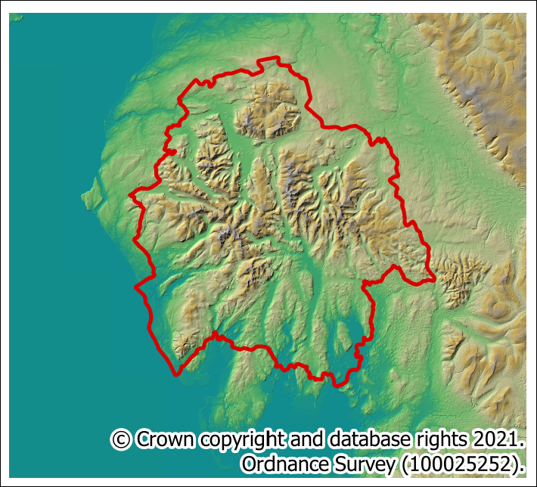

A comparison of the extent of the DTM and National Park. The DTM covers a much larger area.

For our purposes the extent of the DTM should be the same as the National Park so let’s **clip** it.

 **Clipping a raster to a vector extent in QGIS.**

This video clip can be found in the module area of [Minerva](https://minerva.leeds.ac.uk) or in the [full list of video clips](https://cgordon-gis.github.io/videoclips.htm).

* On the menu bar go to Raster > Extraction > Clip raster by extent...
  + The Input layer is the Terrain 50 DTM layer
  + For Clipping extent click on the three dots button at the end of the line and select Calculate from Layer then select your Lake District National Park layer.
  + Set the nodata value to output bands to -9999
  + Under Clipped (extent) browse to where you want to save the output and give it a name that will help you to remember what it is.
* Click on Run then Close

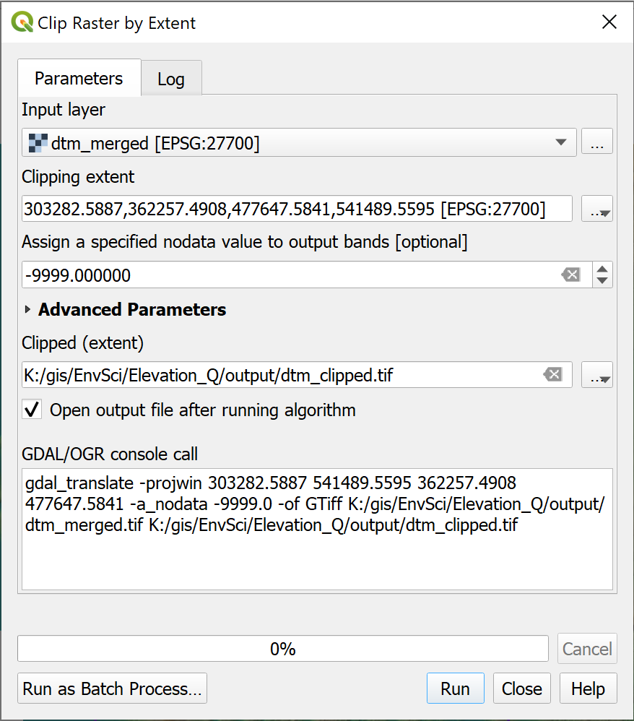

Filling in the form to clip the dtm to the same extent as the outline of the Lake District National Park.

The output should be a new DTM layer which only covers the area of the Lake District National Park. Note that it won’t be the same shape as the vector outline, rasters are always rectangular, but the extent should be the same as the extremities of the outline.

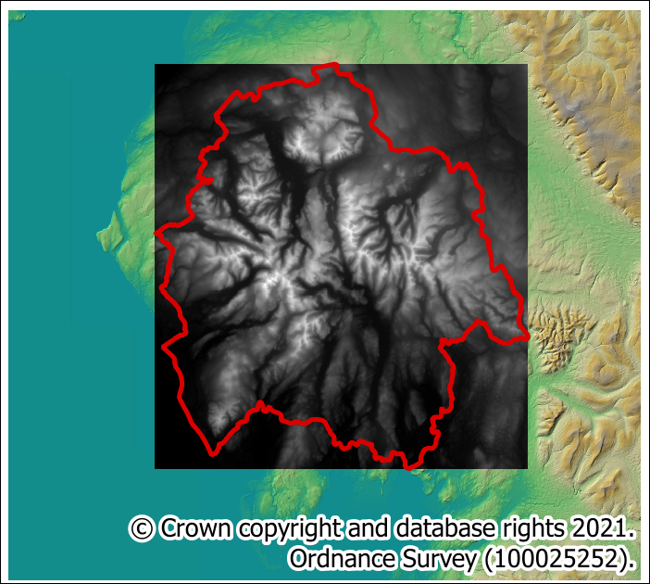

The extent of the clipped DTM - the greyscale layer - compared to the original DTM which is coloured.

Tidy up your map by removing the original DTM and hillshade layers. Move the new DTM to the lowest position in the Layers panel and make it invisible. You don’t need it to be visible to use it for analysis.

If you like you can create a hillshade layer and create a colour relief map in the same way as you did for the whole dtm. You don’t need the layer visible for analysis, but you may want to use it as a background for the display of your final data.

Make sure that the following layers are visible on your map:

* Lake District hill summits
* Lake District outline
* Background map

## Viewshed analysis

Julia Bradbury [18] is out and about with her copy of [Wainwrights Pictorial Guide to the Lakeland Fells](https://en.wikipedia.org/wiki/Pictorial_Guide_to_the_Lakeland_Fells) and has reached the top of Blencathra. She’s trying to work out how many other Lake District summits it is possible to see from the summit of Blencathra. If only she’d asked you!

Using **viewshed analysis** in a GIS it is possible to work out which places are visible from any particular point without having to climb the hill yourself.

Let’s work out which summits are visible from **Blencathra - Hallsfell Top**. You’ve already loaded the height and summit data that you need to do this.

### Finding the observer point

The first thing you need to do is find the point for Hallsfell Top on your map. You will need the **1:50 000 raster layer** visible as your background map for this section. Alternatively use the labelling tools to label the summits layer so that you can see which one is which.

Back in the first chapter you used Type to locate to search a vector layer. You can do the same here to search the list of Lake District hills.

* Type af Hallsfell Top in the Type to Locate box at the bottom left of the map window.
* You should find Blencathra - Hallsfell Top from the Lake District Summits layer as the result. Double-click on it to zoom and pan to it on your map.

### Running the viewshed tool

 **Viewshed analysis in QGIS.**

This video clip can be found in the module area of [Minerva](https://minerva.leeds.ac.uk) or in the [full list of video clips](https://cgordon-gis.github.io/videoclips.htm).

Now that you know the location of the observer point you can run the analysis. The tool to work out which areas are visible from a particular point is called the **Viewshed** tool.

* In the menu bar click on Processing > Toolbox to open the toolbox. You’ll get a list of the tools available to you.
* In the Search box at the top search for viewshed. This should take you to a choice of two.
* Under GRASS > Raster double-click on r.viewshed to open the dialog.

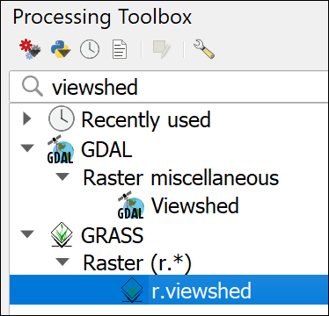

Selecting the GRASS r.viewshed tool in the Processing toolbox.

 **Warning**

If you find that you can’t run the GRASS tools then it may mean that you have the wrong version of QGIS open. I’ve found that the GDAL version of the viewshed tool doesn’t work as well so don’t use that instead.

If you’re using version 3.16 of QGIS - Save your map and close QGIS.

Search for QGIS in the start menu and make sure that you open the version that is called QGIS Desktop 3.16.2 with GRASS 7.8.4. Note that your version numbers may be different, but it’s the **with GRASS** that is important.

If you’re using a higher version of QGIS, e.g. 3.22 or 3.24, start by checking whether the Processing library is enabled.

Go to Plugins > Manage and install plugins.... In the list of installed plugins check that Processing and GRASS GIS provider are both ticked. Note, this is different to GRASS 7 - if you have that in your list, leave it unticked.

Now close the plugin manager and try the GRASS tools again. If they still don’t work, try closing QGIS and opening it again. So far ticking the plugins has worked for everyone. If you find it doesn’t, please get in touch with me.

* Fill in the form for the tool
  + Set Elevation to your clipped DTM layer
  + To set the Coordinate identifying the viewing position click on the three dots button at the end of the line, the dialog will disappear, giving you the chance to click on the dot for Hallsfell Top on your map. When the dialog reappears it will have the coordinates for the location that you clicked.
  + Set the Viewing elevation above the ground to the average height of a person, e.g. 1.75 - this will be in map units which are metres.
  + Note that it is also possible to set the height of the target, but that isn’t necessary in this case.
  + Most other settings can be set as the defaults, but you do need to drop down Advanced Parameters and put a tick in the box next to Output format is invisible = 0, visible = 1
  + It’s also a good idea to fill in the extent and cellsize. Set GRASS GIS 7 region extent by clicking on the three dots button next to the field and selecting Calculate from Layer and your input DTM.
  + Set the GRASS GIS 7 region cellsize to the same cellsize or pixel size as your input DTM - remember you can check this in the layer properties. In this case we’re using Terrain 50 data which has a cellsize of 50, so put 50 in the box.
  + Then in the Intervisibility box at the bottom browse to where you want to save the output and give it a name which will help you remember what the layer shows, e.g. vshHallsfell for viewshed from Hallsfell Top.
* Click Run, then Close when it finishes. It could take a while.

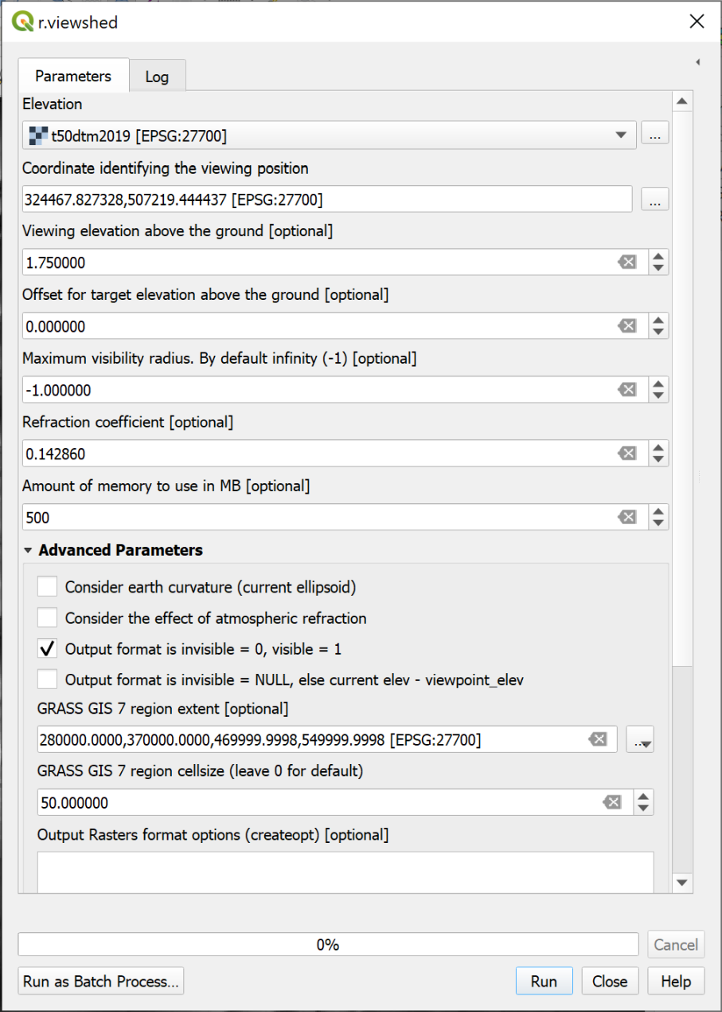

Filling in the viewshed tool for Hallsfell Top.

 **Warning**

In the instructions above I’ve kept it relatively simple, but you may have problems running this tool. If you do there are a couple of extra suggestions here.

Make sure that when you enter the DTM into the Elevation box, the CRS is given in the square brackets after the name. If not, you need to either assign the CRS or Warp (Reproject) the DTM before you use it in the tool. Refer back to the CRS chapter if you can’t remember how to do this.

Double-check that the Project CRS and the dtm layer CRS are the same. If they aren’t you’ll probably get an error message telling you that the viewpoint is outside of the layer extent.

Try closing QGIS and opening it again - it’s surprising how often this helps!

If these suggestions don’t help, and it isn’t a problem with where you save your files, then it may be a case of reinstalling QGIS and seeing whether a new version makes a difference.

Once the viewshed has been added to your map, zoom to layer on it, then open the Layer Styling panel and click on the Classify button. For some reason this cleans up the number of values.

Your map should show a layer with two colours, probably different colours to those shown below (make sure it’s above the background map in your Layers panel if you can’t see it). If you look at the layers panel and remember the Output format tick box, you should see that there are two values

* 0 = not visible from the observer point
* 1 = visible from the observer point.

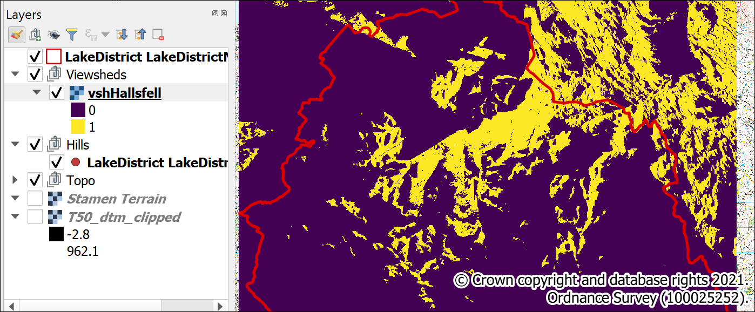

The result of running the viewshed tool. Note the values shown in the Layers panel.

In addition use the Identify Features tool to have a look at the differently coloured areas in this layer.

### Return to the original question

If you to back the start of this section you can see that the original question asked **how many** summits is it possible to see from the summit of Blencathra.

This is a good time to break down exactly what you are trying to do so that you can see what steps you need to carry out.

At the moment you have points in a vector file showing all the summits in the Lake District, and a raster file with two different symbols showing which areas and are not visible. You somehow need to put the two together and work out which of the points are in the area which is visible.

Probably the simplest way to do this is the following:

1. Convert the raster file to vector polygons.
2. Select and delete from the vector polygons all those for areas which are **not** visible.
3. Use Intersection to select all the summit points which intersect with the visible areas and output them as a new layer.

You’ve already used tools which will do most of the above steps.

### Saving output to temporary files

You’ll see from that list that you could end up generating lots of files and taking up lots of disk space. These processing outputs are relatively small, it can be possible to generate output of several gigabytes.

When you are running a series of processes you don’t necessarily need to keep the output from all of them, some are only needed to run the next tool in the sequence. In these cases you can select [Save to temporary file] as the output.

Remember though, that if you close your project these layers will disappear. If you want to save them you can right-click and use the usual **Export** dialog to save them to disk.

We’ll save the output of some of the tools in that list as temporary. When you’ve finished processing the data you want to end up with the following layers, the rest don’t need to be kept:

* A vector layer showing the areas which are visible
* A second vector layer showing points for the summits which are visible

### Convert the raster file to vector polygons

As you are probably starting to realise by now, there are tools to do virtually everything you want to do. Usually the problem is making sure that you can find them.

* Start by opening the Processing toolbox, if it isn’t already open.
* Search for raster to vector

 **Finding the right tool**

In the list of results which tool looks as if it will do what you want it to do? i.e. convert a raster layer to vector polygons?

Once you’ve had a look at the possibilities hopefully you picked out Polygonize (raster to vector) from the GDAL > Raster conversion list.

* Double-click to open the Polygonize tool
  + Fill in your raster viewshed layer as the Input layer
  + The other settings are fine as the defaults
  + Under Vectorized leave the output as [Save to temporary file] so as to save storage space - see above.
* Click on Run, then when it finishes (which could take a while) click Close

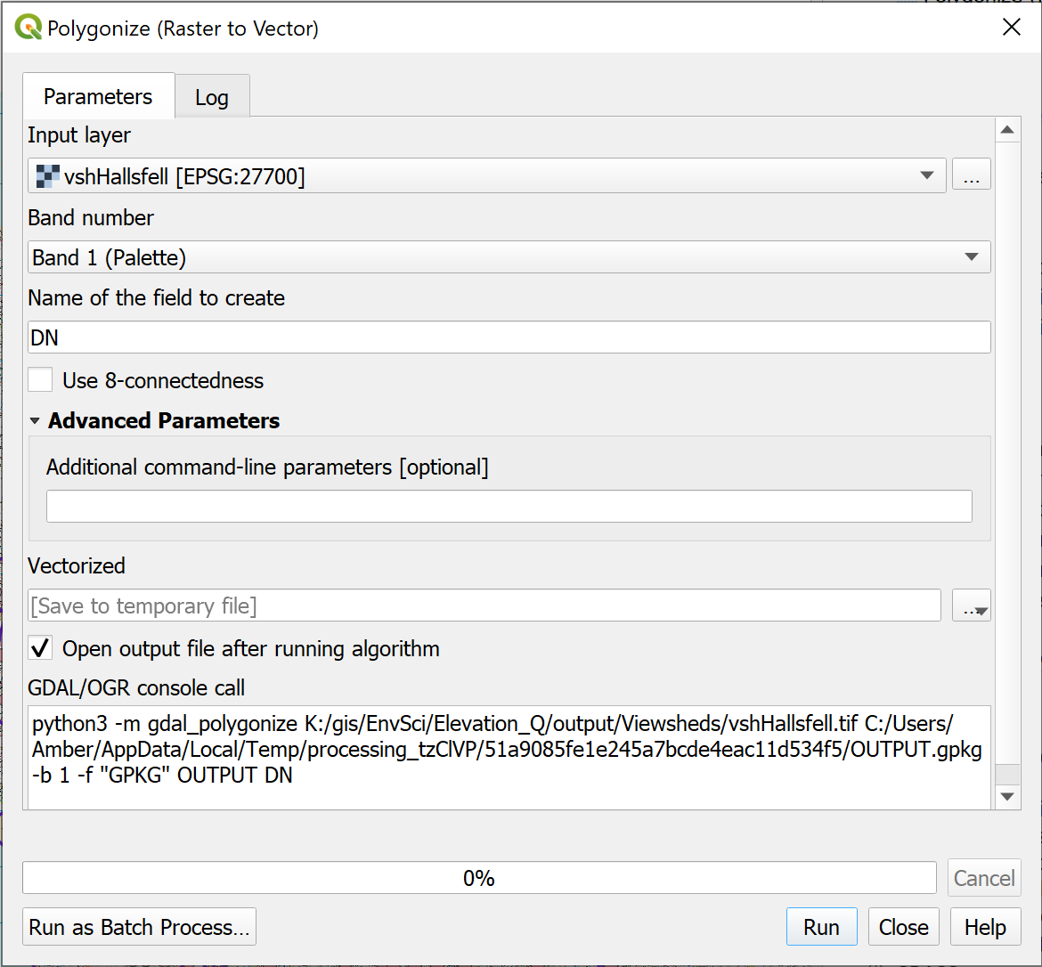

Converting a raster layer to vector polygons with the Polygonize tool.

The output will probably look even less informative than the raster layer did, but this is actually more useful for our purposes.

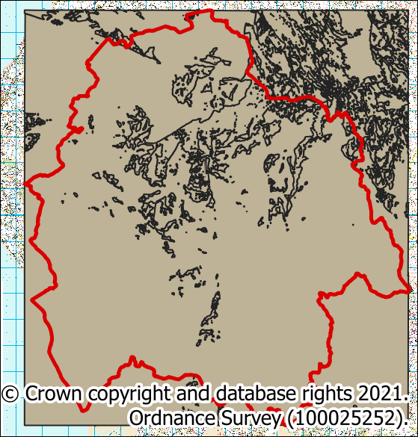

The resulting vector output from the Polygonize tool.

Have a look at the layer in the Layers panel. Because you chose to save this as a temporary file there is an extra symbol next to it in the list to show this. I always think that it looks a bit like a spider.

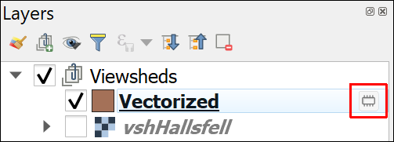

A temporary layer with the symbol showing that it is temporary.

### Extracting vector features with Extract by Expression

Now we have the features in a vector feature class we can get rid of the invisible areas by deleting them.

 **Which attribute shows whether an area is visible or invisible?**

Open the attribute table for your new vector layer and have a look at it.

Bearing in mind the values from your raster viewshed which field holds the information about whether a feature is visible or invisible?

You should find that you have a column which is made up of values of either 0 or 1. This matches the values in the original raster - remember that the value 1 indicated an area that was visible from Hallsfell Top. Make a note of the name of that column, or field.

We can use the **Extract by expression** tool to select the features that we want to keep and save them as a new feature class.

 **Extract by Expression with the toolbox in QGIS.**

This video clip can be found in the module area of [Minerva](https://minerva.leeds.ac.uk) or in the [full list of video clips](https://cgordon-gis.github.io/videoclips.htm).

* Search for Extract by expression in the Processing Toolbox and double-click to open it.
* The Input layer should be your newly vectorized viewshed
* Click on the button at the end of the Expression field
* In the form that opens use the centre panel to go to Fields and Values and double-click on the name of the field that you made a note of above.
* We want this field to match the value for visible area, so click on the = button below the left-hand panel or type = into the left-hand panel after the name of the field.
* Then click on the All Unique button on the right to get all the Unique values in that field.
* The result of clicking on the All Unique button should be a choice of 1 or 0. Remember that 1 shows the areas which are visible and those are the values that you want to keep, so double-click on 1

The panel to the left should now show the expression

"DN" = 1

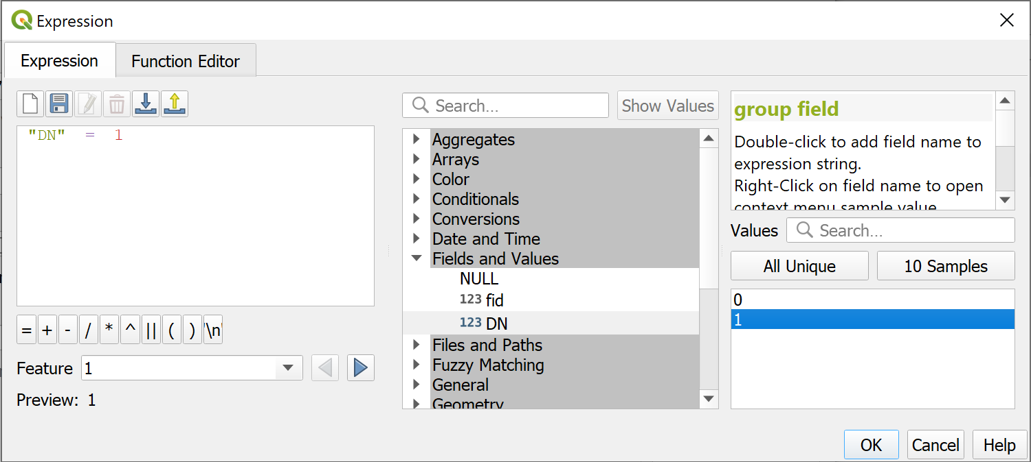

Extracting visible areas by expression.

* Click OK to return to the Extract by Expression tool
* We want to extract the Matching features, i.e. the visible areas, but this can be a temporary layer as we don’t need to keep this so the Matching features can be left as [Save to temporary file]
* Check that Open output file after running algorithm is selected
* Click on Run and wait for it to finish, then click on Close.

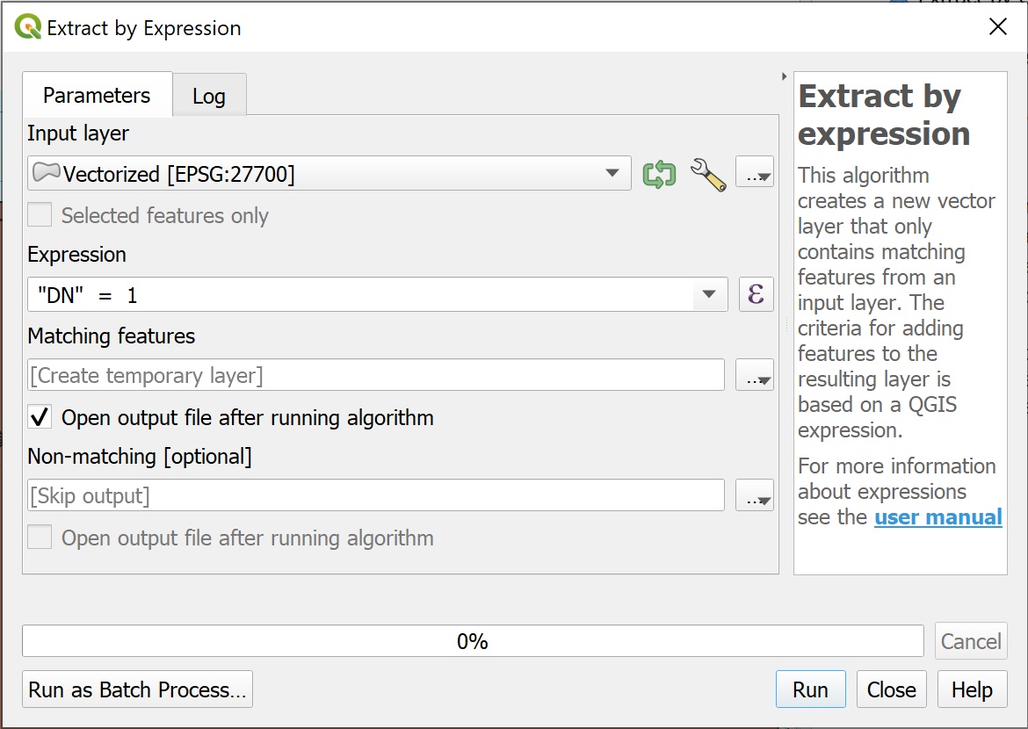

Filling in the form to extract the visible areas from the Hallsfell Top vectorized geopackage layer.

The new layer should be added to your map. You should find that only the visible areas now have a polygon to cover them.

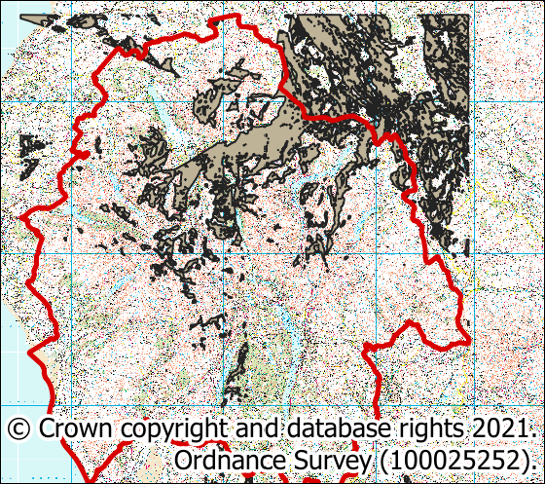

Now only the visible areas have a polygon in the feature class and showing on the map.

### Fix geometries

When putting together these exercises I found that the process above left me with a polygon feature class which created an invalid geometry error when I used it in other tools.

That is easily fixed by running the Fix Geometries tool.

You’ve filled in lots of these tool forms now, so I’m going to start giving less detailed instructions as you should be getting the general idea.

* In the toolbox search for Fix Geometries
* You should find the tool under the Vector geometry heading.
* Double-click to open the tool and fill in the Input layer
* The output layer is under Fixed Geometries. This is one of the layers we want to save to disk so give it a name and browse to the location you want to save it. You should be able to save this to a preexisting geopackage if you want to, but use a new one if you’d rather.

Run the tool, and when the new layer appears on your map, remove the two temporary layers from the layers panel. You can also remove the original raster viewshed layer.

### Intersection

Finally we can create a feature class which only contains those summits which intersect with the visible areas.

You’ve done this before using Select by Location but it is also possible to use the Intersection tool, and we’ll try that here.

* In the toolbox search for Intersection - you should find it under Vector Overlay
* The input will be your Lake District summits layer
* The Overlay layer will be the fixed viewshed polygon layer
* The output is the Intersection box and you can save it to an existing geopackage. Note it is important to keep track of which summit this is the results for as you’ll be doing it for more summits.

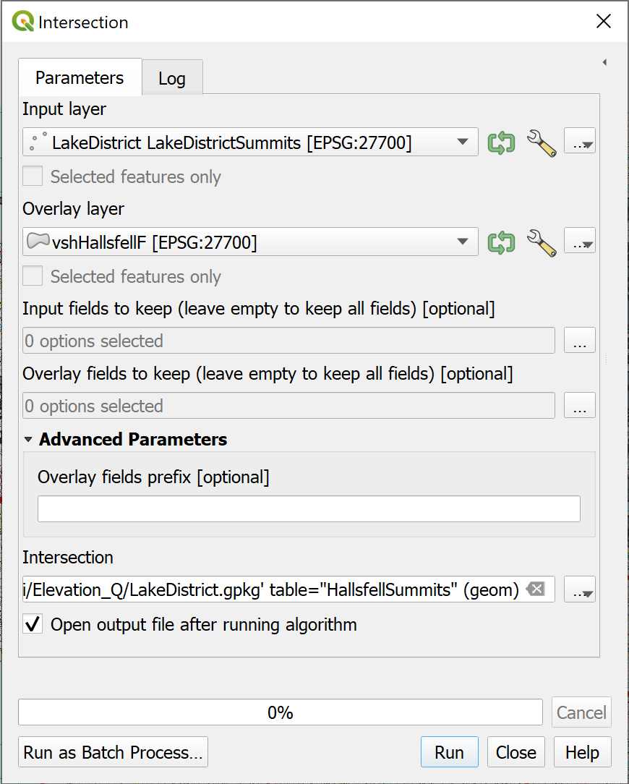

Filling in the form to intersect the summits with the viewshed.

Run the tool then close it and have a look at the output.

Hopefully you can see that the new feature class only contains some of the summit points, but those are the ones that are within the area that is visible from the summit of Hallsfell Top on Blencathra.

### So how many summits are visible?

The simplest way to get the total is to make use of the Layers panel.

* Right-click on the new summits layer in the Layers panel
* Select Show Feature Count

The number of features in the feature class should appear in brackets after the layer name in the Layers panel.

Note that your result may not be the same as mine. In fact, I ran this process several times when writing these exercises and came up with a slightly different result each time. As long as it is close to this number, e.g. 339, then that is fine.

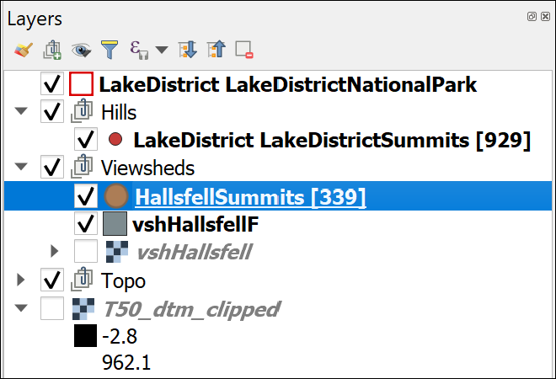

Viewing the number of features in a layer in the Layers panel. This shows that 339 Lake District summits are visible from the summit of Hallsfell Top.

## Batch processing

You’ve successfully worked out how many summits are visible from the top of a single location, but what if you needed to work out the total for another set of locations?

You could go through the full process multiple times, but it would be better if there was some way you could use the GIS to repeat the process.

In a future chapter we’ll be looking at **models**. These are a way of using a graphical user interface to build a python script to do repetitive processes. If you are good with python scripting you can also do this directly, but that doesn’t come under the scope of this module.

In this section we’ll have a look at how you can use tools with **batch processes** when you are trying to answer the same question multiple times.

 **Batch processing viewsheds**

The task is to work out from which of the following summits is it possible to see the most other summits?

Helvellyn

Catbells

Great Gable

Blencathra - Hallsfell Top

You’ve already worked out the total for Hallsfell Top so don’t need to do that one again.

The tools that you need to run for each location are:

1. The viewshed tool
2. Polygonize (raster to vector)
3. Extract by expression
4. Fix geometries
5. Intersection

Refer back to the previous sections for detailed instructions for each tool.

Note that if you look at the top of the Processing Toolbox and clear any previous searches, the Recently used section will show the tools that you have used most recently.

Unfortunately the batch processing mode doesn’t usually let you save output as a temporary layer, so you will end up with lots of output files. Remove any you no longer need from the Layers panel to keep it tidy as you go along.

 **Batch Processing in QGIS**

This video clip can be found in the module area of [Minerva](https://minerva.leeds.ac.uk) or in the [full list of video clips](https://cgordon-gis.github.io/videoclips.htm).

* Start with the viewshed tool.
* Once you’ve opened the tool go to the bottom left and click on Run as Batch Process

A different form will open. It will be worth enlarging the dialog horizontally as this contains the same boxes, but across the page rather than down.

* You are going to be running this tool three times, so click on the plus button twice to add two more rows (there is already one blank row there)
  + in the first row under Elevation (actually with the number 2 next to it) dropdown the box and select your clipped DTM layer.
  + Now click on Autofill... above that and select Fill down. All the fields below should be filled in with the same choice.
  + In the first row of the Coordinate identifying the viewing position... click on the three dots button to be taken to your map so that you can click on the point for Helvellyn. Repeat this for Catbells and Great Gable, remembering you can use the Type to Locate box to find them.
  + The Viewing elevation above the ground column can be filled in using the Autofill > Fill down again, if it isn’t already correct
  + One field that is missing from the form is the one for Output form is invisible = 0, visible =1. You can find this by clicking on the cog wheel button to the left of the Batch Processing menu bar. Then set this to Yes for all rows.
  + Finally fill in the details of your output in the Intervisibility column if you want to save it.
  + Put a tick in the Load Layers on Completion box at the bottom left
* Now click on Run.

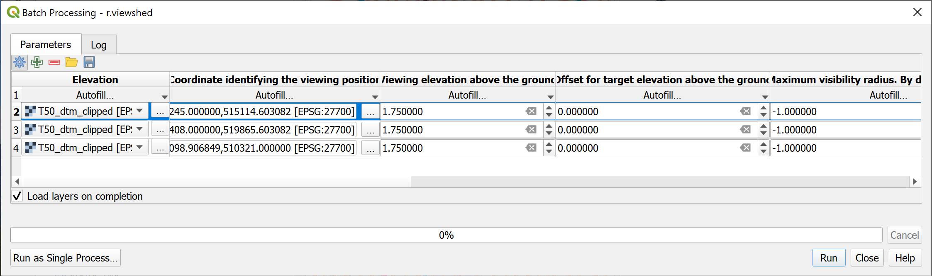

Filling in the Batch Processing dialog to generate a viewshed for three observer points.

If you don’t Close the dialog until you have checked the output you can go back to the form by clicking on the Parameters tab and make any changes without having to fill in the whole form again. Just move the form out of the way to have a look at the layers on your map.

Check the new layers, and if you’re happy with them Close the batch processing form.

I’ve only suggested you run this for three extra datasets here to give you an idea of how batch processing works without it taking you too long. The real economy of scale will start to show if you are processing a lot more points.

 **Continuing with batch processing**

Continue with the list of tools that need to be run. Use each in batch processing mode and see how you get on.

Investigate some of the options under Autofill and see whether any of those help you to streamline the process.

For example, if you need to add a different input file for each line of the batch processing you can Select Files... or Add all files from a directory.

## Labelling the viewpoints

You selected particular hills as viewpoints from which to generate your viewsheds. For the final map it would be helpful to be able to display those hills and label them so that your audience can see where they are in the Lake District.

### Selecting the viewpoints to label

The first step is to create a new feature class containing just the viewpoints / hills that you want to label.

You can use Select by expression to select multiple points and then export the selection as a new feature class.

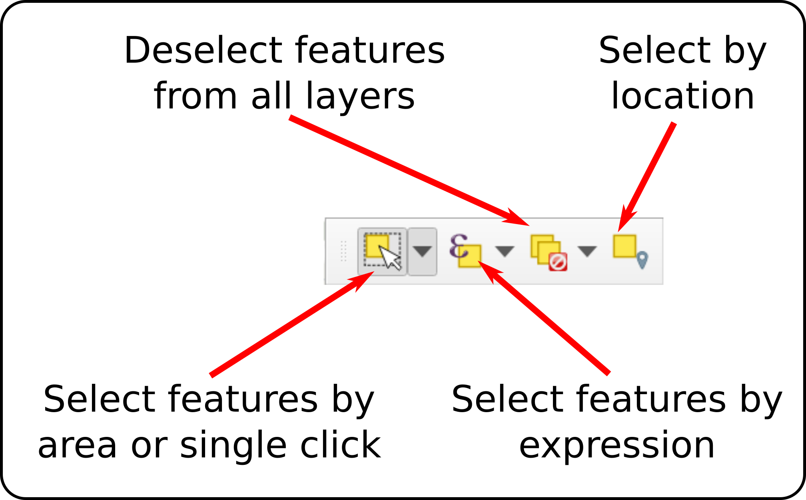

The selection toolbar.

* Select the Lake District Hills layer in the Layers panel.
* From the selection toolbar click on Select features by expression.
* In the dialog, use the expression form to construct the following expression in the left-hand box.
  + In order to select the correct hill names start by double clicking on Name in the Fields and Values then type IN and open brackets.
  + Now search for the first hill name in the Values box on the right and double-click on the correct entry to add it to the statement on the left. By doing this you are ensuring that you are using the correct form of the name.
  + Continue like this for each of the hills, adding a comma between each name, then finishing by closing the brackets.

"Name" IN ('Helvellyn`,'Blencathra - Hallsfell Top', 'Catbells', 'Great Gable')

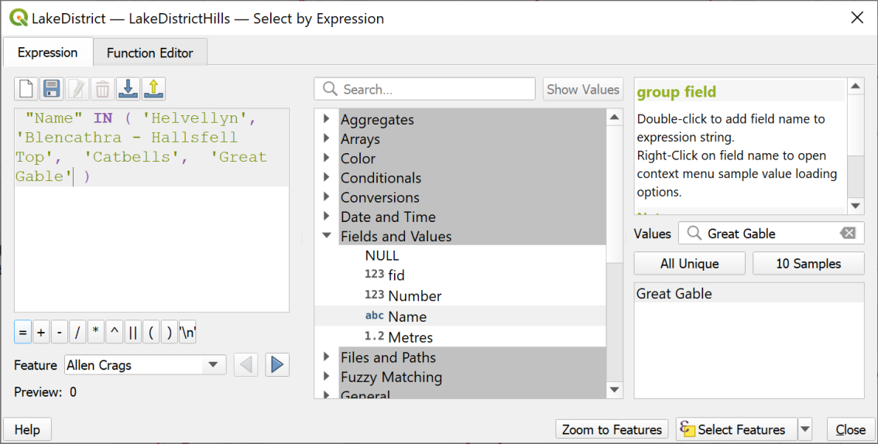

Selecting multiple features in a single statement.

* Once you have the statement in the left-hand window click on the Select Features button.

If you look at your map now the symbols for the four hills should be selected in bright yellow.

* Close the Select by Expression window.
* Now right-click on the Lake District Hills layer in the Layers panel and Export > Save Selected Features as...
* Save the layer as a new feature class in your geopackage and make sure it is added to your map.
* Style the points as you wish using the tools in the Layer Styling panel.

### Labelling points

 **Labelling features in QGIS**

This video clip can be found in the module area of [Minerva](https://minerva.leeds.ac.uk) or in the [full list of video clips](https://cgordon-gis.github.io/videoclips.htm).

Start by having a look at the attribute table of your new feature class. You want to label your map with the names of the hills.

 **Which field do you need to use to label your map?**

Make a note of the name of the field which contains the information you want to use to label your map.

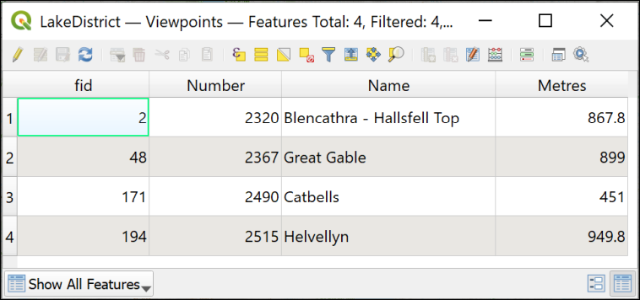

The attribute table showing the Name field which can be used to label the features on the map.

* Once you’ve made a note of the field, close the attribute table.
* Make sure that you’ve selected the new feature class in the Layers panel.
* Open the layer styling panel in the usual way.
* Click on the Label tab on the left of the panel. Initially it will say No labels.
* Drop down where it says No labels and select Single labels.

At this stage QGIS usually just labels your features with the first field in the feature class, which isn’t usually the right one. **Never just accept the defaults without checking!**

* Now you need to select the correct field. Next to Value, drop down the choices and select the field that you made a note of above - it should be called Name.

Immediately the names should appear on your map next to the symbols.

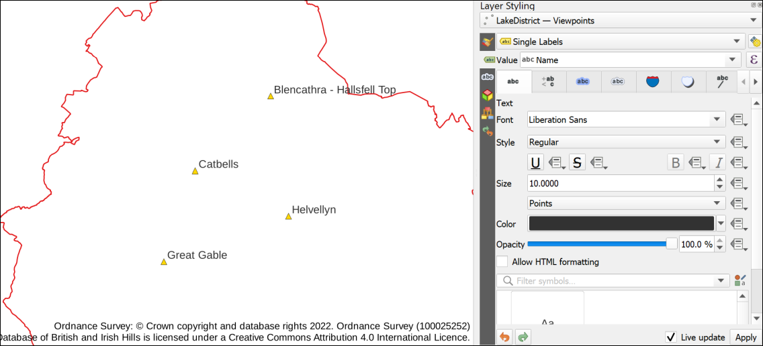

The default labels once the correct field has been set, also showing the default settings.

The default fonts, colours and placements are not always what you want. Use the settings on the panel to change how your labels look and how they are placed around your points.

Click on the Placement tab to change how your labels are placed relative to the point symbols.

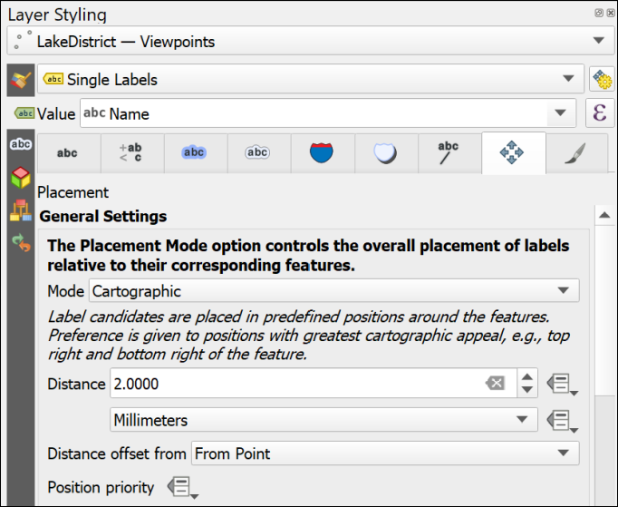

The label placement options.

* Try changing the Mode - what effect does that have on your labels?
* Try changing the Distance - does that help readability?

There are other tabs and options too, try them out and see what you can do with your labels.

## The final viewshed map layout

The final step of any analysis is to display your results. Try creating a layout which shows how many Lake District summits are visible from the four viewpoints. You’ve generated a lot of data for these exercises and if you try to put it all on a single map it would be rather a mess. You’ll find out more about adding multiple maps to a layout in the next chapter but just experiment for now. Don’t forget to include copyright information for both the data that you downloaded from Digimap, for the Database of British and Irish Hills (check their website for their requirements) and for any other data layers that you have used.

When you have created a layout export it to either an image or pdf and upload it to your GIS Portfolio in the Class Notebook. If you upload it within a week of the class, I will provide brief feedback on your work.

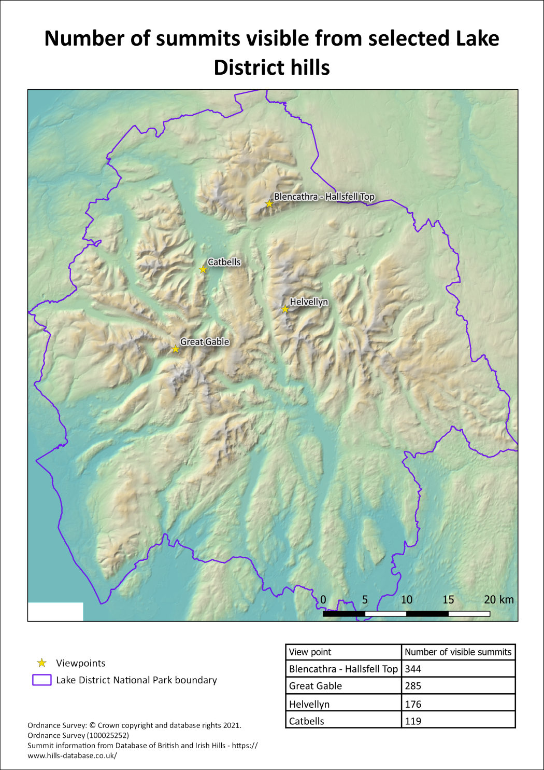

Possible final layout for a map of the Lake District showing the viewpoints and the number of hills visible from them.

## Further information and suggested reading

The suggested reading at the end of the previous chapter is still relevant for this chapter.

In addition try the following technical information:

* The **QGIS Documentation** has a chapter on [Working with Raster Data](https://docs.qgis.org/3.16/en/docs/user_manual/working_with_raster/index.html) which should help you with some of the techniques that have been covered in this chapter.
* [QGIS Tutorials and Tips](https://www.qgistutorials.com/en/index.html) tutorial on [Batch Processing using Processing Framework](https://www.qgistutorials.com/en/docs/3/batch_processing.html)
* For viewsheds have a look at [Viewsheds and visibility analysis in QGIS](https://www.thinkwhere.com/viewsheds-and-visibility-analysis-in-qgis/).

# Layout and presentation

Last Modified: 04 Nov 22, 16:31:54

The background to layout and presentation will be covered in the lecture segment at the beginning of the class, and the presentation and any other supporting materials will be available in Minerva. The lecture segment should help you to understand **why** you are doing these exercises. If you still aren’t sure, please ask [Clare](mailto:c.e.gordon@leeds.ac.uk).

## Learning outcomes

When you have completed this section of the workbook you should be able to

* Layout your maps in such a way that they effectively communicate the content and purpose of your work to a user
* Select relevant map elements to include in a layout and set their properties to match the requirements of your map
* print or export your map layout to show your work to it’s best advantage

## Introduction to layout and presentation

Once you’ve put in all the hard work to produce a map of your field area or project, it is worth making the extra effort to ensure that you lay it out clearly and print or export it in a professional fashion. Make sure that you allow the time to do this. Care and patience can make the difference between a scruffy, unimpressive map that loses you marks, and a clear, professional map that gives a good first impression and causes your audience to take your work seriously.

 **Warning**

Don’t underestimate the time that the final details can take and don’t leave this part of the preparation until the last hour before a deadline!

You won’t need to use all the elements and features outlined here for every map. Equally this is not an exhaustive list of possible elements. You should already have some idea of what elements are useful, and should be able to make a decision for each case based on your existing knowledge of maps. If you think that you need to add something that is not listed here, e.g. a report based on a table, then use the extra information available at the end of the chapter and search on-line to find out how to add it.

This chapter isn’t necessarily for working through in order. Make sure that you are aware of the contents and of what QGIS is able to do, and then make your own decisions about what you need to include based on the principles that will be covered in class.

Note that the examples in the images use a general map which isn’t the same as the one you will be working on. The techniques and the buttons in QGIS are still the same, though.

## The data for this chapter

You should use a map that you have been creating in previous chapters as instructed below [19]. Try out all the techniques listed below and then decide which you need to include on this layout before you export it.

* Level 1 geologists use the Cononish map from the previous chapter.
* Level 2 and above geologists. You should be working on your own maps.
* Level 2 environment students use the Lake District map.
* Level 1 geophysicists continue working with the Llanbedr map.

## Creating and saving layouts

In QGIS a **print layout** allows you to control the format and scale at which you print and export your map, and to lay out additional elements to complete the final product.

### Creating a print layout

 **Creating a print layout in QGIS and adding a map view.**

This video clip can be found in the module area of [Minerva](https://minerva.leeds.ac.uk) or in the [full list of video clips](https://cgordon-gis.github.io/videoclips.htm).

To create a new print layout

* Open your map project in QGIS if it isn’t already open
* Add a print layout by going to Project > New Print Layout...
* You’ll be asked to Enter a unique print layout title - call it something that will tell you what this layout is intended for. For example, enter A3 for printing. You can leave this blank if you wish.
* Click OK

QGIS will open your new blank layout in a new window. It should look something like the image below - though your toolbars may be in different places.

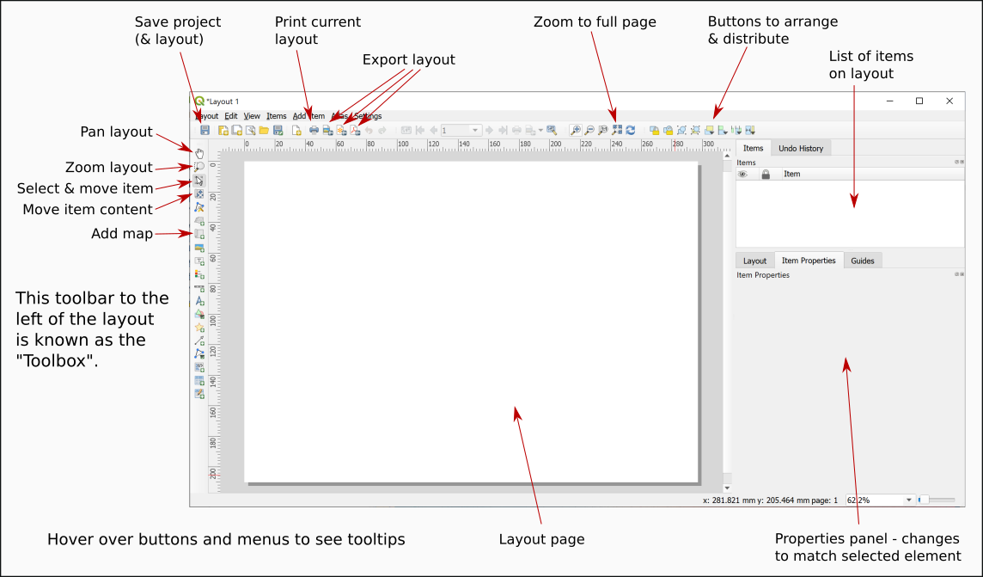

Your new print layout showing a blank page.

In this view you will see your map laid out as it will be when it is finally printed or exported. You’ll see the page outlined on screen and, once you have started adding elements you will see the content as it will look on the page.

### Opening existing print layouts

Once you have created a print layout you can close it and open it again without losing it.

* Close the window containing the print layout (Layout > Close)
* To reopen it go to Project > Layouts and select your layout from the list - there is only one there at the moment so click on that.

### Saving layouts

A layout is saved as part of the project so whenever you click on Save in your project it will save the layout too.

For now:

* Click on the Save button in the layout window.
* Or Layout > Save Project

## Adding a map to a layout

At the moment all you have is a blank page. To add a map to a layout:

* Click on the Add Map button on the Toolbox
* Or Add Item > Add Map
* Then use the mouse cursor to drag a box across the page. It doesn’t matter about the size at the moment you can change it later.

You should now be able to see a section of the map from your main project window. The Item Properties on the right will now give options for the map. You’ll explore these in more detail later.

## Size and scale of pages and maps

The size of the page and of the map “window” will affect the scale and extent of the map. These are all linked so if you change one remember to check that your map is either still at the correct scale, or still covers the correct area.

 **Setting the size and scale of a map layout in QGIS.**

This video clip can be found in the module area of [Minerva](https://minerva.leeds.ac.uk) or in the [full list of video clips](https://cgordon-gis.github.io/videoclips.htm).

### Page size and orientation

The page that you see in the layout window shows how the page will look when you export or print your map. Remember to check the paper size and set it correctly before you spend time arranging your layout.

To change the paper size and orientation:

* Right-click somewhere on the “page” and go to Page Properties

The page properties should open in the Item Properties on the right.

* The Size setting allows you to choose from a wide range of standard sizes, e.g. A4, A3 etc.
* The Orientation setting allows you to choose between portrait and landscape orientation.
* You can also set the page measurements manually by changing the Width and Height in the boxes below.
* The page in the main view should change automatically when you change a setting.

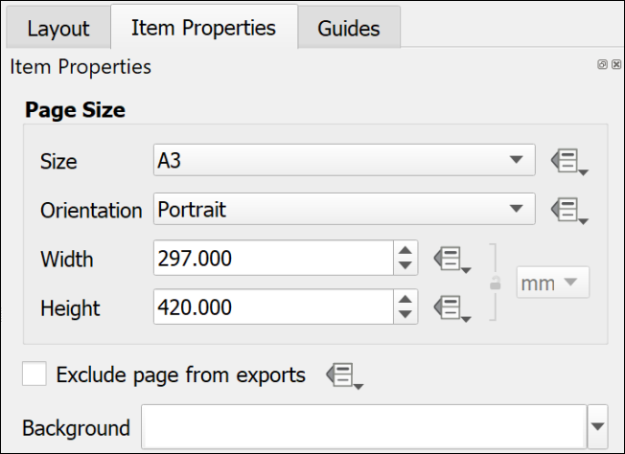

The page properties set to an A3 Portrait page.

 **Changing paper size and orientation**

Change your page size and orientation to A3 Landscape. This will give you more space to experiment with adding other elements to your page.

Once you have changed the paper size you may find that you can no longer see the whole page in the layout view. To zoom in or out use the buttons on the toolbar at the top. In particular use the Zoom full button.

### Setting up a multi-page layout

It is possible to create layouts with multiple pages in QGIS.

* On the menu bar go to Layout > Add pages...
* In the box which opens select the number of pages to create and whereabouts you want them to be added.
* Set the size and orientation of your new page(s)
* Then click on OK to add them to your layout.

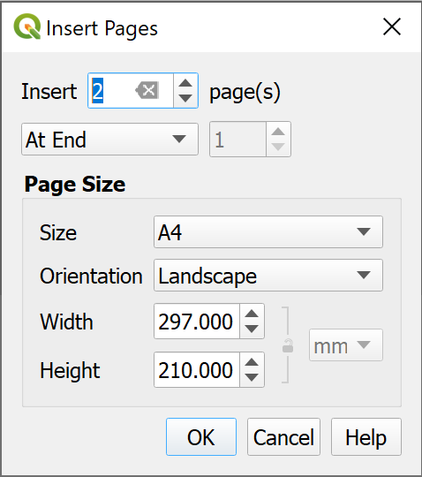

Inserting two new pages at the end of the layout.

If you decide you don’t need any of the pages you can delete them:

* Right-click on the page you wish to delete and select Remove page.

### Resizing the map in a layout

When you first set up a layout the size of the map may not be the size that you want it to be eventually. Changing the size of the frame is easy, but can take a little experimentation. You will also need to look at this in conjunction with the instructions on changing paper size in the previous section.

 **Resizing the map frame in a layout in QGIS**

This video clip can be found in the module area of [Minerva](https://minerva.leeds.ac.uk) or in the [full list of video clips](https://cgordon-gis.github.io/videoclips.htm).

* Make sure that the map frame is selected in the layout by clicking on it.
* When the map frame is selected you should be able to see that there are small boxes at the corners and on each side.

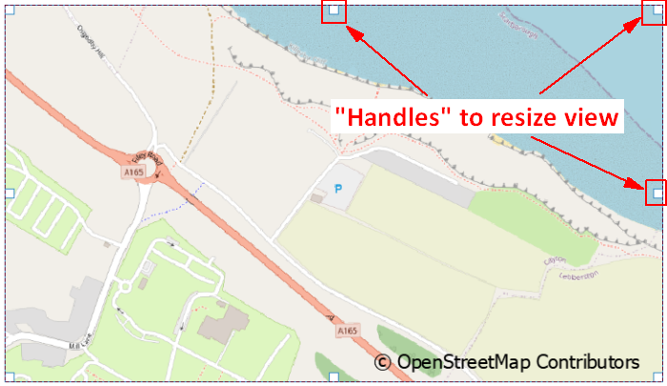

Using the handles on each corner and side of a map to resize a map frame in a layout.

* Use the boxes as “handles” to resize the map frame by dragging them
* Keep an eye on the scale in the map Item Properties. If you need to make a map at a particular scale you may need to keep putting this back to the correct scale each time you resize the map.

 **Warning**

This process can take patience to get the map frame the correct size for the scale and area. There don’t appear to be any short cuts so just stick with it and keep repeating the process!

### Moving the map within a map frame

If you need to move the map itself within the frame, e.g. so that you see a different part of it:

* Click on the Move Item Content button on the Toolbox
* You’ll be able to use the mouse cursor to move the map around within the frame.
* You’ll also be able to zoom in and out on the map.
* Remember to click back onto the Select/Move Item button to be able to select items again. It’s frustrating when you forget and find that you can’t move any elements around!

### Controlling the map with the Item Properties

If the map is selected on the layout you will see its properties in the Item Properties panel on the right. You can use these to control various settings for the map. The ones you need to know now are:

* The most obvious is Scale. Use this box to type the scale that you want your map to print at.
* Extents is useful if you don’t need to worry about the scale but do need to show a map covering a particular area. You can type the east, south, west and north coordinates and the map frame will change accordingly.
* The Frame setting allows you to put an outline around the outside of your map. This can make the map look more professional.

## Adding items to a layout

The information below includes details on adding many different items to a layout. Not all these will be appropriate to every layout, but it is up to you to decide which items to use depending on the purpose and audience of your map and any guidelines specified for assessments or reports. Some of the references on the reading list, particularly Darkes and Spence (2017), should help you with this.

Remember that the [QGIS Documentation](https://qgis.org/en/docs/index.html) will provide you with plenty of extra information on how to add items to a layout.

Most items are added to a layout in a similar way to each other using the buttons on the Toolbox. In most cases you’ll then be able to use the Item Properties to make changes to the item.

### Selecting items on a layout

There are a couple of ways of selecting items on a layout.

* Click the Select/Move Item button on the Toolbox then click on the item you wish to select
* Alternatively, use the Items panel. As you add more items to your map they will be added to this panel. All you need to do then is click on them in this list to select them on the map.

You can also use the items panel to lock items in place and make them invisible.

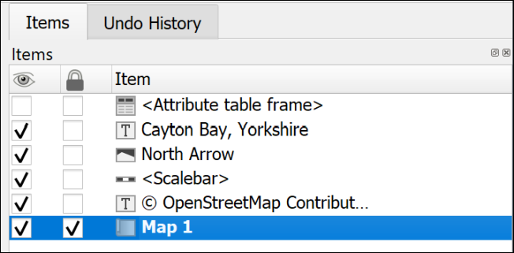

The Items panel showing that Map 1 is select and locked, while the attribute table frame is invisible.

Once an item is selected it will have the little “handles” visible for resizing.

### A legend or key

You will have added various data to your map, and it is necessary for you to explain to anyone looking at your map what those layers and symbols show. To do this you’ll need to add a legend or key. Note that this can be a relatively complex procedure and there are a lot of instructions in this section. It’s worth having a quick look at the whole section to get an overview before you start trying to add a legend.

 **Adding a key or legend to a map layout in QGIS.**

This video clip can be found in the module area of [Minerva](https://minerva.leeds.ac.uk) or in the [full list of video clips](https://cgordon-gis.github.io/videoclips.htm).

Start by using the default options to create a legend. Once you have the basic legend it is possible to make alterations later.

 **Warning**

Save your map and take a backup copy of your project folder before you start doing this.

While it is usually fine, if you have a lot of big layers on your map QGIS can crash when you first add a key and you don’t want to lose the work you’ve already done.

There are ways to get around this problem with the legend crashing QGIS.

To add a legend / key:

* Click on the Add Legend button on the Toolbox
* Click on your layout in roughly the location that you want your legend to appear. You can move and resize it later. You can also “drag” the box to the correct size as you add it.
* If the New Item Properties dialog appears click OK

QGIS will add a legend which includes all the items from all the layers on your map. This is likely to be rather a lot! The first thing to do is to remove any that you don’t need.

As usual, while the legend is selected, the Item Properties will show the specific properties for this element.

* In the Item Properties start by checking that the legend is referring to the correct map on your layout - use the dropdown box next to Map to select the correct one if you have more than one.
* You can give your legend / key a title if you wish, but note that this isn’t always necessary.
* Then move down to the Legend Items heading
  + If you don’t want all your layers to appear then untick Auto update - you can always click on the Update All button later if you change symbols etc on your map.
  + Now you can select layers and then click on the red minus button under the list to remove them.
  + To only show elements which appear on your map tick next to Only show items inside linked map - this can be a great help to remove surplus symbols.

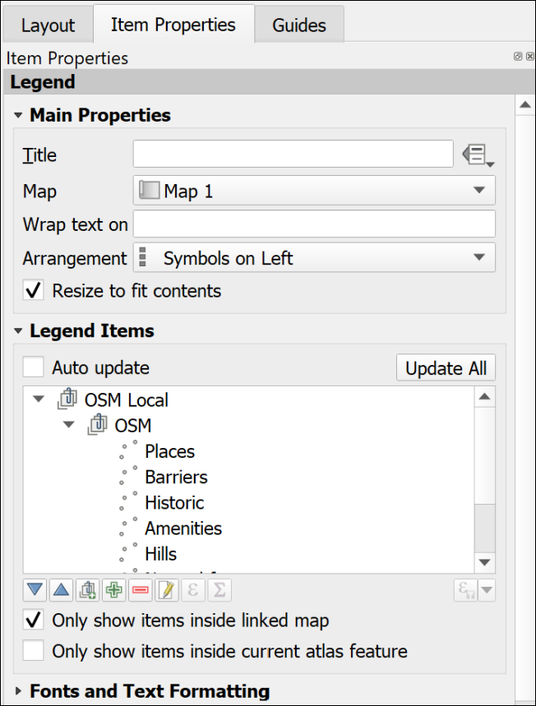

Setting the legend properties to control the layers and symbols on the key.

Once you have just the layers that you want on your key you can then use the rest of the properties to set fonts, backgrounds etc.

* It is possible to drag and drop the layers in the Items list and rearrange them.
* The Columns section allows you to split your legend into two or more columns.
* The Symbol section will let you change the size of symbol, or patch, on the legend - sometimes it is useful to be able to enlarge the “patch”.
* To change layer names in the legend without changing them on your map you can select the item in the list and click on the pencil icon below.
* Alternatively, you can change the names in the Layers panel in map view then click on the Refresh button in layout view to refresh the map and all associated items.

#### Changing the order of items within a categorized layer

If you have a layer styled by categories, the initial legend entries will usually be in alphabetical order starting from the top.

If you are creating a legend for a layer for which the order is important, for example, a geology bedrock layer where the younger rocks should be at the top and the older at the bottom, you will probably need to rearrange the legend entries.

There are two ways of doing this.

##### In the Layer Styling panel:

* Open the Layer styling panel and check the correct layer is selected.
* In the categories list drag and drop each entry to change the order.

This also changes the order in which categories are drawn on the map, so you may also need to check that your map still appears correct.

##### In the Layout legend options

* Select the legend and untick Auto update under Legend Items, if it isn’t already unticked.
* Select one of the categories you want to move and use the blue up and down arrows below the list to move it up or down.

This method only changes the order in the legend and doesn’t affect the order in which your categories are drawn on the map.

#### Changing the size of the legend patch

Sometimes the patches are too small to see clearly. This can be a particular problem for continuous colour ramps, but vector patches can be resized the same way.

To change the size of a legend patch:

* With Auto-update off…
* In the legend properties double-click on the layer to change or click on Edit selected item properties below the list of items.
* In this dialog you can also change the text next to the legend item.
* Use the Width and Height settings to make the patch larger - it should update automatically as you type numbers.

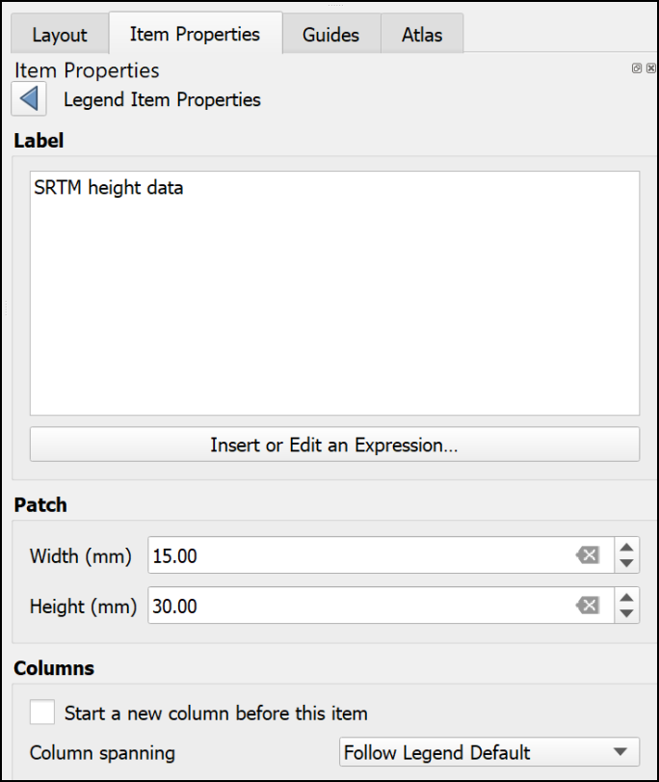

Changing the size of a legend patch in the item properties.

#### Creating a legend for a continuous raster

Version 3.20 and above of QGIS will automatically create a continuous patch. So if you are using version 3.20 or above **you don’t need to worry about the rest of this section**.

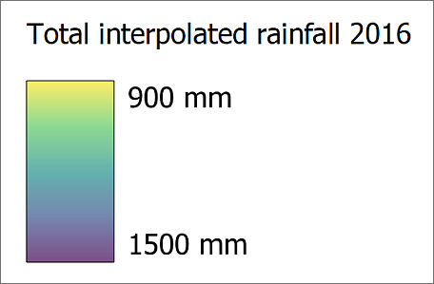

A legend for a continuous raster which was produced automatically by version 3.20 of QGIS.

Unfortunately the tools in version 3.16 and below of QGIS don’t make it easy to create a patch for a continuous raster. The quantities will appear as separate boxes. There are ways around this.

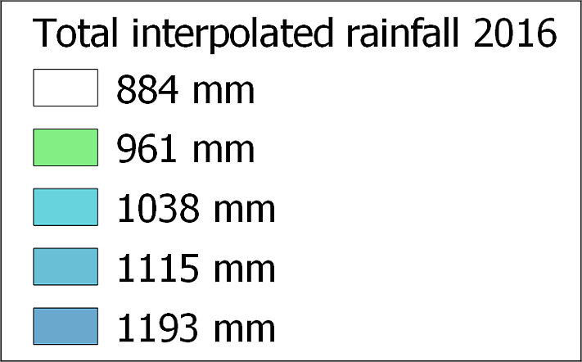

A legend for a continuous raster which isn’t showing a continuous scale.

If you look at the article by EcoDiv entitled [Legend for continuous raster in QGIS composer](https://ecodiv.earth/post/legend-for-continuous-raster-in-qgis-composer/) you’ll find a way to generate a continuous legend patch [20].

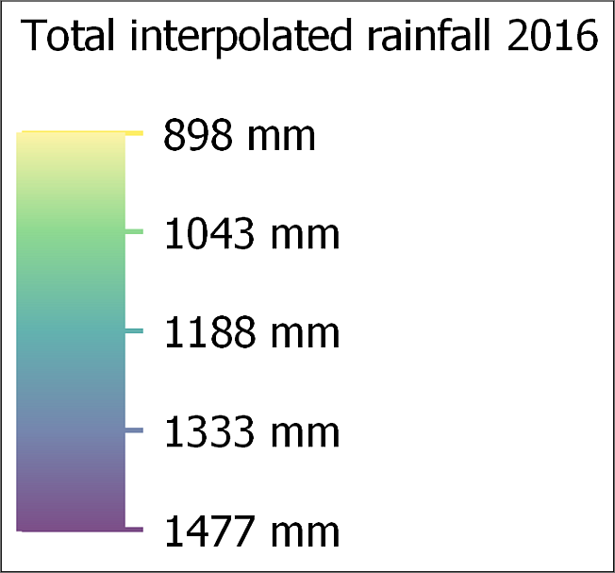

A continuous legend scale produced using the method at the web page above.

#### Manually editing the legend

There is a limit to what you can do with the automatic functions and properties but do as much as you can as that will save some time. It’s particularly important to play around with the spacing settings as there isn’t a way to change that manually.

Once you have finalised as much as possible on your legend using the item properties, the instructions below show how to manually add and edit elements manually.

Alternatively, it is possible to export the map as pdf or svg format then edit the legend in a vector graphics editing program such as Inkscape, CorelDraw or Adobe Illustrator.

 **Manually editing a legend in QGIS**

This video clip can be found in the module area of [Minerva](https://minerva.leeds.ac.uk) or in the [full list of video clips](https://cgordon-gis.github.io/videoclips.htm).

##### Adding or editing items not created automatically

As an example, this could be a way to add a patch for a combined colour on the layout which isn’t actually part of a layer so doesn’t appear in the legend.

To do this, you add the shape you want using the menu items listed below, “draw” it on the layout, then style it using the item properties.

* To add a rectangle or circle go to Add Item > Add shape > Add Rectangle or Add Ellipse.
* To add a marker symbol, e.g. for a point, go to Add Item > Add marker, then choose a marker from the properties as you would for marker symbols in Layer styling.
* To add a line go to Add Item > Add Note Item > Add polyline. Click each node to draw the line, then left-click to finish.

##### Matching a colour on the map using the color picker

Legend items need to accurately reflect the colour of the equivalent feature on the map, so it’s important to be able to set this. QGIS provides a colour picker feature which is ideal.

* Make sure that the item you want to colour is selected on the layout.
* In Item properties click on the button next to Style. The Symbol Settings dialog should appear. This works in the same way as the Symbol Settings when you’re styling map features.
* click on the colour you need to change.
* Choose the Color picker tab (as usual, hover over the buttons to see the tips).

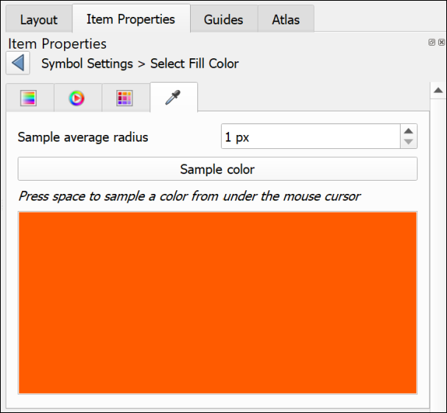

The color picker tab.

* Click on the Sample color button to get the color picker cursor, then hover the cursor over the correct colour on the map.
* To select the colour, press the spacebar on your keyboard.

The colour should be applied automatically to your element.

##### Covering unwanted text or elements

This is an example of lateral thinking, but the easiest way to get rid of unwanted text or elements that can’t be removed using the legend properties, is the following:

* Go to Add Item > Add Shape > Add Rectangle and draw a rectangle over the text or elements you want to remove.
* Set the fill of the rectangle to the same colour as the background (using the color picker as above if necessary).
* Set the stroke style to No pen.

You can then add any new elements on top of the “invisible” rectangle.

##### Adding new or extra text

Adding new or extra text is really just a case of adding a label in the usual way.

* Add Item > Add Label
* Change the font, font size, colour, etc, to match any other text on the legend.

#### Preventing the legend from crashing QGIS

If you have a problem with QGIS crashing when you add a legend, try the following. It is probably crashing because you have a lot of layers on your map and, because Auto update is selected, it is struggling to add all of the details.

* Open a new, empty project in QGIS
* Create a new blank layout as you did above.
* Add a legend to the layout. It won’t have any content, but that’s fine.
* Untick the box in the legend properties that says auto-update
* It’s a good idea to add a title and a frame to the legend so that you can find it again!
* Save the layout as a template (Save as template button on the toolbar)
* Close the blank project and reopen your real project
* Create a new layout use the template that you saved by doing the following:
  + Project > Layout Manager
  + Under New from Template select Specific from the dropdown
  + then click on the three dots button next to the blank field
  + Select the template that you just created and Open
  + Click on the Create... button and you’ll be asked for a name for your layout

Once you have the layout open add a map frame. You’ll then need to associate the map frame with the legend by selecting the legend and setting the Map to the correct map.

Now use the + (plus) button below the Legend Items to add the layers that you do want to be included. Ticking Only show items inside linked map will also help.

This is a fiddle and not ideal, but if it stops your QGIS project from crashing hopefully it is worth it!

### Scale bar and scale text

Some indication of scale should always be added to both printed and screen maps. A scale bar is a useful convention for both. Scale text (e.g. 1:50,000 or 1 cm = 1 km) is only relevant for printed maps, not for maps on screen where someone can zoom to any scale. If you add scale text you must also ensure that you print or export the map at the correct scale.

 **Adding a scale bar and scale text to a map layout in QGIS.**

This video clip can be found in the module area of [Minerva](https://minerva.leeds.ac.uk) or in the [full list of video clips](https://cgordon-gis.github.io/videoclips.htm).

#### To add a scale bar

* Double-check first that you have the correct map selected on your layout. Particularly important if you are including multiple maps at different scales.
* Click on Add Scale Bar on the Toolbox
* Click on the layout in roughly the position you want the scale bar (you can always move it later)
* Select OK on the New Item Properties box that pops up

The scale bar should appear on your layout. You can now go to the Item Properties to change various parameters.

* The Map dropdown is where you check that the scale bar is set for the correct map
* Use the Style dropdown to select how you want the scale bar to appear - try a few of these and see what effect they have
* The Scalebar units should be set to something appropriate for your map
* You can use the settings under Segments to change the length and intervals of your scale bar. Try these out and see what happens.

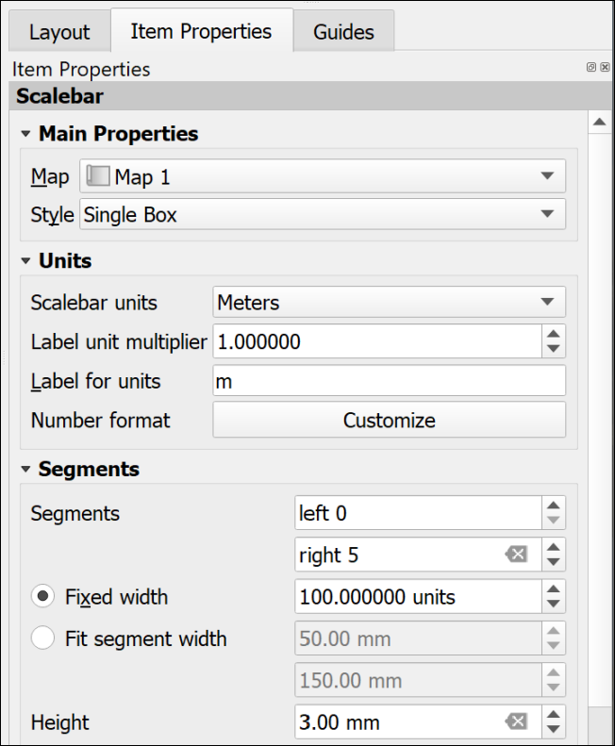

The most important settings for the scale bar.

There are a lot more settings so just explore these and see what they do. In particular you may want to change the Font under the Display settings. You can always remove the scale bar and start again!

#### To add scale text

* Click on Add Scale Bar on the Toolbox
* Click on the layout in roughly the position you want the scale text (you can always move it later)
* Select OK on the New Item Properties box that pops up

A scale bar should appear on your layout. You can now go to the Item Properties to change this to numbers.

* The Map dropdown is where you check that the scale text is set for the correct map
* Use the Style dropdown to select Numeric

The text should appear and automatically match the scale of your map. There are far fewer options for this - mainly just the Font settings.

### Text or labels

Text is an essential part of any map layout. Maps need an informative title to show the audience what the map is about. You should include your name (or for an assessment your student ID) as creator of the map. Copyright statements are essential if you have used data from other sources and you may also want to include acknowledgements and further explanations of your maps and data.

There are two main ways to add text, static text and dynamic text. The instructions for static text are shown below. Dynamic is more complex and won’t be covered here. If you are interested in using it you can look at the tutorial on [Creating a Dynamic Print Layout](https://docs.qgis.org/3.10/en/docs/training_manual/map_composer/dynamic_layout.html) in the QGIS Training Manual.

 **Adding text to a map layout in QGIS.**

This video clip can be found in the module area of [Minerva](https://minerva.leeds.ac.uk) or in the [full list of video clips](https://cgordon-gis.github.io/videoclips.htm).

#### Static text

Static text is text that you type into the box on the Item Properties. This stays the same once you have added it. Most of the text that you add to your layout will be of this type. For example, a title or subtitles to individual maps, your name or ID as the creator of the map, copyright text etc.

##### To add static text:

* Click on the Add Label button on the Toolbox
* Click on your layout in roughly the location that you want your text to appear. You can move and resize it later. You can also “drag” the box to the correct size as you add it.
* If the New Item Properties dialog appears click OK
* A new label item should appear on your layout. By default the text will be “Lorem Ipsum” (placeholder text).
* Type your text in the box on the Item Properties panel
* The options on the panel will also allow you to change the font, font size and colour, the alignment, and add a frame.

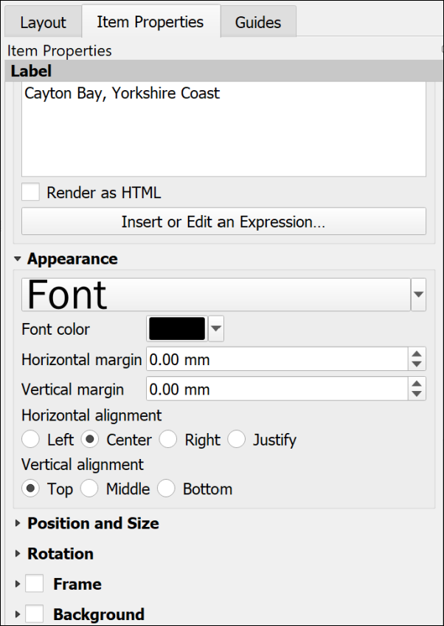

Item Properties for text. Note the large box to type your text and the options in the Appearance section below.

##### Copyright acknowledgements

Copyright is important. Remember that most data providers ask you to sign up to conditions that include an obligation to add a copyright acknowledgement to your map. Check what that copyright statement is and make sure that you add it.

For example, when you signed up to use the Digimap collections you agreed to add copyright acknowledgements whenever you created a map with the data. These acknowledgements do change from time to time so it’s worth knowing how to check what they are for yourself.

* To find the Digimap copyright acknowledgements go to the Digimap Resource Centre (**Resources** at the top of the main Digimap page)
* Look for a link to Digimap Licence Agreements and click on it.
* Click on the End User or Sub-licence agreement for the data that you’ve used. Some of these are pdf documents that you need to download.
* Then look for the information under In return, you must: - that gives you the acknowledgement text.

For example, from April 2019, when you use **Ordnance Survey** data obtained from Digimap you are expected to add the following text to your map.

© Crown copyright and database rights *year*. Ordnance Survey (100025252).

Where *year* is replaced by the current year.

Remember that you do have to acknowledge each different dataset that you use and will have signed up to that when your registered.

 **Adding the copyright symbol to your text**

To add the copyright symbol (©) to your text (Windows computers)

Check that the Num lock is on on the keyboard

Hold down the Alt key

Use the number pad to type 0+1+6+9

Release the Alt key

If you are **not** using U.K. Ordnance Survey data this is **not** the correct copyright acknowledgement to use. For example, if you are using data for Spain or the United States, or indeed UK data that you haven’t downloaded from Digimap. You’ll need to find the correct copyright acknowledgement for yourself. You can often find this sort of information on files that come with the data or on the webpage you downloaded it from.

Digimap also give advice on [citing Digimap data](https://digimap.edina.ac.uk/webhelp/digimapsupport/about.htm#license_and_terms_of_service/citation.htm) as opposed to the copyright acknowledgement.

GIS Lounge have an article about [How to Cite GIS Materials](https://www.gislounge.com/how-to-cite-gis-materials/) which includes the software as well as the data and the maps.

### A measured grid

Measured grids add labelled grid lines to a map. If you are using Ordnance Survey or other UK data projected in British National Grid then you can easily add National Grid lines and numbers to your map. The O.S. Raster tiff files already have grid lines marked, but adding a measured grid allows you to include coordinates around the edge of your map - making it possible to read grid references.

 **Adding a measured grid to a map in QGIS.**

This video clip can be found in the module area of [Minerva](https://minerva.leeds.ac.uk) or in the [full list of video clips](https://cgordon-gis.github.io/videoclips.htm).

* Click on the map to which you want to add grid lines.
* In the Item Properties scroll down until you reach the Grids heading and click on the little arrow next to it.
* Click on the + (plus) button below the Grids heading to add a Grid to the list below.
* Select the Grid in the list and click on Modify Grid...

The Item Properties will change to show the properties for the grid.

* Under Interval set the X and Y boxes to the interval that you want between the lines. This depends on the scale of your map and you can experiment to see what looks best and would be most useful. For now try 1000 - this is in map units which for British National Grid will be metres.
* The lines are often too bold, so click on the Line style dropdown and select a paler shade of grey. You could also make the lines thinner.

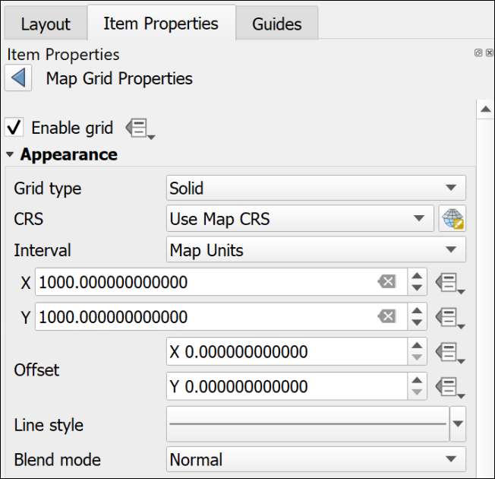

The top of the Map Grid Properties showing the interval and the paler line style.

* Scroll down and tick next to Draw Coordinates - this adds the numbers.
* I usually change the Left and Right coordinates from Horizontal to Vertical so that they follow the edge of the frame.
* Alter the Font as you wish - don’t make the coordinates large. They need to be visible, but not intrusive.
* Change the Coordinate precision to 0

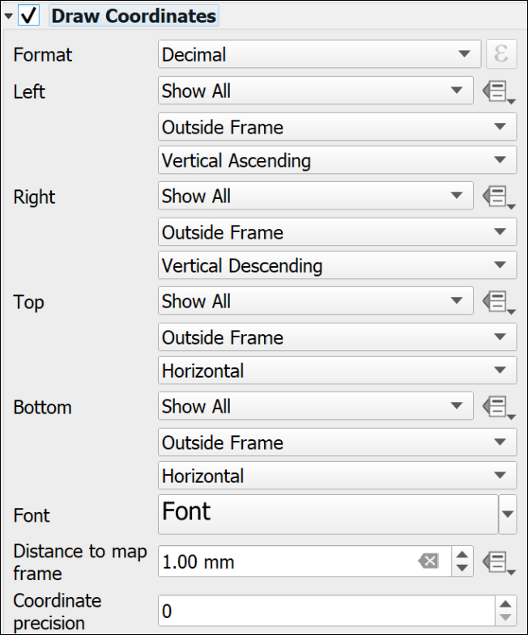

The Draw Coordinates part of the Map Grid properties showing the Vertical setting for Left and Right and Coordinate Precision set to 0.

Note that the grid that QGIS adds is fully numeric, you may be more used to seeing grid letters for 100 km grid squares, e.g. the University grid **reference** is similar to SE 2934 3444, the University grid **coordinates** are similar to 42934 43444. It is the latter that will appear on a measured grid generated by QGIS.

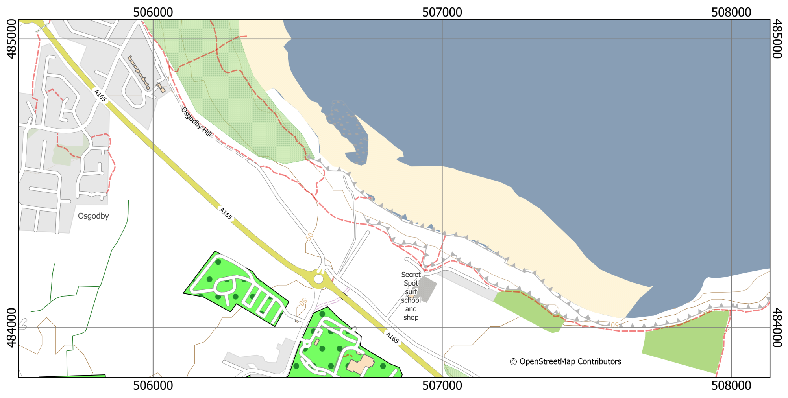

A map with a measured grid that shows British National Grid coordinates on a 1000 m grid.

### North arrows

Before adding a north arrow to your layout stop and think about how you need to indicate north on your map. If you look at the technical information on an Ordnance Survey Landranger (1:50 000) map you’ll see a diagram showing Grid north, True north and Magnetic North. The information given there shows how to plot the difference of magnetic north from grid north. Adding this to your own maps can be useful, particularly if you, or anyone else, are going to be using the map in the field.

If you are taking strike and dip measurements in the field you should have corrected your compass-clino for declination (the horizontal angular difference between true north and magnetic north) anyway. When you plot the measurements on your map it isn’t worth worrying too much about whether you are plotting against grid or true north as the difference on any grid, not just the British National Grid, is unlikely to be that big. See the image below for the different types of north and the declination.

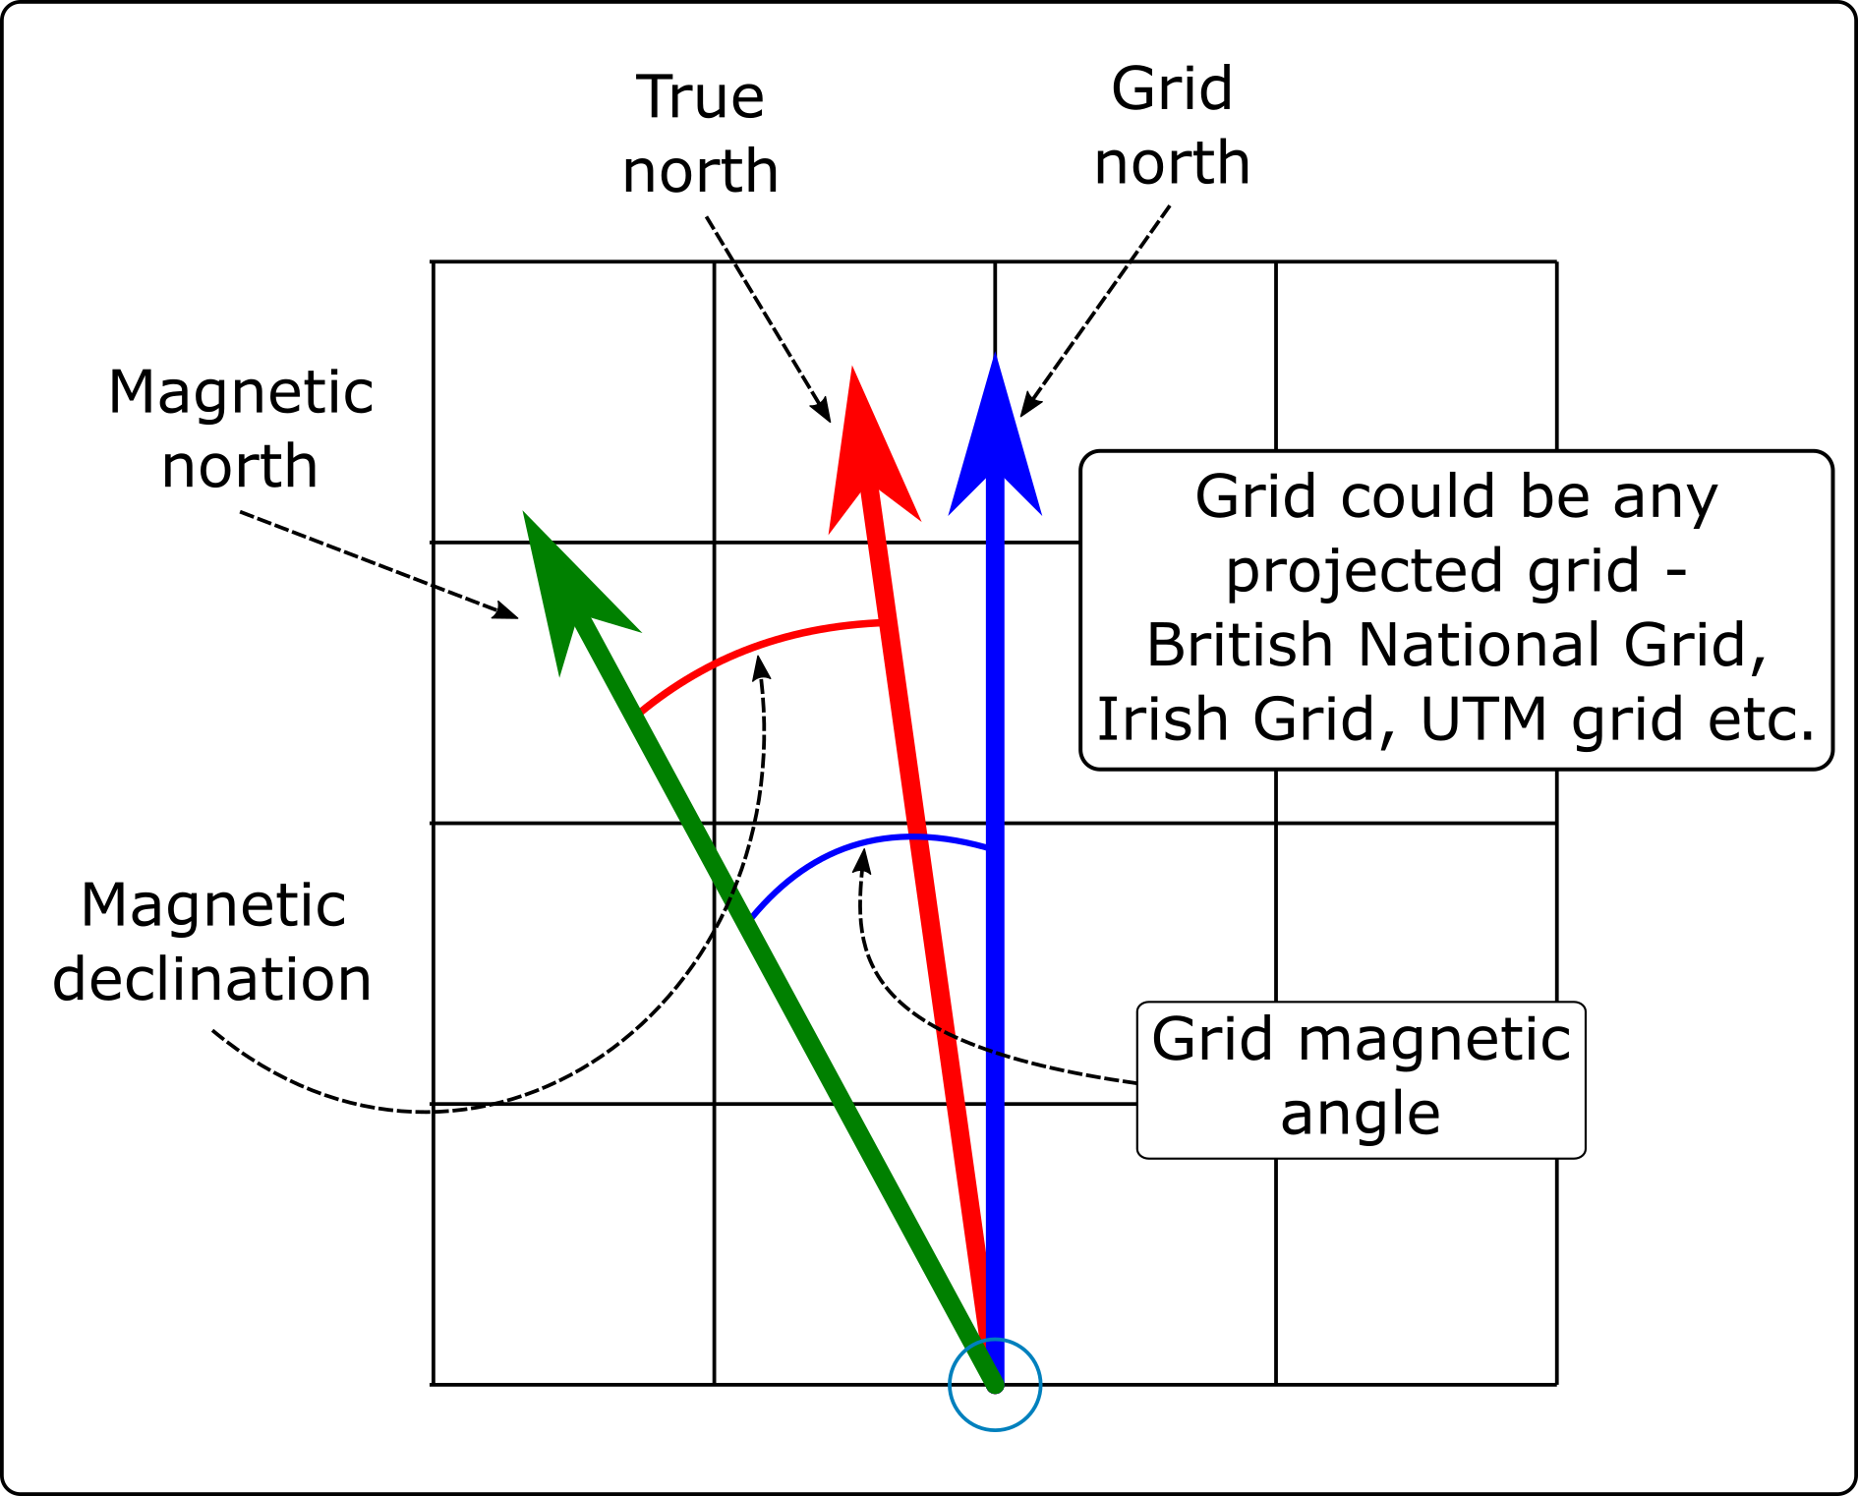

The different types of North that you will find on a map set to a projected coordinate system, such as British National Grid.

 **Labelling north arrows**

If you add any north arrows to your layout do remember to label them in some way which shows which version of north each one is showing.

 **Adding north arrows to a layout in QGIS.**

This video clip can be found in the module area of [Minerva](https://minerva.leeds.ac.uk) or in the [full list of video clips](https://cgordon-gis.github.io/videoclips.htm).

#### North arrow: Grid north / Map north

If a map is in a projected coordinate system QGIS will automatically lay it out aligned with the grid. So for example, any map set to British National Grid will be aligned to grid north.

In this case it isn’t strictly necessary to add a north arrow to show grid north if you also include a measured grid on your map, but it doesn’t hurt.

* Click on the Add North Arrow button on the Toolbox
* Click on your layout in roughly the location that you want your north arrow to appear. You can move and resize it later. You can also “drag” the box to the correct size as you add it.
* If the New Item Properties dialog appears click OK

QGIS will add a default north arrow to your layout and open the Item Properties.

* Under Picture check that SVG image is selected
* In the box below scroll down to svg > arrows to select a different north arrow. Note that it’s usually a good idea to keep these simple.
* Change the colours and stroke width under SVG Parameters if required
* Under Image Rotation the North alignment should be set to Grid North by default - if it isn’t set that now.

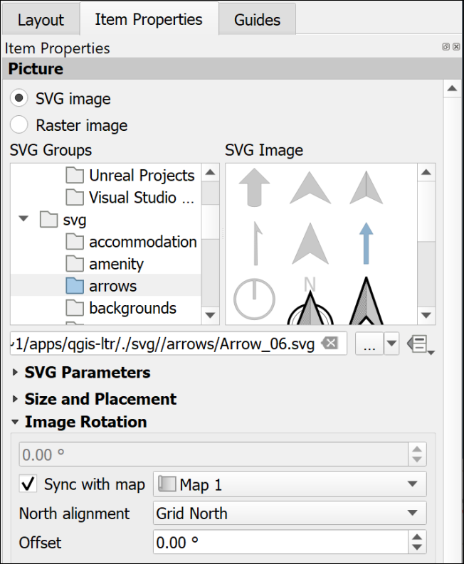

The Item Properties for a north arrow showing Grid North.

If you check this against your measured grid lines you should find that it matches exactly.

#### North arrow: True north

True north is the direction from the area of your map to the North Pole. In the east/west centre of a grid, such as that set for the British National Grid, it may well be the same as grid north, e.g. in Leeds the difference is extremely slight. As you go further east or west towards the edges of an area covered by a grid the difference becomes more noticeable, e.g. at Lands End in Cornwall, or in Norfolk.

* Click on the Add North Arrow button on the Toolbox
* Click on your layout in roughly the location that you want your north arrow to appear. You can move and resize it later. You can also “drag” the box to the correct size as you add it.
* If the New Item Properties dialog appears click OK

QGIS will add a default north arrow to your layout and open the Item Properties.

* Under Picture check that SVG image is selected
* In the box below scroll down to svg > arrows to select a different north arrow. Note that it’s usually a good idea to keep these simple.
* Change the colours and stroke width under SVG Parameters if required
* Under Image Rotation set the North alignment to True north

You should see the rotation in the box above change to a slightly different number.

If you check this north arrow against your measured grid lines you may well find that the north arrow is slightly tilted.

#### North arrow: Magnetic north calculated by declination

Magnetic north is the direction from the area of your map to the **magnetic** north pole. This is the number that is given on the corner of Ordnance Survey maps and the one geologists need for setting their compass-clinos in the field, so it is worth making a note of this on your map too.

##### Finding the magnetic declination

First you need to find the magnetic declination.

* Go to the World Magnetic Model 2020 Calculator on the [BGS Geomagnetism Group web pages](http://geomag.bgs.ac.uk/data_service/models_compass/wmm_calc.html)
* Use the map to navigate to your location and click to drop a point.
* A small results box will appear. The number you want is the Magnetic declination, which is in in the D column and MF row. There is a key to the results below the map and you are looking for degrees east.
* Make a note of the declination, including any minus sign.

##### To set magnetic north on a layout

* Click on the Add North Arrow button on the Toolbox
* Click on your layout in roughly the location that you want your north arrow to appear. You can move and resize it later. You can also “drag” the box to the correct size as you add it.
* If the New Item Properties dialog appears click OK

QGIS will add a default north arrow to your layout and open the Item Properties.

* Under Picture check that SVG image is selected
* In the box below scroll down to svg > arrows to select a different north arrow. Note that it’s usually a good idea to keep these simple.
* Change the colours and stroke width under SVG Parameters if required
* Under Image Rotation set the North alignment to True north as declination is the angle from True north to Magnetic north.
* In the Offset field enter the angle that you obtained from the BGS website.

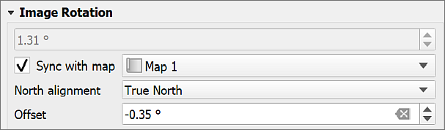

Setting the image rotation for a magnetic north arrow. The declination from the website is -0.35 degrees.

Don’t forget to add text to your map showing the date of the reading. It changes with time.

For more about how the [magnetic north pole is moving see the BGS blog](http://britgeopeople.blogspot.com/2014/01/somethings-happening-to-magnetic-north.html).

### Multiple maps on one page

It can be very useful to be able to place more than one map or map view on a single page, either so that you can show a different area, or a different zoom level for the same area. You can also use this to set up an automatic extent indicator which marks your study area on a map of a country.

 **Adding multiple maps to one layout in QGIS.**

This video clip can be found in the module area of [Minerva](https://minerva.leeds.ac.uk) or in the [full list of video clips](https://cgordon-gis.github.io/videoclips.htm).

#### Different areas of the same map

You can add multiple maps to your layout using the Add Map command in the same way you added a single map earlier.

If you add them directly both maps will show the same data and styling. You can then change the scale and extent on each one individually using the Item Properties and the Move Item Content button.

#### Maps showing different content

If you want to add further maps to your layout but have them showing different content you can do that too.

* Select the initial map frame on the layout
* Make sure that it shows the content that you want it to show and it is all styled correctly
* In the Item Properties go to the Layers subheading and tick on Lock layers
* Once you’ve done that you’ll have the option to tick Lock styles for layers too. This stops your styles from changing if you change them in the main map.

Now go back in to the map view and set up the map and layers so that they are as you want them for the second map.

* Back in layout view add a new map frame as before. This should reflect the map that you have open in the map view now.
* Once you are happy with this view in the Item Properties go to the Layers subheading and tick on Lock layers
* Once you’ve done that you’ll have the option to tick Lock styles for layers too. This stops your styles from changing if you change them in the main map.

As both of your maps are locked you will have to remember to unlock them if you need to make any changes to the styles or combinations of layers.

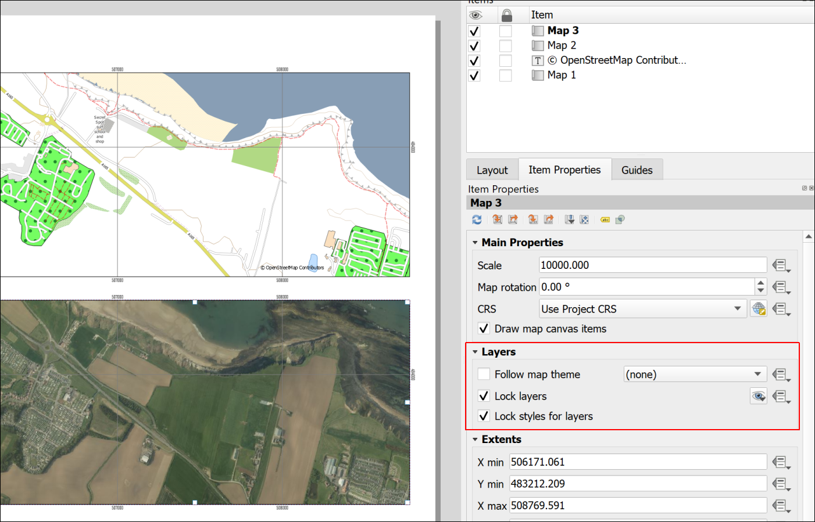

Two views from the same map with layers locked.

### Extent indicator or locator map

For some maps, particularly large scale (detailed) maps of very small areas, it is useful to show a small scale map of the general area with the area of the main map marked, as in the figure below.

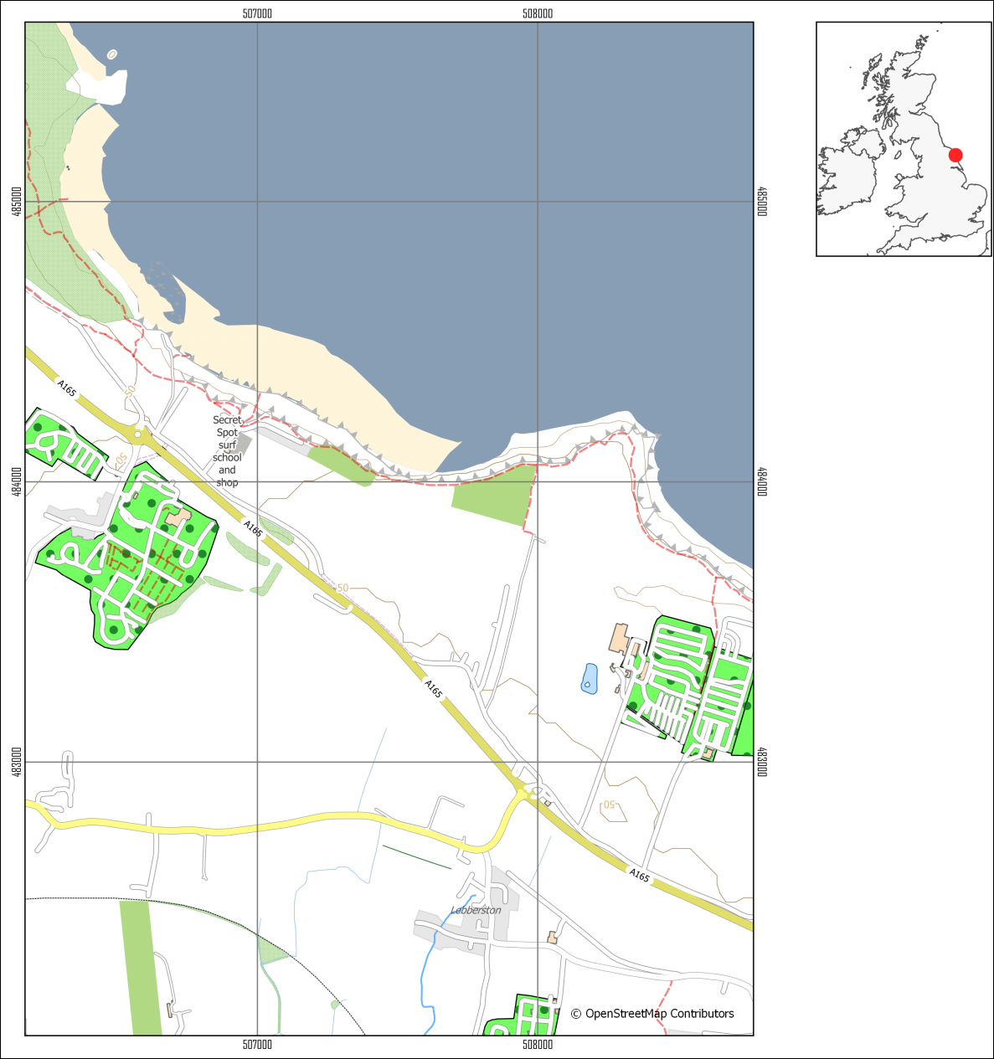

A map of a small area with an extent indicator or locator map to give context.

To do this you need to obtain small scale data and add it to your map. You really only need a general map, even just an outline of a whole country.

#### Natural Earth data

It is possible to do this using [data from Natural Earth](/finding_data/#natural-earth-data). Download the Countries data from Medium scale data, 1:50m > Cultural > Admin 0 - Countries - click on the Download countries button to download a zip file containing a shapefile.

#### Quick World map

There is also a little trick hidden in QGIS which makes adding a World map with country outlines really easy.

* In your QGIS project click in the Coordinate box at the bottom of your map then delete the existing contents.
* Type world (all lower-case) and press enter.

A map of the world with country outlines should appear on your map and in your Layers panel. When you zoom to layer the result might be a bit odd if you have a projection such as British National Grid set for your map, but try it out and see whether the area you need looks right.

You can style the map as usual, e.g. if you just want outlines.

 **Warning**

Using a screenshot from Google Earth or Google Maps (or similar) with a marker on it doesn’t look professional and should be avoided. Not least it is surprisingly easy to end up with the marker in the wrong place.

#### Adding the extent indicator to your layout

Note that the extent indicator does not need to be large, but should be a small map which doesn’t take up too much space on the layout.

 **Adding an extent indicator to a layout in QGIS**

This video clip can be found in the module area of [Minerva](https://minerva.leeds.ac.uk) or in the [full list of video clips](https://cgordon-gis.github.io/videoclips.htm).

* Set up your main map and lock the layers on the layout.
* Add the Countries outline to your map and turn off the other layers
* Symbolise the countries as a thin black outline and zoom in to the country containing your study area
* Add a new map to your layout and resize it as appropriate so that it shows the country as a small map.
* Make sure that the small map is selected then go to the Item Properties panel
* Scroll down to the Overviews section and click on the little arrow next to it to open it out
* Click on the + (plus) button then select the new Overview title that appears
* Check that Draw "Overview 1" overview (or whatever your new Overview is called) is ticked.

The properties to change how the overview looks are below.

* Under Map frame select your main map - the one of the smaller area.

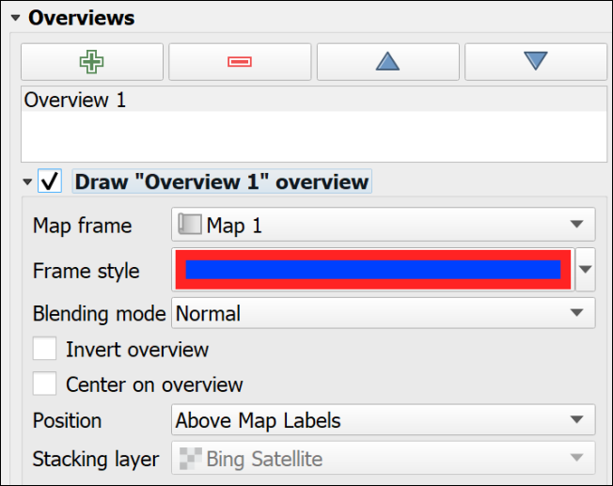

The Overview properties in the Item Properties for the small map.

* Set the Frame style as you wish. If you can’t see the frame on the indicator map because it is too small
  + I found that setting the Simple fill Stroke style to Solid Line in the Symbol Settings
  + then giving it a thicker Stroke width and setting the Join style to Round gave the effect of a dot on the map.

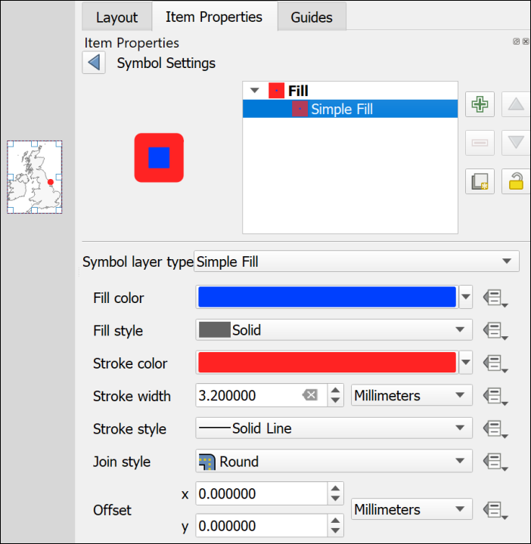

Using the Symbol Settings to make the overview frame look like a dot.

You should now have a map with a marker showing the location covered by your main map. If you move the main map the “frame” on the smaller map will automatically update to reflect the new location.

### Inserting photographs and images

You may want to include photographs and diagrams on your map layouts. Geological cross-sections will come under this category too.

 **Inserting photographs and images in a layout in QGIS**

This video clip can be found in the module area of [Minerva](https://minerva.leeds.ac.uk) or in the [full list of video clips](https://cgordon-gis.github.io/videoclips.htm).

#### To add a raster image

This includes photographs or any image in a format such as jpg, png, tiff, gif.

* Click on the Add Picture button on the Toolbox
* Click on your layout in roughly the location that you want your image to appear. You can move and resize it later. You can also “drag” the box to the correct size as you add it.
* If the New Item Properties dialog appears click OK

QGIS will add a blank picture place holder to your layout and open the Item Properties.

* In the Item Properties click to add a Raster Image
* Use the three dots button to navigate to and select your picture file then click Open

Your picture should appear on your layout. As usual you can resize it and move it on the layout and change the properties in Item Properties

#### To add an SVG image

SVG stands for Scaleable Vector Graphics. It is the native editing format for the vector graphics program [Inkscape](https://inkscape.org/). If you have used Inkscape to draw your diagrams you can import them as follows:

* Click on the Add Picture button on the Toolbox
* Click on your layout in roughly the location that you want your image to appear. You can move and resize it later. You can also “drag” the box to the correct size as you add it.
* If the New Item Properties dialog appears click OK

QGIS will add a blank picture place holder to your layout and open the Item Properties.

* In the Item Properties click to add a SVG Image
* Use the three dots button to navigate to and select your picture file then click Open

Your picture should appear on your layout. As usual you can resize it and move it on the layout and change the properties in Item Properties

 **Warning**

Unfortunately svg images with gradient fills don’t seem to work well in QGIS. In many cases it will be better to export your diagram from Inkscape as a png file then import that to QGIS as a raster image.

Alternatively, you can export the layout from QGIS when you have finished adding all the map elements and then open it in Inkscape and add your diagrams there. This is usually a better option and instructions will be given for exporting from QGIS later in this chapter.

## Checking your map

Checking your map is a very important stage but one that can easily be forgotten if you are in a hurry.

In addition to the points below have a look at Darkes (2017) which gives a lot of quick tips on map layout and presentation. On pages 92 and 93 Darkes includes a section with quick wins for improving your map before publication if you have 5, 15 or 50 minutes.

### Suggestions for things to check

* Check that you have included everything you need to include. If this is an assignment reread the instructions and check that you haven’t forgotten to do anything.
* Check that you have left space for margins on the page. This is particularly important if you are printing your map - you don’t want to lose any of the content - but leaving some white space around the outside of your layout looks better even if you’re not printing.
* Check spelling. It’s easy to miss something obvious so if possible print your map out, or put it on screen and stand back a bit then have a look at it. In particular check geological and geographical names and any technical terms.
* Check that your map doesn’t include anything that you don’t want to include! Did you add some experimental polygons when you were editing, then forgot to delete them? Have you added text boxes and then not removed any that you don’t need?
* Look at the article on [Using a mapmaking checklist for map design](https://www.esri.com/arcgis-blog/products/arcgis-online/mapping/using-a-mapmaking-checklist-for-map-design/?rmedium=redirect&rsource=blogs.esri.com/esri/arcgis/2012/05/03/using-a-mapmaking-checklist-for-map-design) on the ESRI blog. Read about what makes a map great, then click on the link to the checklist and use the questions there to evaluate your own map. Have you included everything you need to include, or do you have a good reason if something is not on your map? Have you taken care with your presentation?

### Printing a copy to pdf to check

Almost inevitably you’ll notice something not quite right with your map after you have printed it. To minimize the chances of this happening if you are printing an expensive A0 copy it is a good idea to print your map at A3 and have a close look at it. This isn’t such an issue if your map is only A3 or A4 when full size.

If you don’t have access to a printer then you’ll need to export as pdf and then zoom in and out on your screen.

* Export your layout as a pdf file following the instructions below.
* Open your pdf map file in your usual pdf reader (instructions below are for Adobe Acrobat but you should be able to find similar commands in other programs)
* File > Print
* Choose your printer and use the printer properties to set the paper size to A3 then choose to print in colour.
* In the Page Handling section set Page Scaling to Fit to Printable Area. In Acrobat this should show you a small preview of how your file will print.
* When you are happy with the settings send your file to the printer.

## Printing and exporting map layouts

When you have finished creating your map layout in QGIS, you will often need to export it to pdf for printing. The following instructions should help to ensure that your map is the correct size and scale.

 **Printing or exporting a layout from QGIS**

This video clip can be found in the module area of [Minerva](https://minerva.leeds.ac.uk) or in the [full list of video clips](https://cgordon-gis.github.io/videoclips.htm).

### Printing a map layout from QGIS

The best quality output is probably obtained by printing directly from QGIS, though this isn’t always possible. If it is, print as follows:

* Start by checking that the page size and the map scale are correct.
* Go to Layout > Page Setup and check that the paper size matches the size you set in the layout properties.
* Then Layout > Print to actually print your map.

You’ll need to set up the printer as you usually would. This is system and printer specific so I can’t include fuller instructions here.

### Exporting a map layout from QGIS

#### Exporting to pdf

These instructions show you how to export the map to pdf - the format that is usually required if you are having the map professionally printed.

* Start by checking that the page size and the map scale are correct.
* You should also check the Export Settings under Layout (the next tab to the left of the Item Properties. Check that the Resolution is set appropriately - too high and you’ll have an enormous file, too low and the print quality won’t be good. Try 300 dpi and see how that goes.
* In a layout go to Layout > Export as PDF... or click the button on the toolbar.
* Select where you want to save your output and give it a name
* Then click on Save
* The PDF Export Options should open. The defaults are fine, so stick with those
* Click Save to export the pdf.

You should get a message saying that your layout was successfully exported.

At this stage open the pdf and make sure it looks as you expect it to.

##### Important note on printing a map layout from pdf

If you are printing your final copy from pdf double-check in the pdf reader you use that the Page Scaling or Zoom is set to Actual size... or None. The actual terminology depends on which pdf application you are using.

This is important to ensure that your map is printed at the scale at which you intend it to be printed. This is particularly important if you are printing maps to be used as field slips. Major problems with measurements can be caused if your map is reduced by even a tiny amount.

##### Importing a pdf map layout in to Inkscape

 **Export pdf and import to Inkscape**

It is possible to export a map layout to svg which would work in Inkscape, but at the moment the export is rather unreliable. If you want to open your map layout in Inkscape to finish it off it is better to export pdf and import that to Inkscape.

I have experimented a bit with using the output from QGIS in Inkscape for a large map, and have found that, unless you are going to actually want to edit some aspects of the actual map, Inkscape is more stable if you import the map as an image, e.g. png format, and then add other elements around it. The next section below shows how to export your map as a png image.

If you need to make changes to a single element of your map, e.g. the legend, try creating the legend on a separate, smaller layout, export that as pdf and then add that to the main layout in Inkscape.

If you are importing the pdf in to Inkscape and if your map is going to be part of a bigger presentation where scale is important, such as the Geology degree final dissertation map, be very careful to import it without changing scale, size or proportions. The Interactive Inkscape exercises[21] have a section on how to import a map layout.

#### Exporting a map to import to Word and PowerPoint

You can also export the layout to include in programs such as Word or PowerPoint if you are intending it to accompany a report.

* Start by checking that the page size and the map scale are correct.
* You should also check the Export Settings under Layout (the next tab to the left of the Item Properties. Check that the Resolution is set appropriately - too high and you’ll have an enormous file, too low and the print quality won’t be good. Try 300 dpi and see how that goes.
* In a layout go to Layout > Export as image or click the button on the toolbar.
* The Image Export Options will open. This gives you another chance to check the resolution.
* It’s usually worth ticking Enable antialiasing - but if your map looks very blurred it will be worth trying again with this unticked.
* If you are likely to want to open your output in GIS again click to Generate world file
* Click Save and wait for your file to be exported. You’ll get a message when it finishes.

Be aware that it is a good idea to create your layout at the correct size in QGIS before you export it. You can resize jpg or png files in Word and PowerPoint but you’ll lose some of the quality.

## Setting up to print multiple map pages

Sometimes, once you have a map set up, you need to print it across multiple pages. The most likely example of this is for Geology students, where you set up your field slip ready for mapping, but it will need more than one page to print it at 1:10,000. Other students probably won’t need to do this, but the instructions are here anyway.

 **Warning**

Unless you need to set up a map as a series of field slips, or atlas pages, don’t follow these instructions now. It will be better to spend your time on other aspects of your map.

There are a couple of different ways you can do this and instructions are below.

* For all of the options, start by setting up a layout with a map frame and any other elements you need to include, e.g. a scale bar, copyright text, date etc.
* It can be useful to have an outline of your area of interest so you can keep track of the area you need. If you don’t already have one in your map, create it as a polygon and roughly digitise the outline of your area.

### Moving the map around within the layout

This method is probably the simplest, but it can be easy to miss bits, and if you do, it isn’t always easy to repeat the process.

 **Generating multiple map pages by moving the map around in the layout**

This video clip can be found in the module area of [Minerva](https://minerva.leeds.ac.uk) or in the [full list of video clips](https://cgordon-gis.github.io/videoclips.htm).

* Set up your map layout, then move the map so you are looking at the north-west corner of your area of interest.
* Check the scale is correct.
* Print or export your map. If you export, you’ll be able to print further copies if you need them.
* Now **carefully**, using the Move item content tool, click and hold on the north-east corner of your map, and drag the map content across so that the bit you are dragging from is in the north-west corner of the layout. It’s usually a good idea to have an overlap.
* Once again, print or export your map.
* Continue doing this, dragging the map upwards from one of the southerly corners when necessary, so you have complete coverage of your study area.

### Using the QGIS atlas function

This seems more complex, but if you make the effort, it is more reliable and if you need to generate maps for the same area again, it will be much simpler to do so than with the method above.

Once you have set up an atlas, QGIS will automatically export the pages based on your settings.

 **Generating multiple map pages with the QGIS atlas tool**

This video clip can be found in the module area of [Minerva](https://minerva.leeds.ac.uk) or in the [full list of video clips](https://cgordon-gis.github.io/videoclips.htm).

#### Creating a grid to control your atlas

You need to start by creating a coverage layout to control the area of each page of your atlas and the most reliable way to do this for field slips is to set up a vector grid to cover your area of interest.

To generate your vector grid:

* Search for Create Grid in the Processing toolbox and open the tool from under Vector Creation.
* Set Grid type to Rectangle (Polygon).
* If you have a layer covering the whole of your area of interest on your map, click on the three dots button at the end of the Grid Extent line and select Calculate from Layer, then select your area of interest layer.
* If you don’t have a layer covering the whole of your area of interest, select either Use map canvas extent or Draw on Canvas. If you select the latter, you’ll have a chance to draw your area on the map.
* Use the table below to select your Horizontal spacing and Vertical spacing based on the scale of your maps, and the size of your paper.
* Set the Grid CRS to the correct CRS for your map.
* Either create a temporary layer, or choose where to save your vector grid.
* Run the tool.

Note that the values in the table allow for a bit of an overlap. For landscape orientation instead of portrait, swap horizontal and vertical spacings.

This is a process which is likely to involve a bit of experimentation and changes in spacing to get the coverage you want.

| Paper size and orientation | Scale of map | Horizontal spacing (metres) | Vertical spacing (metres) |
| --- | --- | --- | --- |
| A4 landscape | 1:2,500 | 600 | 400 |
| A4 landscape | 1:5,000 | 1250 | 850 |
| A4 landscape | 1:10,000 | 2700 | 1800 |
| A4 landscape | 1:25,000 | 6500 | 4400 |
| A4 landscape | 1:50,000 | 12000 | 9000 |

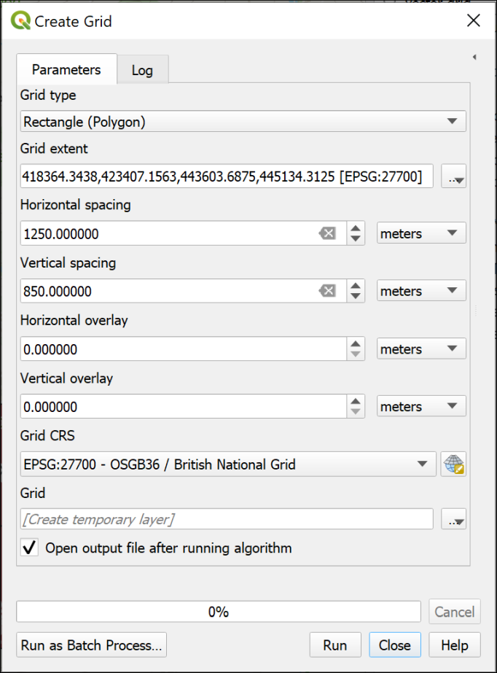

Creating a grid on which to base an atlas.

The result should be a regular grid, shown as the blue, dashed lines in the image below. (The thin, solid blue line is my area of interest.) The grid starts from the top left, so you may find you have too much space on the right and bottom of the grid. The main way to deal with this is to change the grid spacing, or use a slightly different area. If any of your grid rectangles have very little or none of your area of interest in them, as in the right-hand rectangles in the example below, you can delete them.

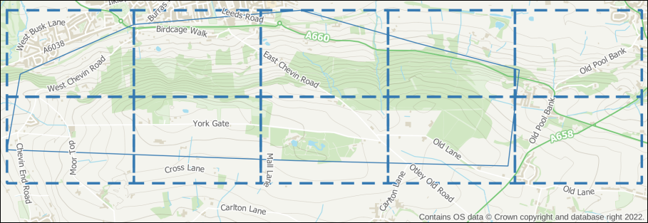

The resulting vector grid shown as a blue, dashed line. The rectangles on the right contain very little of the area of interest, and I will delete them.

#### Setting up the atlas

Once you are happy with your coverage layer, you can start setting up the atlas.

* Enter Layout view and check your layout is set up correctly, e.g. with titles, scale bar, copyright, etc as required.
* Go to Atlas > Atlas Settings - the settings should open to the right of your layout.
* Tick the box labelled Generate an atlas.
* Set the Coverage layer to your vector grid layer.
* For now leave the Hidden coverage layer box unticked - being able to see the coverage layer while you are setting up, helps to get the correct areas on each page.
* For now you can leave the other settings as they are. You can come back to the settings and change those later if you need to.

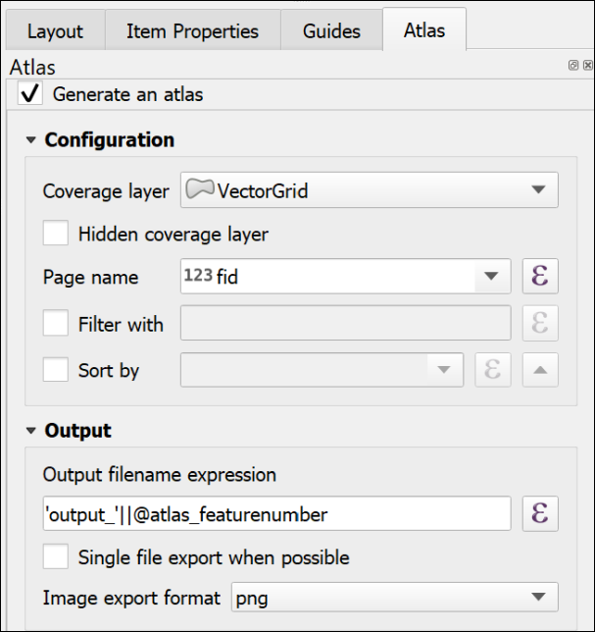

The basic settings for an Atlas. Note that there has to be a Coverage layer, which in this case is my vector grid layer.

The next options are in the map properties:

* Click on the map frame that will control your atlas.
* Click on the Item Properties tab on the right.
* Scroll down and tick the box next to Controlled by Atlas.

If you are setting up a field slip you will need your maps to be at a fixed scale, usually 1:10,000. To set that fixed scale:

* Check next to Fixed scale.
* At the top of the Map Properties, check the Scale is set correctly - in my case to 10000.000 for 1:10,000.

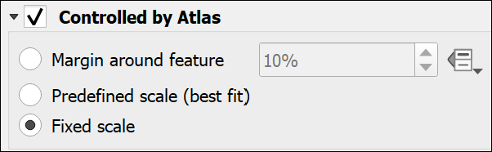

Controlling the Atlas as a Fixed Scale in the Map frame properties.

* Now go up to the Atlas toolbar - if it isn’t visible go to View > Toolbars > Atlas toolbar.

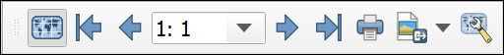

The Atlas toolbar with the Preview Atlas button clicked.

* Click the button on the left of the toolbar - the tooltip should say Preview Atlas.

Your map frame should jump to the first atlas page for your map. As you’ve left the coverage layer visible, you should be able to check whether you have the coverage you need.

* To preview your atlas, use the arrows on the toolbar. The numbers show which page you are on.

 **Changing the coverage**

If you need to change the coverage, you’ll need to regenerate the vector grid, add it to your map, and change the coverage in the Atlas settings.

Preview your atlas again, and check whether it looks right.

#### Printing or exporting an atlas

Once you are happy with the coverage of your atlas pages:

* If you want to, make the coverage layer invisible by going to the Atlas settings and putting a tick next to Hidden coverage layer.
* Also in Atlas settings, you can choose whether to export multiple files, or tick next to Single file export when possible to generate a single file with multiple pages. This will work for pdf, but not most image formats.
* Double-check the scale is still correct.
* Go back to the Atlas toolbar and either click on the button to print your atlas, or choose one of the export buttons.
  + If you are printing later, then choose pdf. This will also work best if you are going to make changes to your maps in Inkscape.
* If exporting, choose the folder you want to save your output(s) into, then click Select Folder.
* The defaults are usually fine, so stick with those for now, and press Save.

Depending on the number of pages you may have to wait for a bit, but once QGIS tells you it has finished, your file(s) should be available in the folder you selected.

Check the output, and make any changes to your coverage or layout as necessary.

There are other settings you can try, including using Expressions to add a page number or a different title for each page. The sources of help suggested below include more on this.

If you have a vector grid, it is also possible to create a final, less detailed map, which shows the coverage of each individual page - a map index.

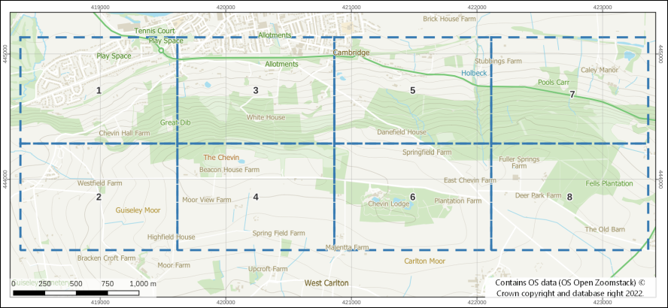

A map index created from the coverage layer with the grid rectangles labelled with the map number.

#### Other sources of help for creating an atlas

There is a lot online about creating atlases in QGIS. Try any of the following:

* [Training manual lesson on using the Atlas Tool](https://docs.qgis.org/3.22/en/docs/training_manual/forestry/forest_maps.html) - this uses a vector grid to control the pages of the atlas and this is what you are most likely to need for field slips.
* [QGIS manual page for Generating an Atlas](https://docs.qgis.org/3.22/en/docs/user_manual/print_composer/create_output.html#generate-an-atlas)
* [Klas Karlsson YouTube video on creating an atlas](https://youtu.be/KgPOwm7GrIo)

## Recommended reading: layout and presentation

The following references from the reading list[22] will give you information on the principles behind producing a professional layout.

* **Darkes and Spence (2017)** - large parts of this book are particularly relevant but it is formatted as a quick reference guide so it’s easy to get quick information about what ever you are looking for. If you can’t get hold of the 2017 version the link to the downloadable pdf of the 2011 edition is available on the reading list too.

Particularly useful in the Darkes and Spence book are the pages at the end titled “Better mapping in 5, 15 and 50 minutes”.

* The article by **Frye (2001)** gives you quick information about communicating with maps.

### Technical information

* The QGIS User Guide includes a chapter on [Laying out the maps](https://docs.qgis.org/3.16/en/docs/user_manual/print_composer/index.html) which covers a lot of the techniques from this chapter plus a few other things such as generating an atlas.
* QGIS Tutorials has a tutorial on [Making a map](https://www.qgistutorials.com/en/docs/3/making_a_map.html) in QGIS 3.

### Further information and inspiration

* For examples and ideas look at the [ESRI Map Book Gallery](https://www.esri.com/en-us/esri-map-book/maps#/list).
* The British Geological Survey printed maps are available online via the [BGS Maps Portal](https://webapps.bgs.ac.uk/data/maps/) and it’s worth having a look at the layout of some of the more modern sheets, such as the [Glossop sheet](http://www.largeimages.bgs.ac.uk/iip/mapsportal.html?id=1009336) or the [Bath sheet](http://www.largeimages.bgs.ac.uk/iip/mapsportal.html?id=1004283).

# Raster analysis 1

Last Modified: 14 Mar 22, 10:49:26

The background to raster analysis will be covered in the lecture segment at the beginning of the class, and the presentation and any other supporting materials will be available in Minerva. The lecture segment should help you to understand **why** you are doing these exercises. If you still aren’t sure, please ask [Clare](mailto:c.e.gordon@leeds.ac.uk).

## Learning outcomes

When you have completed this section of the workbook you should be able to

* Define raster data and understand how to find out raster properties and apply them to analysis
* select appropriate tools to carry out geoprocessing tasks
* Convert between vector and raster data types and describe the potential limitations

## Introduction

Raster analysis is a way of taking existing raster datasets and using them to generate new locational information. Analysis can show how locations are associated with one another based on properties and spatial relationships.

Virtually all the analysis that we will be doing on raster data can also be done on vector data, but due to the differences in the data models the analysis often works in a very different way.

You have already seen examples of raster analysis in the sessions on using elevation data. This chapter will build on that and introduce you in detail to more of the tools for processing raster-based data.

The first exercise will look at the Hebden Bridge area of West Yorkshire. In 2012 Hebden Bridge and nearby towns suffered two major flooding events within a few weeks of each other. Cloud-bursts on the moors above them caused heavy run-off. Sediment quickly blocked drains and shops and houses were flooded [23].

In this chapter and the next two you will investigate the catchment area of the River Hebden / Hebden Water, combining dtm data with rainfall data and then data on the population of the catchment.

## Data for the raster analysis exercises

 **Warning**

Being able to find, download and prepare your own data is an essential part of using GIS. For the exercises in this chapter you will need to download several datasets. While these should not take too long to download and prepare, don’t leave it until the last minute. Websites can become unavailable either permanently or temporarily, or computers can crash.

If there are problems with a website then try again later. If the problems persist please get in touch with me ([c.e.gordon@leeds.ac.uk](mailto:c.e.gordon@leeds.ac.uk)) and I will try to contact the site or find an alternative source of data.

### Data required

Download the following data - full instructions are below:

* From Digimap
  + Background mapping - Vector Map District Raster
  + Height data - OS Terrain 5 DTM - ASC (ascii text) format. Note that this is the more detailed version of the data that you used in the previous exercises.
* From Minerva
  + Rainfall data for 2016. This is in the RainfallData.zip file.

#### Data from Digimap

Download the data listed above from Digimap for the following minimum area around **Hebden Bridge**.

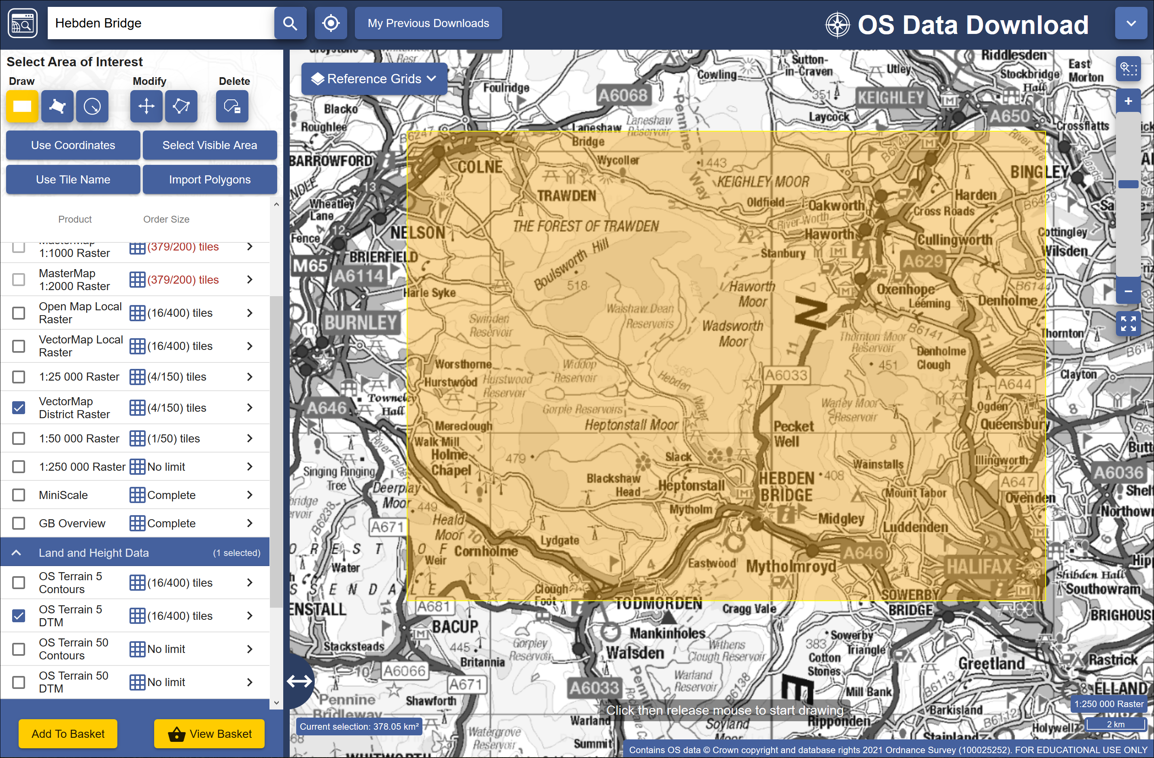

The minimum area for which to download data from Digimap for the Hebden Bridge exercises.

##### Preparing the data

* Add the background mapping (VectorMap District Raster) to a new map in QGIS. Check that the project coordinate system is British National Grid.
* Merge the asc tiles for the Terrain 5 DTM layer using the instructions from the elevation model exercises. Remember to add .asc files from any folder within your download or you won’t have the full area that you need. You need a single merged tif file for the dtm for the whole area. Remember that you may need to assign the CRS of the new layer to British National Grid.
* Don’t delete the original .asc files yet - you will also need these during the exercises.
* Use the hillshade tool to create a hillshade layer based on the merged dtm and add it to your map. Set the transparency of this layer to approximately 70%.

Make sure you have saved your map for use in the exercises that follow.

## What is raster data?

You should already have discovered that raster files show data in a grid. Each cell in that grid gives one value. Information in the raster file tells GIS the location of each grid cell, allowing QGIS to display the data in the correct location and to run processing tasks on multiple files.

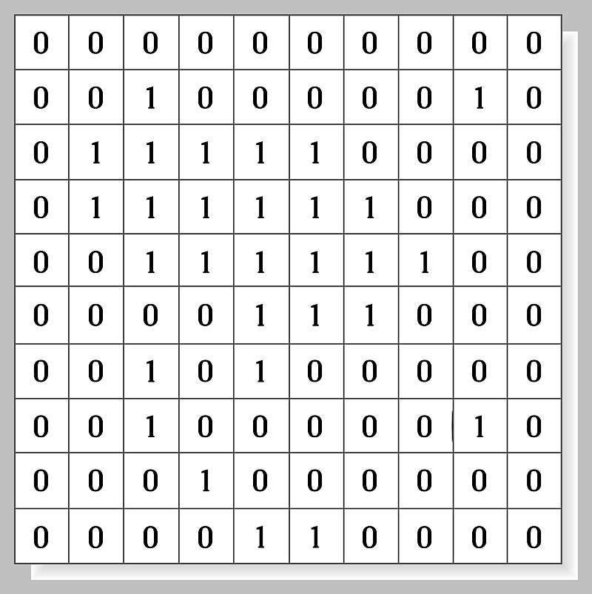

An example of raster structure. Note cells containing one value each.

For most of these exercises we’ll be using a raster format called tiff or GeoTiff which has a file extension of .tif [24].

## Raster properties

You have already been adding raster datasets to maps and using geoprocessing tools to analyse them, but now let’s have a closer look at them.

 **Checking layer properties in the Browser in QGIS.**

This video clip can be found in the module area of [Minerva](https://minerva.leeds.ac.uk) or in the [full list of video clips](https://cgordon-gis.github.io/videoclips.htm).

### Finding layer properties in the Browser panel

If you haven’t yet added data to a map you can check the properties using the Browser panel. This also allows you to have a look at a preview of how the data will look on a map.

You will have used the Layer properties window from the Browser panel already, in the elevation models chapter. You should also have checked this information about the original dtm files **before** you merged the Terrain 5 dtm tiles.

If you haven’t already made a note of the properties of this data, do so now.

 **Make a note of the following information about the original dtm files**

CRS:

Unit:

Width and Height:

Data type:

GDAL Driver:

Dimensions:

Pixel Size:

### Finding layer properties in the Layers panel

Once you have added data to your map you can check the layer properties via the Layers panel.

 **Checking layer properties in the Layers panel**

This video clip can be found in the module area of [Minerva](https://minerva.leeds.ac.uk) or in the [full list of video clips](https://cgordon-gis.github.io/videoclips.htm).

* Right-click on the merged Terrain 5 dtm layer in your Layers panel
* Select Properties...
* Click on Information on the left-hand side.

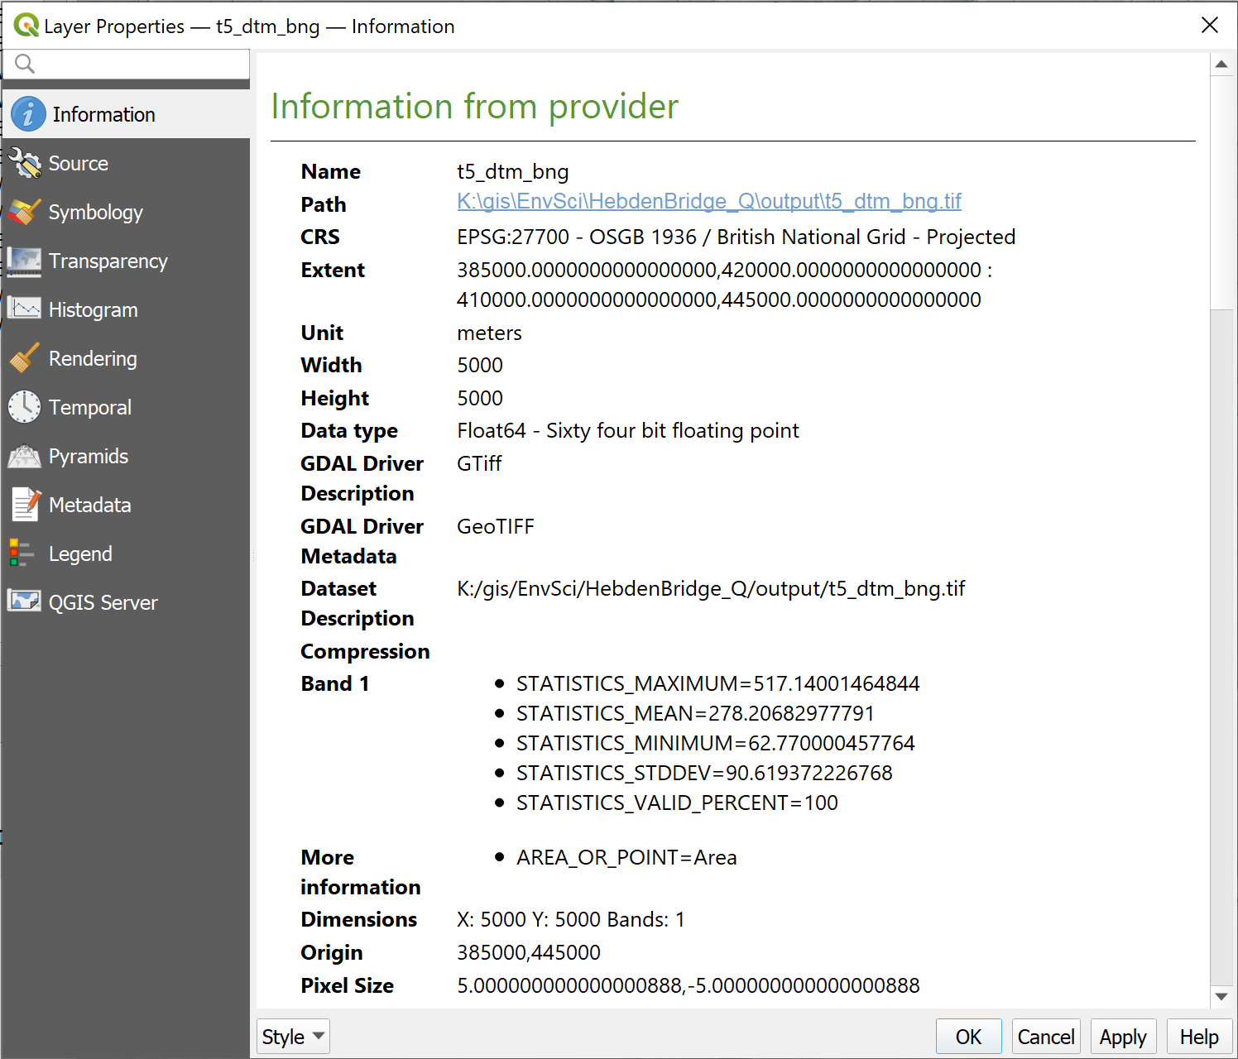

The layer properties opened from the Layers panel, showing the Information tab.

 **Comparing layer properties**

Have a look at the properties for your hillshade layer and make a note of the following.

CRS:

Unit:

Width and Height:

Data type:

GDAL Driver:

Dimensions:

Pixel size:

There is a lot of useful information here, but what does it all mean?

* You have already looked at the CRS and should know about that.
* Width and height show how many pixels there are in the x and y dimensions - this is also shown by the Dimensions
* The GDAL Driver shows you the type of file format
* Dimensions show you the pixels in the x and y dimensions, but also how many bands of colour or information the file holds. For a DTM file it is usually only 1, but colour images, such as background layers, often have three bands, one each for red, green and blue.
* Pixel size shows the size of each pixel in the Unit shown.

Between them the Width and height, Unit and Pixel size will give you a good idea of the **area** of your data.

 **What is the area of your hillshade layer?**

Given the pixel size and the width and height of your hillshade, what is the coverage of the file in square metres? You’ll need to do something like the following:

(width * pixel size) * (height * pixel size) = area in square units

### Data type

The Data type shows how the data is stored and knowing this can be essential when you start using your data for analysis.

* Floating point is data with a decimal point, e.g. 12.45
* Integer rasters store whole numbers.
  + Unsigned integers will represent only non-negative values
  + Signed integers will represent negative and positive values

It is possible to convert from one to the other, but data can easily be lost. When converting from floating point to integer types the numbers after the decimal points are merely truncated rather than rounded.

Floating point rasters tend to be used for **continuous** data. Values can change gradually over an area, such as a rainfall raster.

Integer rasters are more likely to be useful for categorised data. For example, a land-cover raster could contain values such as 1 for forest, 2 for farmland, 3 for scrub, etc.

* In QGIS make sure that you have the hillshade and merged DTM layers on your map. If you have the VectorMap Raster background layer make sure that it isn’t visible.
* Using the Identify Features tool click somewhere on your map in an area which has both the hillshade and dtm layer.
* Select to Identify All if you need to. If you have the Identify Results window set to Top down mode you won’t need to.

You should be presented with the Identify Results window showing both of the visible layers.

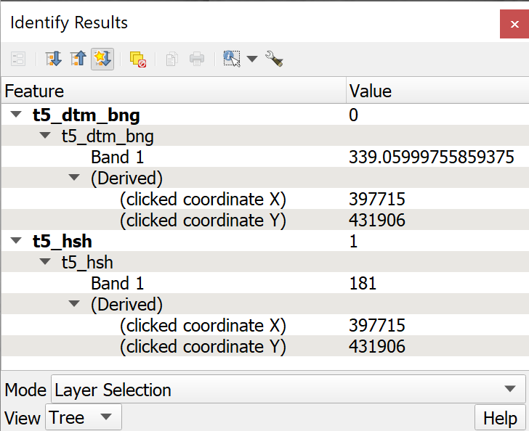

Using the Identify Features tool to compare the hillshade and dtm raster layers on a map.

Can you see the difference between the pixel values in Band 1 in the two layers? They will be different numbers anyway, but the floating point layer (the DTM) should have a value with decimal points, the integer (the hillshade) will only have rounded values.

Click in a few more places to compare further.

### Raster statistics

Each raster should have a section called Statistics in its properties.

* Return to the layer properties for the merged DTM layer from the Layers panel.

You should find in the Information tab that there is a section which contains statistics. Have a look at the information that is available to you there.

You should be able to see the maximum and minimum values, which in this case show the highest and lowest heights above sea-level, but also the mean and standard deviation.

## Creating an interpolated surface from point data

For the next section we’ll create a new raster layer from a vector dataset which contains rainfall data.

You should have downloaded from Minerva a csv file (comma-separated values) containing 5 km gridded rainfall data for the U.K. for 2016 by month [25].

Open the file in a spreadsheet app such as LibreOffice Calc, Office365 Desktop (not web), Google Sheets or Pages, and have a look at the data. This covers the whole of the UK and the first two columns give you locations in British National Grid eastings and northings.

You will want to use the **total rainfall** for 2016 rather than the monthly figures you have at the moment but you can add this to the attribute table within QGIS later.

* Add this point data to your map of the Hebden Bridge area in the same way that you added the hills data to the Lake District map.
* When using the Spreadsheet Layers plugin to import the spreadsheet, check that the data type for the monthly figures is set to Real, which is a number format, not Text.

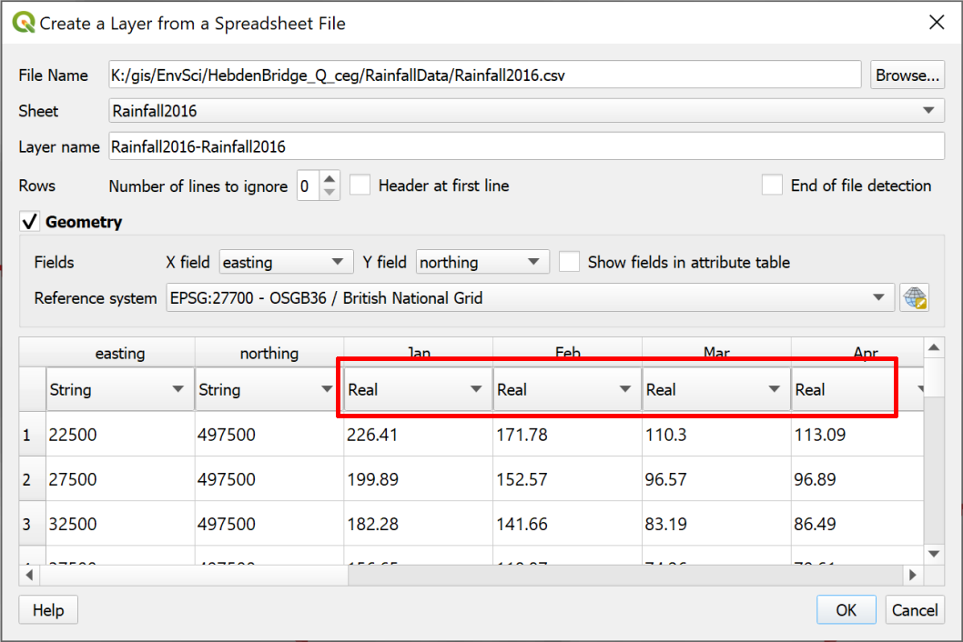

Checking that monthly totals are set to Real, not Text.

You should end up with a grid of points at 5000 metre intervals covering the whole UK - zoom to layer to check. If you don’t, check that you have added the file correctly. In particular check that you have chosen the correct columns to use for the x and y data.

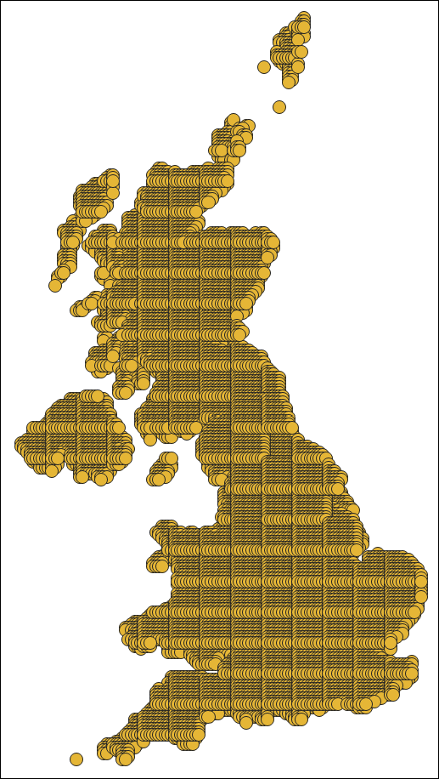

5 km gridded rainfall data for 2016 covering the U.K.

### Creating a new feature class with a subset of the data

For the analyses in these exercises you only need the rainfall data covering the same area as your dtm. You can restrict the data to that area at the same time as exporting it to a geopackage.

 **Exporting a subset of a feature class**

This video clip can be found in the module area of [Minerva](https://minerva.leeds.ac.uk) or in the [full list of video clips](https://cgordon-gis.github.io/videoclips.htm).

* Right-click on the Rainfall layer in the Layers panel
* Select Export > Save features as...
* Fill in the form as you have before, creating a new geopackage called Hebden Bridge
* This time put a tick in the box next to Extent and make sure you can see the boxes underneath.
* click on Calculate from layer and select your merged DTM layer - the North, South, East and West boxes should automatically fill.

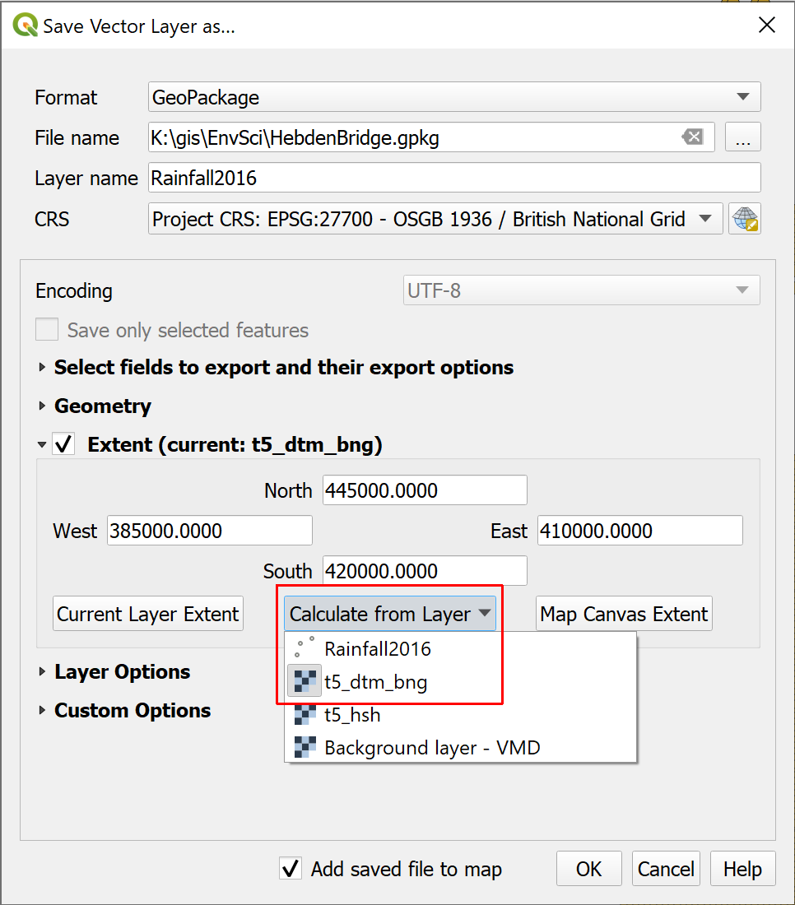

Saving just the rainfall points within the extent of the DTM layer.

* When you click OK to run the tool the output should be just those points which are within the extent of the merged DTM Layer.
* Remove the original Rainfall layer from your Layers panel to save time when the map redraws.

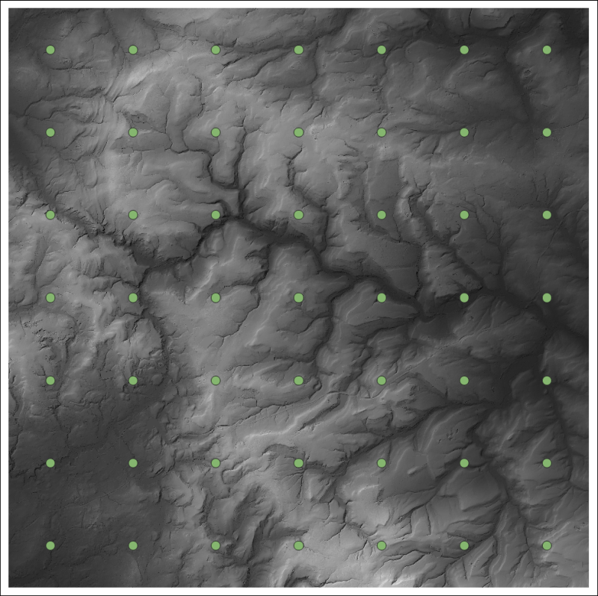

5 km gridded rainfall data for 2016 covering only the area selected in the Export tool - the area of your merged DTM.

### Creating a new field with the Field Calculator

If you look at the attribute table for your rainfall layer you’ll see that you have monthly rainfall totals for each location.

For the analysis you will need to calculate the total rainfall for each location for 2016 rather than using the monthly totals.

Luckily you can do this in the attribute table within QGIS.

 **Using the field calculator in QGIS**

This video clip can be found in the module area of [Minerva](https://minerva.leeds.ac.uk) or in the [full list of video clips](https://cgordon-gis.github.io/videoclips.htm).

* Open the attribute table for the rainfall layer if you don’t already have it open.
* Click on the Open Field Calculator button at the top of the attribute table, or use the keyboard shortcut Ctrl+I

The field calculator allows you to enter expressions to either update an existing field or create a new field. In this case we need to sum the existing fields.

* Check that Create a new field is already ticked
* Below that give your field a new name such as TotalRainfall
* Set the Output field type to Decimal number (real) - if you look at your existing data it consists of decimal numbers
* Now set up the Expression
  + The result will include unlimited decimal places, which is a bit silly in this case, so to limit it to two decimal places you can search for “round” in the Search box above the centre box - it will be under the Math list. Double-click on it to add it to the expression box then clear your search.
  + In the centre box look for the Fields and Values section and drop it down to see a list of the fields in your feature class.
  + Double-click on Jan to add it to the box on the left
  + Then click on the + under the left-hand box
  + Repeat this with each month field right up to December
  + put a comma - , then the number of decimal places that you want - in this case 2
  + Then close the brackets

Your expression should look as follows:

round("Jan" + "Feb" + "Mar" + "Apr" + "May" + "Jun" + "July" + "Aug" + "Sep" + "Oct" + "Nov" + "Dec", 2)

The form will show a preview at bottom left - check that this looks as you would expect it to.

* Once you are happy with your expression click on OK

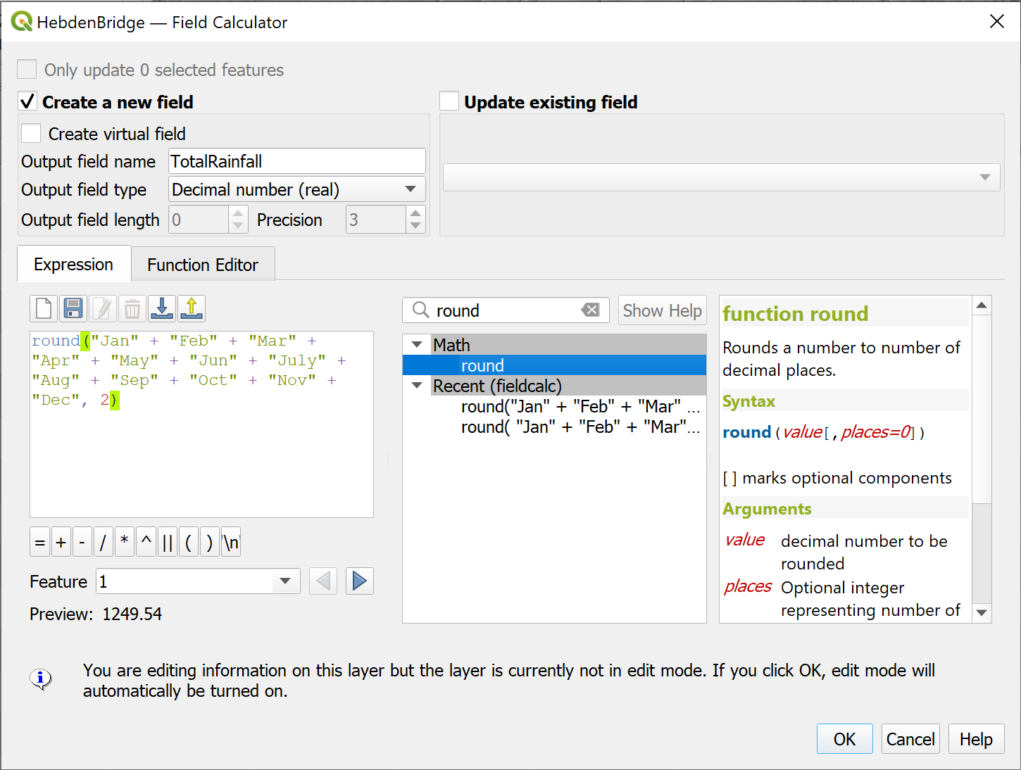

Entering the expression to total the monthly rainfall totals for each location into the field calculator to create a new field.

Calculating the new field will have put the feature class into Editing mode, so save the edits and click on the “Pencil” icon to stop editing before you go any further.

* Check that the results look correct then close the attribute table.

## Interpolating your data

This feature class shows the total rainfall at each particular point. What do you do if you want to know the rainfall at any point between those points, or over an area? GIS gives you the tools to **interpolate** point data to a continuous raster **surface** and calculate *z* values, or **totals**, for the spaces between the points. Inevitably the accuracy of the surface will increase if you have more data points in a particular area, but it still works if your points are widely spaced.

 **What are the potential issues with interpolation?**

Think about the potential issues. How reliable do you think the results are likely to be? How can this be affected by the original data?

There are several methods of interpolation available in the QGIS toolbox. The instructions below use Spline (RST) but you can also try IDW.

 **Interpolating surfaces from point data**

This video clip can be found in the module area of [Minerva](https://minerva.leeds.ac.uk) or in the [full list of video clips](https://cgordon-gis.github.io/videoclips.htm).

ESRI, who make the ArcGIS software that we’re not using, have an article entitled [Interpolating Surfaces in ArcGIS Spatial Analyst](https://www.esri.com/news/arcuser/0704/files/interpolating.pdf). Whilst that refers to their software not to QGIS, the principles are the same. Have a look at the article and their discussion of IDW and Spline amongst others.

The analysis tools in QGIS can all be accessed from the Processing Toolbox.

* Open the toolbox by going to Processing > Toolbox in the menu bar

The Processing Toolbox should open to the right of your map.

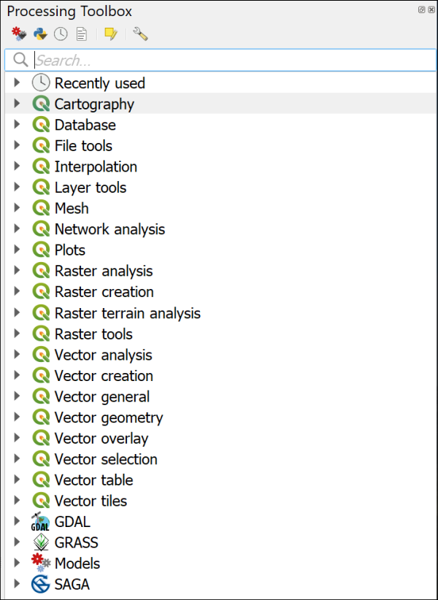

The Processing Toolbox when you first open it, showing the main tools and tool providers.

There is a choice of tool providers in the toolbox. Depending on your settings you should see a series of QGIS logos denoting native QGIS tools, but there may also be GDAL, GRASS and SAGA. You should be able to use GDAL and GRASS. If GRASS isn’t available make sure that you’ve started QGIS with GRASS. SAGA may well be greyed out, but you won’t need to use it in this chapter.

For more information about the processing framework in QGIS see the page in the [QGIS User Guide](https://docs.qgis.org/3.16/en/docs/user_manual/processing/index.html)

To use the tools:

* Start by searching for Spline in the box at the top of the toolbox
* Several options should appear. Double-click on the one under the GRASS heading called v.surf.rst
* Fill in the dialog as follows:
  + The Input points layer is your rainfall points layer
  + The Name of the attributes column... is the one containing the total rainfall for each location
  + Drop down the section for Advanced Parameters
    - Under GRASS GIS 7 region cellsize type the value 5 - this means that your pixels will be 5 x 5 m, which will match your elevation raster
  + Go down the form to the Interpolated RST field, click on the three dots button at the end and then on Save to file...
  + browse to the folder in which you want to save your output, then give your RST interpolated layer a name
  + Leave the tick under that box in place, but untick the rest of the boxes below.
* Now click on Run

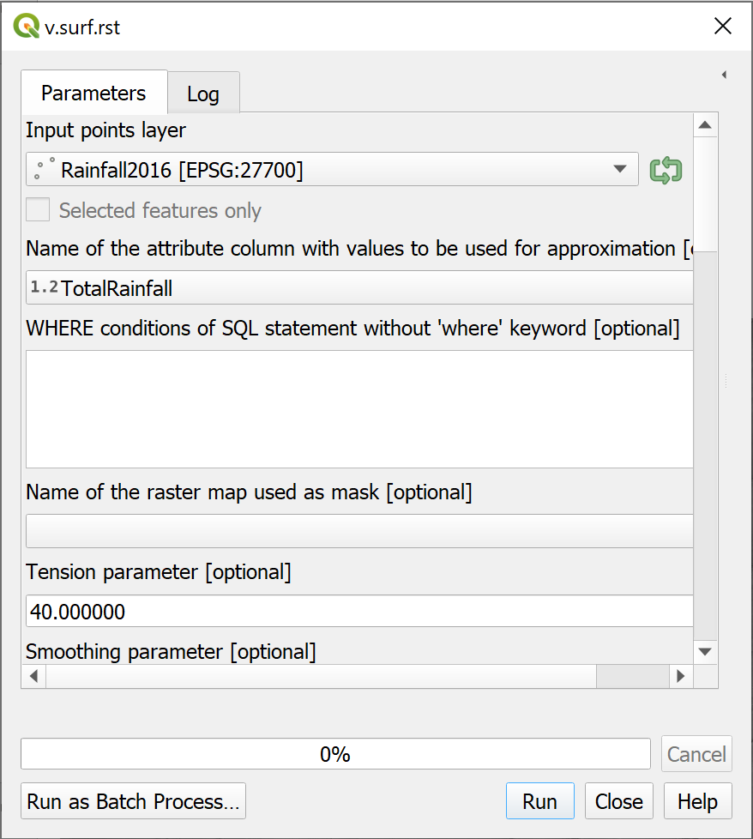

The form for RST interpolation.

The tool should run and add a new layer to your map. If it isn’t added automatically drag it there from the Browser.

 **Warning**

If the tool doesn’t run but says that GRASS is not available make sure that you have opened the version of QGIS which includes GRASS in it’s name. You may need to save and close your map, open the correct version of QGIS with GRASS, then reopen your map to get this working.

The tool will have interpolated the surface from your data points. You should end up with something similar, but probably not identical to, the picture below.

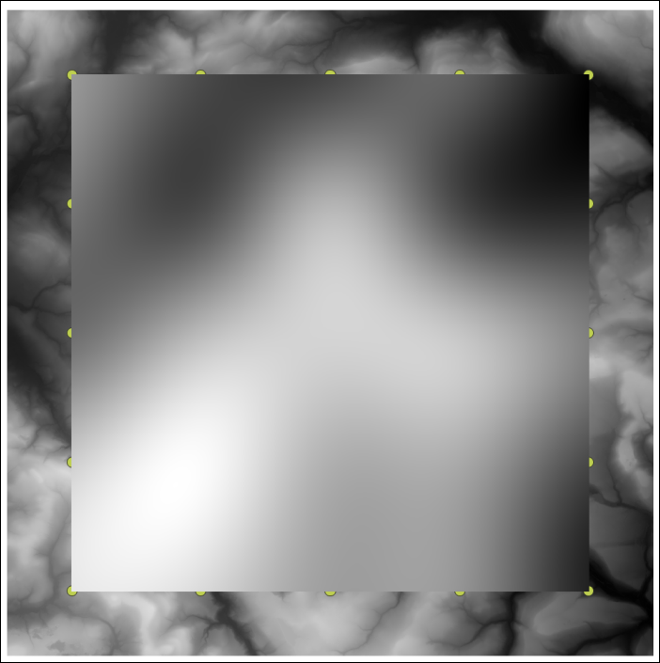

The output of the GRASS v.surf.rst tool.

 **Looking at your data**

If you look at the Layers panel you’ll be able to see the low and high measurements for the surface that you’ve just generated. Have a look at the attribute table of the points too. Do the measurements on the surface make sense in terms of the high and low of your original data?

If you look at the [ESRI article on interpolation](http://www.esri.com/news/arcuser/0704/files/interpolating.pdf) does that help you to understand why the surface may or may not vary from your data?

### Change the symbology of the raster surface

QGIS has used a default black to white colour ramp to display the rainfall surface but it should be possible to find a style which will be more informative for this raster layer.

You have already seen how to style a raster elevation surface. Styling this rainfall layer works in exactly the same way so have a go at that now. If you browse through the choices of colours available you should be able to find a suitable one for precipitation.

### Raster transparency

In addition make the rainfall surface transparent as follows:

* In the Layer styling panel click on the Transparency tab on the left
* Use the Global Opacity slider to change the layer so that the data below shows through.

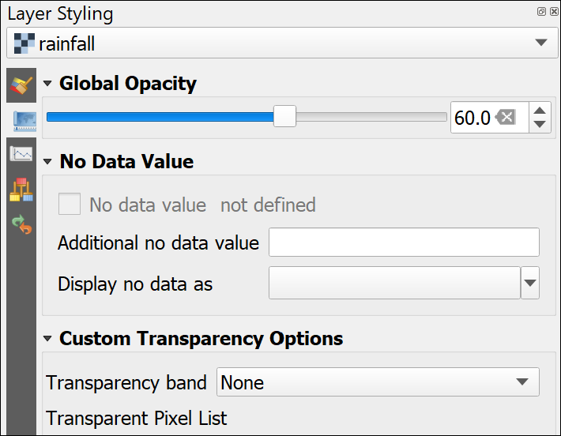

Setting transparency in the Layer styling panel for a raster layer.

Play with the slider until you are happy that your layer is suitably transparent so that the background layers show through but the raster surface is still clear.

 **Trying out other forms of interpolation**

The article linked above should give you an idea of which form of interpolation is best for your data, but it’s worth experimenting.

Search for IDW in the processing toolbox and try out the tool listed under the QGIS Interpolation heading.

Compare the resulting surface with the RST surface. What differences and similarities do you notice?

## Watershed delineation

This section will give you more experience of running geoprocessing tools and also of keeping track of new layers. Try to understand what each layer that you produce shows so that you can give it a name which makes sense, and so that you can keep track of what you are doing. It isn’t always easy, so do ask if you find you are getting confused!

We’ll be generating an outline for the watershed for the Hebden Water. A watershed, or catchment, shows the area over which any rain that falls will drain into a particular watercourse so once we have the outline we can combine it with the rainfall layer to see how much rainfall fell in that area during 2016.

Catchment boundaries are often used for environmental analyses. Generating your own watersheds from a DTM is not difficult but can be complex. As with many things in GIS there is more than one way to do it. I’ve chosen a simpler way here, which is sufficient for what we will be doing with it, but it does mean that you don’t have as much control over the final output. If you want to be able to specify a watershed based on a particular stream or outflow then you can follow the more complex workflow shown in [the video on Stream and catchment delineation in QGIS 3](https://youtu.be/Ro-RRzMMw-c).

Once you have delineated a watershed, or basin, you can use the boundary with other tools to limit the processing area.

### Preparing your map

You should already have a merged DTM layer from Digimap Terrain 5 DTM data in your map and will be using that to generate the watersheds. Make sure that you have it at the bottom of the list of layers in the Layers panel - you don’t need to be able to see it all the time.

You will also have the rainfall layers that you imported and interpolated. Make those invisible for now, you won’t need to use those until later.

In addition you should have a background map made up of Digimap Ordnance Survey VectorMap District data. Make sure this is visible and above the dtm layer so that you can see it. You will need this for checking locations.

* Save your map!

### Getting a rough idea of the output

Before you start to run the tool it would be a good idea to get a rough idea of what sort of area the final watershed should cover.

Start by having a look at the Hebden Water and its tributaries.

You can search for a particular coordinate in the Type to Locate box, as well as for features.

* Click in the Type to Locate box at the bottom left of the map, or use the keyboard shortcut Ctrl+K
* Type the following to be taken to the outflow of the Hebden Water

go 399078 427154

Your map should pan so that point is in the centre of your map, and a small (rather inconspicuous) dot should flash.

The Hebden Water is the river which goes up to the north-east from this point.

Pan and zoom so that you can follow the river up and get a rough idea of the sort of area that its watershed is likely to cover.

This will help you when it comes to running the watershed tool in QGIS.

### Running the watershed tool

You have run plenty of tools by now and should be getting used to them. Of course, sometimes you open one you’ve never used before and have no idea what anything does! There can be a lot of trial and error and searching online involved in working out which tool is best for your purposes.

 **The r.watershed tool in QGIS**

This video clip can be found in the module area of [Minerva](https://minerva.leeds.ac.uk) or in the [full list of video clips](https://cgordon-gis.github.io/videoclips.htm).

* From the Processing Toolbox search for watershed and open the r.watershed tool from the GRASS > Raster toolbox.

The form may open with the help visible on the right-hand side, but this is nothing if not minimal.

* Set your merged DTM as the Elevation at the top of the form
* I’m guessing that a lot of the other fields won’t mean much to you, but most of them are marked as [optional].
* Try just clicking on Run and see what happens!

In my case doing this resulted in a lot of red errors in the Log panel and no output. It may have caused QGIS to crash on your computer - though it can be worth waiting even if it looks as if a tool is Not responding. Sometimes they resolve themselves.

It’s always worth having a look through the log to see whether you can solve any of the errors, but often they still don’t make sense.

The next step would often be to search the web for help - either in the QGIS manual or maybe someone will have put up a tutorial on how to use this tool.

In this case I’ll walk you through how you actually need to fill in this form.

* Return to the Parameters tab, or reopen the r.watershed tool if you need to.
* Set your merged DTM as the Elevation at the top of the form
* Go down to the box which says Minimum size of exterior watershed basin [optional].

It turns out that the minimum size of the exterior watershed basin is key to the output. This is the smallest watershed basin that you will generate and working out what number you need to put in here is a bit of trial and error based on the expected ball-park extent of the watershed. The number is the area of the basin in pixels, which in this case are 5 x 5 metres.

* Start by setting the Minimum size of exterior watershed basin to 5000 (three zeros)
* Continue down the form and put a tick next to Enable Single Flow Direction (D8) flow
* Untick all the output files **except** Half-basins - you can leave this as [Save to temporary file]
* Click on Run then wait for the tool to run.
* Don’t close the tool but move it out of the way so that you can see your map.

You should have a new layer called Half-basins and with the temporary layer symbol next to it in the Layers panel. If you can’t see it on your map move it upwards in your Layers panel so it is above any other layers.

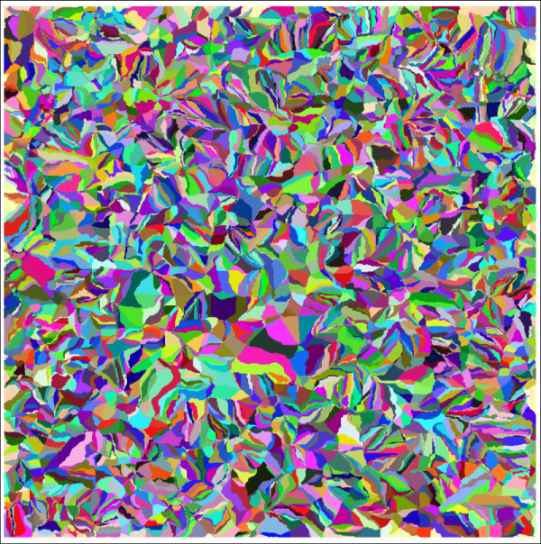

The output for the Half-basins layer when minimum size is set to 5000.

This all looks rather alarming! In effect this is lots of small half-watershed basins for each small stream on the map. Obviously 5000 is not the minimum area to go with!

* Remove the Half-basins layer from your map then go back to the parameters in the r.watershed tool
* Change the Minimum size of exterior watershed basin to 50000 (four zeros) and Run the tool again.

Is the output any better? Does it look anything like the area that you would expect yet?

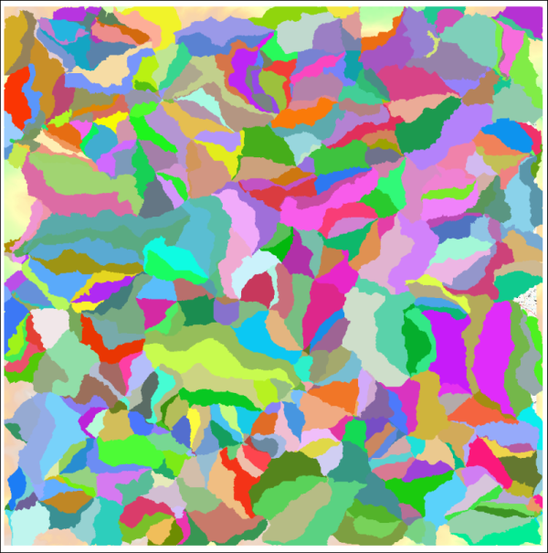

The output for the Half-basins layer when minimum size is set to 50000.

* Remove the Half-basins layer from your map again then go back to the parameters in the r.watershed tool
* Change the Minimum size of exterior watershed basin to 500000 (five zeros) and Run the tool again.

Is the output any better? Does it look anything like the area that you would expect yet?

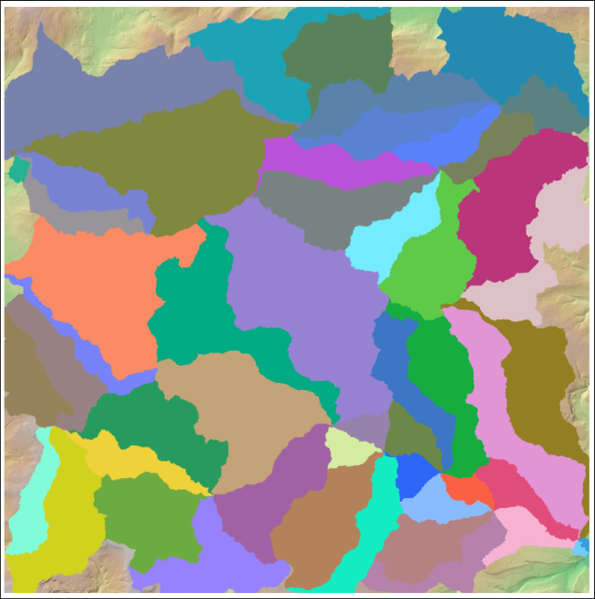

The output for the Half-basins layer when minimum size is set to 500000.

Given that these are half-basins, this is looking much better. If you go to the coordinates of the outflow of the Hebden Water again (GR 399078 427154) you’ll see several basins meeting at this point, and two of those are the ones that we want.

### Vectorize the half-basins

For the next few steps we’ll need to use a vector version of this layer.

* From the toolbox select the Polygonize (Raster to Vector) tool
* The input is the raster half-basins layer
* The output can be left as a temporary file

### Selecting the correct watersheds

If you make the vector half-basins layer transparent you should be able to see that the boundary between two of them fairly well follows the river upstream. These are the two that we want.

* Use the Select Features by area or single click tool from the toolbar
* Click on each of the two half-basins in turn, holding down the Ctrl key to select both. They should look like the bright yellow selected features in the image below.

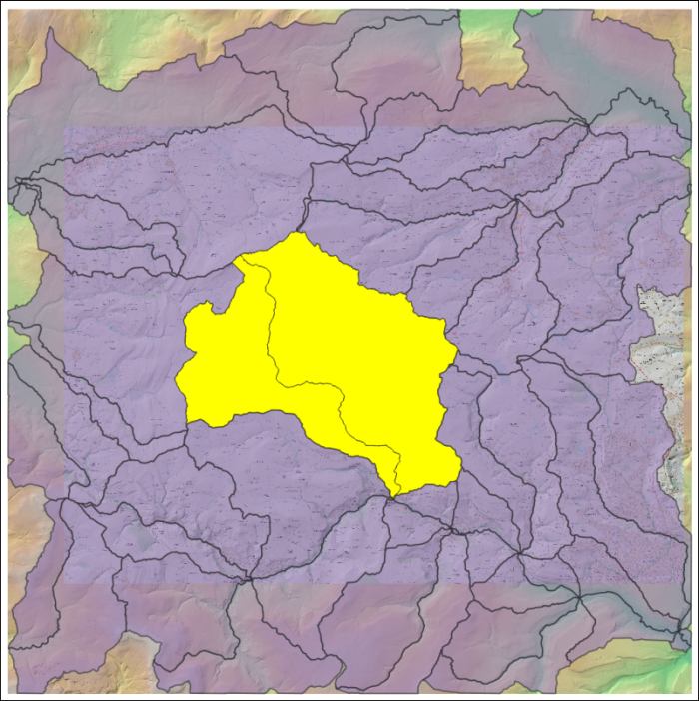

The half-basins of the Hebden Water selected.

We can convert these to a single polygon and save as a new layer at the same time.

* On the menu bar go to Vector > Geoprocessing Tools and have a look at the choices available to you. The little icons are very useful!
* The tool we need is Dissolve which combines features into new features, so click on that
* The input layer is the temporary vectorized layer
* Tick Selected features only
* Under Dissolved click on the three dots button to save the output to a geopackage. This is the final result that we need. You can save it to an existing geopackage and give the layer the name Watershed
* Run the tool

The output, once symbolised as an outline with no fill, should look something like the image below.

You can remove all the temporary layers as those are no longer required.

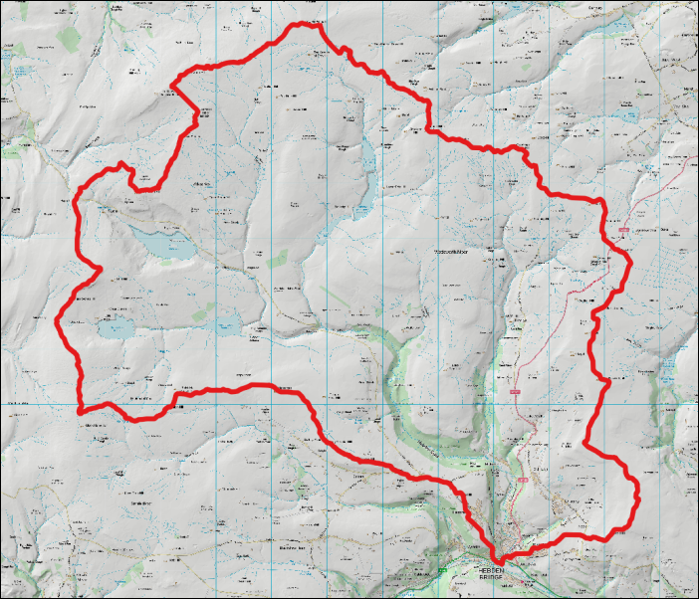

The final watershed symbolised as an outline with no fill to show the watershed of the Hebden Water.

## Suggested layout

Use the layers that you have created to layout a map similar to the one below. Include your chosen interpolated rainfall surface, a hillshade layer and a topographic background layer. Don’t forget to include the usual map elements, such as title, key, scalebar etc. Refer to the Layout and presentation chapter for ideas and instructions.

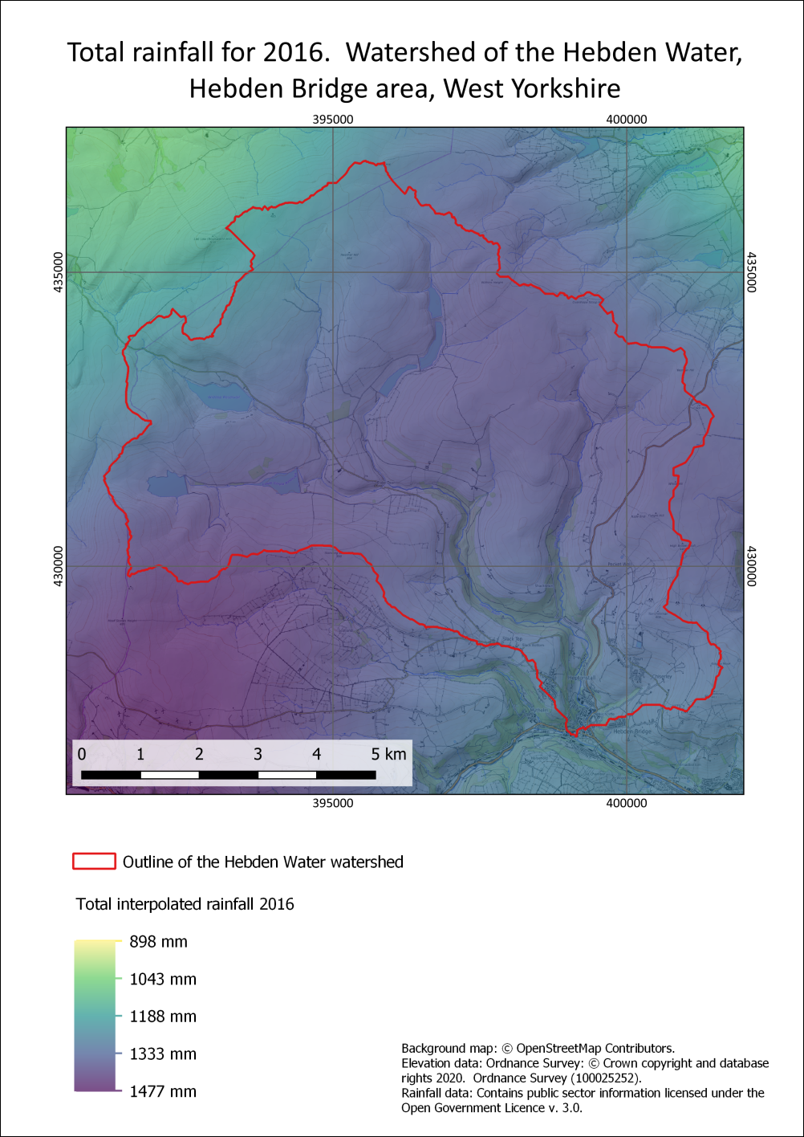

An example of a final map of the total rainfall of the Hebden Bridge area in 2016.

## Next practical

Please note that the next chapter is raster analysis part two. You will need the output and project from the exercises here to complete the exercises in part two, so make sure that you keep it all. Try to make sure that you remember where you have stored the files, and what you have called them.

## Recommended reading for Raster analysis

Many of the books in the reading list[26] have general information about elevation data. Suggestions include the following:

Heywood (2011), Chapter 6, p. 198-217. Sections on Spatial Interpolation and Analysis of Surfaces.

Longley (2011), Section 13.3.6, p. 313-317. Spatial Interpolation and Section 15.3. p. 386-393. Analysis of Surfaces.

### Further information

Hans van der Kwast from the IHE Delft has created a series of videos with in-depth information about various GIS subjects. His [video on Raster Processing](https://youtu.be/kZRcP7NrobU) would be helpful for the background to this chapter and it would also be worth looking at his other theory videos for help with other chapters. His practical video clips are also very good and he does use QGIS.

# Raster analysis 2

Last Modified: 16 Mar 22, 17:02:49

The background to raster analysis will be covered in the lecture segment at the beginning of the class, and the presentation and any other supporting materials will be available in Minerva. The lecture segment should help you to understand **why** you are doing these exercises. If you still aren’t sure, please ask [Clare](mailto:c.e.gordon@leeds.ac.uk).

## Learning outcomes

When you have completed this section of the workbook you should be able to

* Demonstrate the use of masks to limit processing areas and explain the reasons to do so
* Use the raster calculator to build expressions in order to analyse raster layers

## Introduction

In the previous chapter, Raster Analysis 1, you looked in more detail at the properties of GIS raster files and how these make a difference to settings and usage. You ran some of the raster processing tools available in the toolbox to interpolate a grid from point data and to delineate a watershed or catchment area.

In this chapter, Raster Analysis 2, you’ll do further raster processing using more advanced tools from the toolbox including the Raster Calculator.

## Data for this chapter

For the exercises in this chapter you will need the project for the Hebden Bridge area that you worked on in the previous chapter - including the output that you created.

You will also need to download a new geopackage - CrimsworthDean.gpkg from Minerva.

If you wish to save some disk space and tidy up your files then you can delete the original Terrain 5 dtm files. You only need to keep the merged dtm. If by some chance you do need the files again you can either unzip them from the original download or download them again from Digimap.

## Using a vector mask to clip a raster

For the exercises in this chapter it would be useful to restrict further geoprocessing to the area of the Hebden Water watershed.

 **Why limit processing area?**

What do you think are the advantages of restricting your datasets and processing tasks to a smaller geographic area?

We’ll start by clipping the Terrain 5 merged DTM to the area of the watershed.

To clip the raster to the correct area you need a vector layer to use as a mask. This should contain a single polygon covering the area you wish to analyse. Luckily we already have a layer that will do this job for us - the Hebden Water watershed.

 **Using a vector mask to clip a raster in QGIS**

This video clip can be found in the module area of [Minerva](https://minerva.leeds.ac.uk) or in the [full list of video clips](https://cgordon-gis.github.io/videoclips.htm).

* From the menu bar go to Raster > Extraction > Clip raster by mask layer...
  + The Input layer will be the merged dtm
  + The Mask layer will be the vector polygon watershed layer
  + Under Assign a specified nodata value to output bands enter -9999 - this will tell QGIS not to display this part of the output or use it in analysis
  + Tick to match the extent and keep the resolution of the input raster
  + Under Clipped (mask) use the three dots button to browse to where you want to store the output and give the output a name.
* Click on Run

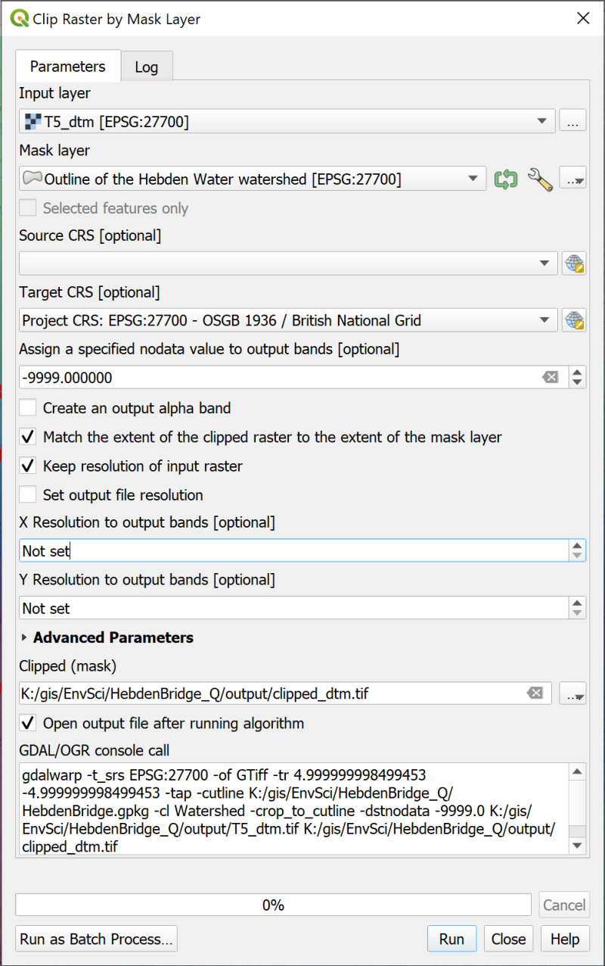

Clipping the Terrain 5 merged DTM to the outline of the Hebden Water watershed.

Hopefully a new layer will be added to your map. It should look very similar to the original dtm layer, but this time it will only fill the area within the watershed.

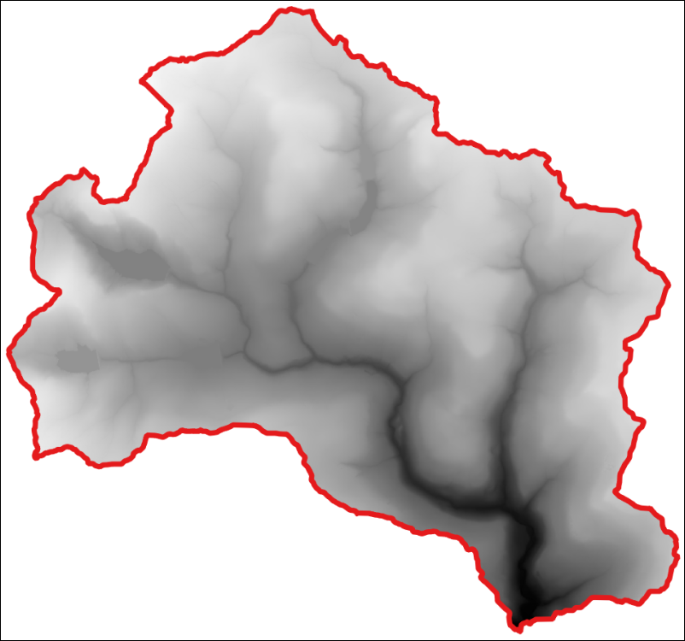

The DTM raster clipped to the watershed boundary.

 **Check the processing area**

Check that this works to restrict processing by running the hillshade tool with the clipped dtm as the input. Check where the new hillshade layer is generated for - it should just be within the watershed.

## Raster statistics

At the moment the interpolated rainfall surface that you generated in the previous chapter covers a larger area than the watershed. If we want to work out the total rainfall that fell on the watershed during 2016, but not include anything from outside of the watershed, we’ll need to restrict it to just that area first.

 **Restricting the rainfall surface to the watershed**

Above you used the vector watershed layer to clip the dtm raster. Repeat the process, but this time clip your interpolated rainfall surface to the watershed.

Once you have the output rainfall change the symbology as you did for the whole raster.

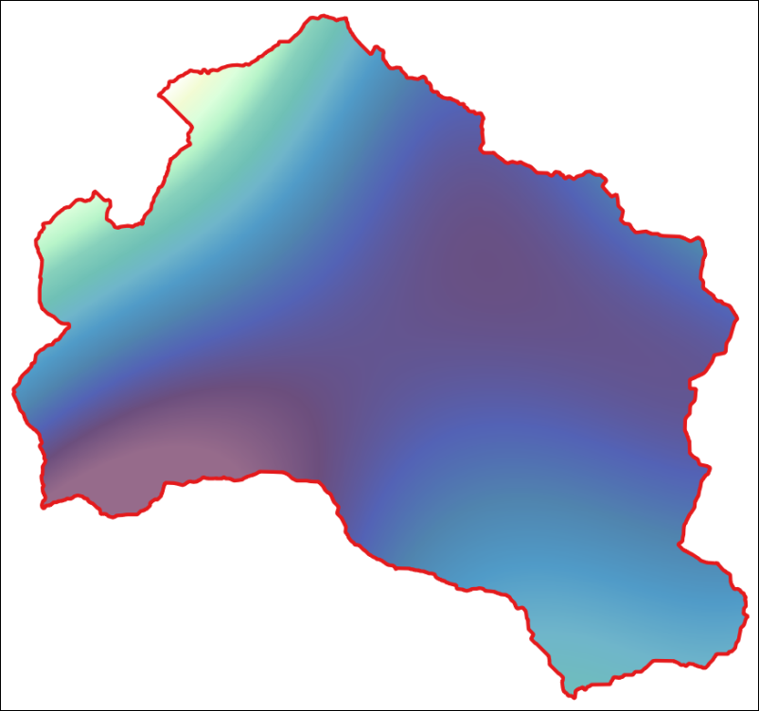

The clipped rainfall layer. Yours may well look different as you probably chose different styling.

### Background to raster statistics

GIS carries out three main categories of operation on rasters: Local; Neighbourhood and Zonal.

* Local operations work on a cell-by-cell basis - reclassification is an example of this and you’ll be doing more of that soon.
* Neighbourhood operations involve a focal cell and its surrounding cells - terrain analysis such as slope and aspect are examples of this.
* Zonal operations work with groups of cells with the same values or similar features, for example zonal statistics.

You have a raster showing the annual rainfall for 2016 for the Hebden Water watershed, now how do you use that to calculate statistics for the area, such as the mean rainfall or the total sum?

### Using the Zonal Statistics tool

We’ll use the Zonal Statistics tool from the QGIS toolbox as that puts the statistics into a table that we can store and look at later too.

 **Using the Zonal Statistics tool in QGIS**

This video clip can be found in the module area of [Minerva](https://minerva.leeds.ac.uk) or in the [full list of video clips](https://cgordon-gis.github.io/videoclips.htm).

* In the Processing Toolbox search for the Zonal Statistics tool and open it
* Under Input layer you’ll need to choose the vector watershed layer
* Under Raster layer select your clipped rainfall layer
* Click on the three dots button under Statistics to calculate and tick the statistics you require. In this case go for at least:
  + Count
  + Sum
  + Mean
* Click on OK to go back to the form and click on the three dots button at the end of the Zonal Statistics field
* Select to Save to file... and navigate to where you want to save the output. Give it a name and set the Save as type: to csv
* Click Save, then click on Run

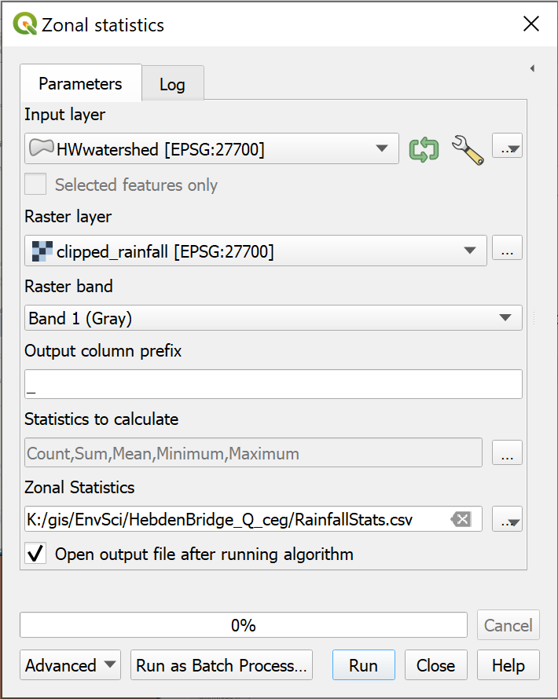

Filling in the Zonal Statistics form.

The output will be saved to your computer, but also added to your Layers panel as a table.

To view the results within QGIS:

* Open the attribute table of the new layer

You’ll have an attribute table with just one row. That row will include the statistics that you chose to calculate for your rainfall within the watershed.

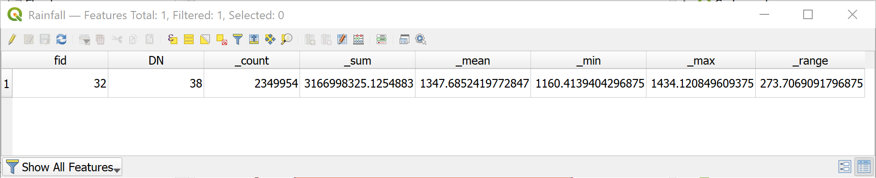

The attribute table of the output from the Zonal Statistics tool.

In this case we were looking for the Sum rainfall in this area in 2016. In other words, the amount of rainfall that could potentially flow through the outflow of the watershed.

The Sum field above shows the sum total of all the pixels in the clipped raster.

You should be able to view the csv output outside of QGIS by opening the file in a spreadsheet program or text editor.

It is also possible to save the output as other GIS formats, but in those cases you will need to export the output to csv to view it outside of GIS.

## Using the raster calculator

Once you have a raster containing data it isn’t a case of just editing it to make changes. Instead there are plenty of tools which will help you to combine, clip, and alter the data in a raster.

The **raster calculator** allows you to perform calculations on the pixels or cells within a raster layer. The results are written to a new raster layer.

### Converting the units of the dtm

 **The raster calculator in QGIS**

This video clip can be found in the module area of [Minerva](https://minerva.leeds.ac.uk) or in the [full list of video clips](https://cgordon-gis.github.io/videoclips.htm).

As an example let’s convert the dtm data from the current units of metres, to feet. This involves multiplying the measurements in metres by 3.281.

 **DTM in metres**

In the layers panel have a look at the dtm that you clipped to the watershed boundary. What are the minimum and maximum values for height?

Now let’s do the conversion.

* To open the raster calculator go to Raster > Raster calculator on the menu bar.

The raster calculator should open and look something like the following.

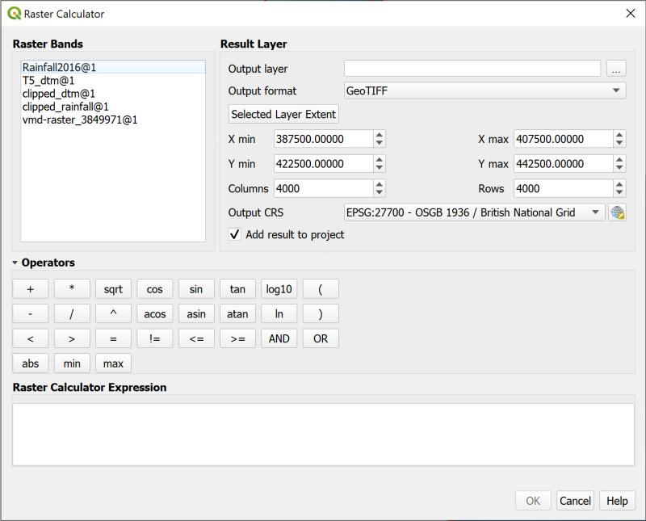

The raster calculator when it is first opened.

The panel at the top-left should include a list of all the raster layers in your project (note that rasters have to be in your map to be used in the raster calculator).

The panel to the top-right sets the layer to which to write the results. You have to fill in an output layer or the tool won’t run. The default format is usually GeoTIFF.

The panel at the bottom is where you compile the expression that you wish to use and the operators above will help you to do that.

* Start by setting the Output Layer by clicking on the three dots at the end of the line and browsing to where you want to store your output.
* To limit the extent you can click on one of the layers in the raster bands list and then click on Selected Layer Extent - do this now with your clipped dtm.
* Now build up the Raster Calculator Expression by first double-clicking on the clipped dtm layer in the Raster Bands panel
* Next click on the * under Operators
* Then click in the expression box and type the number 3.281
* If you’ve done it correctly it should say Expression valid under the expression box. Once that happens click on OK.

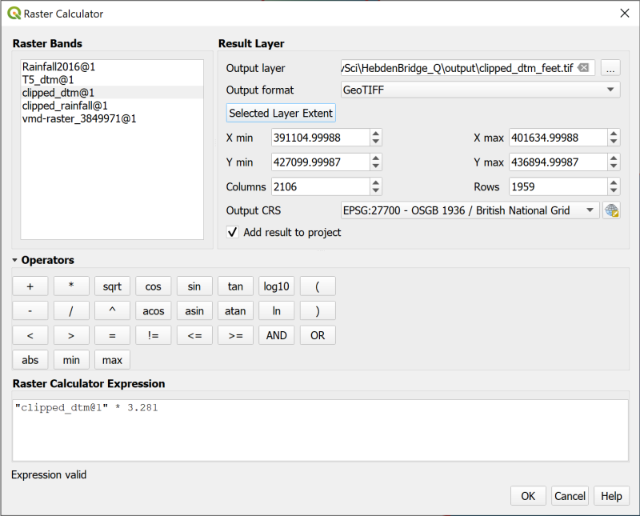

Converting dtm metres to feet with the raster calculator.

The new layer which appears on your map should look the same as the original clipped dtm layer but if you look at the Layers panel the values should now be much higher. You can easily check that they are correct by using the Identify Features tool on the map, then multiplying the metres value for one location by 3.281.

### Using a mask

With the raster calculator you can mask out certain parts of a raster. For example, if you have a rainfall raster which you want to restrict to areas that you consider high rainfall.

 **Setting a mask with the raster calculator in QGIS**

This video clip can be found in the module area of [Minerva](https://minerva.leeds.ac.uk) or in the [full list of video clips](https://cgordon-gis.github.io/videoclips.htm).

For the purposes of this exercise let’s say that we are only interested in the areas with **total rainfall in 2016 of equal to or above 1350 mm**.

If you look at the clipped rainfall raster for the Hebden Water watershed the values range from approximately 1160 to 1431, so we want to **mask** the lower values.

* Open the raster calculator and set the result layer. Give it a name and set the extent to the same as the clipped rainfall layer.
* In the Raster Calculator Expression use the Raster Bands and Operators to build up the following expression

("clipped_rainfall@1" >= 1350) * "clipped_rainfall@1"

Effectively you are building up a conditional statement. If part of the statement evaluates to *true* for a particular cell it will be given the value 1 otherwise it will be given the value 0. So in the first part of the expression, if a cell has a value above or equal to 1350 it will have the value 1. This means that in the second part of the expression when cells are multiplied by their value in the original raster, the cells with a value of 0 will be given that value (multiplying by 0 always gives the answer 0), while the cells with a value of 1 will regain their previous value.

Don’t worry if this seems complicated! I have to stop and think it through each time I use the raster calculator. There are [examples in the QGIS user manual](https://docs.qgis.org/3.16/en/docs/user_manual/working_with_raster/raster_analysis.html) which may help too, though these examples were based on those.

* Once your statement is evaluated as valid, click on OK to run the expression.

The output should be added to your map, but may look rather odd.

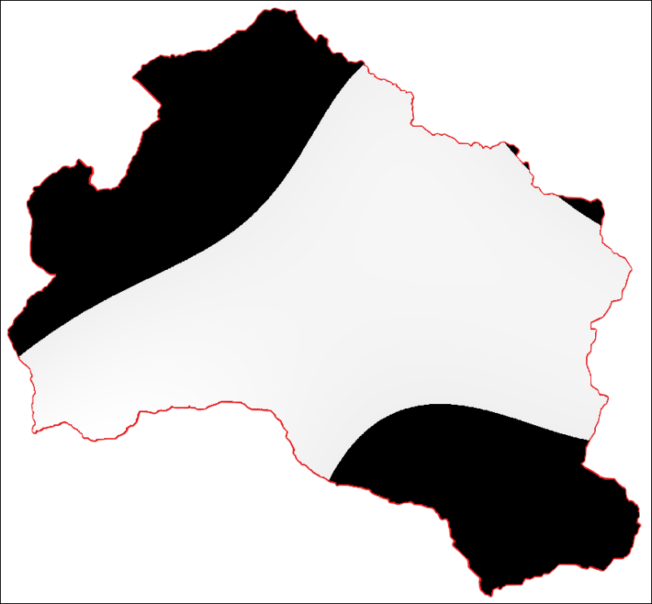

The masked rainfall layer when it is first added to your map.

To display it properly you need to style it.

* Go to the Layer Styling panel and click on the Transparency tab.

The areas that you don’t want to display should have a value of 0. Check this with the Identify Features tool if you want to be sure. To prevent these areas from displaying you need to tell QGIS that 0 is a no data value.

* Next to Additional no data value enter the figure 0.

The areas with a value of 0 should disappear from your map.

* While you are on the transparency tab set the Global Opacity so that any layers underneath the rainfall layer will show through.
* Now return to the Symbology tab and style the remaining data with a colour ramp in the usual way so that the layer looks something like the image below.

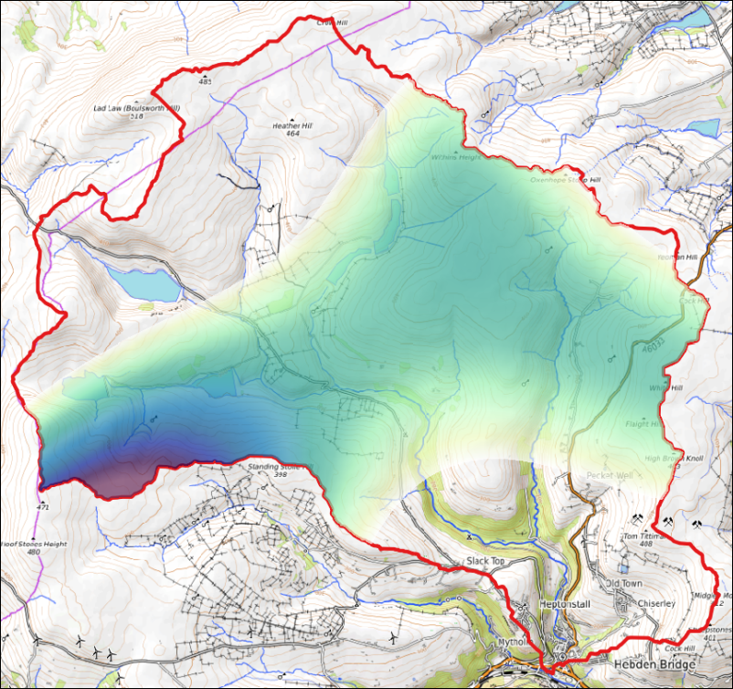

The styled rainfall showing only the areas with total rainfall above 1350 mm in 2016.

### Reclassifying a raster

In this section we’ll look at how it is possible to **reclassify** a raster to extract areas which agree with certain criteria. The example we will use is simulating flooding with a dtm, but there are plenty of other potential applications.

 **Reclassifying a raster with the raster calculator in QGIS**

This video clip can be found in the module area of [Minerva](https://minerva.leeds.ac.uk) or in the [full list of video clips](https://cgordon-gis.github.io/videoclips.htm).

Imagine that there is a plan to build a reservoir where Crimsworth Dean Beck runs into the Hebden Water.

If you haven’t already, download the file CrimsworthDean.gpkg from Minerva and save it to the folder for this project to use for this exercise.

The geopackage contains a feature class called CDWatershed - add that to your Hebden Bridge map. We’ll use this watershed to limit the potential reservoir to the valley above that point rather than flooding the whole of the area of the DTM under that height.

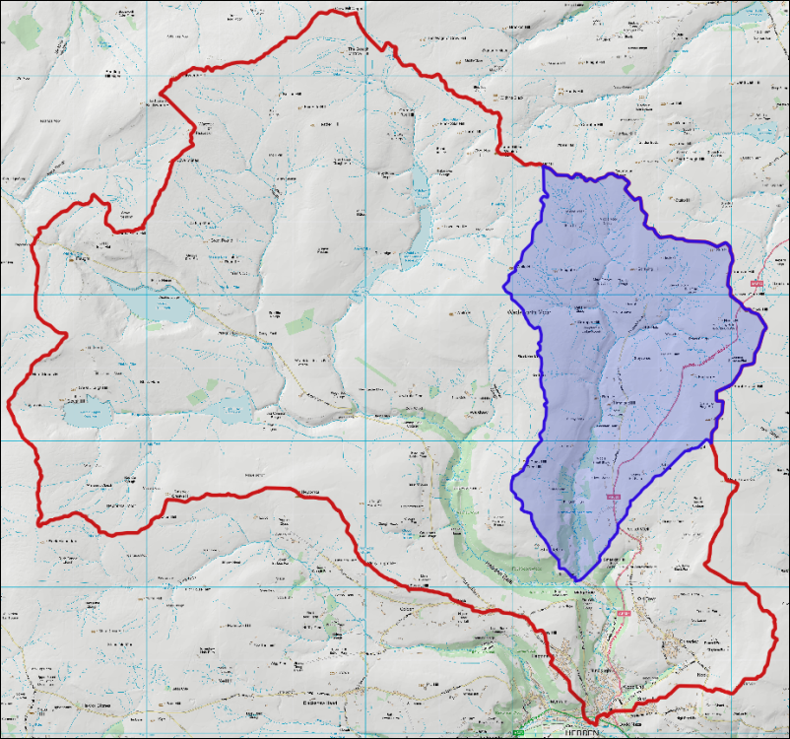

The watershed of Crimsworth Dean Beck (blue) within the Hebden Water watershed (red outline).

If you have a raster which goes down to sea-level that may not be so much of an issue. If the flooding came from the sea then you are unlikely to need the watershed to restrain it.

* Use the Crimsworth Dean watershed to clip the dtm again to this smaller area.

Use this smaller clipped version of the dtm for the rest of the steps in this section.

#### Finding the height of the initial point

Before we can reclassify the raster to show flooding we need to know the height of the land at the point where the dam is to be built.

To find this, use Type to Locate to find the following grid reference:

398862 429076

Check that your Terrain 5 dtm layer is visible (the original one in metres, not the one in feet). Then use the Identify Features tool to find out the value of Band 1 at that point - checking that it is just within the Crimsworth Dean Beck watershed and on the beck itself. That value will be the height above sea-level in metres - make a note of it for later.

#### Reclassifying the raster with the raster calculator

* Open the raster calculator and set the result layer. Give it a name and set the extent to the same as the dtm layer you clipped to the Crimsworth Dean watershed.
* Use the Raster Bands and Operators to set up the following expression where clipped_dtm@1 is the dtm layer clipped to the Crimsworth Dean watershed.

"clipped_dtm@1" < (132.6 + 30)

where 132.6 is the height above sea-level that you made a note of earlier. 30 is the figure below which we want to “flood” the raster.

* When your statement is valid, click on OK.

The output should be black and white, with one area indicating a value of 0 and the other a value of 1. There should be a small area close to the confluence where the cells have the value of 1. This is the flooded area.

#### Converting the result to a vector polygon

In many cases it will be most useful to have the output as a vector polygon. This is a very similar process to that we used to convert the viewsheds in the elevation chapter so have a go at that now. Make sure that the area that you keep is the small part near the outflow of Crimsworth Dean Beck. It should look something like the image below which has been styled as Paletted/Unique values, the value 0 removed from the list and the value 1 coloured blue and transparency applied to show the map below.

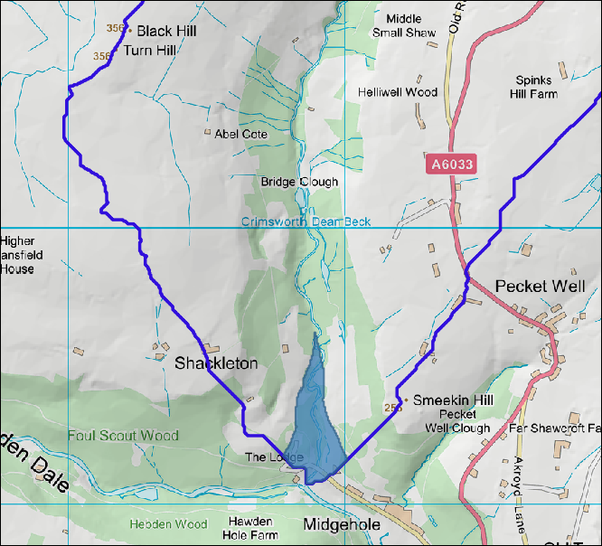

The flooded area with a height of 30 m above the outflow of Crimsworth Dean Beck.

## Reclassifying rasters with Reclassify by Table

The section above showed you how to reclassify a raster using the raster calculator. That is a very flexible way of doing it, and often gives you more control, but it’s also useful to know how to use the **Reclassify by Table** tool, particularly if you want to use batch processing.

We’ll carry out the same task again so that you can compare the results.

 **Reclassifying a raster with Reclassify by Table in QGIS**

This video clip can be found in the module area of [Minerva](https://minerva.leeds.ac.uk) or in the [full list of video clips](https://cgordon-gis.github.io/videoclips.htm).

We want to flood the valley up from the confluence of Crimsworth Dean Beck with the Hebden Water to a maximum depth of 30 m. You should already have a note of the height above sea-level of the outflow of Crimsworth Dean Beck.

* In the Processing Toolbox search for Reclassify by table and open the tool from the Raster Analysis section.
* Under Raster layer select your Crimsworth Dean clipped dtm (metres not feet)
* Click on the three dots button next to Reclassification table
  + In the table click on Add Row
  + Then click in the boxes on the row and set as follows
    - Minimum = 0
    - Maximum = the height at the outflow, plus 30 m. e.g. 162.6.
    - Value = 1
    - You can set multiple classes here, but we only need one.
  + Click on OK

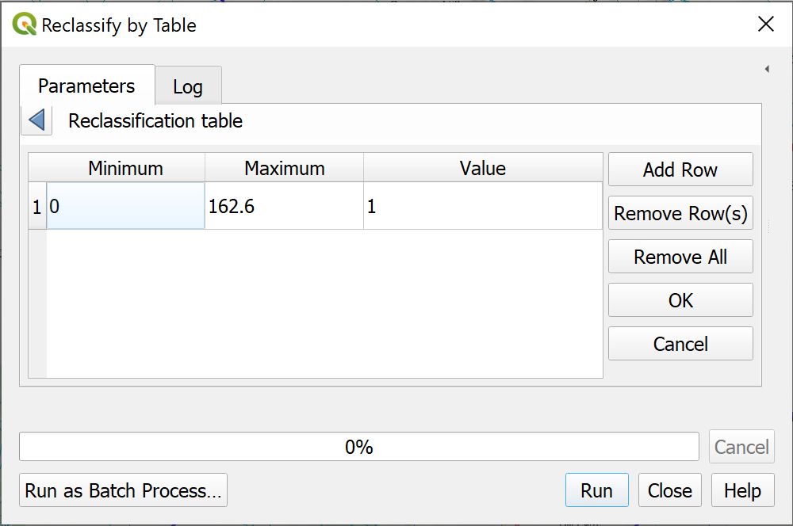

The table for reclassifying.

* Drop down the Advanced Parameters
* Set Output no data value to -9999
* Tick next to Use no data when no range matches value
* Select Output data type as Int16
* Set Reclassified raster to your output location and give it a name
* Click Run

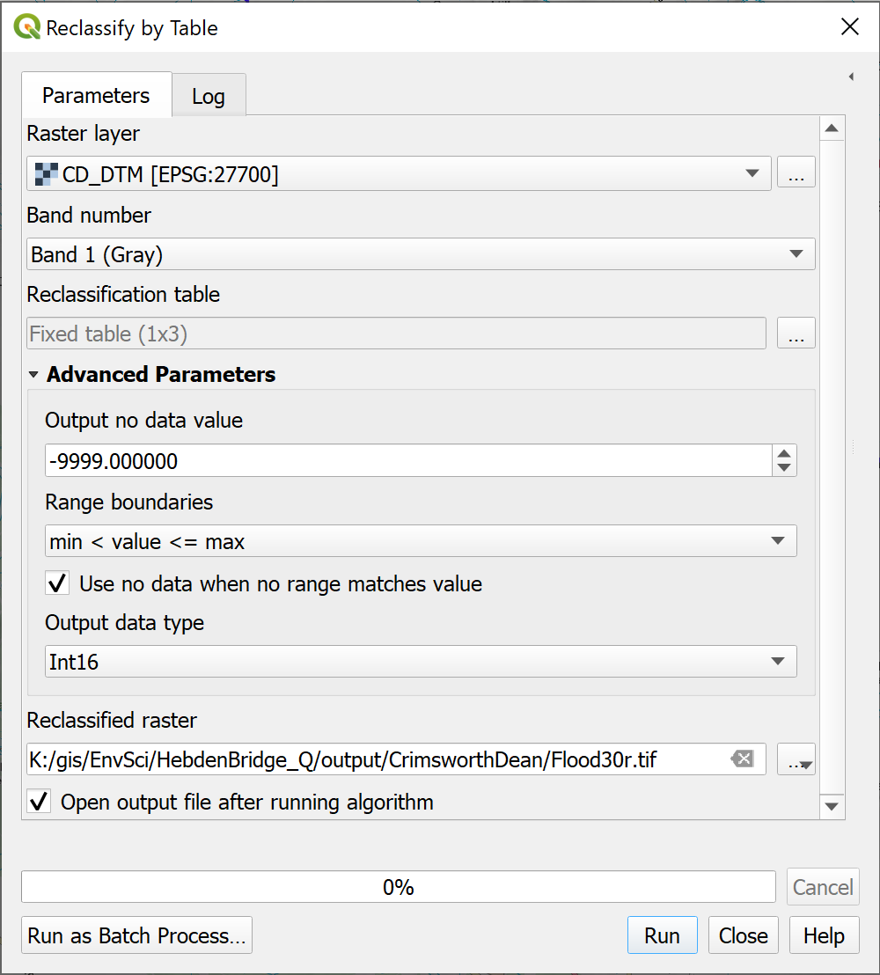

The Reclassify By Table form. Note the settings under Advanced Parameters.

Once the tool has run you should find that you have output very similar to that from the raster calculator. Though because you set the no data, you won’t see that on the map.

 **Compare the two results**

Again, polygonize the result and compare it to the result from the raster calculator.

I said earlier that this method will work better if you need to use batch processing. Use the Reclassify by Table tool in batch processing mode to produce polygons showing the size of a reservoir for dams of the following heights at the outflow of Crimsworth Dean Beck:

40; 50; 60; 70 and 80 m.

## Final map for this chapter

For your final map for this chapter polygonize the potential reservoir sizes and present them as possible alternatives to show the effect of each height of dam.

The outlines will look rather “square”. This is because they were generated from a raster layer consisting of 5 m pixels. Those 5 m still show as part of the outline. One solution to this that you could try is to use the Vector geometry Smooth tool from the processing toolbox.

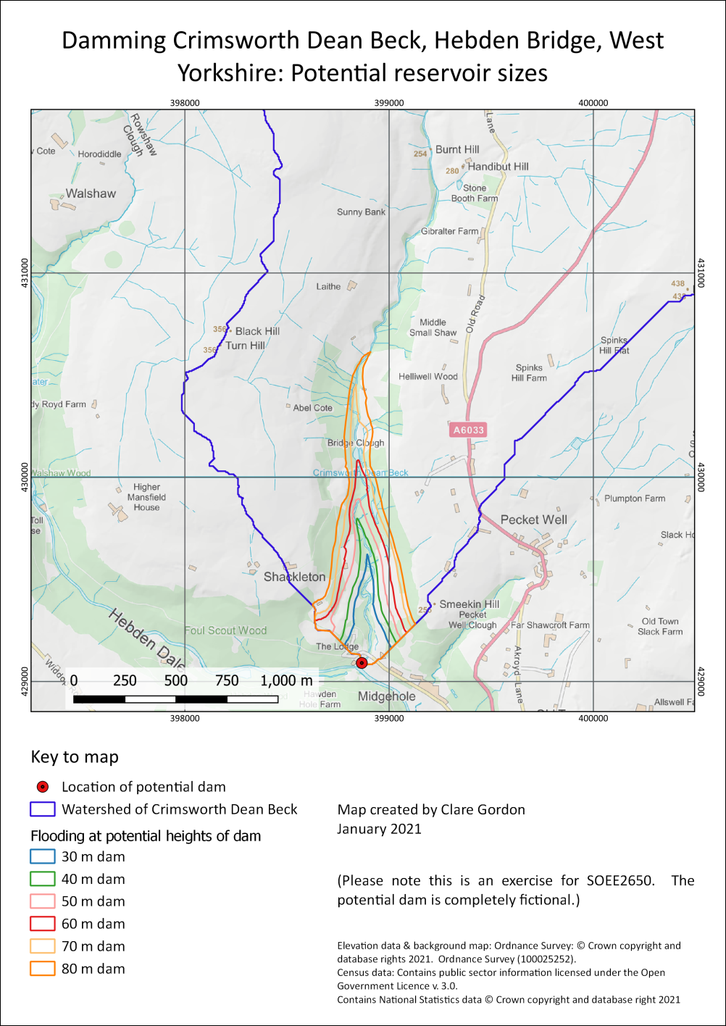

Possible final map for this chapter showing possible reservoir sizes for different dam heights on Crimsworth Dean Beck.

Once you have completed your map, export it as either an image or a pdf and upload it to your GIS portfolio. If you upload it before the next class I will provide brief feedback on your work.

## Next chapter

The next chapter on downloading and using census data follows on from this one. You’ll need your Hebden Bridge map again so save it now.

## Recommended reading: Raster analysis and reclassification

Refer back to the recommended reading at the end of the Raster 1 chapter.

### Further information

You can find more about the raster calculator in the QGIS user guide.

* [QGIS user guide on the raster calculator](https://docs.qgis.org/3.16/en/docs/user_manual/working_with_raster/raster_analysis.html)
* QGIS Tutorials and Tips has a tutorial on [Basic Raster Styling and Analysis](https://www.qgistutorials.com/en/docs/3/raster_styling_and_analysis.html) which is basically a guide on how to use the raster calculator with gridded population data.

# Census data for England and Wales

Last Modified: 16 Mar 22, 17:01:23

The background to census data will be covered in the lecture segment at the beginning of the class, and the presentation and any other supporting materials will be available in Minerva. The lecture segment should help you to understand **why** you are doing these exercises. If you still aren’t sure, please ask [Clare](mailto:c.e.gordon@leeds.ac.uk).

## Learning outcomes

When you have completed this section of the workbook you should be able to

* Download data from the UK census for use in GIS
* Explain how to join attribute data to a feature class in QGIS
* Combine census data with other data in a GIS to answer questions

## Introduction to the census

In the previous two chapters you were looking at the watershed, or catchment, of the Hebden Water north of Hebden Bridge, and the rainfall in that area which is prone to flooding.

To find out more about the population for the area we’ll download the census data for this area and use that to work out how many people live within the catchment of the Hebden Water.

The Census is a tremendous source of data about the population of Great Britain, but it is not always easy to find what you need. The census takes place every 10 years, the latest one being in 2011, and collects data from every person resident in the UK on a particular data in that year. Very general data is released first, with more detail being made available later, though the full personal data is only made available after 100 years. [27]

A lot of the data is based around social identifiers, such as type of house, or occupation, but the Office for National Statistics also provide key sets of data which can be combined with physical data to allow useful analysis. For example, in conjunction with viewshed analysis, population data can be used to find out approximately how many people live within sight of a proposed wind farm or would be affected by other types of development.

The [DataShine Census web map](https://datashine.org.uk/) allows you to play around with different data and view the results on a map. Try looking at the percentage of houses with five or more bedrooms in Headingley compared to most other parts of Leeds, or where are people with professional qualifications most likely to live in Leeds?

## Downloading UK Census data

As a member of UK Higher Education you have access to data via the UK Data Service and UK Borders.

**InFuse** on the UK Data Service includes 2011 data for England and Wales. The instructions in this section show how to use InFuse.

The data from InFuse needs to be joined with boundary data from **UKBorders** to display in GIS. You will also be shown where and how to download this and how to link it to the population data from the census.

 **Accessing census aggregate data in InFuse**

See this video on YouTube about [How to access census aggregate data in InFuse](https://youtu.be/AzK04BOFd_s). Note that the data downloaded is different to the data required in this chapter.

Data from the Scottish census of 2011 is available from their [Census Data Explorer](http://www.scotlandscensus.gov.uk/).

## Logging in to the UK Data Service for the first time

You’ll need to start by logging in to the UK Data Service and signing for “Special Conditions” so that you have permission to use all the data that you will need.

* Go to the [UK Data Service Census Support page](https://census.ukdataservice.ac.uk/)
* Click to LOGIN and login via the UK Data Service - you’ll be logging in via University of Leeds using your usual username and password.
* Review and agree to all Special Conditions
* **Close all browser windows**. If you try to carry straight on you’ll probably find later that the services don’t acknowledge that you have signed up to the special conditions and you’ll have trouble downloading the data.

## InFuse: 2011 data for England and Wales

For the purposes of this exercise we’ll aim to download data on the population of **output areas** for **Calderdale District (West Yorkshire)** for 2011. This will include the data that we need for Hebden Bridge. There are, of course, lots of other census datasets available and it is worth exploring and thinking about what could be of use to you in the future.

* Go to the [UK Data Service Census Support page](https://census.ukdataservice.ac.uk/) again
* Click to LOGIN and login via the UK Data Service - you’ll be logging in via University of Leeds using your usual username and password.
* Now go directly to [InFuse](http://infuse.ukdataservice.ac.uk/) at <http://infuse.ukdataservice.ac.uk/>.
* Choose 2011 Census Data
* Next go to Topics - the original InFuse interface.

You’ll be presented with a screen full of possible data choices. The topics in the list on the left allow you to filter the choices in the boxes in the main area.

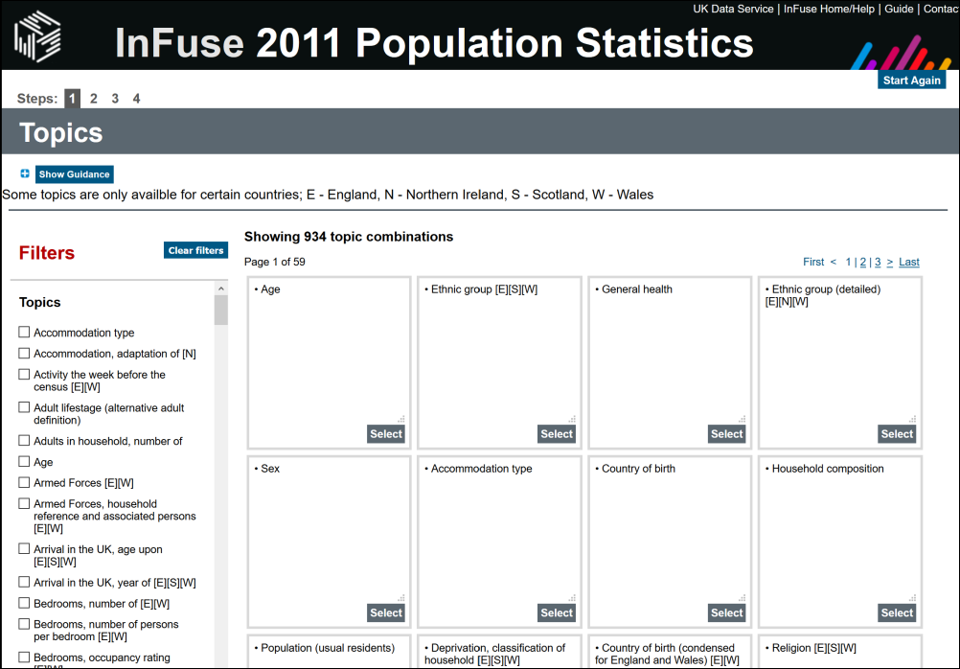

The InFuse selection screen.

* For now click to select Age in the left-hand list. All we actually want is **total population**, but this seems to be the simplest way to find it.
* Now click on the Select button in the Age button on the right. You’ll get a bit of information about the topic.
* Click Next

This time you’ll be presented with a list of options, basically a long list of age groups.

* Click to tick the box next to Age > Total:Age at the top of the list
* Go to the bottom of the page and under Unit select Persons by ticking in the box next to it - this means that the data you download will show the total number of people in each area - not broken down by age.
* Then click Add so that your choices show in the box at the bottom - 167 - Age : Total: Age - Unit : Persons
* Click Next to start selecting the geographic units that you want.

The **geographic units** used for the census are rather complex and you need to be careful about the level of detail that you pick. Have a look at the [Census Boundary Data page](https://census.ukdataservice.ac.uk/use-data/guides/boundary-data.aspx) for more detailed information.

* Click on the plus sign next to Local Authorities to open out the list
* Click on the plus sign next to Calderdale (be careful not to put a tick in the box at this stage!)
* Then put a tick in the box next to Output Areas and Small Areas
* Next go to the bottom of the page and click to Add your selection to the box at the bottom of the page. At this point the text in the box should say something like All Output Areas and Small Areas (668) in Local Authorities (404 areas) - Calderdale
* Click Next - to hopefully see the following screen

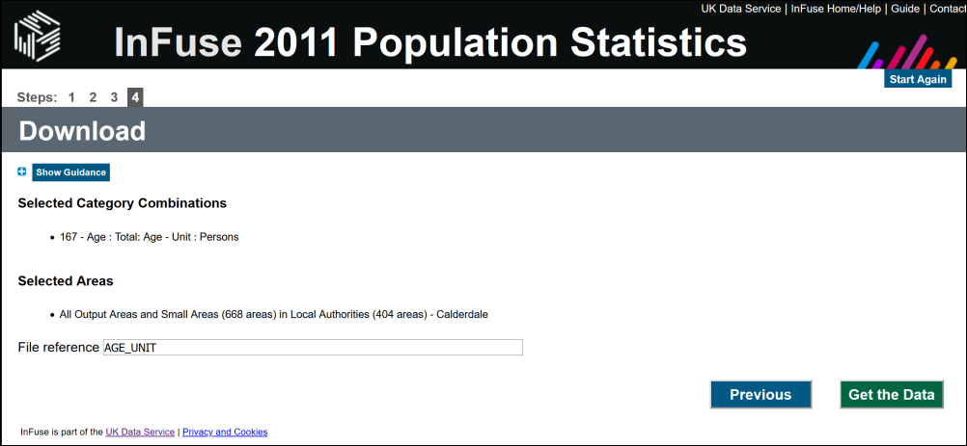

Choice of data to download.

* Check your selections and then Get the Data
* Once the orange/pink button appears click it to Download Data and save the data (which will be a zip file) to your computer. You may want to rename the file so that it’s clear what you’ve just downloaded.
* If you want to download any further data click on Start Again at the top of the page

Once you have unzipped the resulting download you should find yourself with two csv (comma separated value) files.

As usual, make sure you understand what the data you have downloaded consists of.

* Open the csv file with the name beginning with Data_ (it should open in Excel or another spreadsheet program but can be opened in a text editor) and have a look at the contents.

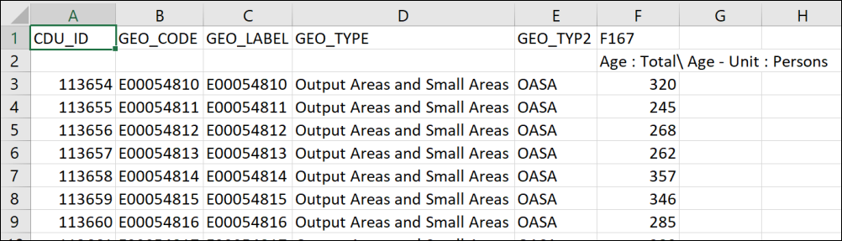

The Census data for Age in output areas in Calderdale. The csv file has been opened in Excel.

Also have a look at the other csv file in the download - the one with the file name that starts with Meta_. This gives information about the data in the other file, including what each column contains.

You should be able to see that you have data for areas which have a geographic code, but no information on coordinates that will allow you to add the data to GIS.

The final column - F167 - contains the total number of people in that output area.

To be able to display this data in GIS you need some way of showing the geographic units - the output areas - in their correct places. The next section shows you how to download the extra data that you need to be able to do that.

## Copyright and source acknowledgement

Information about the required acknowledgement for the census data that we downloaded is [available on the web](https://census.ukdataservice.ac.uk/use-data/citing-data).

Make sure that you check the requirements for each dataset you download. The census data falls under the Aggregate data heading.

## Downloading UK Boundary Data

If you have downloaded a csv file containing census data you will need to associate it with the correct geographic boundaries.

Note that this is where it becomes important that you signed up to the **Special conditions** earlier. If you didn’t you will have to do so now.

The data for the geographic boundaries can be downloaded as follows:

* Go to the [UK Data Service Census Support Census Geography page](https://borders.ukdataservice.ac.uk/)
* Select Boundary Data Selector
* Select the country as England
* Select Geography as Census
* Select Dates as 2011 and later [28]
* Click on Find

A list of boundary datasets should appear.

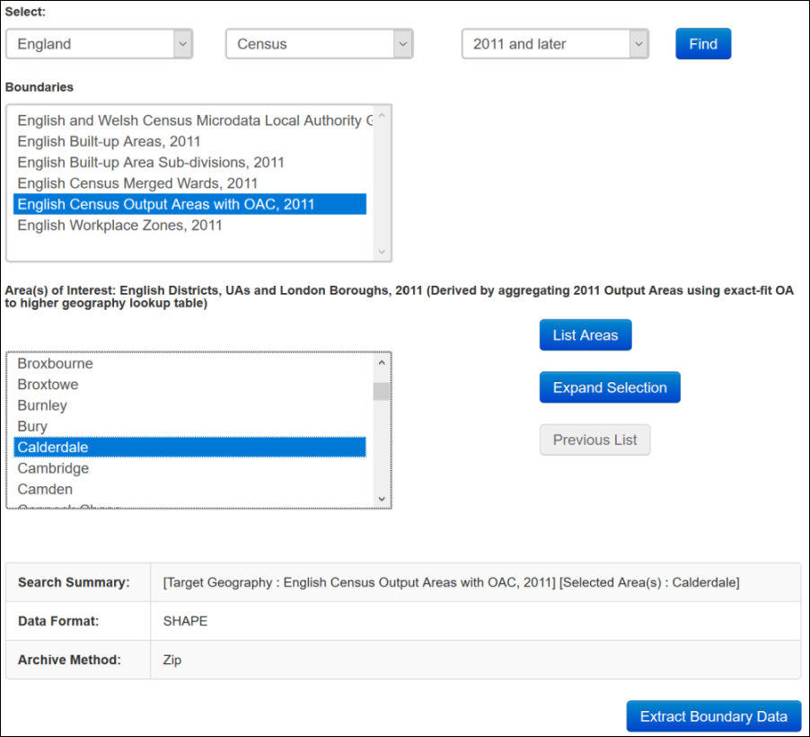

The completed form for the Boundary Data Selector.

* In this example you’ve downloaded the population data for output areas, so select the English Census Output Areas with OAC, 2011
* Click on List Areas. Scroll down the resulting list and select Calderdale
* Click on the button to Extract Boundary Data

You may need to wait a short while, but eventually you can download the resulting file by following the instructions on the page and save it to your computer. You’ll need to unzip the file that you downloaded and should find that it contains the multiple components of a shapefile and a Terms and Conditions file.

Have a look at the Terms and Conditions file - amongst other information it includes the appropriate data acknowledgement for the boundary data.

### Alternative source for UK boundary data

Note that if you have successfully downloaded boundary data from the instructions above you don’t need to complete this section as well. It could be useful for you in future to be aware of this alternative and open source of boundary data so it would be worth at least looking at the website.

Data downloaded from this site covers the whole UK, so the downloads are larger than the boundary data from the Boundary Data Selector.

UK Statistical Geographies are complex. If you need to decide on the appropriate boundaries for your data the Office for National Statistics (ONS) provides guides which include a [hierarchical representation of UK statistical geographies](https://geoportal.statistics.gov.uk/documents/9c04ff58854040d09a5a7ce146ab59b4/explore).

To download the data, use the [ONS Open Geography Portal](https://geoportal.statistics.gov.uk/).

For example, to download the boundaries to match the data that you’ve downloaded from Infuse do the following:

* Go to the [Open Geography Portal](https://geoportal.statistics.gov.uk/).
* Using the menu bar across the top click on Boundaries > Census Boundaries > Output Areas > 2011 Boundaries.
* Click on Output Areas (December 2011) Boundaries BFE (The BFE indicates Full extent not clipped).

You’ll be presented with a map, and probably an error message saying that there are too many records. Just get rid of the error message.

* The map should have a Download button on the left-hand side, click on that.
* From the Download Options click the Download button under Shapefile and save the download to your computer.

You’ll need to unzip the file once you have downloaded it, but once you do you should have a shapefile which can be added to GIS in the usual way and used for the further instructions below.

## Adding census data to a map

Once you have downloaded a csv text file (also known as attribute data) from InFuse, and separate boundary data, you need to tell QGIS how to link the attribute data in the csv file to the boundary data in the shapefile. To do this you will join the data.

### Preparing the data

We need to start by cleaning up the csv file containing the age/population data so that it will work in QGIS.

* Open the file in either Excel or a text editor (note that Excel on the web won’t save csv files)
* Check that the data is as expected (see the example above)
* Check column headers.
  + For import to GIS it is best to use headers that are 8 characters or less, start with a letter, and don’t contain spaces. So rename the column headers appropriately where necessary
  + Make sure that there isn’t a second header line - InFuse often does this. Delete if present! The example above has a second line which says Age : Total\ Age - Unit : Persons in one of the columns. **Delete** this line.
* Save the file - making sure that it remains as csv.
* Open your Hebden Bridge map in QGIS, if it isn’t already open
* Now add both the boundary shapefile and the csv file to QGIS by dragging and dropping them from the Browser panel. You won’t be able to see the csv file on your map.
* Style the boundaries so that they are outlines with no fill.

The csv file should appear in the Layers panel but not on the map. You’ll see a table icon next to it in the Layers panel.

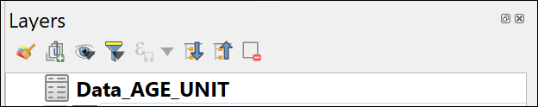

The table showing the icon on the Layers panel.

### Joining data from a table to a feature class

If you have a look at the attribute table of the england_oac_2011 shapefile that you downloaded for the boundaries you’ll see that there is information about the population of the output area, but no total population. This is contained in the separate data that you downloaded.

 **Joining data from a table to a feature class in QGIS**

This video clip can be found in the module area of [Minerva](https://minerva.leeds.ac.uk) or in the [full list of video clips](https://cgordon-gis.github.io/videoclips.htm).

To join the data you need to have fields in each source file that match. So have a look at the attribute tables of both the boundary layer and the data file now. This is where you need to be able to think about, and understand, the data that you have downloaded.

 **Which fields contain matching data?**

Which fields in the shapefile and the csv file contain matching data that can be used to join them? The fields will probably have different names in each file, but should contain the same data.

Close the attribute tables then join the attribute data to the shapefile as follows:

* Double-click on the boundary shapefile in the Layers panel or right-click and go to Properties...
* On the left select the Joins tab
* Click on the plus button at the bottom of the blank window so that the Add Vector Join window opens
* Next to Join layer select the csv table from the dropdown
* Next to Join field select the field that you picked from the table as matching a field in the shapefile - that should be either GEO_CODE or GEO_LABEL (both seem to contain the same data)
* The Target field should be the matching field from the boundary shapefile - that should be code
* To keep the result tidy tick the Joined fields box and select the GEO_CODE and F167 fields from the list - the GEO_CODE will allow you to check the join, and F167 contains the population data we want to have available to display on our map.

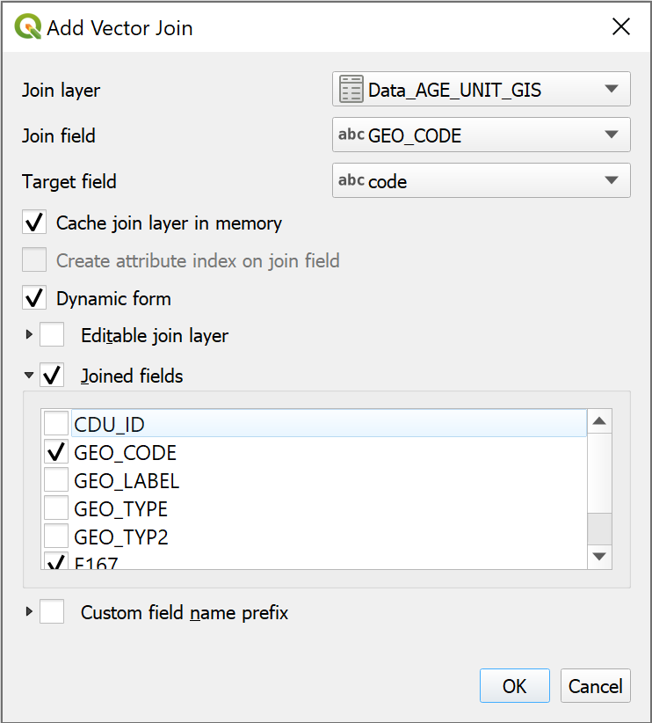

Filling in the fields to create the join.

* Click OK to add the join to the properties window. If you want to check the details you can click on the arrow next to the Setting.
* Click OK to set the join

You won’t see any obvious difference, but now open the attribute table of the boundaries shapefile again.

If you scroll to the right you should see that the new fields have been added to the attribute table.

At the moment this is a temporary change. If you remove the boundaries shapefile from your map then add it back in the fields will disappear.

To make the join permanent you could export the feature class as a new feature class, as you’ve done previously. There is another change that would be useful, though, and we can combine the two operations.

### Changing feature class field names and types

The name of the newly joined fields are not memorable, particularly that of the total population field which is the name of the original csv file with F167 after it. It would be useful to change the name to something more helpful. It is possible to do that by using the Refactor fields tool and that tool will also change the **type** of data, e.g. from text to integer (number).

 **The Refactor fields tool in QGIS**

This video clip can be found in the module area of [Minerva](https://minerva.leeds.ac.uk) or in the [full list of video clips](https://cgordon-gis.github.io/videoclips.htm).

* In the Processing toolbox search for Refactor fields and open the tool from the Vector table toolbox

The form for this tool looks rather complex, but basically it is a list of the fields in your feature class with details of type and length.

* Check that your boundaries shapefile is selected in the dropdown at the top of the form
* In the list of fields look for the two new fields - probably the two at the bottom of the list
* Click in the NAME field for the GEO_CODE field and type a new field name - in this case type GEO_CODE to remove the name of the original table.
* Click in the NAME field for the F167 field and give it a more useful name, such as TotalPopulation - note no spaces or strange characters.
* All the data in this field should be whole numbers, but at the moment the Type is set to Text (string). Drop down the box under Type and select Whole number (integer - 64bit). This will make it possible to sort the field by population or sum the totals. Change types with care, though, it can cause problems with your data.
* You are creating a new layer with this tool, so click on the three dots button next to Refactored and Save to Geopackage.... You can save this to an existing geopackage. Give your new layer a name, such as Population
* Run the tool to generate your new layer and add it to your map.

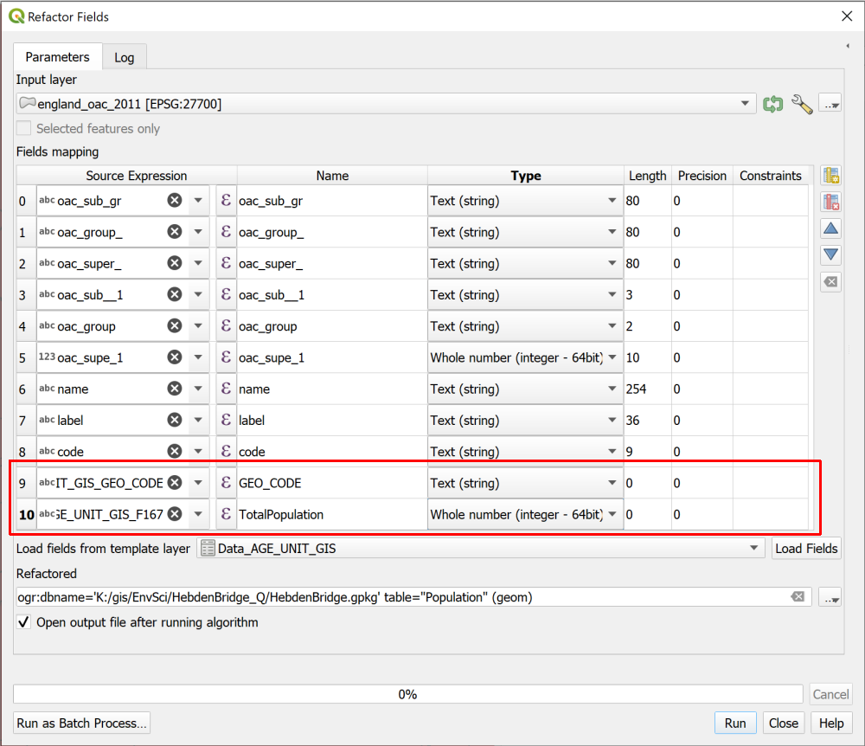

Changing the name and type of the population field with the Refactor Fields tool.

Check the attribute table to see that the changes have been made. The fields will be permanent now. So if you remove the feature class from your map and then add it back again the fields will still be there.

You can remove the original boundary shapefile and the csv table from your map now.

## What is the total population of the Hebden Water watershed?

Let’s see how we can answer this question with the data that we have prepared so far.

You should already have a vector version of the watershed for Hebden Water..

* Use Select by Location to select all output areas in the census data that **intersect** with the watershed polygon.
* Export the selection as a new layer.

At this stage you could open the attribute table and add up the population total for all the output areas, but that’s rather a lot! Let’s get QGIS to do the work instead.

 **Basic statistics for fields in QGIS**

This video clip can be found in the module area of [Minerva](https://minerva.leeds.ac.uk) or in the [full list of video clips](https://cgordon-gis.github.io/videoclips.htm).

* In the menu bar go to Vector > Analysis Tools > Basic Statistics for Fields...
* Check that the feature class of the output areas within the watershed is selected as the Input Layer
* The Field to calculate statistics on should be the TotalPopulation
* Under Statistics set the location and name of the output, which will be a web page html file.
* Then run the tool
* Don’t close the Log - that will show the results.

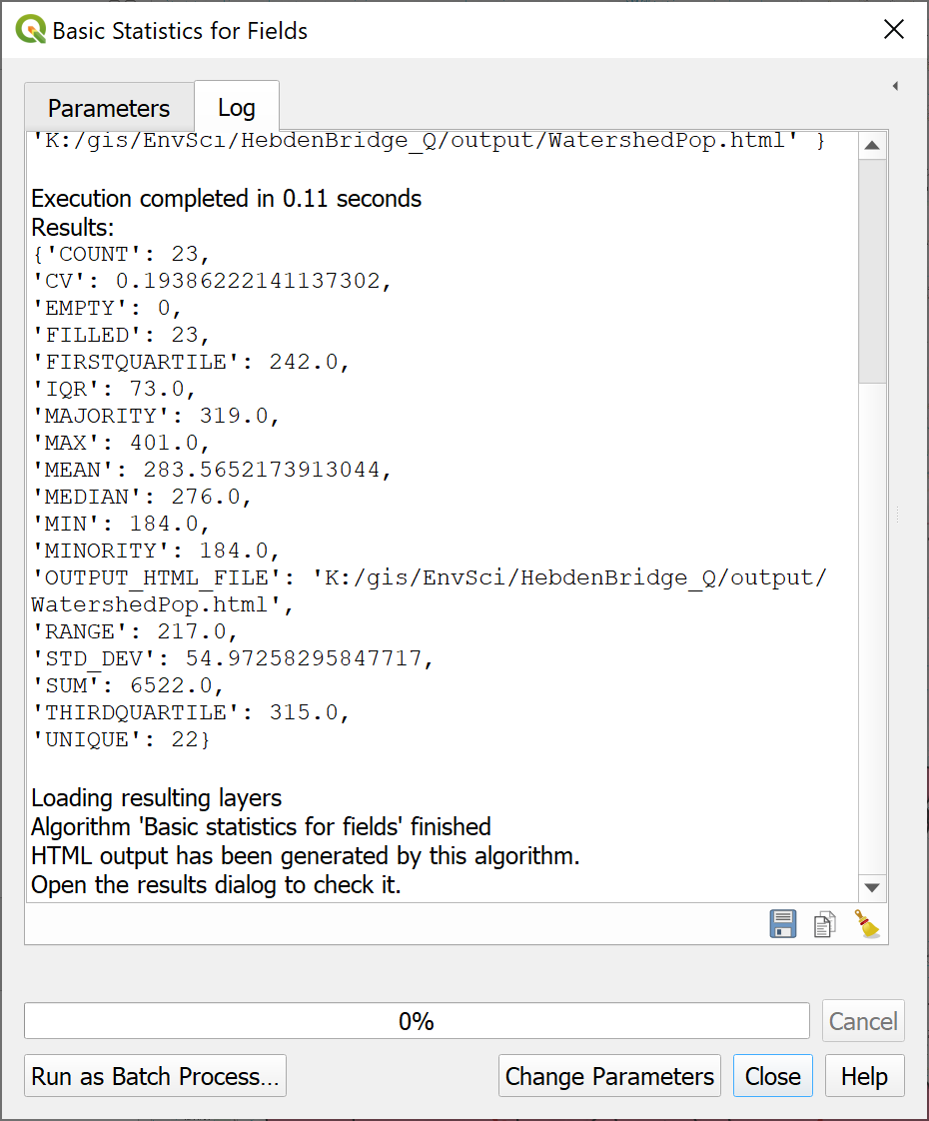

The processing Log showing the results of the field statistics. Look for the SUM of the TotalPopulation.

Don’t worry if you do close the Log, though, the Results Viewer should open on the right of your map. You can double-click on the Statistics entry to open a webpage with the results. The html file will also be saved to your computer and that should open in a browser if you double-click on it.

 **Think about your results**

Make a note of the sum population in the output areas that intersect the watershed.

Then stop and think about the data that you have used and look at your map.

Output areas are the smallest unit that we can download for census population data. How do those match the area that we are analysing? How would you phrase the explanation of the figures that you have just produced to make it clear what the data shows?

## Suggested layout

Use the layers that you have generated to create a map similar to the one below. Include the watershed outline and the output areas which intersect the watershed.

You should also include a brief explanation of what you are showing, and the number of people in the selected output areas. Don’t forget to include the usual map elements, such as title, key, scalebar etc.

When you have finished your map, export it as either pdf or an image and upload it to your GIS Portfolio. If you upload it before the next class I will give you brief feedback on your work.

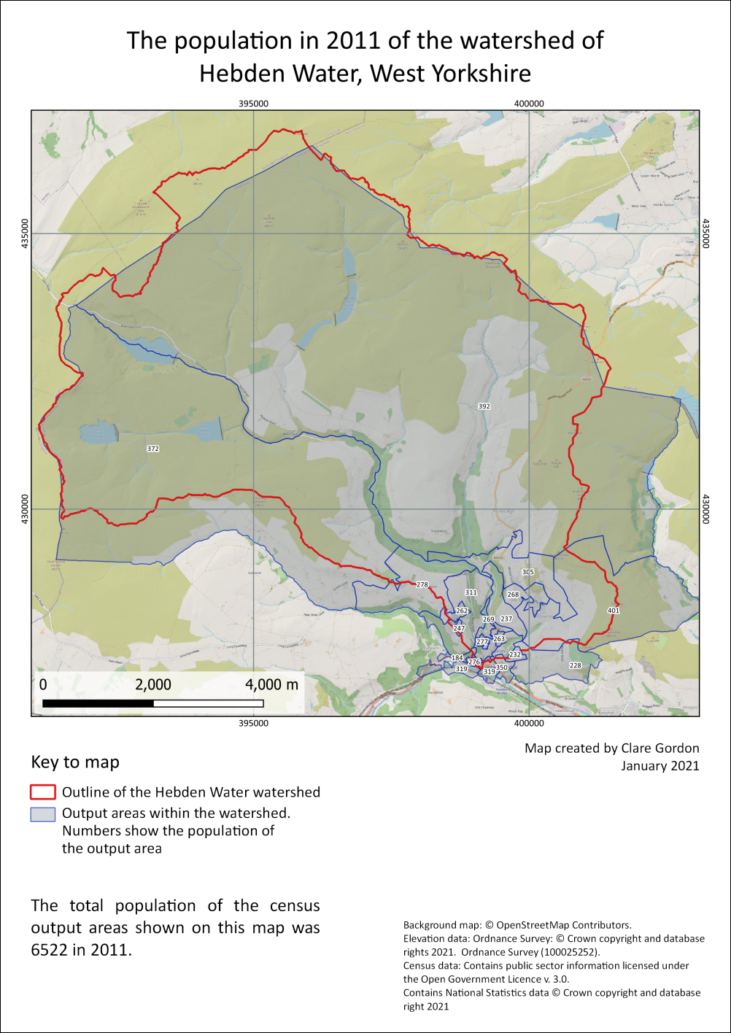

Example of a final map for the census data and flooding the Hebden Water. As usual you will have made your own decisions about styles and layout.

## Recommended reading and further information on census data

Many of the books in the reading list[29] have general information about elevation data. Suggestions include the following:

* Longley (2015) discusses the considerations around census data and data about individuals in chapter 17 - particularly section 17.3.1 onwards. p.394+
* Darkes and Spence (2017) - pages 28 onwards look at census and statistical data and at how to display it. Unfortunately this section is not in the downloadable version.

### Further information

* The geographer Alastair Rae works extensively with UK statistical data. His blog article entitled [Hey, what’s an MSOA?](http://www.statsmapsnpix.com/2020/10/hey-whats-msoa.html) may help to give you a bit more of an idea about census geography. In this chapter we’ve been using OASAs, which are smaller, but the principles are the same.

### More information about downloading census data

If you want more information about how to download census data, and about what is available, the UK Data Service has some guides that you can look at.

The guide for [Census aggregate data](https://census.ukdataservice.ac.uk/use-data/guides/aggregate-data.aspx) includes more data about aggregate data and a video showing how to download data from InFuse.

The [Boundary data page](https://census.ukdataservice.ac.uk/use-data/guides/boundary-data.aspx) has a lot of useful information and links to further tutorials.

The gov.uk website has information about the [2021 Census](https://census.gov.uk/) which happened in March 2021. Aggregate data from this census is not yet available.

# Vector data analysis

Last Modified: 01 Apr 22, 09:11:22

## Alternative chapters

So far we’ve mainly been using raster data for analysis. Where we’ve had vector data we’ve often converted it to raster to carry out the analysis, then sometimes back to vector for display.

In this chapter we’ll look more closely at using vector data for analysis.

This is an optional chapter which follows on from the chapter on downloading English and Welsh census data and adding it to GIS. This chapter covers how to analyse and display vector data to answer research questions with GIS.

**Note that this chapter is optional.** You can choose between working through this one, or the chapter on Environmental Decision Making.

Both chapters contain techniques that past students have gone on to use in their dissertations.

The decision making chapter is mainly raster-based again, and covers combining a series of layers for complex analysis using physical geography examples.

If you are more interested in human geography-type applications of GIS you may find this vector analysis chapter more useful.

Of course, you are welcome to work both chapters if you wish.

## Learning outcomes for vector analysis

When you have completed this section of the workbook you should be able to

* Demonstrate how to analyse and display vector data in a variety of ways to answer research questions with GIS.

## Introduction

In this chapter we will use vector boundary layers and vector point data in various ways to explore the distribution of reported crimes in Leeds from a single month.

These methods should give you an idea of what is possible with vector data and how you can display it. Try out the suggestions, then investigate some more of the tools in the vector processing toolboxes in QGIS to see what else is possible.

## Downloading data for vector data analysis

The data for this chapter can all be downloaded from the web. Much of it is freely available under the [Open Government licence](https://www.nationalarchives.gov.uk/doc/open-government-licence/version/3/).

### Census boundary data for Middle Layer Super Output Areas

We are going to use slightly larger census areas than we did in the census chapter, otherwise the data could get too fine-grained. This time we will use **Middle Layer Super Output Areas**, or MSOAs, covering the Local Authority District for Leeds.

For more information about MSOAs it’s worth having a look at Alastair Rae’s article, [Hey, what’s an MSOA?](http://www.statsmapsnpix.com/2020/10/hey-whats-msoa.html) if you haven’t already.

#### Searching for boundary data

For these exercises we’ll download boundary data from the Office for National Statistics (ONS). Remember this was listed as an alternative source for UK boundary data in the Census data chapter.

* Go to the [Office for National Statistics Open Geography Portal](https://geoportal.statistics.gov.uk/).
* Search for “Middle” then when the results come up use the selection menu on the left to select Feature Layer.
* In the list look for Middle Layer Super Output Areas (December 2011) Boundaries Full Extent (BFE) EW V3 and click on the heading.
* The page that opens gives you a preview of the data on a map and a description of the data. Have a look at the page.
* Now click on Download and choose to download Shapefile. Save the downloaded zip file to your GIS project folder.

#### Browsing for boundary data

You’ll also need a layer for **Local Authority Districts**. These are much larger administrative units and will give you a boundary for the whole of Leeds.

Another way of finding boundary layers on the ONS site is by browsing.

* On the menu at the top of the page click on Boundaries
* Go to Administrative Boundaries then to Local Authority Districts
* It makes sense to keep the boundary data consistent, so click on the link for 2011 Boundaries
* Look for the Feature Layer for Local Authority Districts (December 2011) Boundaries EW BFE and download the shapefiles in the way that you downloaded the MSOAs.

#### Preparing the boundary data

The data you’ve downloaded covers the whole of England and Wales. We will be working with data covering only within the Leeds Local Authority so it makes sense to restrict all our layers to that area. As usual it saves processing time and computer space.

* Add the Local Authority Districts layer to a new blank map and check that the CRS has been set to epsg:27700.
* You’ll see that at the moment this covers the whole of England and Wales. Use Select by expression to select the feature for Leeds (use the lad11nm field) and save it as a new geopackage layer. You can then remove the original layer from your map.
* Style the layer so that it is just an outline with no fill.

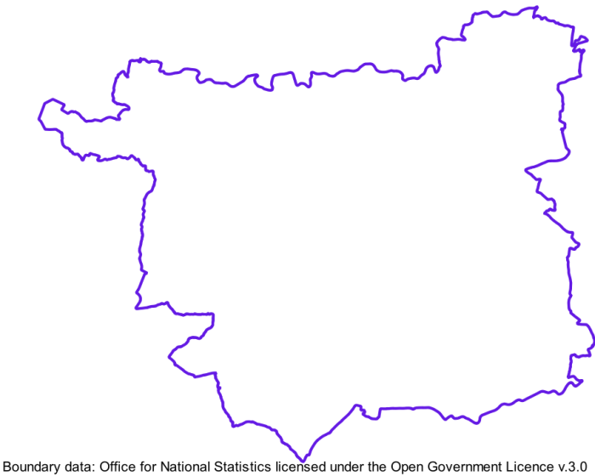

The Local Authority area for Leeds.

We also need to restrict the extent of the MSOAs to match the Leeds Local Authority boundary.

* Add the Middle Layer Super Output Areas shapefile to your map.
* Use Select by Location to select features from the MSOA layer which intersect with the Leeds Local Authority layer.

It’s worth experimenting here, I didn’t find that any of the geometry settings selected **just** the MSOAs in Leeds. The best I could manage was to use intersect, then use the Select features by area or single click to unselect the MSOAs around the outside of the boundary. (Hold Ctrl down to stop it from unselecting all the selected features.)

* Once you have only the MSOAs within the boundary of the Leeds Local Authority selected, save them as a new geopackage layer.
* Again, you can remove the original layer from your map.
* Style the layer so that it is just outlines with no fill.

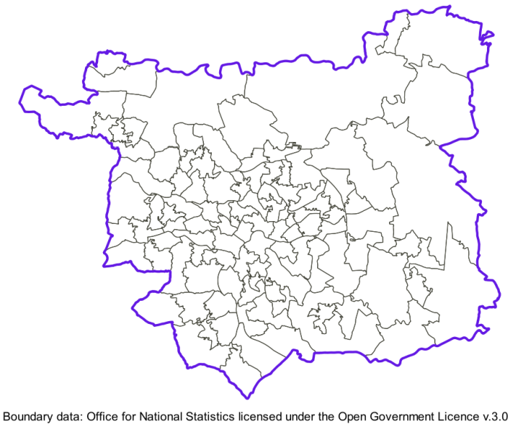

The Leeds MSOA boundaries within the Local Authority Boundary.

### Crime data for Leeds

All the police forces in England, Wales and Northern Ireland publish monthly data on reported crimes. This is freely available to download from the [data.police.uk](https://data.police.uk) website and we’ll use data for Leeds to carry out an assortment of vector analysis processes.

* Go to the [data.police.uk](https://data.police.uk) website and have a look at the information there.
* When you’re ready click on the Downloads link to download data in batches.
* Use the Date range: dropdowns to choose data for a single month. It doesn’t matter which month you choose. I used **January 2021** for the examples in this chapter.
* In the list of police forces put a tick next to West Yorkshire Police - this is the force which covers Leeds.
* Check that Include crime data is ticked.
* Then click on the button to Generate file
* For a single month for a single force it shouldn’t take long to generate the data, so on the next page click on the Download now button to download the data.
* As usual move the downloaded data to your project folder and unzip it.

You should end up with a folder for the month that you selected, which contains a csv file.

#### Adding the crime data to QGIS

Open the csv file in a spreadsheet program or text editor to have a look at the contents.

 **What location information does the csv contain?**

You need to know how you will bring the data into QGIS. What location information does the csv file contain? What are the titles of the columns that give you this information? What is the CRS likely to be?

You will be using this data for analysis, so you will also need to reproject it to match the rest of your data. The Download page includes a link to an [About page](https://data.police.uk/about/#crime-and-asb-anonymisation). If you look down that there is a statement quite a bit of the way down which says

Anonymised in line with the location anonymisation process. Converted to WGS84 longitude.

And a similar one for latitude. This should tell you that we need to reproject the data back from WGS84 to British National Grid.

Once you can answer the questions above, go back to your project in QGIS, the one that you added the boundary data to, and add the crime data.

* Export the points to a geopackage layer, reprojecting it to British National Grid in the process.

Once you have the data in your map and reprojected, you also need to **clip it to the extent of the Leeds boundary**.

* Use either Extract by location or Select by location and export the selection to restrict the points to the Leeds Local Authority.
* You can then remove the points layer covering the whole of West Yorkshire from your map.

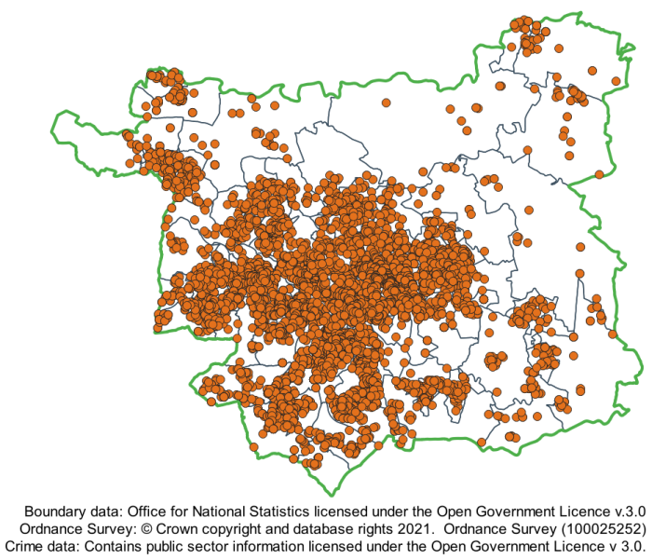

The Leeds Local Authority with crime data for January 2021 and MSOA boundaries.

### Leeds Census data

We’ll use the 2011 census data to provide the population figures for each MSOA.

 **Download census data**

Use the instructions on using InFuse to download census data from the census chapter.

This time download Age data for the Leeds Local Authority and download the data by Middle Super Output Areas and Intermediate Zones, not Output Areas and Small Areas.

#### Preparing the census data

Once you have downloaded your data, move it to your project folder and unzip it.

You will need to clean up the column headings before adding the file to QGIS. Then you will need to Join the data to the MSOA layer, in the way that you joined the data to the boundary data in the census chapter.

Joining this data won’t change the appearance of your map, but you should now have an MSOA layer for which the attribute table includes the population of each area.

The population field will probably be a text data type at the moment, and for analysis we are going to need it to be numeric. So the final preparation stage is to refactor the MSOA layer so that we can change the data type, and while we are at it, tidy up any unhelpful field names.

* Use the Refactor fields tool to change the data type of the population field in the MSOA layer from Text (string) to Whole number (integer - 64bit)
* Save the refactored file as a new layer.

You will need to style the new layer so that it is outlines with no fill, and you can remove any other MSOA layers that you have generated from your map, to keep it tidy.

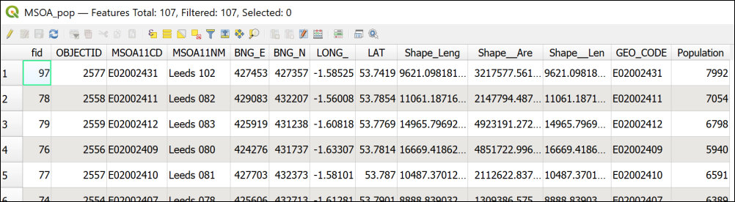

The attribute table of the refactored MSOA layer showing the population field taken from the census data - you may well have named your fields differently.

### Background map

You can choose to use either a background map from QuickMapServices, or download a background layer from Digimap. If you decide to download data it is probably worth downloading the 1:250 000 raster data as a general background. It may be worth downloading the VectorMapDistrict raster data too, in case you wish to zoom in and look at the data in detail.

If you use the Digimap background layers you might want to fade them by using opacity. They are quite strong colours which don’t allow the data to show well.

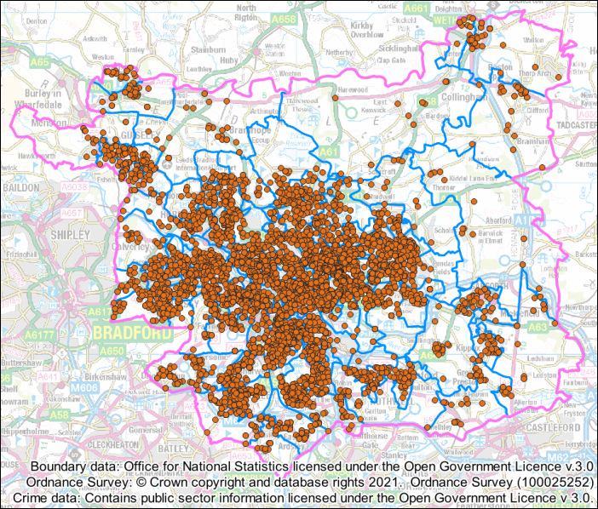

All the data layers on the map so far. The background is the 1:250 000 raster layer from Digimap faded with some opacity.

## Displaying data as a form of analysis

Analysis does not just mean running tools and generating new output. You can also analyse data by displaying it on a map in certain ways. In this way it can become possible for you to pick out patterns in the data.

We’ll style the crime data in a variety of ways to look for patterns, such as where the most crimes take place, and whether there is a pattern in the type of crime.

### Categorizing data

Start by looking at the attribute table for your crime data. There is a column for Crime type which gives information about each crime such as whether it was a Burglary or Anti-social behaviour.

The simplest way to display the data would be to categorise the points by the type of crime.

 **Styling a vector layer as categories in QGIS**

This video clip can be found in the module area of [Minerva](https://minerva.leeds.ac.uk) or in the [full list of video clips](https://cgordon-gis.github.io/videoclips.htm).

* Select your crimes layer in the Layers panel and open the Layer Styling panel.
* Set the type of styling to Categorized and the Value to the Crime type field and click to Classify.
* It’s probably a good idea to untick the all other values symbol.

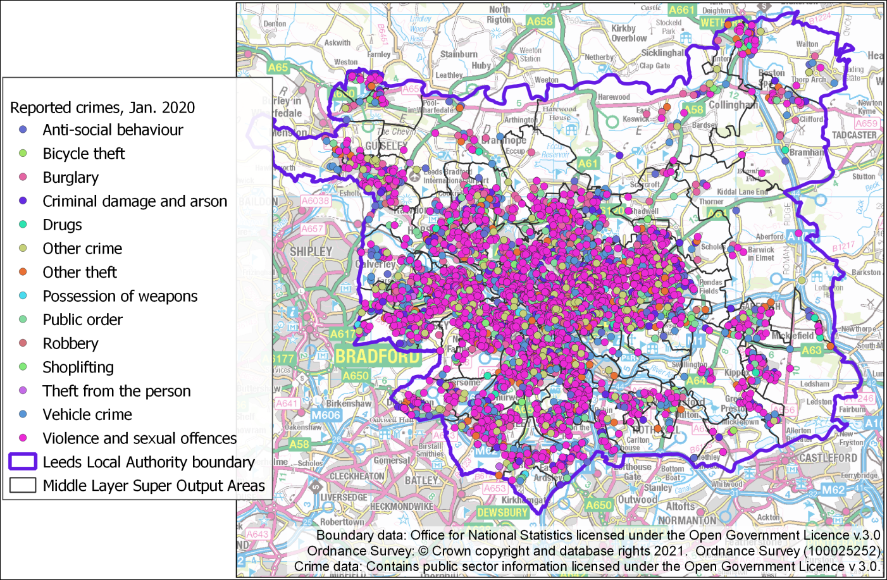

The categorized crime types.

Now zoom in and pan around and have a look at your map.

 **Can you spot any patterns in the type of crime?**

You may not be able to, that doesn’t matter! There may not be anything obvious. In this case, when you are viewing the data for the whole of Leeds, the points are rather densely displayed and there is a lot of overlap.

You can also try making some of the categories invisible to see whether that accentuates any patterns or not.

### Viewing data with a heatmap

Heatmaps can show dense point data more effectively than just the points. They are a way of interpolating data to show density. If you remember, we have already covered interpolating point data to a raster surface in a previous chapter, this is another method.

#### Creating a heatmap with styles

If you have a vector point layer for which you wish to show density, the easiest way to do so is by setting the style for the layer.

 **Setting vector styles for a heatmap in QGIS.**

This video clip can be found in the module area of [Minerva](https://minerva.leeds.ac.uk) or in the [full list of video clips](https://cgordon-gis.github.io/videoclips.htm).

* Right-click on your crimes layer in the Layers panel and select Duplicate layer. This adds the copy as a new layer in your map. Remember though, that this layer still references the same dataset, it’s just that you can now change the styling but still go back to the original version of the layer styling if you wish to.
* Select the visible copy of the crime layer in the Layers panel.
* In the Layer Styling panel set the type of Styling to Heatmap - note that this can take a while to redraw, so your map may disappear for a short while.
* The default Color ramp is white to black, for a heatmap it probably makes more sense to choose the Reds colour ramp, so that the densest areas are the darkest red.

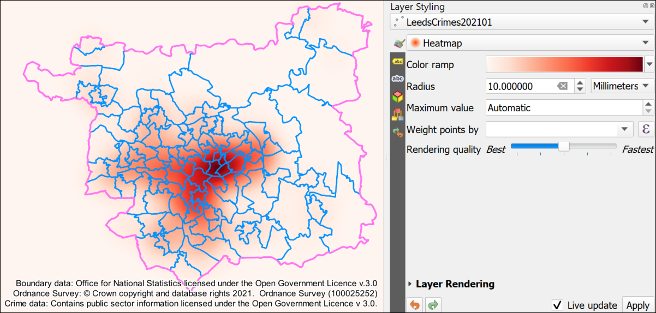

The Heatmap settings and output for the crime layer. Note that I have the crime data layer beneath the boundary layers.

The Radius controls the area over which each point has influence.

* Try changing the radius setting, for example to 30 instead of 10, and have a look at the difference it makes to the heatmap. Be aware that the higher you set it, the longer the map will take to redraw.

Note that the measurement is in Millimetres. This is millimetres on the map canvas, so if you zoom in close the area of influence changes.

* Set the unit of measure to Map units.
* You’ll then need to change the Radius to a much higher number to see the difference, for example, 1000. That will then make each point influence the area for a 1 km radius.

If you zoom in and out on the map now you should be able to see that the area covered by the darkest red doesn’t change compared to the boundary data.

 **Taking a screenshot to check changes**

I found that taking a screenshot of the heatmap before each change made it easier to see any differences, otherwise when QGIS took a while to redraw the heatmap I forgot what the previous version had looked like!

* Make your Crimes layer transparent so that the background map shows through and you can see the names of the locations. You will need to use the Layer Rendering setting at the bottom of the Layer Styling panel to set Opacity for the heatmap.
* You may find that setting the Blending mode to Multiply is more effective than using Opacity. Experiment!

#### Weighting the heatmap by classification

It is also possible to **weight** the points by classifying the crime type, but to do this you first need to add a new calculated field to the attribute table.

 **Using the field calculator to weight vector data in QGIS.**

This video clip can be found in the module area of [Minerva](https://minerva.leeds.ac.uk) or in the [full list of video clips](https://cgordon-gis.github.io/videoclips.htm).

* Open the attribute table for the Leeds Crimes layer and open the Field calculator.
* We want to create a new field so fill in an Output field name such as Weighting. Leave the field type as Whole number (integer).
* It is necessary to create an expression to assign the weightings. Type the following into the expression box using the elements from the central panel to help you.

For example, if you select Crime type under Fields and Values you should then be able to click on All Unique to the right and get a list of each crime type which you can then enter in the expression.

CASE  
WHEN "Crime type" = 'Violence and sexual offences' THEN 10  
WHEN "Crime type" = 'Criminal damage and arson' THEN 8  
ELSE 1  
END

You should be able to Preview your output below the expressions box.

* When you are happy with the expression click on OK to write the values to the attribute table.
* Check that the attribute table has been updated correctly, then click to Save the edits and toggle editing off by clicking on the pencil icon.
* Now you should be able to enter the Weighting column in the Weight points by dropdown and see what difference it makes to your map.

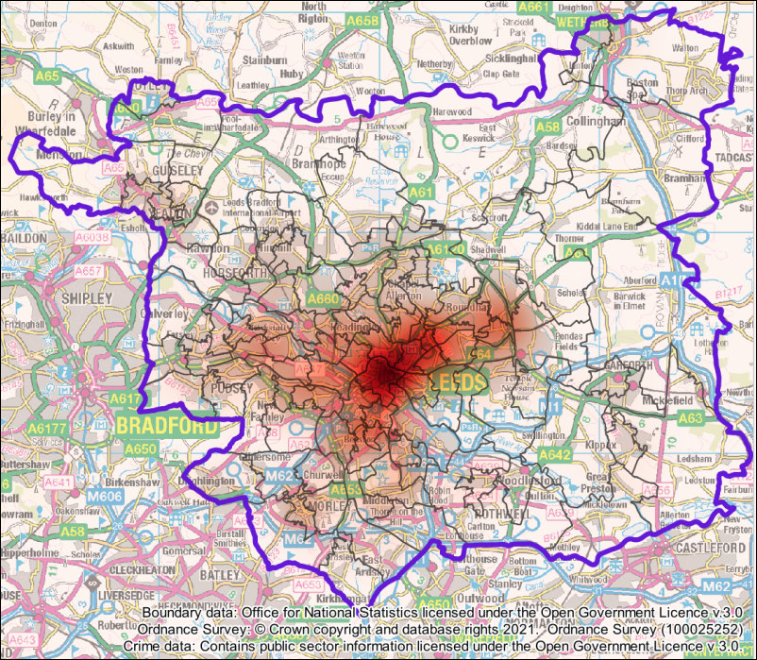

The weighted vector heatmap layer with layer rendering set to Multiply.

Feel free to experiment by adding more or different categories, and weighting them as you wish between 10 and 1.

 **What do you notice if you look at the Crime layer in the Layers panel?**

Can you use the layers panel to see the values for your heatmap?

It should be obvious that you can’t. This is a problem with using styling to display heatmaps, it isn’t possible to provide a key for them. Instead you need to generate a raster heatmap using the **Heatmap (Kernel Density Estimation)** tool.

#### Creating a raster heatmap from point data

It is also possible to create a heatmap as raster output and this has the advantage of being able to generate a key to include on your layouts.

 **Creating a raster heatmap in QGIS.**

This video clip can be found in the module area of [Minerva](https://minerva.leeds.ac.uk) or in the [full list of video clips](https://cgordon-gis.github.io/videoclips.htm).

* Make the vector heatmap layer invisible.
* From the Processing toolbox search for Heatmap and open Heatmap (Kernel Density Estimation).
* Enter your crime layer as the input Point layer. (Make sure you use the one that you added the weighting to. Although the Layer panel entries point to the same datasource, there can be a delay in refreshing the new attributes.)
* Set the radius to the same as you decided to use for the styling - in this case you will choose meters as the unit rather than map units. They are the same in this case.
* To save processing power set the Pixel size x and y to 5.00. You can always run the tool again with a lower pixel size if you decide you want more detail and have a good enough computer.
* Under Heatmap click on the three dots to save your output to your computer.
* If you want to weight the result again you can drop down the Advanced Parameters and enter your weighting field under Weight from field.
* When you are ready run the tool.

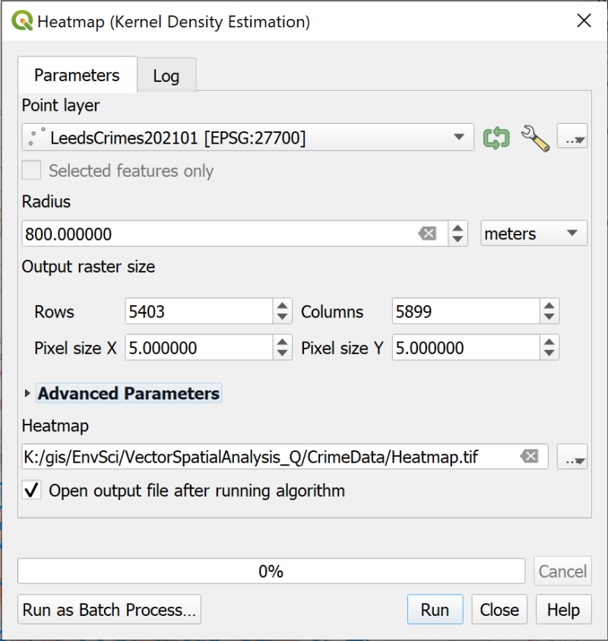

Filling in the Heatmap dialog.

The result may look rather odd at the moment, but use the Layer Styling panel to change the type of styling to Singleband pseudocolor and set the red color ramp again. You’ll probably need to click on Classify to set the classes. Once you’ve done that you’ll be able to experiment with the Mode and classes to see what displays the density of crime across the Leeds Local Authority area the best.

Part of the point of generating the heatmap with the processing tool is to make it possible to add a key to a layout so have a look at the layer in the Layers panel. You should be able to see what value the colours indicate now.

Again, styling the layer with the Multiply blending mode appears to work better than making it transparent, but experiment to see what works best on your map.

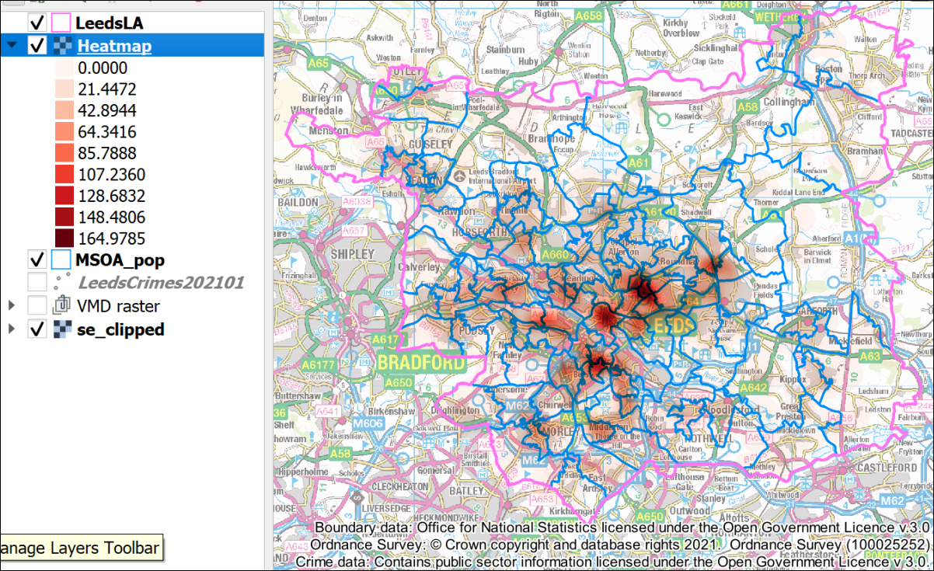

The styled raster heatmap with legend in the Layers panel.

## Relating point data to areas

So far we’ve been looking at the crime data in relation to the whole of the Local Authority area of Leeds, but it would be useful to be able to break it down into smaller areas, in this case the Middle Layer Super Output areas, or MSOAs, that you already have on your map. We already have population data for the MSOAs joined to the attribute table, if we can also add a figure for the total number of crimes in each MSOA then we can work out the number of crimes per head of population in each MSOA and display that on our maps.

### Counting the number of points within each polygon

Luckily we don’t need to carry out this process manually, there is a tool in the processing toolbox which will count the number of points from a layer which occur within the area of each of the polygons in another feature class.

 **Counting the number of points within each polygon in QGIS**

This video clip can be found in the module area of [Minerva](https://minerva.leeds.ac.uk) or in the [full list of video clips](https://cgordon-gis.github.io/videoclips.htm).

* In the Processing Toolbox search for Count points and open the Count points in polygon tool.
* The input Polygons are the MSOA layer which already contains the population data.
* The input Points are the Leeds crimes layer.
* Under Count field name give the new field a name that tells you what data it contains, e.g. CrimeTotal.
* Click on the three dots at the end of the Count line and tell QGIS where to save the output and what to call it.
* Click on Run to create the new layer.

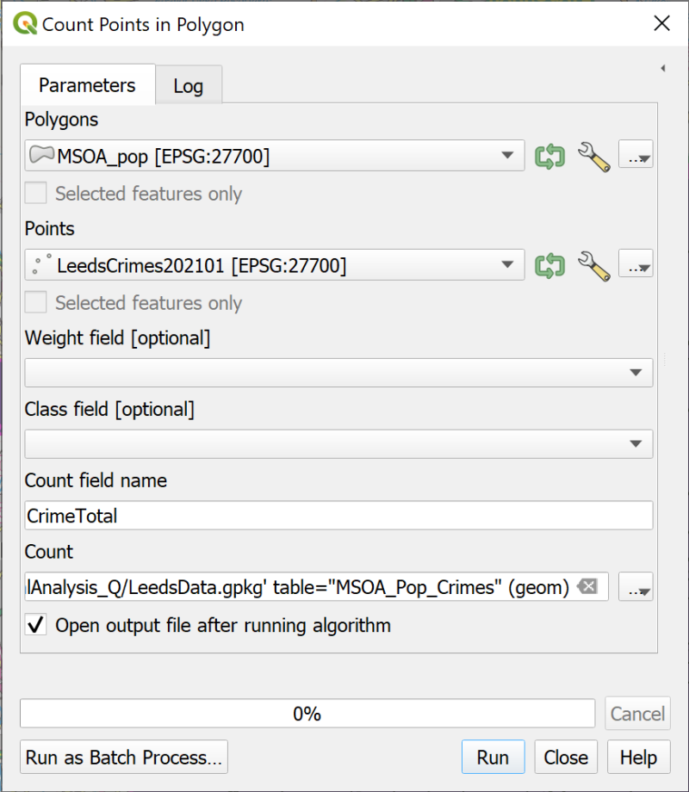

Filling in the form to count the number of crimes in each MSOA polygon.

The new layer will look the same as the existing MSOA layer. Don’t worry about styling it yet.

Check the attribute table of your new layer and QGIS should have added a new column to the end of the table which shows the total number of crimes in each MSOA.

Remove the previous MSOA layer from your map to save confusion later.

### Calculating the number of crimes per head of population

Now that you have both the total population and the number of crimes in the same feature class it is easy to work out the number of crimes per head of population.

 **Using the field calculator to create new fields in QGIS.**

This video clip can be found in the module area of [Minerva](https://minerva.leeds.ac.uk) or in the [full list of video clips](https://cgordon-gis.github.io/videoclips.htm).

* Open the attribute table for your new MSOA layer
* Click to open the Field Calculator
* Create a new Decimal number (real) field called Crime_per_pop, or something that tells you what data it contains.
* In the expression area construct an expression which divides the number of crimes by the total population. Remember you can use the Fields and Values part of the central box to find the field names accurately.
* Use the Preview below the expression box to check the output.

The result is likely to be a number with rather a long string of digits after the decimal point. Remember that it is possible to round the result to a more reasonable number of decimal places.

* Change your expression so that the number is rounded to 5 decimal places. Remember you can search for round in the central box and you will be shown how to use it in an expression on the right-hand side.
* When you are happy with your expression click on OK to add the calculated field.
* Remember to save the new edits and click on the pencil icon to stop editing mode.

Check the result in the attribute table. These are small numbers, but we can display them in a way which allows us to see comparisons between the MSOAs in Leeds.

### Creating a choropleth map

A choropleth map can be used to show **ratios** in your data. Examples include population per square kilometre, or crimes per head of population. The data is applied to an area and it becomes easy to compare different areas.

We’ll use this technique to map the number of crimes per head of population in each MSOA in the Leeds Local Authority.

 **Displaying data as a choropleth map in QGIS.**

This video clip can be found in the module area of [Minerva](https://minerva.leeds.ac.uk) or in the [full list of video clips](https://cgordon-gis.github.io/videoclips.htm).

To style the MSOAs by crimes per head of population do the following:

* Open the Layer Styling panel for your MSOA layer which has the result of the previous calculation, that is, the number of crimes divided by the total population for each MSOA.
* At the top of the panel choose to style as Graduated
* Set the Value to your calculated column
* Choose the colour ramp that you want to use, e.g. Reds.
* Click on the Classify button to apply the styles.
* It’s a good idea to set transparency either via the Symbol colour, or via the Layer Rendering, where it’s worth trying the Multiply blending mode.
* Remember to make the heatmap layer invisible or you could end up with a rather confusing result.

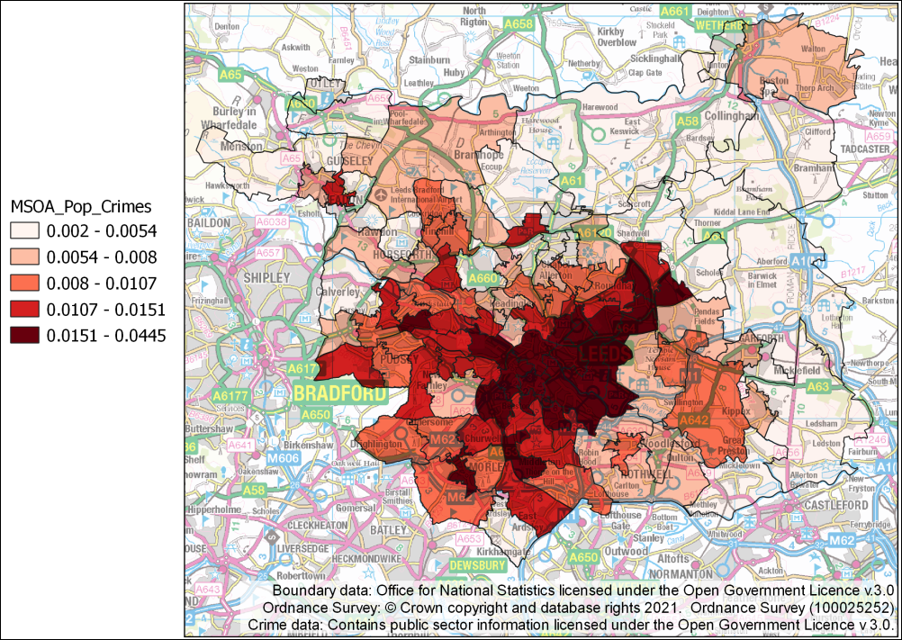

The number of crimes per head of population by MSOA styled as a choropleth map with a graduated classification. This uses the default settings with the Reds colour ramp.

Now that you have the basic styling, you can experiment with the settings to see how you can best display your data.

* For example, try changing the Mode to Equal interval or Natural breaks.
* You can also change the number of Classes, though it’s not a good idea to set too many. The usual recommended maximum is six, unless you have a good reason to use more. Higher than six it can become difficult to see the categories on the map.
* You can also try alternative colour ramps to see what effect you get.

There are principles for styling these choropleth maps that you can find in the cartography texts on the reading lists, but in the end it comes down to experience, both as a map-maker and as a scientist. Experiment and see what works for your data.

#### Viewing a histogram

The Layer styling panel also allows you to view a **histogram** of your data. That is a graphical view of your data showing how many instances of each value or group of values you have.

* On the Layer styling panel look just underneath the Colour ramp. You should see that you currently have the Classes tab selected, now click on the Histogram tab.
* Click on the button to Load Values

The histogram showing your data should appear, showing how many MSOAs are in each colour class, and what the boundaries of those classes are.

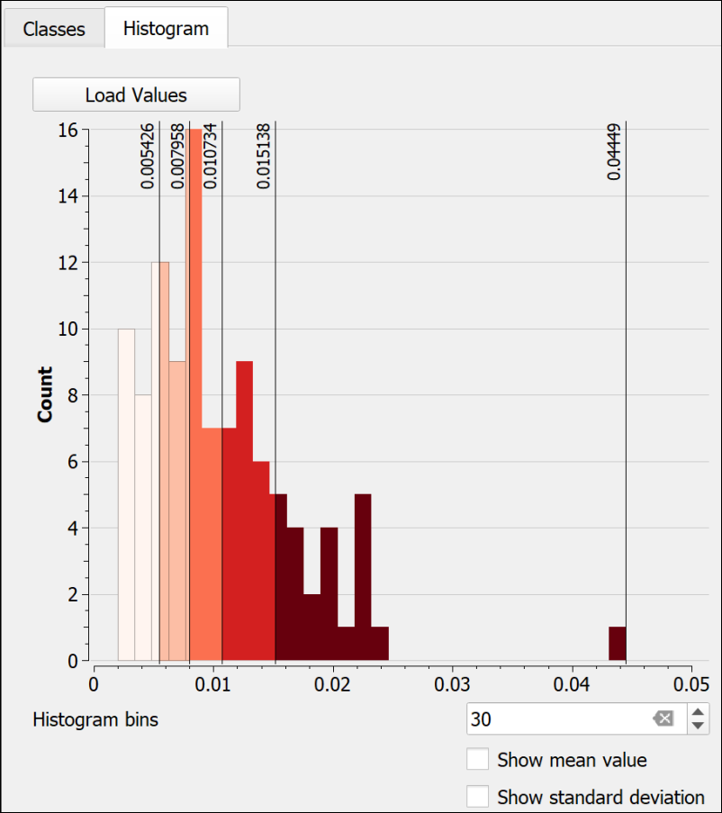

The histogram for my choropleth map, showing the distribution of data in the classes.

In my example (Classes are set to Equal Count (Quantile)) it suddenly becomes possible to see that there is a MSOA which has a comparatively high value for crimes per head of population compared to the other MSOAs.

I can now go back to the Classes tab and change the Mode then check the Histogram again to see which setting makes it most clear that there is this single MSOA in a class of it’s own.

It is also possible to manually adjust the classes using the Histogram.

* Use the mouse to “grab” one of the class boundaries in the histogram and drag it to left or right.
* It is also possible to click on the histogram to add another class, though it only appears to be possible to remove one by going back to the class tab and resetting the number of classes.

### Showing statistics

It is possible to open a window showing basic statistics for a layer.

* If you don’t already have the Attributes toolbar open go to View > Toolbars and put a tick in the box next to Attributes.

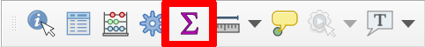

The Attributes toolbar with the Show Statistical Summary button shown.

* Once you have the toolbar, click on the Show Statistical Summary button.
* Check that you have the correct MSOA layer selected in the dropdown box at the top of the Statistics window
* Select the crime per population field

The statistics for your data should be shown in the window. Have a look at what is available to you.

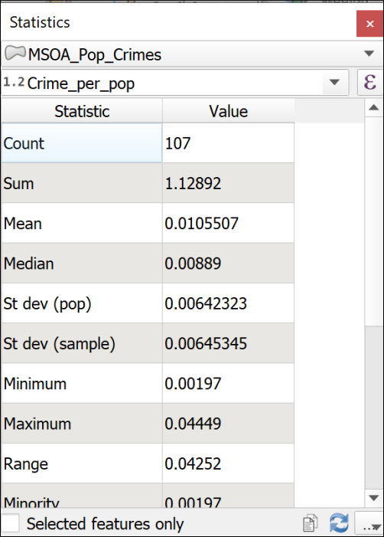

The statistics for the MSOA crimes per head of population field.

## Creating graphs with the Data Plotly plugin

You’ve already seen how to create a histogram of your data, but by installing a plugin it becomes possible to create other graphs too.

* Open the Plugin Manager, search for Data Plotly in the list of Not installed plugins, and Click the button to install it.
* Open it by going to Plugins > DataPlotly > DataPlotly.

The tool should open as a panel to the right of your map.

* Start by choosing the Plot type, e.g. Scatter plot
* Set the layer to the MSOA layer with population and numbers of crimes
* Set the X field to Population
* Set the Y field to Total of crimes
* For now leave the rest of the settings as they are and click on Create Plot at the bottom of the panel.

After a short pause the plot should be generated on a new tab. You may need to make the panel wider, or “pop” it out of the QGIS window so that you can see the plot correctly.

Have a look at the plot, then explore the parameters and settings available to you. The second tab on the left allows you to add a title and various other elements to the plot.

On the first tab you can try out different types of plot and different ways of displaying the data from your map. You may wish to use the Clean Plot Canvas button between each experiment as otherwise they all get added to the same view.

When you have a plot that you want to keep you can use the buttons at the bottom right of the plot window (third tab down) to export the plot as either a html file, or an image.

Once you have DataPlotly installed you can also set up plots from within a layout so they appear next to your map and can update automatically.

You can find out more information about the [DataPlotly plugin on the github webpage](https://github.com/ghtmtt/DataPlotly).

## Final layout for vector data analysis

For your final layout for this chapter try adding multiple maps showing different views of your data, e.g. the categorized point data, the heatmap and the choropleth map with the crimes per head of population. You could also include the graph from the Data Plotly plugin.

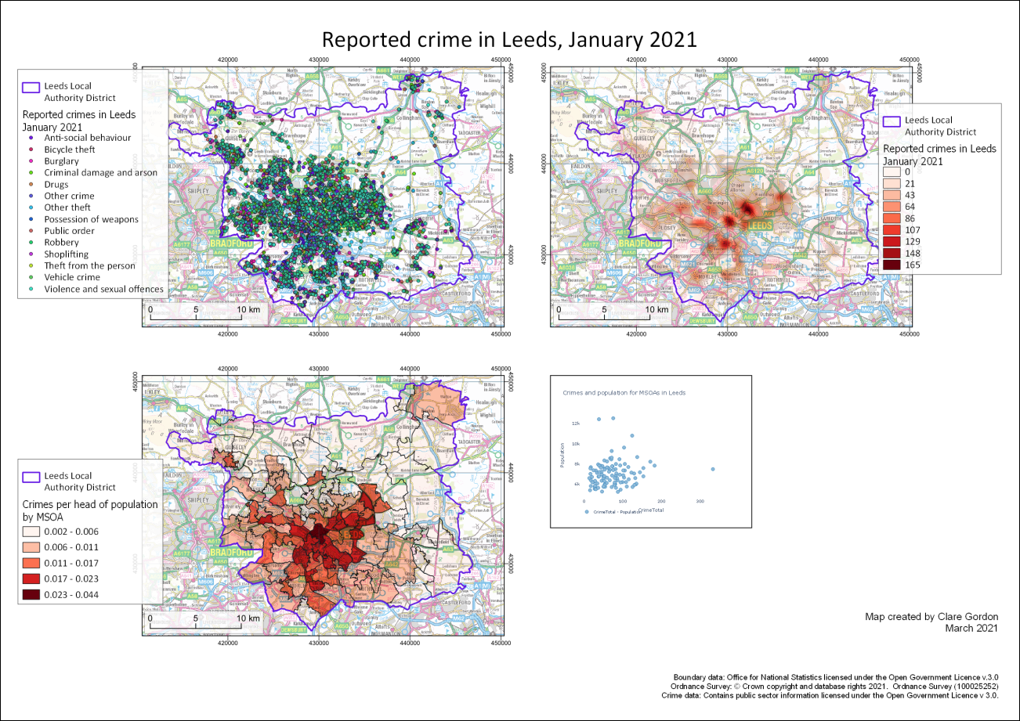

Possible final map for this chapter showing three maps with different techniques for showing vector data.

Once you have completed your layout, export it as either an image or a pdf and upload it to your GIS portfolio. If you upload it before the next class I will provide brief feedback on your work.

## Recommended reading for vector data analysis

Many of the books in the reading list[30] have general information about vector data analysis. Suggestions include the following:

* Darkes and Spence (2017) has a section on ways to present data which includes useful information, see pages 27-35, in particular Mappable Statistics, pp. 28-29; Choropleth maps p.30;

### Further information

* It is worth looking at [QGIS Tutorials and Tips](https://www.qgistutorials.com/en/index.html) for more information on a range of vector analysis techniques.

# Environmental decision making

Last Modified: 21 Apr 22, 08:33:55

## Alternative chapters

This chapter covers the use of GIS to analyse multiple raster data layers through both multi-criteria analysis and least-cost paths.

**Note that this chapter is optional.** You can choose between working through this one, or the chapter on vector analysis.

Both chapters contain techniques that past students have gone on to use in their dissertations.

This decision making chapter is mainly raster-based again, and covers combining a series of layers for complex analysis using physical geography examples.

If you are more interested in human geography-type applications of GIS you may find the vector analysis chapter more useful.

Of course, you are welcome to work both chapters if you wish.

## Learning outcomes for Environmental Decision Making

When you have completed this section of the workbook you should be able to

* use GIS to analyse multi-criteria models to provide answers to complex questions
* explain how to use least-cost pathways to suggest the optimum route from a source to a destination
* give examples of how these analysis techniques can be used to solve environmental questions

## Introduction

In previous exercises you have processed data and added multiple layers to the same map to show where they overlap. You have also selected data that overlaps or intersects particular features in other layers. This is useful, and produces some informative maps, but in this chapter you will learn how to go further and combine data layers to produce a single layer that answers questions such as

* Where am I most likely to find a particular plant?
* Where would be the best place to site some bee hives?
* How will hedgehogs be able to move around the University of Leeds campus?

The first part of the chapter will cover **multi-criteria analysis**, then the second part will go on to look at **least-cost paths**.

## Data required for the environmental decision making exercises

 **Warning**

Being able to find, download and prepare your own data is an essential part of using GIS. For the exercises in this chapter you will need to download several datasets. While these should not take too long to download and prepare, don’t leave it until the last minute. Websites can become unavailable either permanently or temporarily, or computers can crash.

If there are problems with a website then try again later. If the problems persist please get in touch with me ([c.e.gordon@leeds.ac.uk](mailto:c.e.gordon@leeds.ac.uk)) and I will try to contact the site or find an alternative source of data.

### Data to download

Log in to Digimap and download the following datasets from Ordnance Survey data download for the area around **Otley** in **Yorkshire** that is shown in the image below:

* Ordnance Survey Terrain 5 DTM in asc format - from Land Height Data
* OS Open Map Local Vector data in SHAPE format - from Vector Data

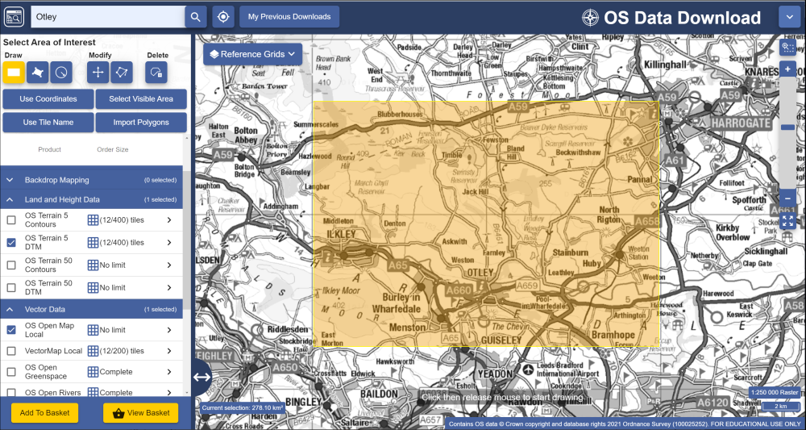

Downloading data for the Otley area from Digimap Ordnance Survey Download.

Then go into Environment Data download and download the following data for the same area:

* Great Britain (vector) in Land Cover Map 2019 - from Environment Data Download. Choose to download as a geopackage.

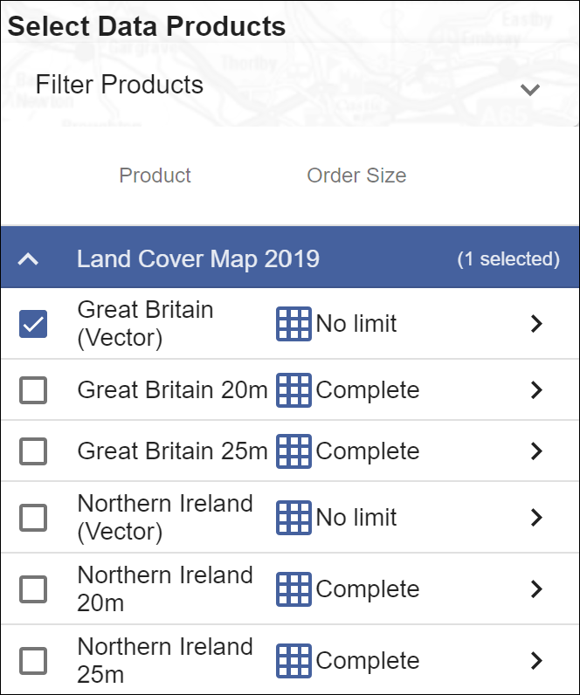

The data to download from Digimap Environment Data Download.

* Also download DecisionMaking.gpkg from Minerva for this week.

As usual save all the data to your project folder.

### Preparing data

Start by unzipping all the data, putting it in a folder for this project, and having a look at what you have downloaded. What formats are the data in, and do you have multiple tiles of data for any dataset that will need to be merged?

#### Defining the study area

The DecisionMaking geopackage includes a layer called StudyArea which defines the area that we will be using when processing our data.

* Start by adding the StudyArea layer to a new map in QGIS. This should automatically set the map CRS to British National Grid (epsg:27700). If it doesn’t, set that now.
* The layer should be styled as an just an outline, if it isn’t set that up now.
* Don’t forget to save your map from time to time.

The other two layers won’t be needed until the second part of the chapter, so just keep them in the geopackage for now.

#### OS Terrain 5 DTM

You should have more than one tile of this DTM dataset.

Follow the instructions from the chapter on elevation models to merge the tiles so that you have a seamless dataset. Don’t forget to check the properties of the tiles before you merge them, e.g. what is the cell size, what is the data type, what is the CRS?

To save processing time and computer space you should also clip the dtm to the StudyArea vector layer extent. You can then remove the merged DTM which covers the larger area.

You don’t need to worry about symbolising the dtm as it won’t need to be visible on the final map.

#### OS Open Map Local vector dataset

The OS Open Map Local vector dataset consists of a number of shapefiles. For this exercise the only layers that you will need are the SE_Road and SE_SurfaceWater_area layers, so add those to your map now.

The layers that we’ve downloaded cover the whole of the SE 100 km grid square but we only need the data for the Otley area. Use Save Features As... to export the Roads and SurfaceWater shapefiles as new layers in a geopackage, setting the Extent to the extent of the StudyArea layer. The layers will still overlap the edges of the study area as this process doesn’t cut individual features, but this will cut down the amount of data that you are working with considerably.

Make sure that the **road** dataset for the smaller area is on your map, and remove the original layers. You can remove the smaller SurfaceWater_Area layer too, as you won’t need that until the second part of the chapter.

You won’t need the original data now, so to save space on your computer delete the folder containing the shapefiles for the Open Map Local vector data. If you need it again you can unzip it from the original download.

#### Land Cover 2019 Data

The land cover data is a single layer within a geopackage so drag and drop that onto your map now. You should find a layer consisting of polygon shapes which all fit together.

 **How do you style this layer?**

Have a look at the attribute table of the layer. Is it obvious which field you should use to style it according to land cover?

You probably answered “no” to the question above! All the fields contain a list of numbers, so it isn’t obvious what they mean.

When you unzipped the downloaded zip file you should also have seen a folder called docs. Enter that folder and open the pdf that it contains. That is the product documentation and gives you information about the data you have downloaded. Have a quick look at the document.

* Now go to page 5 of the product documentation. That gives you a list of how the land cover classes are identified.

The numbers in the LC Identifier column match those in the _mode column of the attribute table.

* Use the _mode column to style the layer on your map by categories. The colours will be random.
* Make the styles transparent so that the layers below are visible through them.

Using the Layers panel and the document you should now be able to work out the land cover for areas of your map.

 **What is the dominant land cover on the map?**

You should be able to work out that it is category 4, **Improved grassland**, which if you’ve explored north of Leeds at all shouldn’t come as much of a surprise.

When we reclassify the land cover data later in the chapter, we will also add the descriptions to the data so that it is easier to work with.

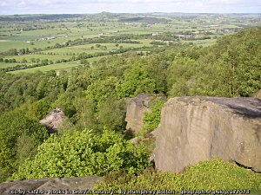

The view over the improved grassland of Wharfedale from Otley Chevin.

#### The map so far

Once you’ve added all four layers, your map should look something like the one below, though most likely with different colours.

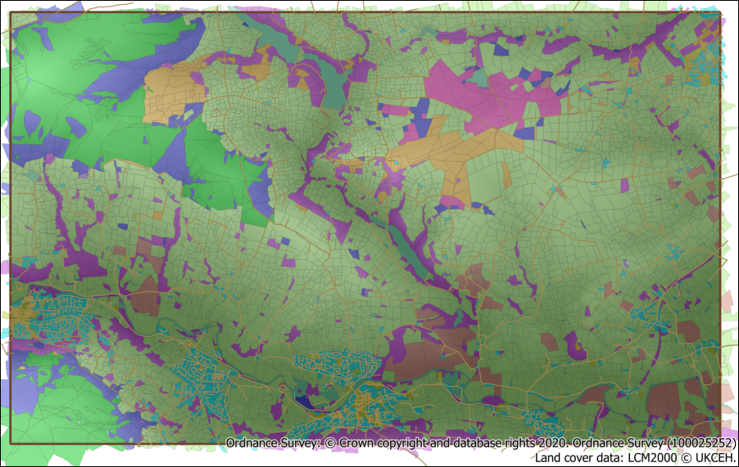

QGIS map with DTM, rivers and land cover added and styled. The colours for the land cover are random so yours will look different to mine.

#### Background map

In addition add a background map so that you can see where places are located. Either download something suitable from Digimap or use one of the layers from the QuickMapServices plugin, e.g. OpenTopoMap or Monochrome OpenStreetMap.

## Analysing multiple criteria

Now that we have the data on our maps we can start to run processing tools to enable analysis, and hopefully an answer to the question of which areas on this map would be suitable locations for bee hives.

In the first part of this chapter we’ll look at an example about locating bee hives as outlined by Zoccali, P. et al. 2017, [31] but simplify it somewhat so that you can get an overview of the GIS techniques involved. If you know a lot about bees you may not agree with some of the criteria below, but for the sake of this exercise they give us a starting point.

The criteria that we will take into account are:

1. **Altitude** - this tends to affect the average temperature and also the types of plants that will grow, so we will assume that lower altitudes are better than higher.
2. **Land cover** - land cover with a higher potential for pollen-producing flowers is likely to be much more successful for bees.
3. **Proximity to roads** - this is useful when transporting hives or when visiting the hives to check on the bees and collect the honey.

The article linked from the footnote above also looks at temperature between April and October and proximity to rivers and lakes.

It would be possible to do the analysis using vector layers, for example, by creating a buffer around the roads; clipping to roads below a certain altitude, then intersecting the best land cover with the clipped buffer. This would give a answer, but what if you wanted to **weight** the different datasets, e.g. if the proximity to a road was more important than the altitude, and the land cover was more important than either?

Instead it is possible to convert all the data to raster layers, normalise them to the same values, usually 0-1, then combine them all in the raster calculator and weight some layers more than others. This is the method we will use in the following exercises.

### Proximity to roads

The first criteria we’ll prepare the data for is proximity to roads.

#### Rasterizing the roads

We have a vector layer for roads so the first step is to rasterize this so that the roads have a value of 1 and the spaces between have a value of 0.

* In the menu bar go to Raster > Conversion > Rasterize (Vector to Raster)
* The Input Layer is the roads vector layer
* A fixed value to burn needs to be 1 (the tool doesn’t produce the right result if you don’t fill this in!)
* Set Output raster size units to Georeferenced units
* The Width and Height resolution should be 5 to match the DTM - this will make analysis simpler later.
* Set the Output extent to the same as the StudyArea layer.
* Choose where to save the output and give it a name.
* Run the tool.

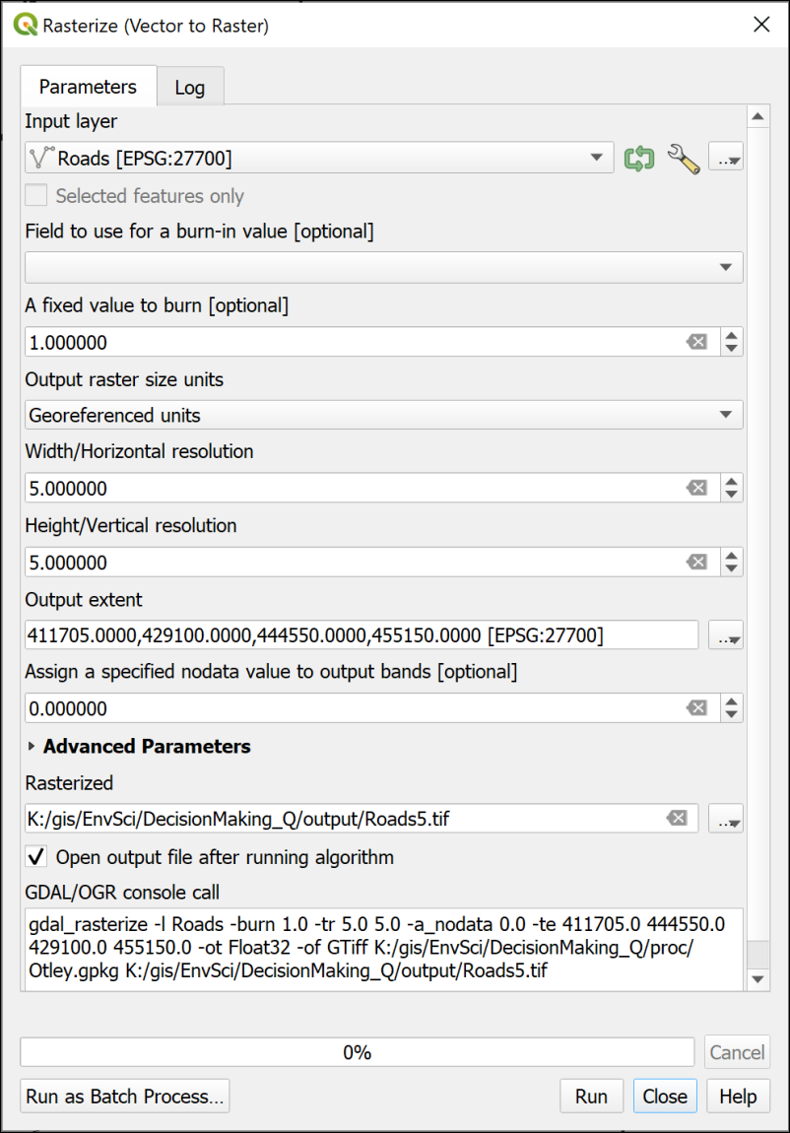

The Rasterize tool to convert the vector roads to a raster layer.

The resulting layer should look very similar to the vector roads layer, but will look pixelated if you zoom in to some of the lines. We set the resolution to 5,5 in georeferenced units, so each pixel is 5 x 5 metres.

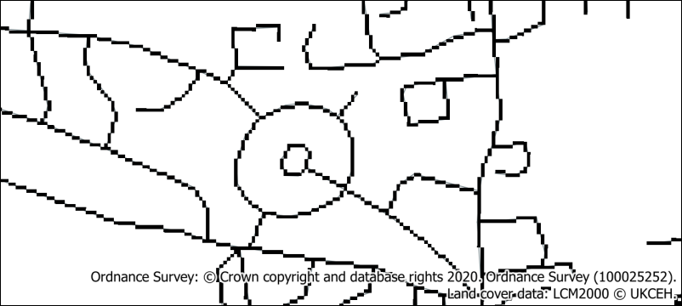

The rasterized roads - the original vector roads are still just about visible as thin lines.

#### Creating a raster showing proximity to roads

The next step is to generate a layer showing proximity to roads across the whole area. For this we can use the Proximity (raster distance) tool.

 **The Proximity (raster distance) tool in QGIS**

This video clip can be found in the module area of [Minerva](https://minerva.leeds.ac.uk) or in the [full list of video clips](https://cgordon-gis.github.io/videoclips.htm).

* Open the Processing toolbox and search for Proximity
* Open the Proximity (raster distance) tool from the GDAL Raster Analysis toolbox.
* The Input layer is the raster road layer.
* The Distance units are the Georeferenced coordinates
* Under Proximity map select where to save your output and give it a name.
* Then Run the tool.

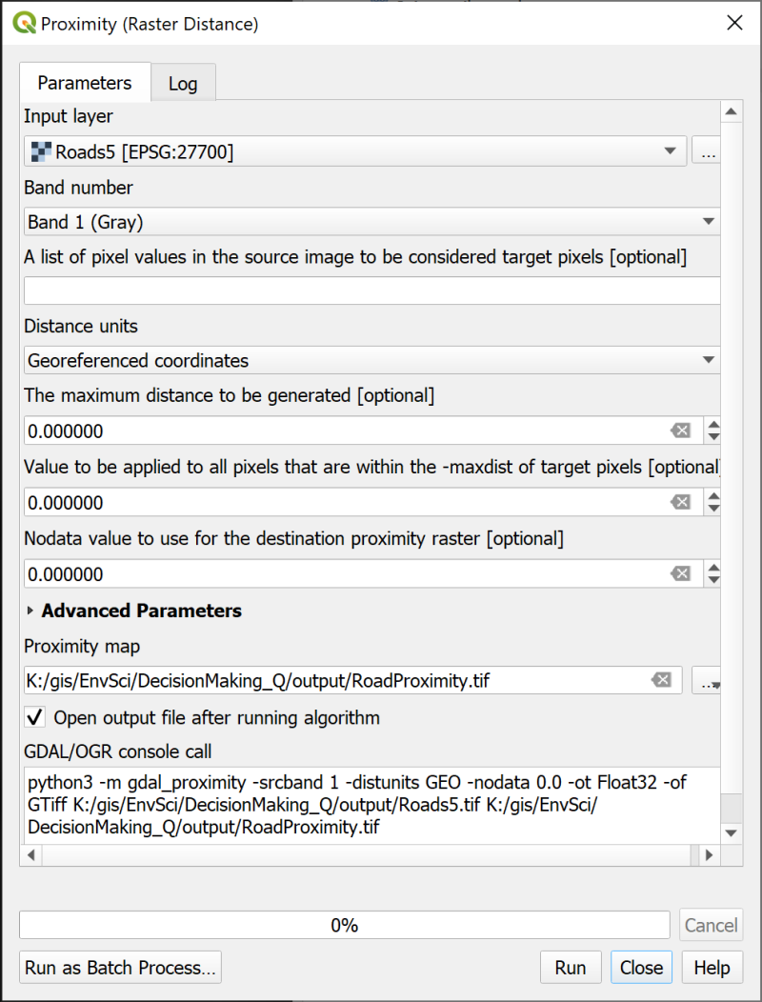

Generating a raster layer showing proximity to roads.

The output looks a bit odd, but if you view it with the vector roads layer above it in the Layers panel you should be able to see that the black areas are the areas closest to roads and the white areas the farthest away. The Layers panel shows the distances in map units, which in this case should be metres.

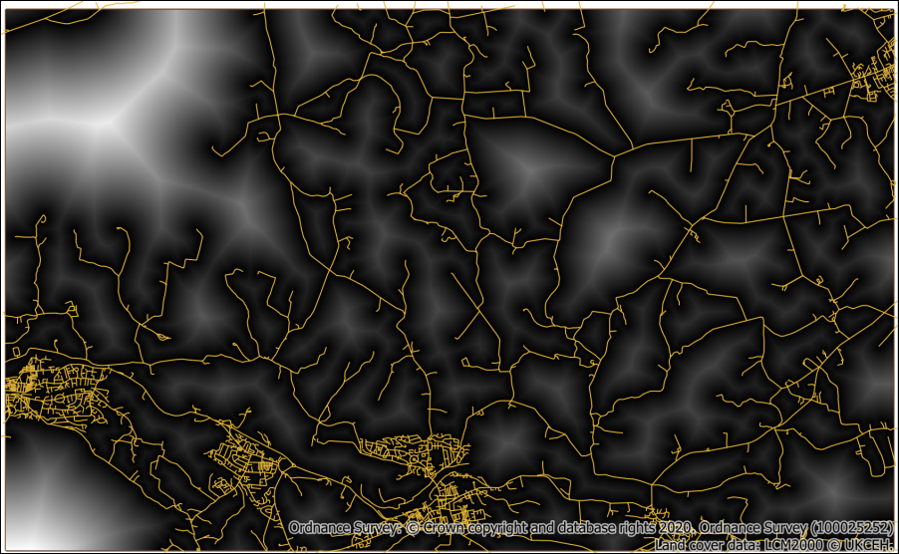

The lines show the roads. Black shows the areas closest to the roads, white the areas that are farthest away.

#### Normalising the proximity raster

When we combine the data for the three criteria we want to be able to weight them. This means that we need to normalise all the layers to the same scale, such as 0 to 1 where

* 1 = most suitable
* 0 = least suitable

At the moment the proximity to roads raster has a scale of something like 0 to 2232.71 (yours may vary), where 0 is actually the most suitable.

It is possible to reverse the numbers and convert them to 0 to 1 in a single process by using the Fuzzify raster (linear membership) tool.

 **Normalizing raster layers with the Fuzzify raster tool in QGIS**

This video clip can be found in the module area of [Minerva](https://minerva.leeds.ac.uk) or in the [full list of video clips](https://cgordon-gis.github.io/videoclips.htm).

* In the Processing Toolbox search for fuzzify and open the Fuzzify raster (linear membership) tool from the Raster Analysis toolbox.
* The input is the road proximity layer
* Set the Low fuzzy membership bound to the current **highest** value. in my case that was 2232.71, yours may well be different - check the Layer styling panel, and drop down Min / Max Value Settings to set Accuracy to Actual (Slower) so that you know you are working with the correct values.
* Set the High fuzzy membership bound to the current lowest value - 0.0000
* Under Fuzzified raster select where to save the output and give it a name.
* Click on Run.

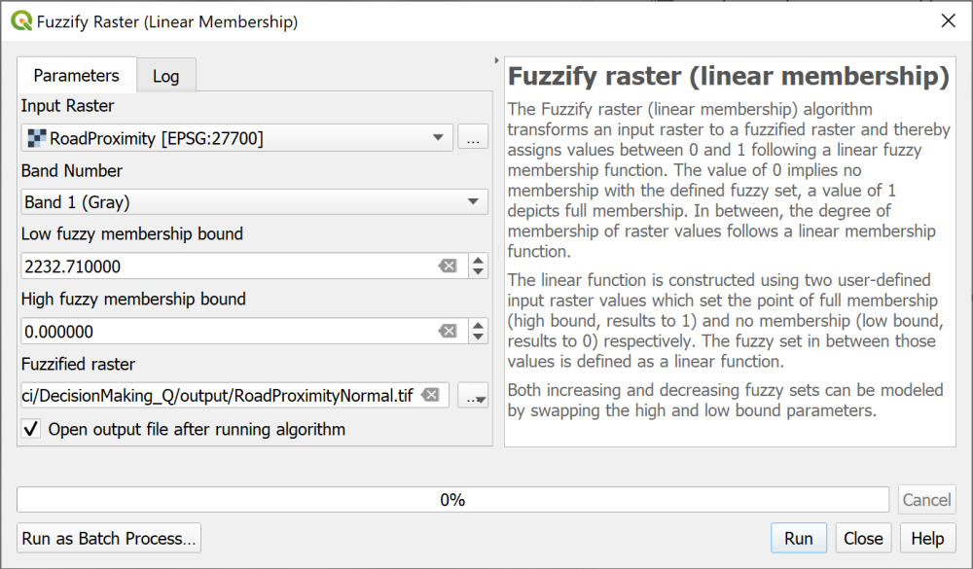

Using the Fuzzify Raster tool to convert the proximity to roads to 0 to 1 and reverse the values.

The output should look similar to before, but this time the highest value is 1, shown as white, and the lowest is 0, shown as black.

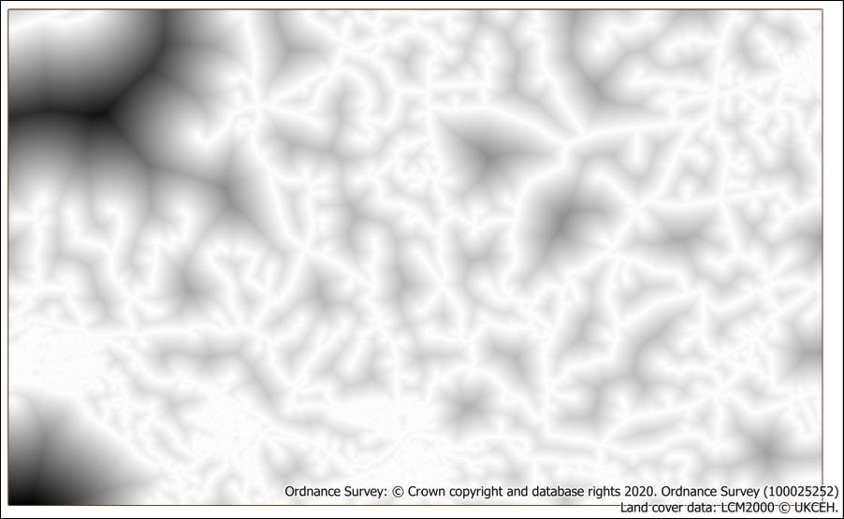

The normalised proximity to roads layer.

The road data is now normalised and ready to use for multi-criteria analysis.

### Reclassifying land cover

The current land cover categories are simply code numbers, they don’t relate to suitability for bees, so the first thing we need to do is decide the suitability of each land cover type and use that ranking to **reclassify** the raster.

We could rasterise the land cover data first, then reclassify the raster with the raster calculator, but instead we will add the classification data to the vector layer and **then** rasterise the result.

#### Set the classification and join to the feature class

In the chapter on census data you joined a data table to the census boundaries and you’ll be adding the data from your csv file to the land cover feature class in exactly the same way.

 **Creating a classified raster from a vector layer with joins in QGIS**

This video clip can be found in the module area of [Minerva](https://minerva.leeds.ac.uk) or in the [full list of video clips](https://cgordon-gis.github.io/videoclips.htm).

To convert the land cover classes to suitability we need to decide how to class them numerically from 0 (least suitable) to 1 (most suitable) and you can see my suggested classification in the table below. You are welcome to decide on your own classification!

| _mode | description | reclass |
| --- | --- | --- |
| 1 | Deciduous woodland | 0.6 |
| 2 | Coniferous woodland | 0.6 |
| 3 | Arable | 0.6 |
| 4 | Improved grassland | 0.6 |
| 5 | Neutral grassland | 1 |
| 6 | Calcareous grassland | 1 |
| 7 | Acid grassland | 1 |
| 8 | Fen | 0.6 |
| 9 | Heather | 1 |
| 10 | Heather grassland | 1 |
| 11 | Bog | 0.6 |
| 12 | Inland rock | 0 |
| 13 | Saltwater | 0 |
| 14 | Freshwater | 0.3 |
| 15 | Supralittoral rock | 0 |
| 16 | Supralittoral sediment | 0 |
| 17 | Littoral rock | 0 |
| 18 | Littoral sediment | 0 |
| 19 | Saltmarsh | 0 |
| 20 | Urban | 0.3 |
| 21 | Suburban | 0.3 |

* Use a spreadsheet program (e.g. Excel (desktop only); Pages; LibreOffice Calc; Google Sheets) to create a .csv file containing the table above (with your reclass decisions in the final column). Make sure you save the file as .csv then close the spreadsheet program.
* Add the csv file to QGIS by dragging and dropping it from the Browser panel to the Layers panel. It won’t appear on the map.
* Open the attribute table of the land cover layer in the Layers panel - you should be able to find a column called _mode which matches the first column in your csv table. Close the attribute table again.
* Go the layer properties for the land cover layer and click on the Joins tab.
* Click the plus button to add a new vector join.
* The Join layer will be your .csv file containing the classifications
* The Join field and Target field should both be _mode
* You can tick Joined fields and just tick description and reclass, as the _mode field is already in the feature class.

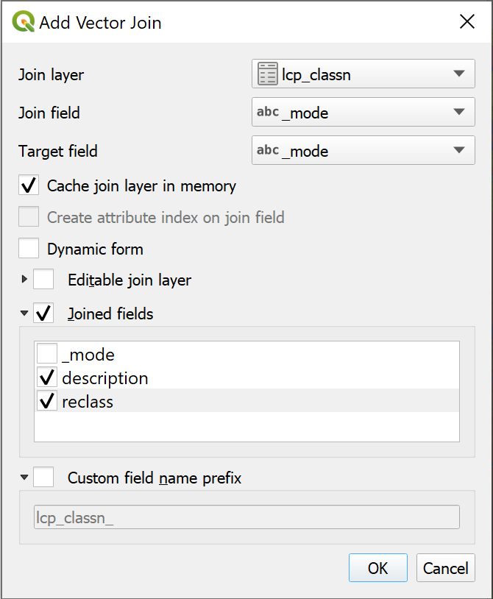

Adding the vector join between the land cover layer and the .csv classification table.

* Click on OK to perform the join, then on OK again to close the layer properties.

If you open the attribute table of the land cover layer again you should be able to see that the description and classifications have been added to all the fields, matching the two _mode columns.

 **Options to make the join permanent and style the layer**

This isn’t yet a permanent join. To make it permanent you can export the layer to a new feature class. You can then style the categories using the description field so that the legend is more helpful.

Alternatively in this case, we need to do another step before rasterizing the land cover ready for the multi-critera analysis, so saving the layer as a permanent join can be done in the same action.

#### Rasterize the land cover

The next step is to rasterize the land cover layer making sure that we keep the codes that we need for reclassification. Unfortunately to do this we need to convert the _mode column from a text data type to a numerical data type.

* Use the Refactor Fields tool to change the reclass field to a Decimal number (double) data type and save the refactored feature class into a geopackage.
* You can now apply style categories to the layer using the new description field to make the legend more useful.

Now we can rasterize the layer with the land cover values (from the _mode field) intact.

* Open the Rasterize (Vector to Raster) tool
* The input is the refactored land cover vector layer
* Set the Field to use for a burn-in value to reclass
* Output raster size units should be Georeferenced units
* Set the width and height resolution to 5
* The Output extent should match the StudyArea layer
* Under Assign a specified nodata value... type -9999
* Under Rasterized browse to where you want to save the output and give it a name.
* Run the tool

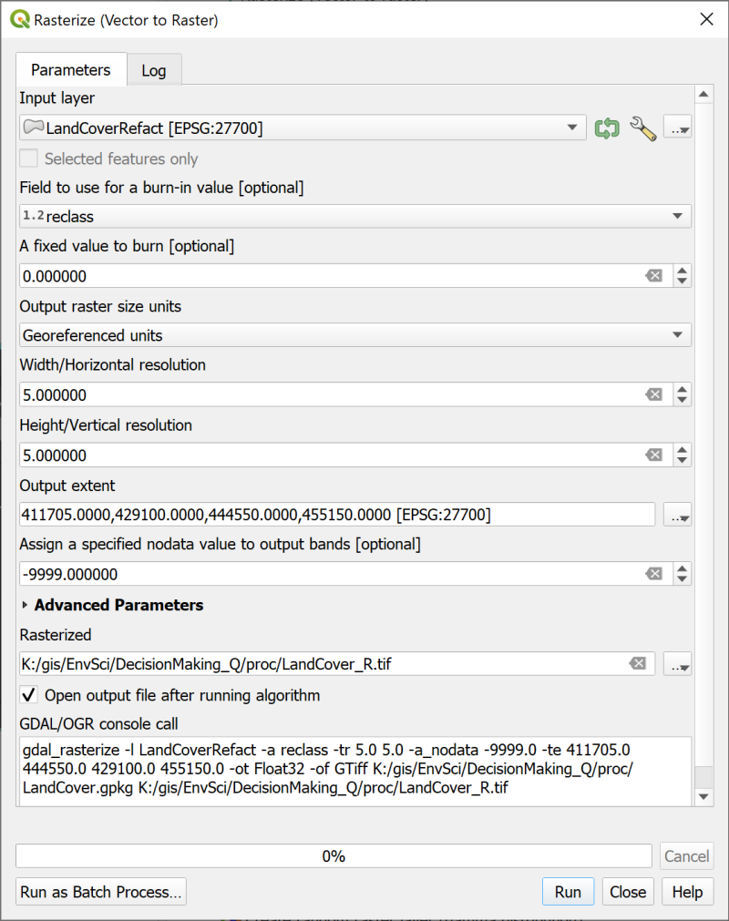

Rasterizing the land cover vector layer and ensuring that it keeps the land cover class values.

The output will be a grey-scale layer with the number of classes that you set - check the values with the Identify tool.

In this case I’ve ended up with a layer with four values between 0 and 1.

I have found that if I try to style this layer I end up with some odd results, and some areas which just don’t appear on the map, but if I check with the Identify tool the values are as I would expect them to be.

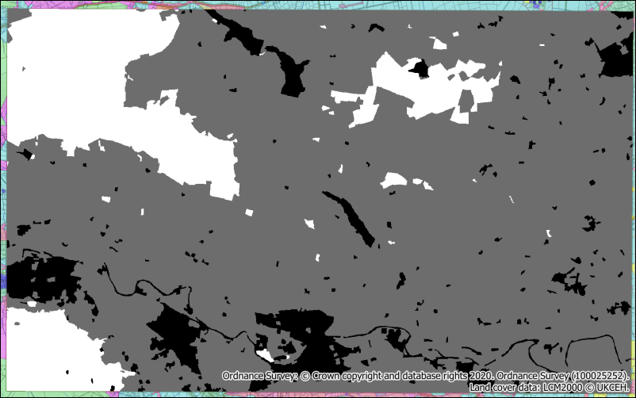

The rasterized land cover layer with the classification applied.

As with the normalised proximity to roads layer the most suitable areas have a value of 1, the least suitable have the lowest value.

### Normalising the DTM layer

Now we’ll move on to normalise the DTM layer to the 0 to 1 scale. In this case the lower altitudes are to be considered most suitable, so need to have a value closer to 1 than the higher altitudes do.

At the moment your DTM probably covers a larger area than the StudyArea outline. We’ll get a better result when we normalise the DTM if the values are calculated only on the study area.

* Export the merged DTM to a new layer
  + ensuring that you set the CRS to epsg:27700 - the correct version of the British National Grid
  + and that you set the extent to the same as the StudyArea layer.

Once again we can use the Fuzzify raster (linear membership) tool.

Before you run the tool

* go to the Layer styling panel for your clipped DTM layer
* Go into the Min/Max Value Settings and check that Min/max is selected then change the Accuracy setting to Actual (slower).
* Make a note of the maximum and minimum values of your DTM layer.

Doing this may well change the minimum and maximum values slightly and will make a difference to the end result.

* Open the Fuzzify raster (linear membership) tool and fill in the details
* Have a go yourself using the instructions from before if necessary, remembering to add the lowest altitude from your Layers panel to the High fuzzy membership bound, and vice versa.

The result should look something like the image below with the valleys in white and the hill tops in the darker colours.

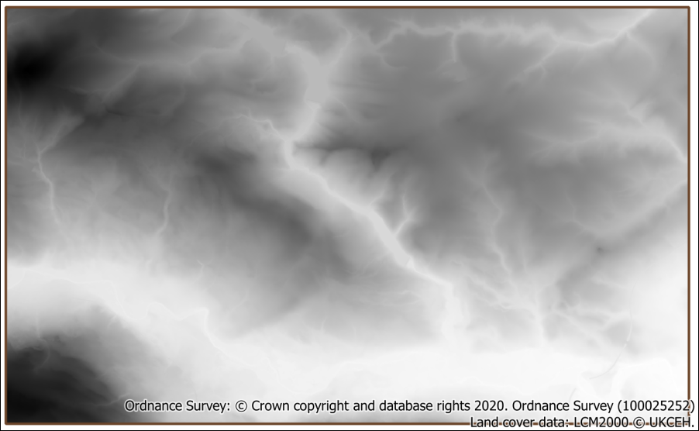

The normalised DTM layer.

### Determining weights for each criteria

At this stage you do need to decide on the relative weighting of your criteria.

* Which is the most important?
* How much more important than the other criteria is it?
* Which is the least important?

With three criteria this isn’t too difficult, but with more it rapidly becomes more complex.

* In a web browser go to [AHP Priority Calculator](https://bpmsg.com/academic/ahp.php)

AHP stands for Analytical Hierarchy Process and is a method of **pairwise comparison**, meaning that you can enter multiple criteria, rank them, and then obtain a percentage for each item as the output.

* Start by clicking on the AHP Priority Calculator link
* We have three criteria, which appears to be the default, so click Go
* Enter the criteria as shown below then click OK.
  + Proximity to roads
  + Altitude
  + Land cover

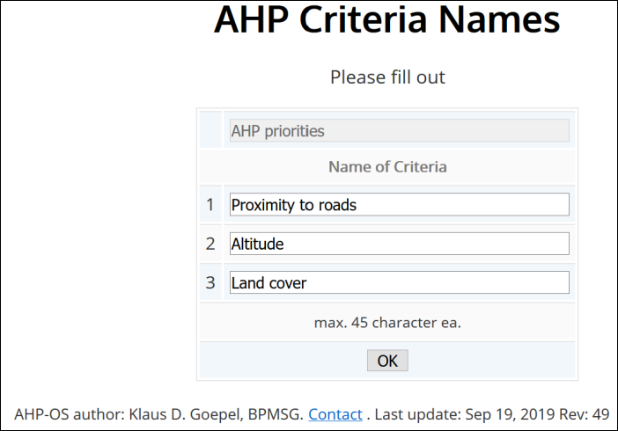

Filling in the AHP Criteria Names.

* Once you’ve done that you should get a matrix showing each of your criteria paired with each of the others. For each comparison select which one you consider to be the most important and then select how much more important you think it is.

I entered Proximity to roads as the most important, altitude as the least. My results were the following percentages:

* Proximity to roads = 52.8%
* Land cover = 33.2%
* Altitude = 14.0%

Note that the results should add up to 100%!

Make a note of your results. Don’t worry about them too much! You can experiment later.

### Running the multi-criteria analysis to combine the layers

Finally you should have three layers all normalised to a range of 0 - 1 and a weighting. You are now in a position to combine them and calculate the most suitable location for the bee hives.

You’ll be carrying out this final step in the raster calculator.

 **Multi-criteria analysis with the raster calculator in QGIS**

This video clip can be found in the module area of [Minerva](https://minerva.leeds.ac.uk) or in the [full list of video clips](https://cgordon-gis.github.io/videoclips.htm).

* Open the raster calculator
* Set up the output as usual
* In the Raster Calculation Expression box compile the following expression, using the names of your normalised layers and the weightings that you gained through the pairwise comparison.

("RoadProximityNormal@1" * 52.8) + ("LandCoverReclass@1" * 33.2) + ("DTMNormal@1" * 14)

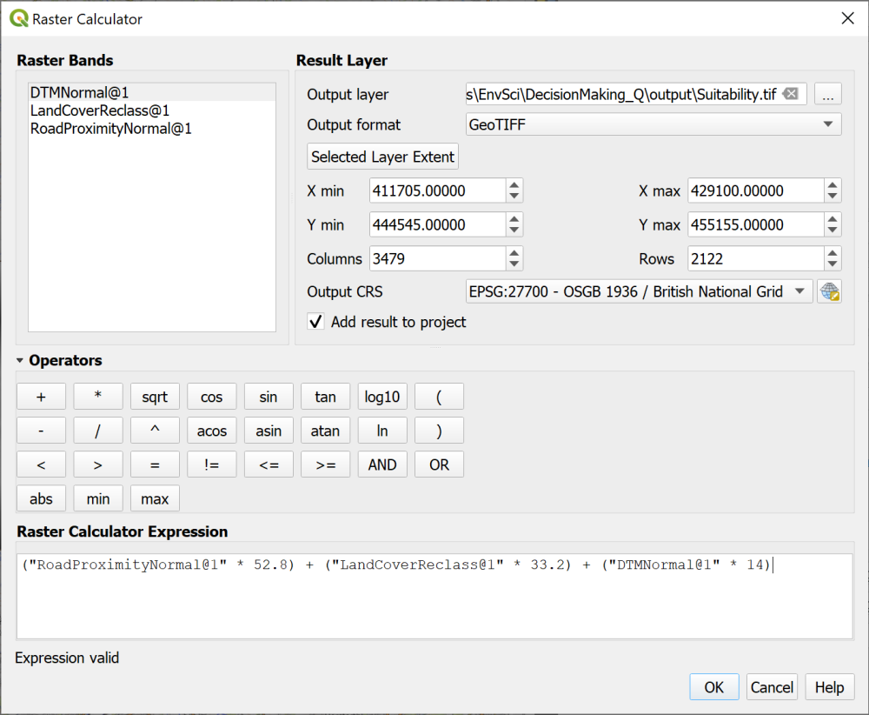

Calculating the suitability by combining the layers with weighting.

The expression is basically multiplying each value by the weighting, then adding them all together so that you get a result out of 100. The higher results being the most suitable.

Once you’ve run the calculation you should end up with a layer something like, but probably different to, the layer below.

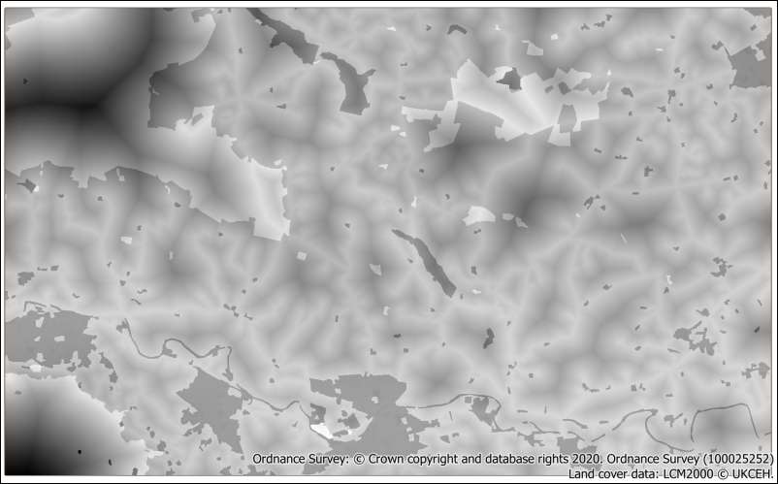

The output of the calculation showing the most suitable areas in the palest shades of gray.

You can now experiment with the weightings to see what different results you can come up with. I tried reducing the importance of the proximity to roads relative to the other two layers as otherwise my most suitable areas were all extremely close to roads.

When you are happy with your output try styling it as follows to show the most suitable areas for bee hives more clearly.

* In the layer styling panel change the symbology type to Singleband pseudocolor and choose a Color Ramp.
* Set the Interpolation to Discrete
* and the Mode to Equal Interval
* You may need to click on Classify to apply the settings.
* Apply transparency so that if you turn on a background layer you can see the places covered by the most suitable areas.
* You could edit the classes so that only the most suitable sites are styled.

### The final suitability map layout

The final step of any analysis is to display your results. Try creating a layout which shows your results and your recommendation for locating the bee hives. Don’t forget to include copyright information for both the data that you downloaded from Digimap, and for any other data layers that you have used.

When you have created a layout export it to either an image or pdf and upload it to your GIS Portfolio in the Class Notebook. If you upload it within a week of the class I will provide brief feedback on your work.

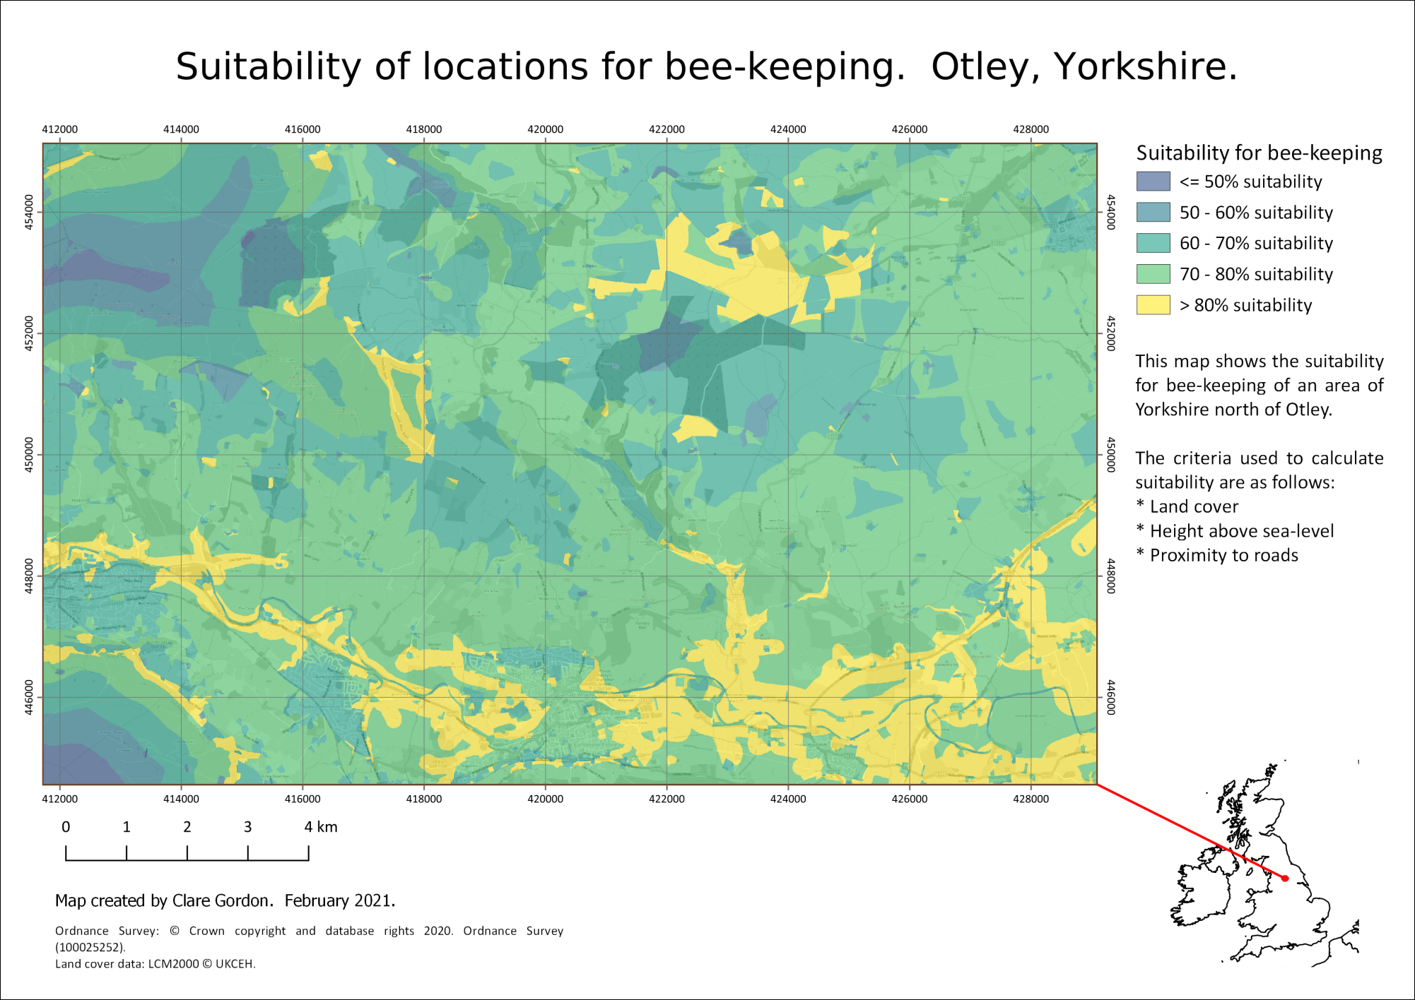

The final multi-criteria analysis map showing suitability of locations for bee-keeping based on the criteria we selected.

## Least cost path analysis

Least cost path analysis is a technique which looks at the least “expensive” way to get from one location to another. The cost is not necessarily financial, it can be time, fuel, damage to the environment and many other examples.

We will be using raster layers to carry out the analysis. Examples of this form of analysis include:

* Planning the creation of a wildlife corridor.
* Planning the route of a new road or a pipeline from one location to another.

The vector equivalent is network analysis. This tends to be used for routing vehicles on roads or rails, which are existing networks. Examples include working out the most economic route for delivery van to take to make multiple deliveries.

### Setting the criteria

You have been asked to produce a map for the local Wildlife Trust, looking at how wildlife moves around the study area. They wish to establish new nature reserves in areas which will improve wildlife corridors and have asked you to suggest the most cost-effective pathways in which to locate the reserves.

For this section you will be using the same area as the previous part of the chapter - Otley and the area to the north. You will be able to use some of the same data and should have downloaded the rest at the start of the chapter.

If we were doing this properly the criteria may well be different, and more tailored to certain species, e.g. red squirrels, or curlew, but this is an exercise designed to give you the experience so we will work with the following criteria:

* Land cover - for example, woodland is ideal for wildlife, but urban areas may well not be.
* Water areas - for some wildlife, rivers and lakes will be barriers that they will be unable to cross.
* Altitude - whilst the range of altitude is not great in this area, there are upland areas which are not conducive to many species so we will consider higher altitudes as having “greater cost”.
* Distance - this is naturally included in the calculations, so we don’t need to include extra data for this.

### Preparing the data for each criteria

As with [multi-criteria analysis](/#analysing-multiple-criteria) the data needs to be normalised to the same scale, usually 0-1, so that when we create a “cost surface” we can weight each factor.

You should already have downloaded all the data below at the beginning of the chapter.

Start a new blank map in QGIS and add the following layers

1. The StudyArea layer from the DecisionMaking geopackage - start by adding this to a new, blank map. This should set the CRS to epsg:27700.
2. Use a background layer, either from the QuickMapServices plugin, or by downloading one from Digimap.
3. The StartPoint and EndPoints layers from the DecisionMaking geopackage.
4. The clipped DTM layer that you created earlier.
5. The SurfaceWater layer from the OS Open Map Local vector dataset - you should have saved this to a geopackage and restricted the extent to that of the study area.
6. The original vector Land Cover 2019 data that you downloaded.

Don’t forget to save your map.

Once again we need to “normalise” the data so that each dataset has values on a scale of 0-1. This time the values indicate **cost**, so a value of 0 is “best” or cheapest, and a value of 1 is “worst” or most expensive.

We need to create a cost surface, which is a single raster layer that indicates the cost of traversing each pixel. To do this we normalise the data for our criteria and then add each of the layers together, weighting them if required.

Once we have a cost surface it is possible to create a least-cost path which takes the cheapest route from a start point to single or multiple end points.

#### Land cover data

For multi-criteria analysis we prepared the data by reclassifying the land cover. We need to reclassify the data again, but this time with different categories.

##### Preparing the classification

To convert the land cover classes to a cost value we need to decide how to class them numerically from 0 (“cheapest”) to 1 (most “expensive”) and you can see my suggested classification in the table below. You are welcome to decide on your own classification!

| _mode | description | reclass |
| --- | --- | --- |
| 1 | Deciduous woodland | 0 |
| 2 | Coniferous woodland | 0 |
| 3 | Arable | 0.3 |
| 4 | Improved grassland | 0.3 |
| 5 | Neutral grassland | 0.7 |
| 6 | Calcareous grassland | 0.2 |
| 7 | Acid grassland | 0.7 |
| 8 | Fen | 1 |
| 9 | Heather | 1 |
| 10 | Heather grassland | 1 |
| 11 | Bog | 0.8 |
| 12 | Inland rock | 1 |
| 13 | Saltwater | 1 |
| 14 | Freshwater | 1 |
| 15 | Supralittoral rock | 1 |
| 16 | Supralittoral sediment | 1 |
| 17 | Littoral rock | 1 |
| 18 | Littoral sediment | 1 |
| 19 | Saltmarsh | 1 |
| 20 | Urban | 1 |
| 21 | Suburban | 0.3 |

Now go to the previous instructions and carry out the reclassification to end up with a classified raster.

The identify tool seems to be more reliable for checking your rasterized classes than the styling does, so it’s worth trying that to check your result.

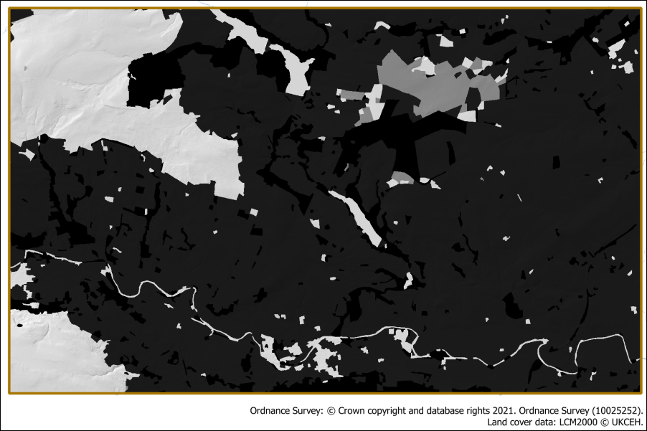

The reclassified land cover data which has now been rasterised. The classes are shown as greyscale from 0 - black - to 1 - white.

#### The surface water data

At the moment this is a vector layer showing lakes, reservoirs and the larger rivers and we will treat these as barriers to the wildlife corridors. We will assume that the smaller streams do not constitute an obstacle.

We need to rasterize the water bodies so that they have a value of 1 - for high cost, and the surrounding areas have a value of 0, for low cost.

* From the Processing toolbox open Rasterize (vector to raster)
* The Input Layer is the SurfaceWater layer
* Under A fixed value to burn enter a value of 1
* The Output raster size units are Georeferenced units
* Width and Height should be set to 5 (the same as the DTM resolution)
* Set Output extent to the same as the StudyArea layer
* Under Assign a specified nodata value to output bands delete the 0.000 so that the field reads Not set - we don’t want a nodata value.
* As usual set where to save the output and what to call it
* Then click Run.

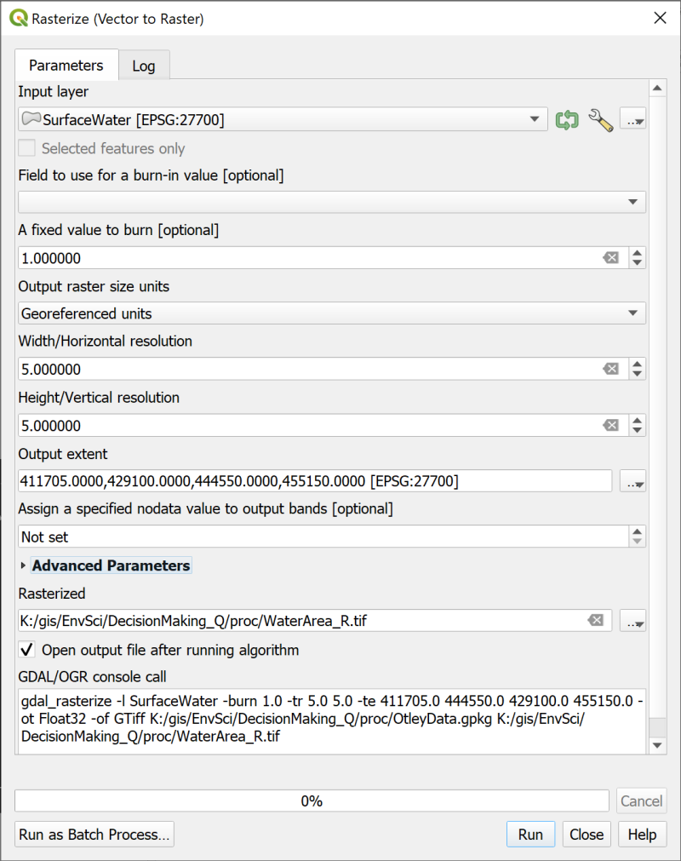

Rasterizing the SurfaceWater layer so that the surface water areas have a value of 1, and the rest a value of 0.

The output should show the water areas in white and the rest in black. Use the Identify tool to check that the lakes etc have a value of 1 and the rest of the layer a value of 0.

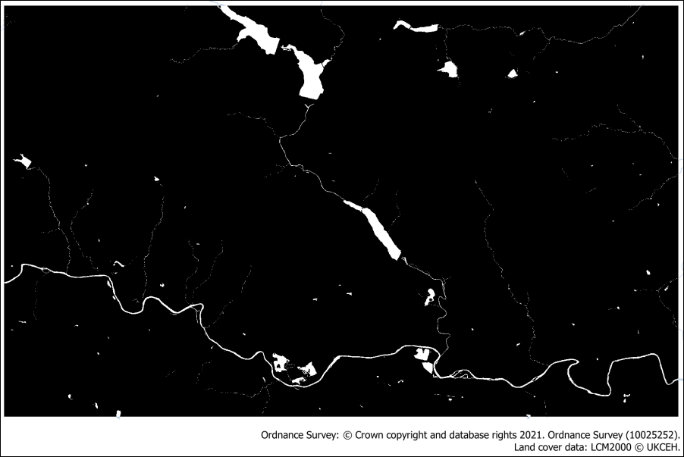

The rasterized SurfaceWater area layer.

#### The DTM layer

We’ll use the Terrain 5 DTM layer for the altitude and normalise it so that the highest land has a value of 1 for the highest cost, and the lowest a value of 0 for the lowest cost.

For the multi-criteria analysis we used the Fuzzify raster (linear membership) tool to normalise the DTM, and we’ll use it again this time. But instead of adding the lowest value to the High fuzzy membership setting, and the highest to the Low fuzzy membership, this time the original layer has values which change in the correct direction.

* So add the **lowest** value to the Low fuzzy membership bound
* and the **highest** value to the High fuzzy membership bound

You should end up with an output layer that looks very similar to the input layer, but which only has values from 0 to 1.

Once again use the Identify tool to check that this is the case.

### Combining the layers as a cost surface

When you’ve normalised all the data layers you need to combine them into a **Cost surface**. This is a raster layer in which each pixel or cell contains the “cost” of moving across it. This cost is obtained by adding all the criteria layers together and saving the output. During this process we can **weight** the criteria if required, rather as we did in the multi-criteria analysis. The process is indeed very similar and we will use the raster calculator again.

You can repeat the step of determining the weights for each criteria via the AHP tool, if you wish. Or use a rough figure for the weighting.

This is another point at which you need to use your experience as a scientist, or the priorities of the organisation for whom you are making the map, to work out what the weighting should be.

I have used the following to indicate the importance of the cost for each layer, remembering that the higher the value, the higher the cost, so the less suitable that path will be.

* Land cover - a weighting of **40**
* Surface water areas - a weighting of **40**
* Altitude - a weighting of **20**

You can experiment with these weightings, if you wish, by producing several versions of the cost surface. Just keep a note of your input values for each output.

* Open the Raster Calculator
* Set the output details as usual
* Enter the following expression into the Expression box at the bottom of the calculator, double-clicking on the layers in the top right to make sure that you enter them correctly.
* Update the weightings that are used to multiply the normalised layers with the weightings that you have decided to use.

("LandCover_R@1" * 40) + ("WaterArea_R@1" * 40) + ("DTM_norm_lcp@1" * 20)

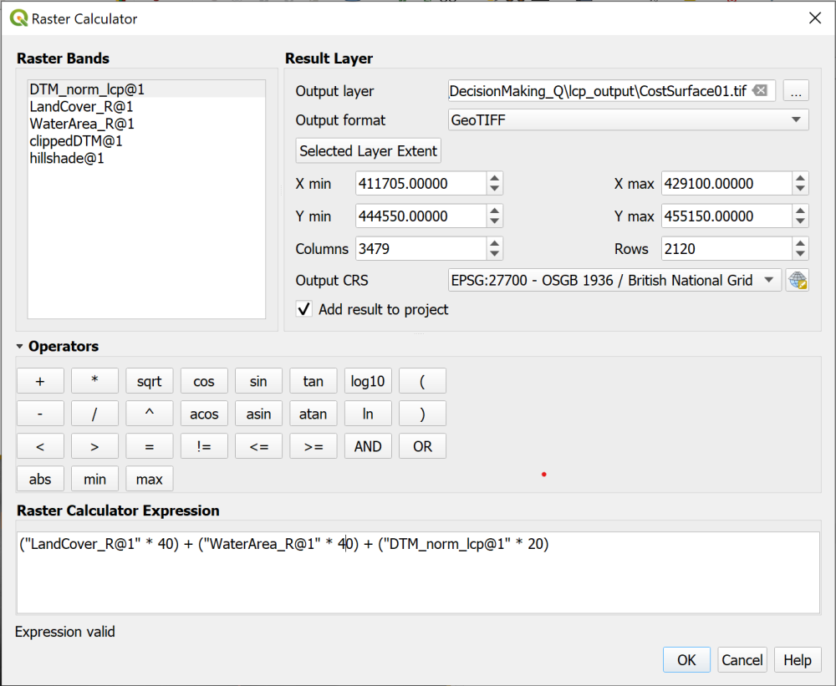

Combining and weighting the data for the cost surface in the raster calculator.

The output will vary depending on the weighting of your criteria, but will be a greyscale layer. See the example below.

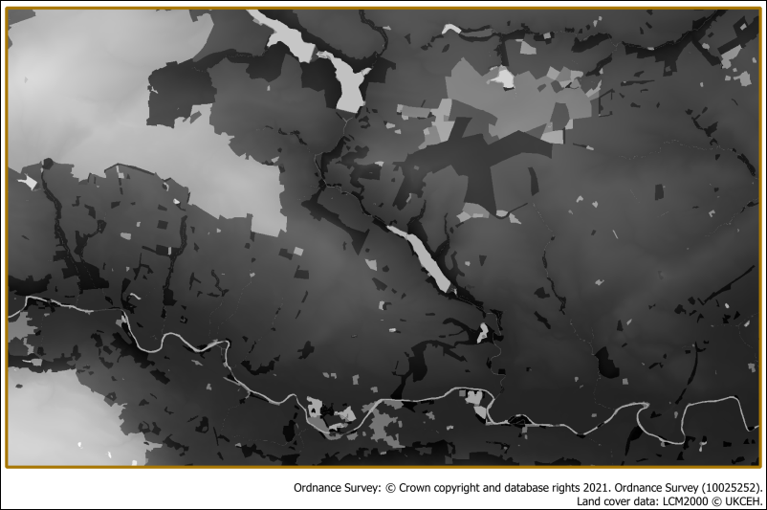

The resulting cost surface. Your cost surface probably won’t be identical to this one.

### The Least cost path tool

Once you have a cost surface you are in a position to work out the cost of travelling from one location to another.

#### Start and end locations

To be able to do this you need to have two point feature classes, one containing the starting point, and the other either single or multiple end points. These have been provided for you in the DecisionMaking.gpkg geopackage and should be added to your map now if they haven’t been already.

* The StartPoint feature class contains a single point in the woodland in the centre of the map.
* The EndPoints layer contains four points located in areas of woodland around the edges of the study area.

#### The Cost distance analysis plugin

There are GRASS and SAGA tools available in the Processing Toolbox that will do various cost distance tasks, but the simplest to use can be installed as a plugin.

 **Using the Cost distance analysis plugin to calculate least cost paths in QGIS**

This video clip can be found in the module area of [Minerva](https://minerva.leeds.ac.uk) or in the [full list of video clips](https://cgordon-gis.github.io/videoclips.htm).

* Go to the plugin manager and install the Least-Cost Path plugin.

Once it is installed you will have a new entry in the Processing toolbox. Search for Least Cost Path to find it.

* Open the Least Cost Path tool from the Processing toolbox
* The Cost raster layer is the cost raster surface that you created in the raster calculator
* Under Cost raster band select Band (Gray), which should be the only choice available.
* The Start-point layer is StartPoint
* The End-point(s) layer is EndPoints
* Browse to where you want to save the output and save it as a geopackage layer.
* Run the tool

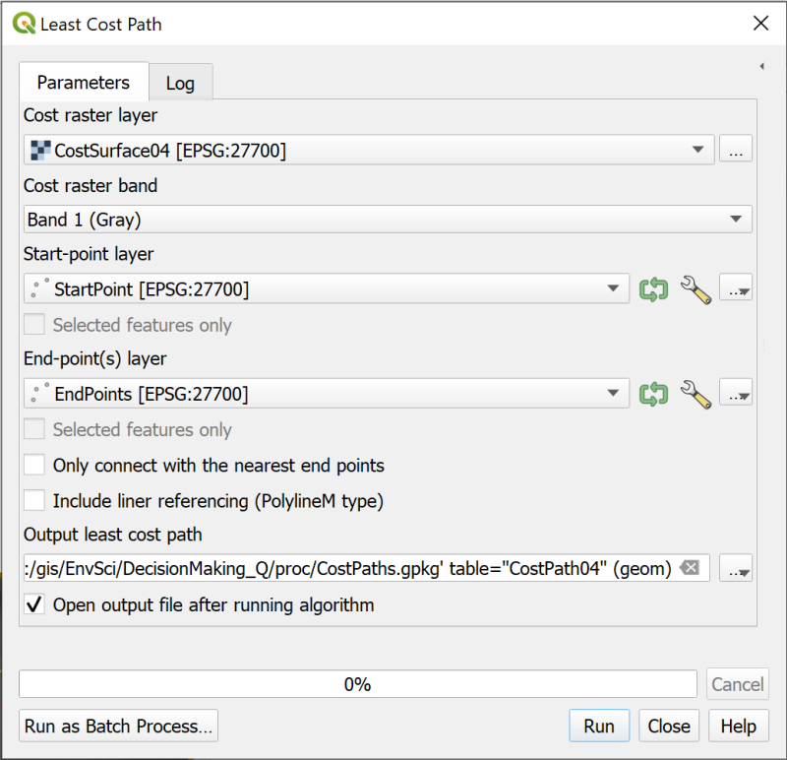

Filling in the form to generate a least cost path.

 **Warning**

This tool can take a long time to run and can give a “not responding” message. Just let it run, don’t try and stop it, or click on anything. Hopefully it will resolve itself after a while.

On my computer, which is pretty good, it took 4 minutes to run. There are a lot of calculations going on behind the scenes.

When the tool finishes the output should be a vector layer with lines running from the start point to each of the end points.

If you look at the attribute table you should be able to see a value next to each line. This is the cost of traversing the raster along that line.

I have labelled the end of each line with the fid, so it is possible to match the line to the cost value.

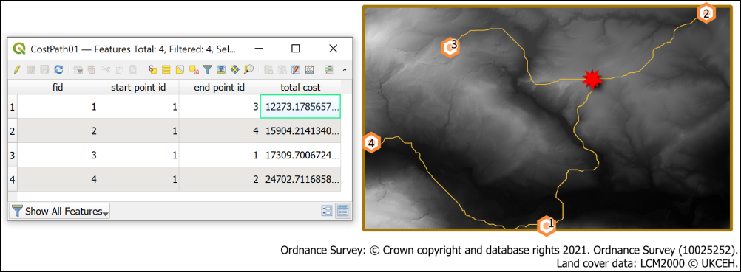

The resulting least cost paths from the start point to each of the end points. Also showing the cost values in the attribute table - the lines are labelled with the fid.

 **Experimenting with different cost surfaces**

Feel free to try creating a cost surface with different weightings and run the least cost path tool again to see what the difference is. You could also create more points in the end point layer - though bear in mind that the tool will take longer to run if there are more end points.

### The final least cost path map

Try making a layout to show your least cost paths and the land cover layer. Don’t forget to add a key to the layers that you’ve displayed, and also include the final costs of each path.

When you have created a layout export it to either an image or pdf and upload it to your GIS Portfolio in the Class Notebook. If you upload it within a week of the class I will provide brief feedback on your work.

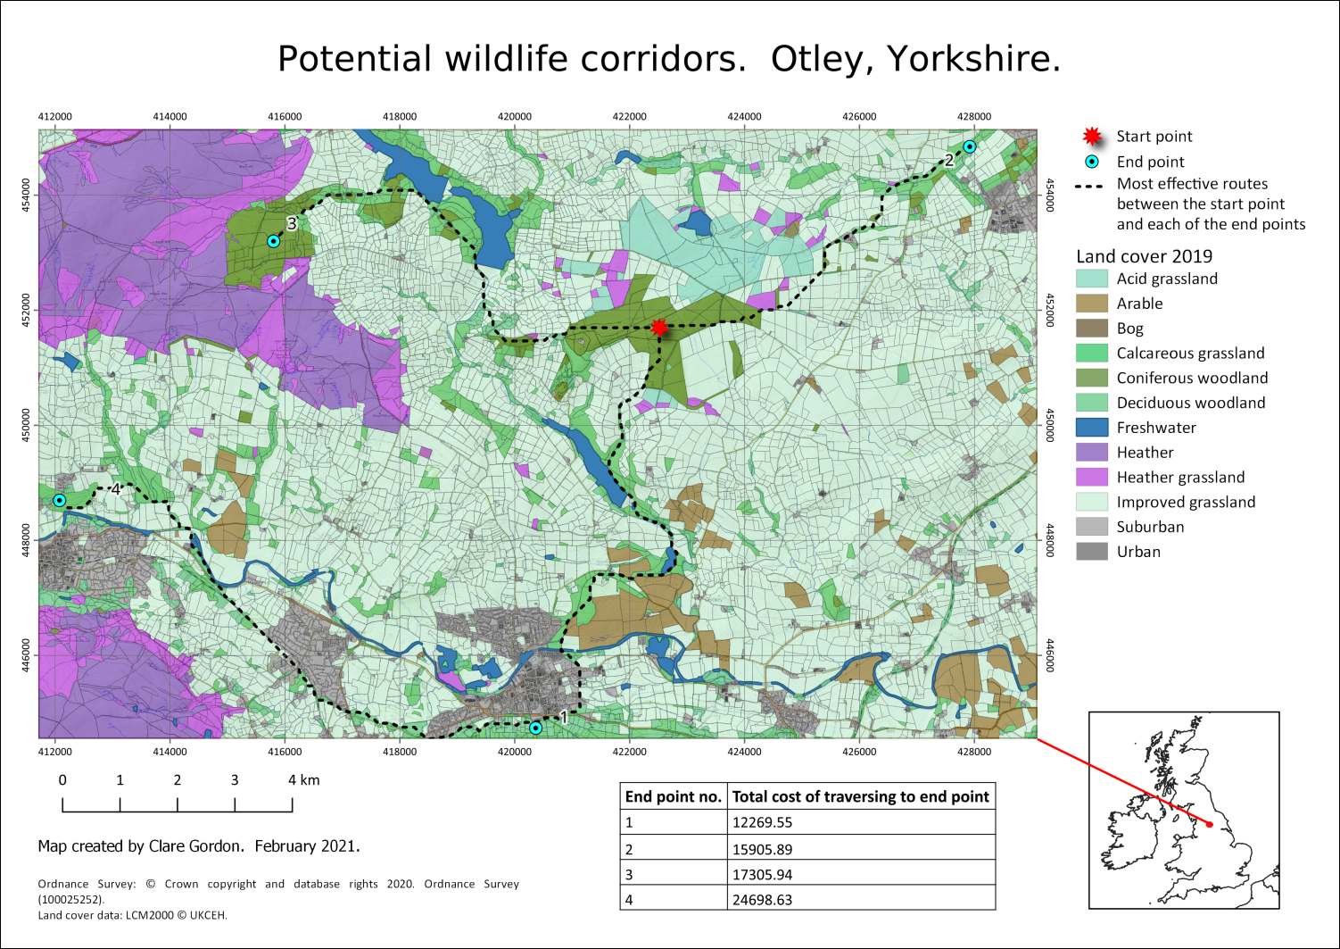

Example of final map showing the land cover and the least cost paths across the landscape. How your paths cross the map will depend on the decisions you made about weighting and values.

## Further information and suggested reading for elevation

Many of the books in the reading list[32] have general information about elevation data. Suggestions include the following:

* Chapter 7, *Analytical modelling in GIS* in Heywood, I., Cornelius, S. and Carver, S. (2011), In particular pp.244 onwards cover “Modelling the decision-making process”.
* Section 15.4 in Longley, P.A. et al (2015) covers Multicriteria methods (p. 352 - 354). It would also be worth having a look at section 15.5 - Accuracy and validity: Testing the model (p.354 - 356.

For technical information that refers specifically to QGIS try the following:

* [QGIS Tutorials and Tips](https://www.qgistutorials.com/en/index.html) - this is a series of tutorials which cover some of the techniques you’ve been using in these exercises. It’s worth browsing the list, but particularly relevant to this chapter would be [Multi Criteria Overlay Analysis](https://www.qgistutorials.com/en/docs/3/multi_criteria_overlay.html).

# Making repetition more efficient

Last Modified: 21 Apr 22, 11:35:53

The background to the techniques for making repetition more efficient will be covered in the lecture segment at the beginning of the class, and the presentation and any other supporting materials will be available in Minerva. The lecture segment should help you to understand **why** you are doing these exercises. If you still aren’t sure, please ask [Clare](mailto:c.e.gordon@leeds.ac.uk).

## Learning outcomes

When you have completed this section of the workbook you should be able to

* demonstrate techniques to use QGIS to carry out repetitive workflows more efficiently
* explain the use of the model builder in QGIS
* analyse a task and build a model to produce the required output
* use batch processing to run a model multiple times to produce multiple outputs

## Introduction

In the chapter on elevation models you saw how to carry out batch processing to repeat the use of tools multiple times to produce maps of which summits were visible from particular viewpoints in the Lake District. This did make processing more efficient, but you still had to run each tool individually. In this chapter we’ll look at other ways to make repetitive tasks more efficient by using the **graphical modeler** in QGIS. We’ll also combine a graphical model with batch processing and then have a quick look at how python can be used within QGIS to extend efficiency even further.

The **graphical modeler** allows you to drag and drop input and processing tools (called **algorithms** in this context) onto a “canvas” and link them together in the order in which they should run. So you can run multiple tools in one pass using the output from one as input to another.

Once you have created a model you run it in exactly the same way that you run any other tool from the processing toolbox. When you run the tool you will get a chance to input the data from your map, or any other variables that you’ve set up, and to give your output names. The form that you need to fill in will look very familiar but have a few key differences.

## Data for the repetition exercises

We will use the Lake District Hills data again for this chapter. I have uploaded a “clean” copy of the project to Minerva as Repetition_Q.zip.

* Download Repetition_Q.zip from Minerva and unzip it to your GIS folder.
* Open LakeDistrict.qgz in QGIS and have a look at the contents.
* All the layers are stored in the geopackage that is also in the folder, so if QGIS opens and gives the error about not being able to find layers, you should be able to tell the program to look in LakeDistrict.gpkg.

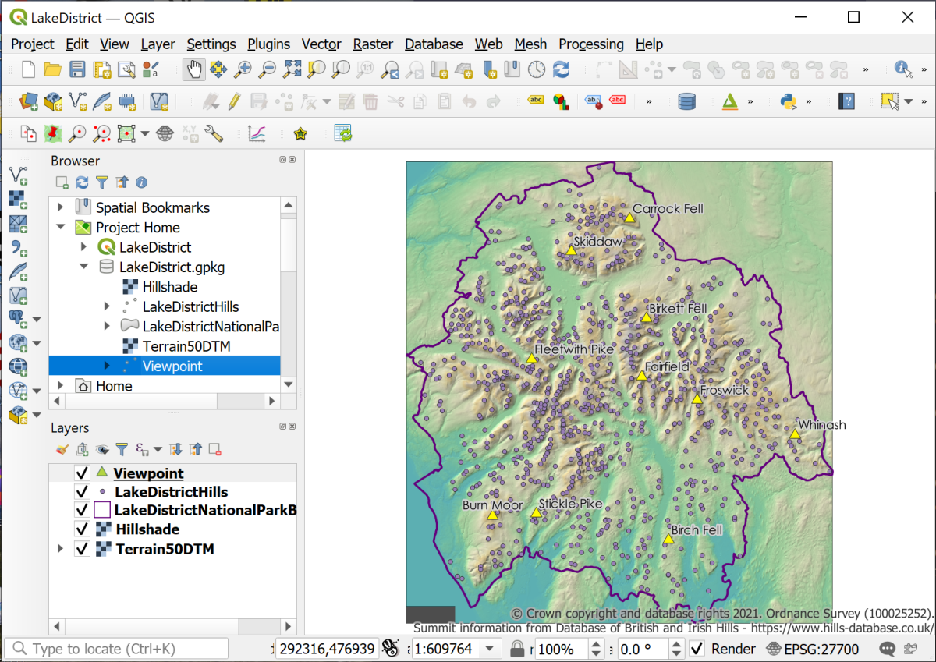

The initial view of the Lake District map showing the layers that you should be able to see.

Most of the layers should look familiar from the previous exercises, but I’ve also included a layer called Viewpoint which contains a small selection of summits to use as viewpoints for processing.

## Planning your graphical model

Before you jump in and start creating your model you should begin by planning what you want it to do. One advantage of building a model is that you can run it and then easily go back and alter it before running it again, but if you plan in advance it makes it much quicker to get the right result.

It is a good idea to start with a simple, basic model and make sure that works first before adding more functionality. Once you have that running you can then look at how to streamline it further or what other algorithms or parameters you can add.

When you look at the process you are automating think about what you **really** need to include, and what is best left out. For example, we’ll be creating a model to run a viewshed and select visible summits. This is based on height data which consists of merged tiles. You could merge the tiles as part of the model, but actually that’s a task that only needs to happen once and then the same output is used to run the model each time. If you include merging the height data in your model you’d actually be processing the data more often than you need to. So in this case it makes more sense to process the data once before you start, then use the merged height data as the input to your model.

As usual in GIS start by thinking about what question you are trying to answer. In this case the question is:

How many summits from within the Lake District National Park can be seen from a selection of viewpoints, also located within the National Park?

Once you know the question you can think about the data that you need.

 **What data do you need to start with?**

I’ve provided you with the data for this exercise, but usually you’ll need to think this through for yourself.

The chapter on elevation models 2 has already shown you the process that you want to automate in this model to answer that question. This is good because it shows that you know how to produce the correct result manually first. But the next question before you start to build your graphical model needs to be:

 **What processes or tools do you need to run on that data to produce the required outputs?**

Have a look at the viewshed analysis exercises and make a list of the data and processes that you need.

In the rest of this chapter, I’ll take you through the processes step-by-step, but usually you’ll need to make a list for yourself. Maybe something like a quickly scribbled version of the diagram below would be useful (I’ve typed this out for clarity, but usually a quick scribble is absolutely fine).

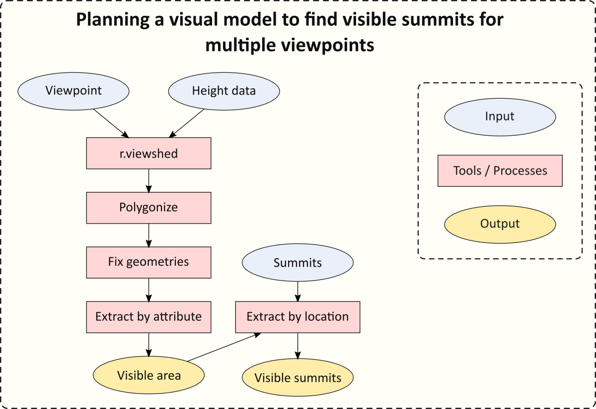

Planning a visual model to find visible summits from multiple viewpoints.

## Building a graphical model in the Model designer

 **Creating a new graphical model in QGIS.**

This video clip can be found in the module area of [Minerva](https://minerva.leeds.ac.uk) or in the [full list of video clips](https://cgordon-gis.github.io/videoclips.htm).

* From the data that you downloaded for this chapter make sure that LakeDistrict.qgz is open and the data is visible in the map.

To open the QGIS graphical modeler **Model designer** go to:

* Processing > Graphical modeler... or the keyboard shortcut Ctrl + Alt + G

The window that opens should look something like the image below, though you may have slightly different panels open by default.

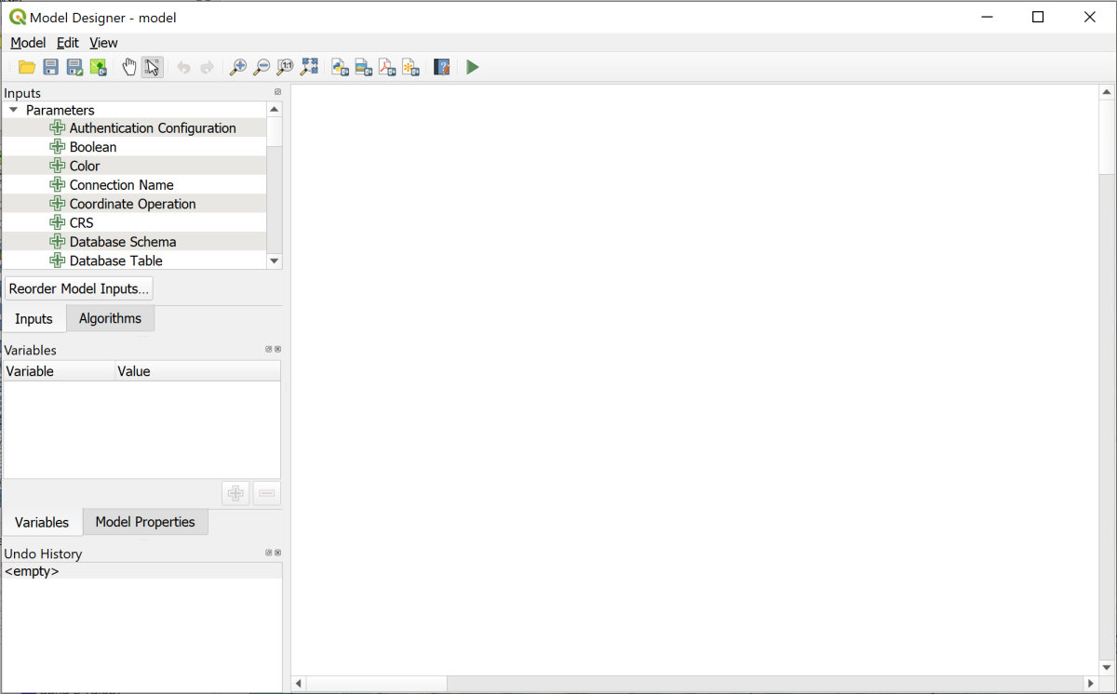

The model designer when you first open it.

You’ll build your model in the blank area on the right using items from the panels on the left. The two panels you’ll use most are the Inputs and the Algorithms.

The panels include a list of Inputs, also referred to as Parameters. This covers a wide variety of types of data from plain text to vector feature classes. I’ll show you how to use a few of these in this chapter, but if you are building your own models you can try out anything that looks as if it might be useful.

The tab for Algorithms contains the list of processing tools that you can use within a model. You should be able to find any of the tools we’ve already used in the exercises.

Remember that in the model designer, processing tools are called **algorithms** and that’s how I’ll usually refer to them in this chapter.

### Saving a new model

As usual it is a good idea to keep saving your work.

Graphical models are stored in a default location on your computer. If you save them to the default then QGIS will pick them up automatically and list them in the Processing Toolbox. It is also possible to save them to a location that you choose. If you do this then you will need to navigate to your model in the Browser Panel each time.

It is also possible to save your models to the project, but this makes it harder to reuse them and to share them.

 **Saving and reopening a graphical model in QGIS.**

This video clip can be found in the module area of [Minerva](https://minerva.leeds.ac.uk) or in the [full list of video clips](https://cgordon-gis.github.io/videoclips.htm).

* Find the Model Properties panel on the left of the model designer. You may need to click on the tab to bring it to the front.
* Enter a name for your model - in this case enter VisibleSummits.
* Enter a group name. This allows you to keep related models together. Enter Visibility as the group name.

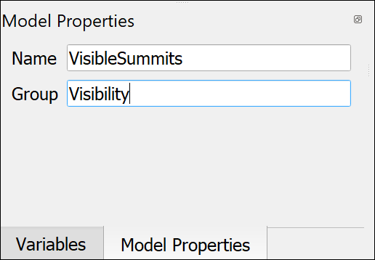

Giving your model a name and group in the model properties.

* Now either press Ctrl-S or go to Model > Save Model to save your model.
* In the dialog your QGIS Profile should be selected by default. This should be fine but if you want to save your model to a different location you should navigate to that now.
* Give your model a File name: - which should be the same as the name you typed into the model properties.
* Click to Save.

Hopefully you’ll get a message at the top of the blank window telling you that your model was saved successfully.

### Reopening a model if it has been closed

If you need to close your model and then reopen it do the following:

If you saved the model to your default model folder you will be able to find it again in the Processing Toolbox.

* Go to Processing > Toolbox and navigate to a section called Models which will probably be near the bottom of the list.
* Open this out and you should find a heading for the name that you gave your group, e.g. Visibility
* Your model will have been saved under this
  + To reopen the model right-click on it and go to Edit model...
  + To run the model double-click on it or right-click and go to Execute...

If you chose to save your model to another location then you will need to reopen it from the Browser panel.

* Find your model in the Browser panel
* Right-click on it and either Edit model... or Run model....

### Adding input

We’ll start by adding the data that is required as input to our model.

 **Adding input to a graphical model in QGIS.**

This video clip can be found in the module area of [Minerva](https://minerva.leeds.ac.uk) or in the [full list of video clips](https://cgordon-gis.github.io/videoclips.htm).

The first layer to add is the **height data**.

Remember in this section that you are not actually adding the data from your map at this stage. You’re adding a “place holder” that you will add the data to when you run the model.

* Go to the Inputs panel on the left of the model designer.
* The required height data will be a raster file so scroll down the list of choices and select Raster Layer.

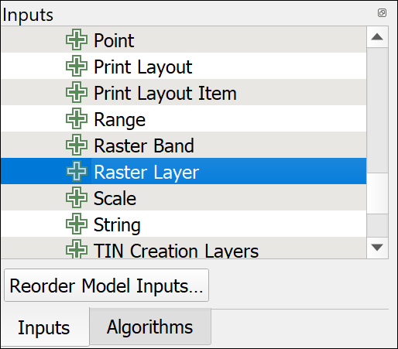

Selecting Raster Layer as the first input.

* Double-click on Raster Layer to open the parameter definition box
* Under Description add the text that you want to see when filling in the tool dialog - so in this case enter Height data.
* This input is required to run the tool so leave Mandatory ticked.
* Don’t tick Advanced.
* Click OK to add the input to the model. It should look something like the image below.

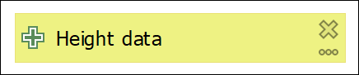

The first item in your visual model - the height data input field.

The second item to add is the input for the **viewpoint**. This isn’t going to be a layer in your map. When running the model you will need to click on the map to enter the location for the viewpoint.

* From the Inputs panel double-click on Point to open the Point Parameter Definition panel.
* Under description type Viewpoint.
* Leave the Default value as Point as 'x,y'
* Leave Mandatory ticked, and Advanced unticked.
* Click OK to add the input to your model.

You will also need the full list of Lake District summits to get the required result.

* From the Inputs panel double-click on Vector Layer to open the Vector Layer Parameter Definition panel.
* Under description type Summits.
* Under Geometry type select Point so that only point feature classes can be added. Restricting parameters where possible can make errors less likely when the model is run.
* Leave Mandatory ticked, and Advanced unticked.
* Click OK to add the input to your model.

At this stage your model designer should contain three input layers as shown below.



The three input layers for your model.

If you want to edit any of the input you can click on the three dots button on each one. To delete any of the boxes just click on the cross.

It’s worth having a look at the input types available to you. Sometimes it’s not clear which one will do what you want it to do. Just experiment. Add possible input types to your model and see what happens.

### Adding algorithms

Remember that algorithms are the processing tools that you have used before.

 **Adding algorithms to a graphical model in QGIS.**

This video clip can be found in the module area of [Minerva](https://minerva.leeds.ac.uk) or in the [full list of video clips](https://cgordon-gis.github.io/videoclips.htm).

#### Adding the r.viewshed algorithm

The first processing tool, or algorithm, on our list is the viewshed tool. The tool which works out which areas are visible from a particular viewpoint and which aren’t.

 **If you have problems with GRASS tools**

If you have had problems with GRASS tools such as r.viewshed and v.surf.rst, then feel free to use the GDAL Viewshed tool instead of r.viewshed. It isn’t as effective, but will work for this exercise. Some of the options are different, but input your DTM, add the Observer Location as you would usually add a viewpoint, and increase the Maximum distance from observer... to something like 20000 metres. You should be able to Polygonize the result as usual.

* On the left of the window click on the Algorithms tab to go to the full list. If you browse the list you’ll see that it is arranged in the same way as the processing toolbox that you are familiar with.
* Note that there is a search box at the top of the panel. Use this now to search for the first tool by typing viewshed.

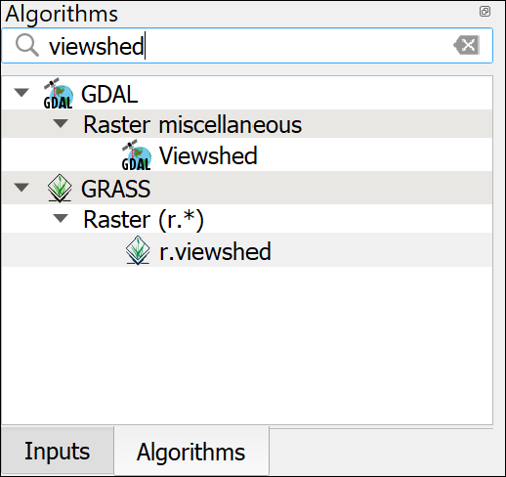

Searching for r.viewshed in the Algorithms tab.

* Double-click on the r.viewshed tool to open the dialog.

This will look familiar, but does include some new options particular to using the tools in a model.

This example makes use of the extra options available for adding input.

* Click on the button to the left of the Elevation field - the one with numbers on it. This will give you some new choices. Select Model input. Then you should be able to select one of your inputs from the dropdown box - make sure that you set this to Height data.
* Do the same with the Coordinate identifying the viewing position, this time selecting the Viewpoint input.

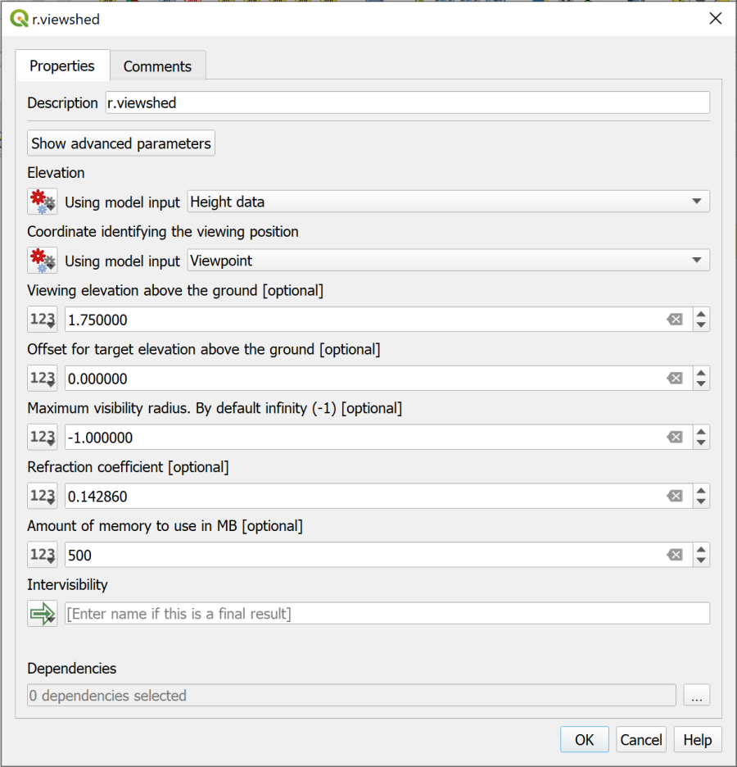

Setting up the r.viewshed tool.

We’ll leave the other fields as they are for now, but remember that we selected a setting from the Advanced section of the viewshed tool before.

* Click on the Show advanced parameters button at the top of the dialog.
* Scroll down and find the Output format is invisible = 0, visible = 1 setting. Change this to Yes.

The output from this tool is required by the next tool in the model, but it isn’t necessary to display it on your map, so you don’t have to save it to your computer. Instead it can just be used directly in the next tool.

* Under Intervisibility check that the button on the left is set to Model Output. The box should say [Enter name if this is a final result]. As it isn’t you don’t need to enter anything.
* Click OK to add the algorithm to your model.

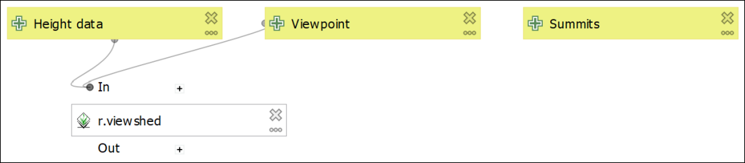

The model so far. Note how the input is now linked to the first algorithm.

The box that is added to your map should show that it is a GRASS tool (icon on the left of the box) and that the Height data and Viewpoint input is linked to the algorithm.

#### Testing the model so far

It is an extremely good idea to run your model at every stage of building it. This gives you a chance to sort out any problems while you can still remember what you have just done, and is essential if you are adding a lot of tools or data.

 **Running a graphical model in QGIS to test that it works.**

This video clip can be found in the module area of [Minerva](https://minerva.leeds.ac.uk) or in the [full list of video clips](https://cgordon-gis.github.io/videoclips.htm).

At this stage there is no output, but it is still a good idea to keep testing your model to make sure that there are no errors.

* Save the model by using the shortcut Ctrl - S or going to Model > Save Model.
* To **run** the model you can either press F5 or use the green arrow button on the toolbar. Do this now.
* Running the model should open a dialog in which you need to enter the layers from your map.
* Under Height data select Terrain50DTM
* Under Summits select LakeDistrictHills
* Under Viewpoint you need to enter the coordinates. With the model designer open QGIS won’t let you click on the map, so instead of clicking on the three dots button enter the following coordinates:

329823,489995

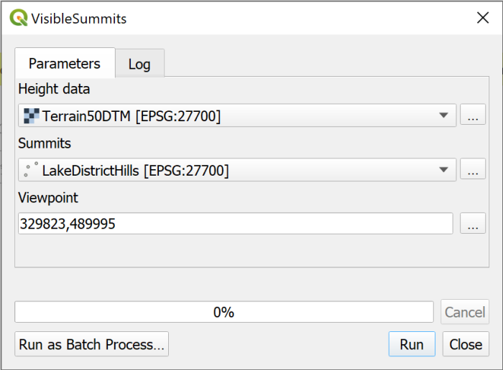

Filling in your layers to test the model so far.

* Click Run to run the tool.

You should see the Log panel and the usual messages going past. It may take a while to run - remember it is the r.viewshed tool that is running.

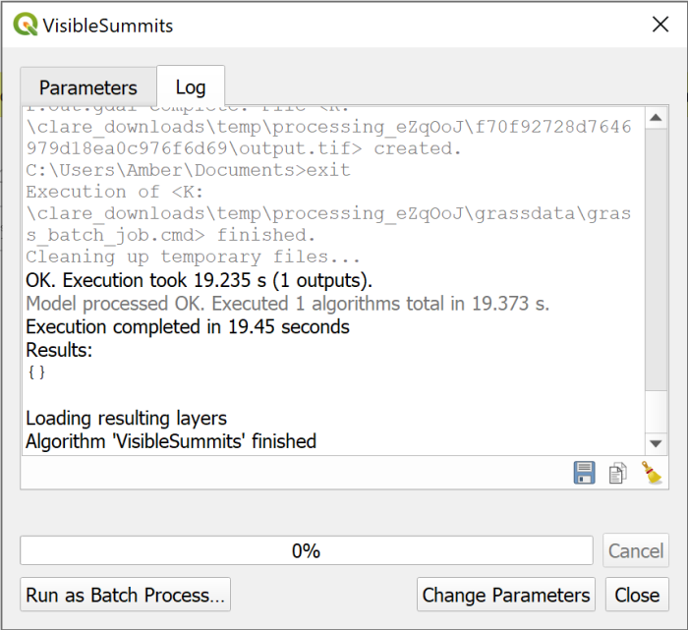

The end of the Log from a successful run.

We’ve selected not to save or display the output so the viewshed won’t appear, but check the Log to see that there were no problems with what you have entered so far. It should say something like

OK. Execution took 19.235 s (1 outputs).

Model processed OK. Executed 1 algorithms total in 19.373 s.

Your times will vary.

#### Adding the Polygonize algorithm

Once you have generated the viewshed the next tool on our list is Polygonize to convert the raster output to a vector polygon layer.

* In the Algorithms tab search for Polygonize
* The tool you need is Polygonize (raster to vector) so double-click to open that from the GDAL toolbox.
* Again the dialog should look familiar, but with the number buttons on the left of the fields.

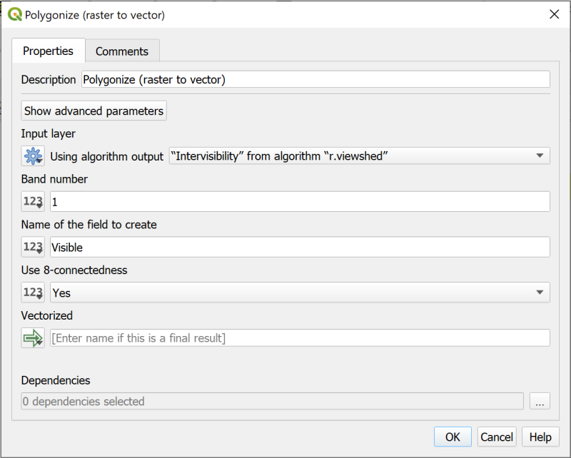

The Polygonize tool dialog showing the Input layer from the r.viewshed tool.

* Click on the number button to the left of the Input layer field.
* This time we’re taking the input from the previous tool so select Algorithm output. Set the dropdown to "Intervisibility" from algorithm "r.viewshed"
* Under Name of the field to create you can enter something a bit more informative than the default DN, for example, enter Visible.
* Under Use 8-connectedness select Yes
* Once again the output from this tool won’t need to be displayed on your map so under Vectorized check that Model output is set and that it says [Enter name if this is a final result].
* Click OK to add the algorithm to your model.

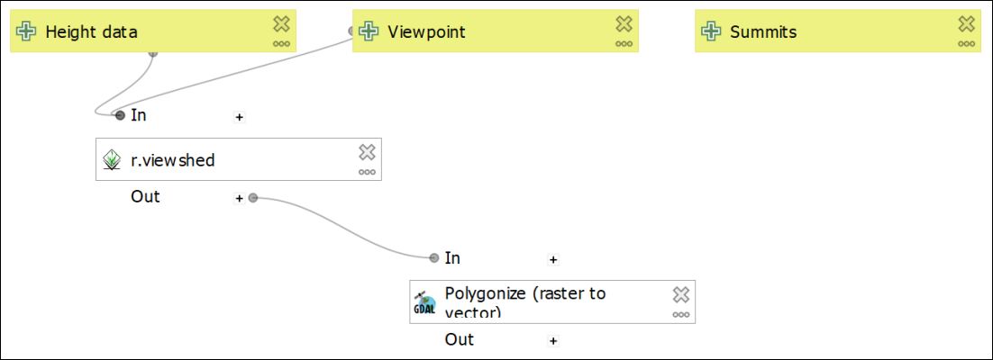

The model with the Polygonize algorithm added. This should link from the r.viewshed tool.

#### Testing the model again

At this stage there still won’t be any output, but again it is a good idea to keep testing your model to make sure that there are no errors.

The input form will look the same as it did before and you need to fill it in in the same way.

* Save the model by using the shortcut Ctrl - S or going to Model > Save Model.
* To **run** the model you can either press F5 or use the green arrow button on the toolbar. Do this now.
* Running the model should open a dialog in which you need to enter the layers from your map.
* Under Height data select Terrain50DTM
* Under Summits select LakeDistrictHills
* Under Viewpoint you need to enter the coordinates. With the model designer open QGIS won’t let you click on the map, so instead of clicking on the three dots button enter the following coordinates:

329823,489995



Filling in your layers to test the model so far.

This time the Log should show that you have executed 2 algorithms rather than 1, but should still say that the Model processed OK.

#### Adding the Fix geometries algorithm

If you remember from when you ran the viewshed tool before and then polygonized the output, it wasn’t possible to feed the result directly into Extract by attribute as it gave an error. To fix this we needed to run Fix geometries. So that is the next algorithm to add to your model.

* Search the Algorithms tab for Fix Geometries and double-click on it.
* You can make the Description at the top a bit more informative, e.g. Fix geometry of visibility vector output.
* Click on the number button to the left of the Input layer box and select Algorithm output as we’re fixing the output from the Polygonize tool.
* In the dropdown select "Vectorized" from algorithm "Polygonize (raster to vector)"
* Once again the output from this tool won’t need to be displayed on your map so under Fixed geometries check that Model output is set and that it says [Enter name if this is a final result].
* Click OK to add the algorithm to your model.

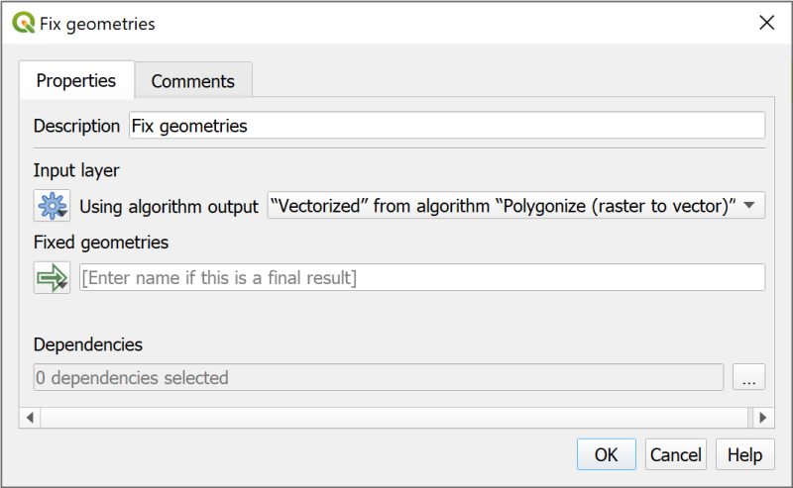

Filling in the Fix geometries algorithm with the output from the Polygonize algorithm.

Your model should look something like the image below at this stage. You can rearrange the boxes if you need to, to make sure that you can still see them all on the page.

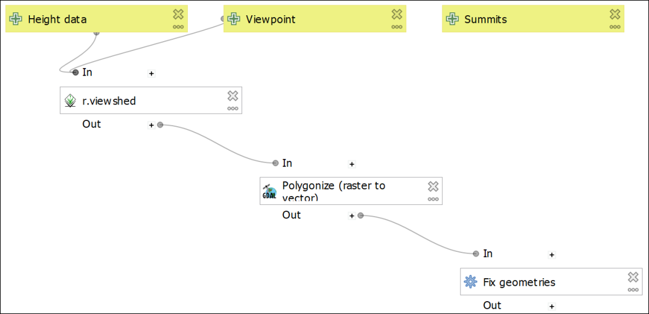

The model with the Fix geometries tool added. It should be linked from the Polygonize tool.

 **Save and test your model.**

Once again save and test your model in the same way as before.

Check the log to make sure it ran successfully and that there are now 3 algorithms.

#### Adding Extract by attribute algorithm

Looking at the diagram above, the next step is to extract all the areas that **are** visible. In this case that means that they have a value of 1 in the Visible field.

As we know the attribute that we want to save we can use the Extract by attribute algorithm.

* Find the Extract by attribute algorithm in the Algorithms panel.
* Change the Description so that it gives a clearer explanation of what this step is doing, e.g. Save all areas that are visible from the viewpoint.
* The Input layer is output from the Fix geometries algorithm
* The Selection attribute is the attribute from the output of the Fix geometries algoritm, in this case back in the Polygonize tool we named this as Visible, so type that into the box.
* The Operator is =
* The Value is 1 (remember, 0 = invisible, 1 = visible).
* This time we do want to save the output so under Extracted (attribute) type a prompt for the output name, e.g. Visible areas. This won’t be the final file name, it is just a prompt for the form that you fill in when you run the model.
* Once you’ve filled in the form click OK to add the algorithm to your model.

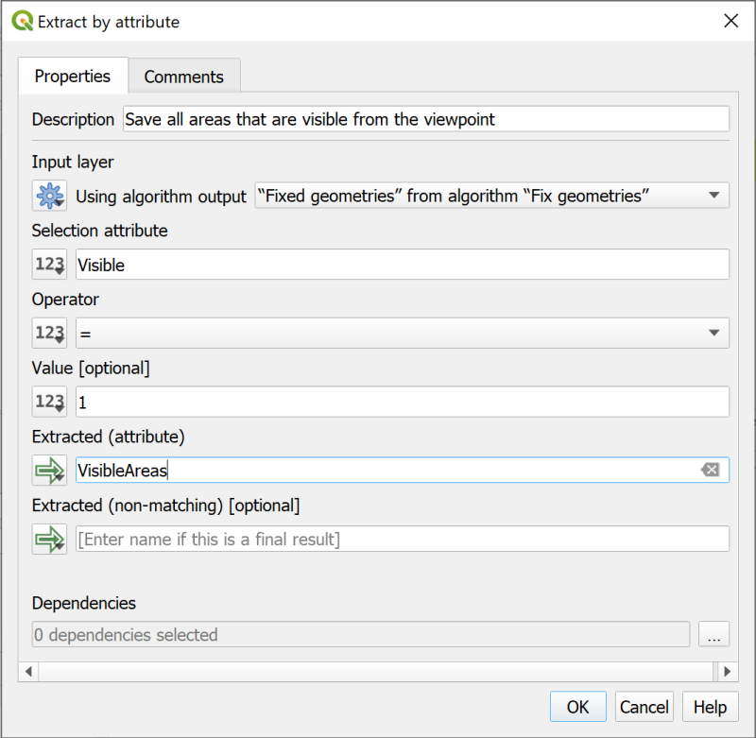

Filling in the form for Extract by attribute.

By this stage your model should look something like the image below. Note that the final algorithm now has output shown - the green box with the arrow icon on the left.

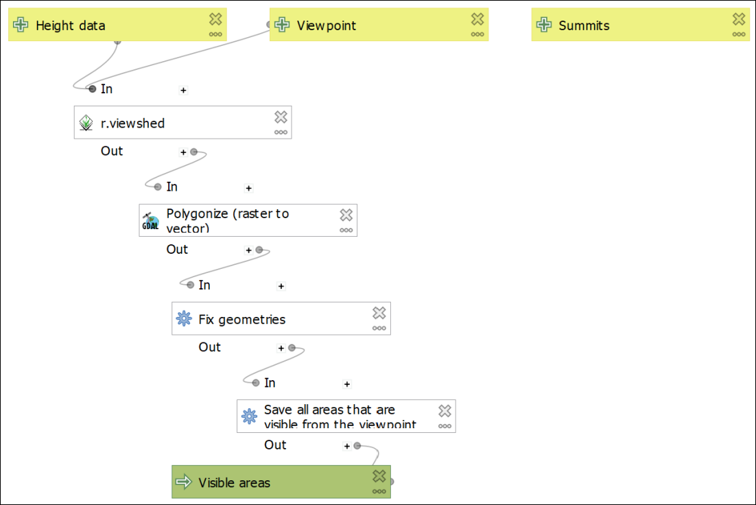

The model with the Extract by attribute algorithm added - note the output which will be available to show on a map.

 **Save and test your model.**

Once again save and test your model in the same way as before.

This time you will also have an option to save the output. For now [Create temporary layer], but also tick to Open output file after running algorithm so that you can check the output.

Check the log to make sure it ran successfully and that there are now 4 algorithms.

Check the layer on the map to see whether it looks as you would expect it to. This will be the visible areas from a point somewhere in the south of the National Park. It should look something like the map below - the orange areas are the visible areas.

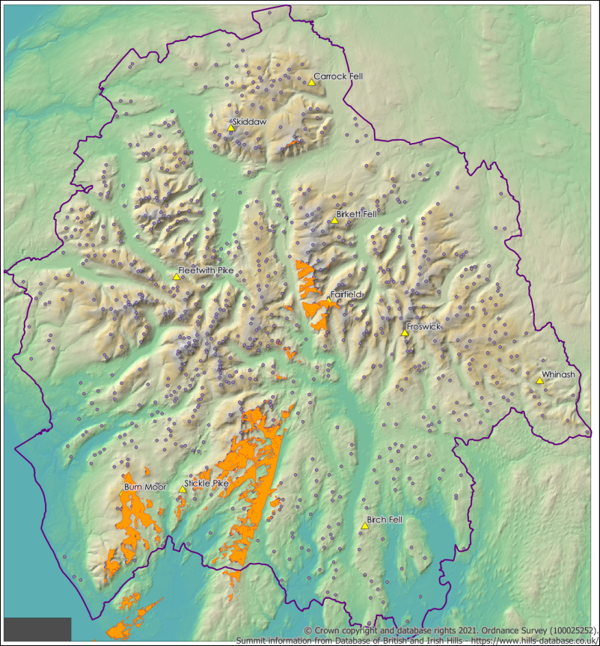

The output of the model at this stage. Showing the visible areas.

#### Adding the Extract by location algorithm

There is one final step for the planned model. We need to extract the summits which are visible from the viewpoint. To do this we can use the Extract by location algorithm.

* Find the Extract by location algorithm in the Algorithms panel.
* Change the Description so that it gives a clearer explanation of what this step is doing, e.g. Extract visible summits.
* Extract features from - use the Model input from Summits
* For Where the features click on the three dots button at the end of the line and check that intersect is ticked.
* By comparing to the features from - use the Algorithm output from the dropdown which says "Extracted (attribute)" from algorithm "Save visible areas".
* Again, you’ll want to keep this output so under Extracted (location) type a prompt for the output name, e.g. Visible summits.
* Click OK to add the algorithm to your model.

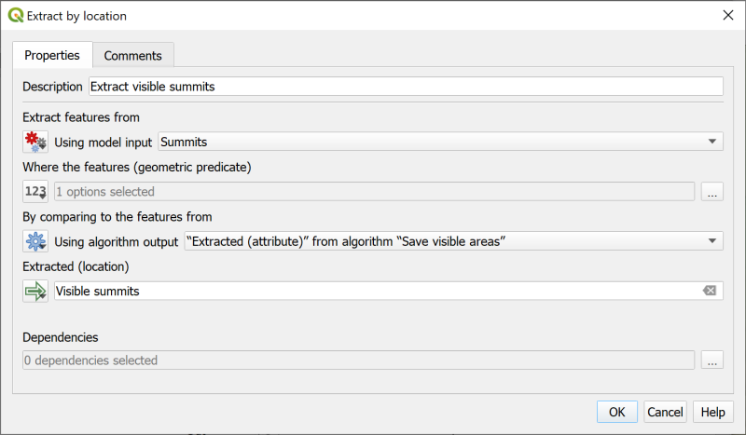

Filling in the form for Extract by Location to select the visible summits.

By this stage your model should look something like the image below. Note that there are now two algorithms with output shown - the green boxes with the arrow icon on the left.

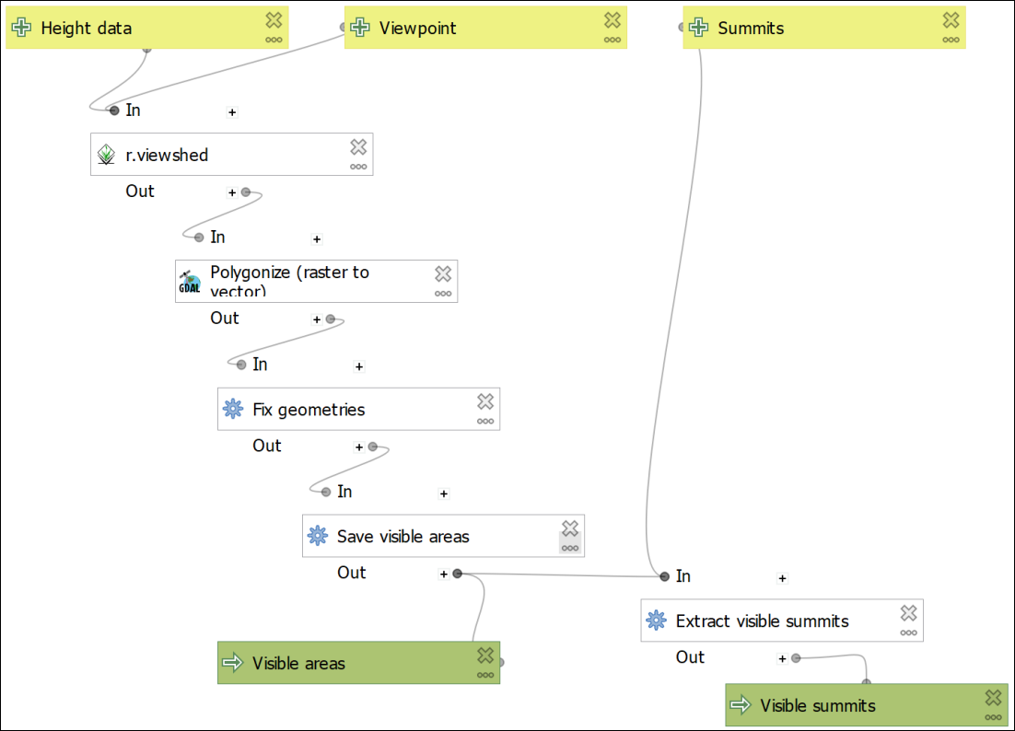

The model with the Extract by Location algorithm and the output for visible summits.

 **Save and test your model.**

Once again save and test your model in the same way as before.

This time you will also have an option to save two outputs. For now [Create temporary layer], but also tick to Open output file after running algorithm so that you can check the output.

Check the log to make sure it ran successfully and that there are now 5 algorithms.

Check the output layers on the map to see whether they look as you would expect them to. These will be the visible areas from a point somewhere in the south of the National Park, and the summits which intersect with those areas. It should look something like the map below - the orange areas are the visible areas and the blue dots are the visible summits.

 **Running a graphical model in QGIS to test that it works.**

This video clip can be found in the module area of [Minerva](https://minerva.leeds.ac.uk) or in the [full list of video clips](https://cgordon-gis.github.io/videoclips.htm).

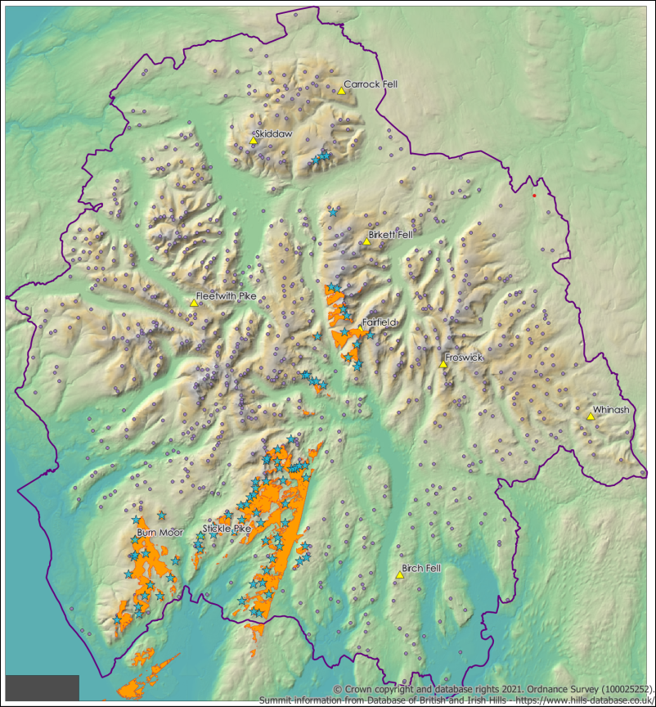

The model output showing visible areas and the summits within those areas.

#### Adding an input field for viewpoint names

If you want to use batch processing to run the model multiple times (which we will do in a moment) there is another input that you can add which could make running it more efficient.

If you add a field to contain viewpoint names then you can use that to “Autofill” the output names when you use the model in batch processing mode.

* Edit your model again and from the Inputs tab add a String input type. This will allow you to type text into the form.
* Under description call it Viewpoint name
* You don’t need to add a Default value.
* Leave Multiline input unticked.
* Untick Mandatory - you probably won’t want to add this when you are running the model a single time, it will only be useful for batch processing.
* Click OK to add the input to your model.

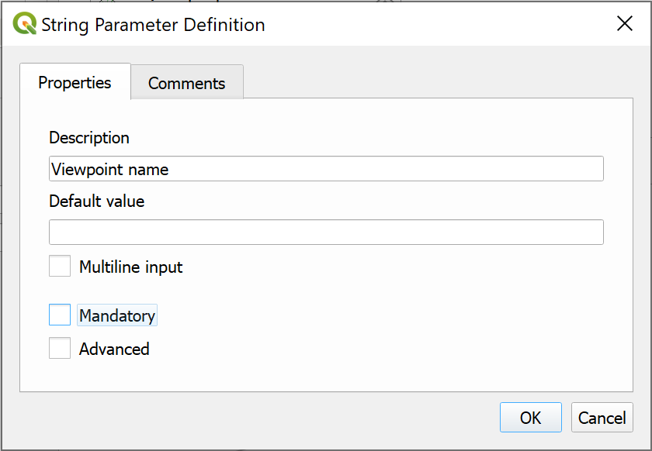

Adding a parameter for viewpoint names - useful if using batch processing.

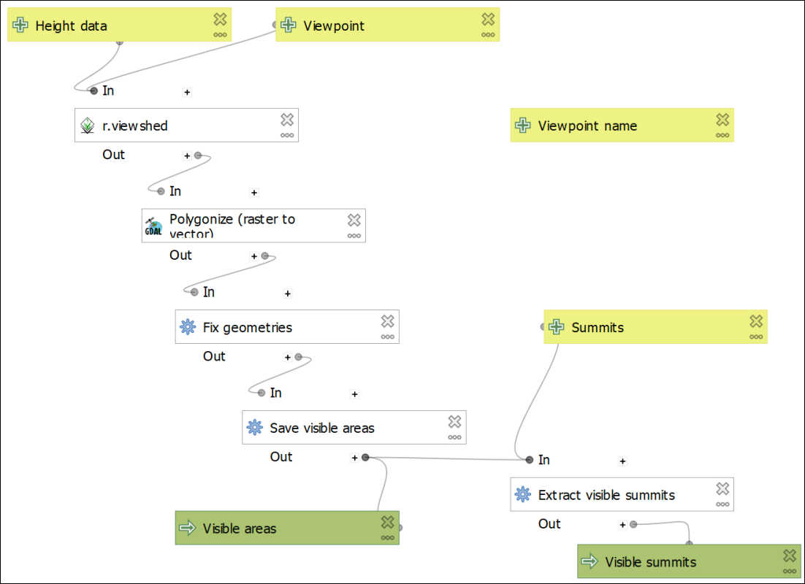

The final model, including a field for Viewpoint name.

The input for Viewpoint name won’t be linked to anything. This is fine.

#### Final test of your model

Run your model to test it for the final time. Try adding a Viewpoint name to check that it doesn’t cause any problems, but it won’t be used by the model on this run anyway.

If everything is running correctly then your model is complete and ready to use for multiple outputs.

* Save your model and close it
* Then go straight to the section on Rearranging your model elements.

If there are problems with your model then the testing at each individual stage should give you some idea of where the problems appeared.

* Go back and try following the instructions again.
* If that still doesn’t work then have a look at the things to check in the Trouble-shooting graphical models section below.

## Rearranging your model elements

You can rearrange the elements on your model simply by dragging and dropping. This can be useful if you are building a complex model with lots of input and processes.

It can also help to “tidy up” the elements if you are going to export your model for inclusion in another document.

It is also possible to resize each of the elements if you need to, for example, if the name of one is too long to fit in the box. You can see this with the Polygonize (raster to vector) algorithm on my model. Resize by clicking on the element, then use the little “handles” to drag the box to the correct size.

## Trouble-shooting graphical models

When programming computers it is very rare for everything to work correctly the first time. If you need to go back and check everything, don’t worry - you’re in good company.

### Things to check

* Looking at the model in the canvas, do the lines between the data and the algorithms link up correctly?
* Check the input for each algorithm. Have you chosen the correct output from previous models? Have you forgotten to choose “Model input” where relevant?
* Are all the parameters for your algorithms correct? Check the logs for red text. Do you maybe need to set the GRASS processing extent or cell size to get the GRASS tools to work?
* Have you chosen to save the correct output and add it to your map?

## Running the final model

Make sure that you have the Lake District map open. If you still have the temporary layers from the last time you ran your model then remove them from your map.

Your model should not be open for editing. If it is you won’t be able to click on the map.

Your map should contain a layer called Viewpoint. This contains ten randomly selected Lake District summits to use as viewpoints when running your model. We could try running the model for all summits in the Lake District - but there are rather a lot of them!

* Zoom in on the point for Stickle Pike in the south-west of the Lake District so that you can add it as the viewpoint when you fill in the form for the tool
* Open your model to run it - either via the processing toolbox or the Browser. Don’t choose to edit your model, but instead run or execute.
* Fill in the form as you have done before, but this time clicking on Stickle Pike rather than typing the coordinates in
* Keep the output as [Create temporary layer] for now.
* Click on Run to generate the output.

 **How many Lake District summits are visible from Stickle Pike?**

By right-clicking on the visible summits in the Layers panel and selecting Show feature count, my result is **154**. Is yours similar?

Don’t worry too much if it isn’t - on a second run my result was **53**. The output of the viewshed depends very much on how accurate you were when you clicked on the point!

## Running the model as a batch process

While being able to “chain” the processes together so that you only have to fill in one form rather than five does save some effort, you will still have to run your model ten times to get the answer for all the viewpoints.

It isn’t (yet) possible to “loop” within a graphical model in QGIS so that you can run it multiple times, but there is an alternative way of doing this, and you’ve already used it back in the elevation models chapter. It is of course **batch processing**. Because your model runs in the same way as any other tool, you also have the option of running it as a batch process.

 **Batch processing in QGIS.**

This video clip can be found in the module area of [Minerva](https://minerva.leeds.ac.uk) or in the [full list of video clips](https://cgordon-gis.github.io/videoclips.htm).

* Remove the temporary layers from your map again.
* Open your model to run or execute it (not edit it) - either via the processing toolbox or the Browser.
* This time click on Run as Batch Process... at the bottom left of the dialog.

You may need to resize the window so that you can see more of the fields, but these should all look familiar.

* Click on the plus button at top left to add another nine rows - the final one should be number 11.
* Add the Height data by selecting the dropdown in the first row and choosing Terrain50DTM.
* Now click on Autofill... and Fill down
* Do the same for Summits which needs to be set to LakeDistrictHills
* Viewpoint has to be added by clicking on the map, so click on the three dots button next to the first box and click on the point for Carrock Fell on the map.
* So that you remember which viewpoint this is, also type CarrockFell into the first box under Viewpoint name. Note that there are no spaces - this will be used in a file name so be careful how you enter it.
* Repeat the previous two actions for each of the ten viewpoints. It doesn’t matter which order you enter them.
* Now move onto the Visible areas field, which is the output. Click on the three dots button on the right of the box and navigate to a folder where you want to store the output. It might be a good idea to create a new folder called Output so you don’t get muddled - you’ll be creating 20 new files.
* Type a file name - try VisibleAreas, and check that you’re creating a new GPKG file. Then click on Save
* The Autofill settings should open. This is where the Viewpoint name field becomes useful. Set Autofill mode to Fill with parameter values and next to Parameter to use select Viewpoint name.
* Click on OK

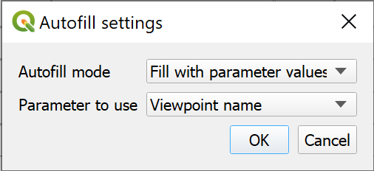

Using the viewpoint name to autoname the output.

You should see the Visible Areas fields fill with the file name that you entered, but also the Viewpoint name. This prevents the output from overwriting on each run, but also makes filling in the form to generate multiple output easier.

* Repeat the last three steps to autofill the Visible summits field in the same way.
* Put a tick next to Load layers on completion

The form should look something like the version below. Don’t click on Run yet - we’re going to save the parameters that you’ve filled in.

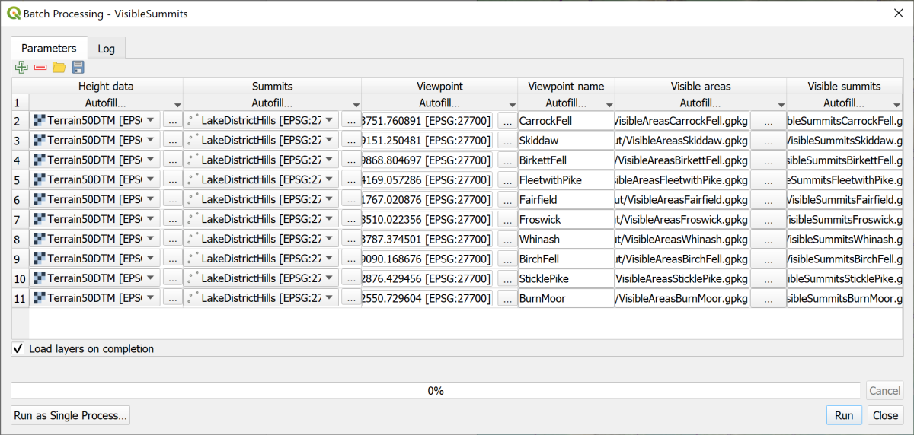

The completed batch processing form with the output names autofilled.

### Saving your batch processing parameters

You’ve spent a bit of time filling in the parameters for the tools. It won’t save you much time if you have to put everything in again next time you run the tool. There aren’t many parameters in this model, but in some you could have many more.

 **Saving and reusing batch processing parameters in QGIS.**

This video clip can be found in the module area of [Minerva](https://minerva.leeds.ac.uk) or in the [full list of video clips](https://cgordon-gis.github.io/videoclips.htm).

To save the parameters that you’ve entered:

* Click on the Save icon at the top left of the batch processing window
* Navigate to your project folder
* Give the saved file a name such as VisibleSummitsCompleted
* The Save as type: will be JSON files (*.json)
* Click on Save

The output is a type of text file. If you open it in a text editor such as Notepad++ (Windows) or TextEdit (Mac) you can see the contents, though it does look rather confusing!

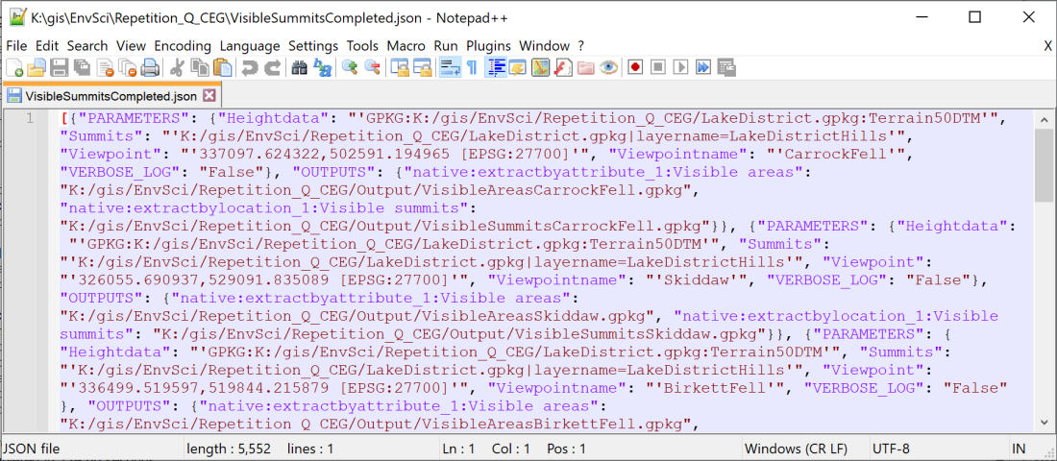

Part of the saved JSON file containing the settings for your batch processing. This is open in Notepad++.

Once you’ve saved a set of parameters you can reopen them by clicking on the folder icon at the top left of the batch processing window.

### Running the model in batch processing mode

Now you can run the model

* Click on Run

This could take a while - remember you’re running five algorithms ten times over. Just be patient and leave it to run!

With luck your model will run straight through and you’ll have twenty new layers added to your map.

Have a look at your map. It should look something like the image below, though your colours will probably be different.

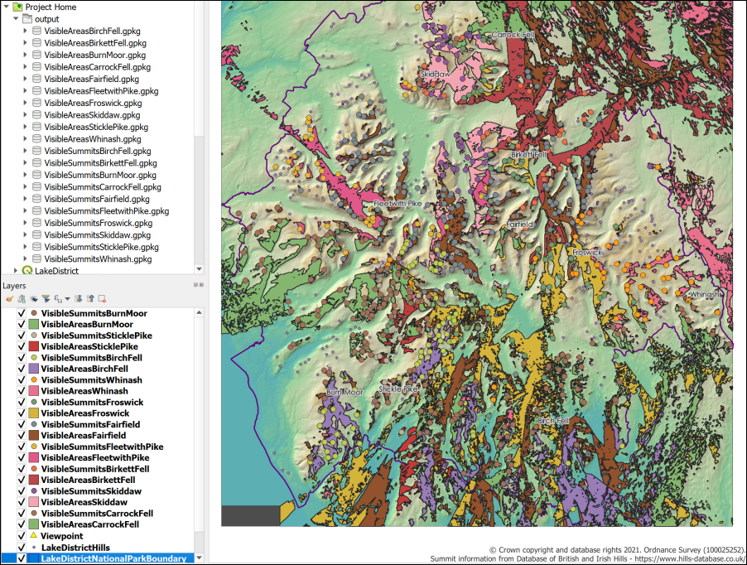

The output from batch processing - twenty new layers styled with random colours.

The Layers panel should show the new layers have been saved with the name of the viewpoint.

Once again you should be able to right-click on the VisibleSummits layers and select Show feature count to see totals.

 **Which viewpoint has the highest number of visible summits?**

On my map it is Fairfield which can apparently see 359 summits. Maybe because it is in the centre of the national park.

## Going further with a graphical model

Once you have the basic model working and producing the output that you need, you can go back to it and add any extras that have struck you while you were working on it. Sometimes you’ll run a model and think “I wonder whether I can do something else here to make it more efficient?”

If you have a working model and want to make alterations to it, first **save a new copy of your model**. This means that if your alteration doesn’t work you can go back to the previous version.

* Go to Model > Save Model As... and give the model a new name. You can just add a number to the end of the existing file name.
* It’s also a good idea to go back to the Model Properties and change the Name of the model in the same way.

Below I give you some suggestions but feel free to come up with your own ideas and experiment.

### Adding further parameters

Adding further parameters can make the model more flexible, though too many can make it confusing to run.

The r.viewshed tool has parameters for Viewing elevation above ground and Offset for target elevation above the ground. You could use additional Input parameters to set these when you run the model.

* Under Description put the name of the parameter, e.g. Viewing elevation above ground
* Look for Number in the list of Input types and set the Properties to Float to allow decimal points.
* Under Default value you can enter a default value of 1.75.
* This won’t need to be Mandatory so you can untick that.
* If you tick Advanced the parameter will be under the Advanced subheading when you run your model. Tick that now to see what effect it has.
* You can then choose Model Input as the input in the algorithm.

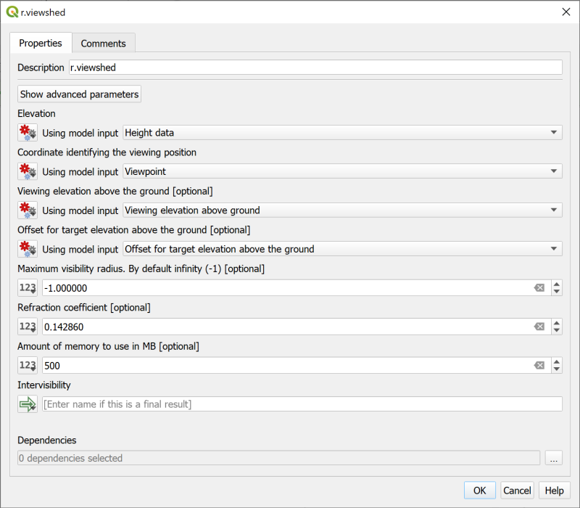

Setting viewing and target elevations via model input.

 **Are there other parameters in this or other algorithms that you could usefully set like this?**

### Using the saved batch processing input to run the model again

Once you have made your changes you’ll want to run the model as a batch process again. Remember that you have the json file that you exported which contains the parameters that you used before.

Although you may have changed or added parameters, you can use that file to fill in some of the previous ones. This will probably still save you time.

 **Saving and reusing batch processing parameters in QGIS.**

This video clip can be found in the module area of [Minerva](https://minerva.leeds.ac.uk) or in the [full list of video clips](https://cgordon-gis.github.io/videoclips.htm).

If you set some of the parameters as **Advanced** you’ll need to click on the settings button at the top left of the batch processing form to see them.

* Close the Model Designer
* Delete the data from your previous run of the model
* Open the model to run or execute it
* Click to Run as a batch process...
* Click on the folder button at the top left of the window and select the .json file that you saved previously.

The Batch Processing dialog should fill with the parameters that match your previous version. You will still need to fill any new parameters that you’ve set up. Remember to click on the settings button to see the advanced parameters and remember that you can use Autofill... to make filling the form a bit easier.

## Packaging layers in a single geopackage

At the moment all your output layers are in individual geopackages. This is messy and would make it harder to share your data with colleagues.

Luckily QGIS includes a tool which will package layers in a single geopackage.

 **Packing layers in a single geopackage in QGIS.**

This video clip can be found in the module area of [Minerva](https://minerva.leeds.ac.uk) or in the [full list of video clips](https://cgordon-gis.github.io/videoclips.htm).

* Open the processing toolbox and search for Package layers. You should find the tool under the Database heading.
* Open the Package layers tool
* Click on the three dots button next to Input layers. Select your twenty visibility layers as shown below and click OK

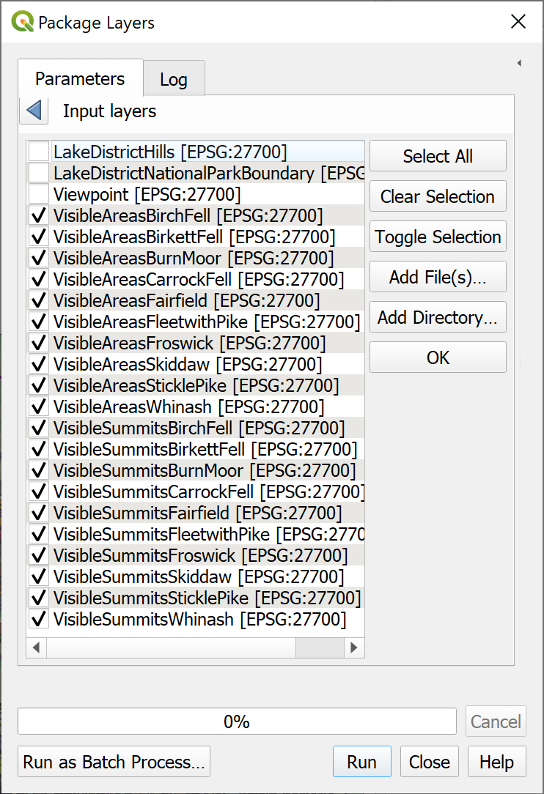

Selecting the twenty visibility layers for packaging.

* Untick Save layer styles into GeoPackage - the styles are random anyway, so there isn’t a lot of point in keeping them.
* Click on the three dots button next to Destination GeoPackage and Save to File...
* Browse to the folder where you want to save the output and give your new geopackage a name such as Visibility.
* Click on Save then Run the tool.

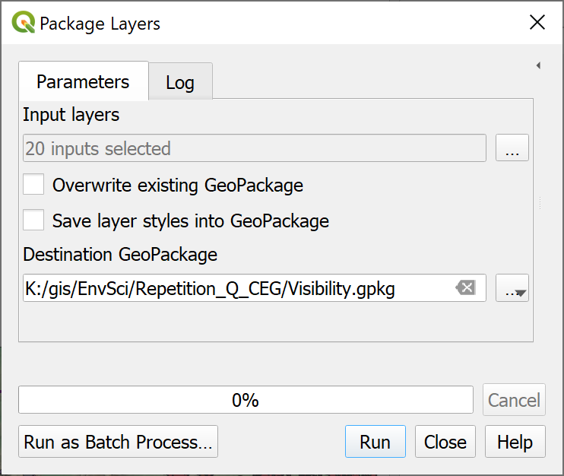

Filling in the form to package layers in a single geopackage.

Now you should be able to remove the twenty visibility layers from your map and add them in again from the single geopackage. Feel free to delete all the individual geopackages from your computer.

## Documenting your graphical model

When creating models, as with scripting, it is a very good idea to **document** them. This involves adding comments which don’t make a difference to how the model runs, but do give information that is useful if you, or someone else, needs to make changes to the model in the future. While you’re writing the model it’s easy to think that you will remember why you have done certain things, but if you come back to it in a year’s time you’ll be thinking “why did I do it that way?” Comments can help you to remember that without wasting time.

You can also add help which appears in the tool when it is being run. Remember the panel to the right in the processing tools? The helpfulness of the information in those varies greatly and this is your chance to provide really useful help to anyone who may run your model.

### Adding comments

Comments appear in the Model Designer and are useful to remind yourself, or any other developer, of what things do and why you did things that way.

Comments are attached to individual elements of your model.

 **Documenting graphical models with comments in QGIS.**

This video clip can be found in the module area of [Minerva](https://minerva.leeds.ac.uk) or in the [full list of video clips](https://cgordon-gis.github.io/videoclips.htm).

To add comments:

* Open your model for editing.
* When adding an element (input or algorithms) to the canvas you’ll see that there is a second tab called Comments. Type information into the box on this tab and click OK.
* To add a comment to an element which is already on your canvas either right-click and Edit Comment or click on the three dots on the element and then go to the Comments tab. Type information into the box on the comments tab and click OK
* You can also change the colour of the background of the comment while you are on the Comment tab.

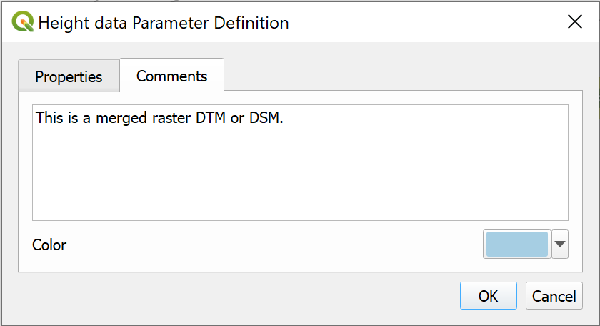

Adding a comment to the input Height data parameter.

* The comment will be added to the canvas with a link to the element.

 **Adding a comment to input**

Follow the instructions above to add a comment to the input **Height data**

Type the following into the box:

This is a merged raster DTM or DSM.

Then click OK to save it.

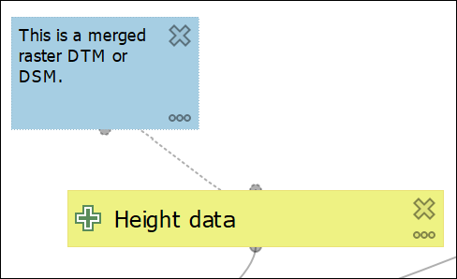

The comment linked to the Height data element on the canvas.

 **Add comments to your model.**

Have a look at the other elements on your model. Add any further comments that you think would be useful to you if you came back to work on this model again in 12 months time. Remember that you can add comments to algorithms as well as input.

### Adding Help for users

The Comments are aimed at a developer, but you may also want to add Help for people who actually use your model, for example if you are producing a model tool to automate a workflow for a team you are working with.

The Help will appear in the help panel when the tool is being run.

 **Adding help for users to a graphical model in QGIS.**

This video clip can be found in the module area of [Minerva](https://minerva.leeds.ac.uk) or in the [full list of video clips](https://cgordon-gis.github.io/videoclips.htm).

To add help:

* Within the model designer go to Model > Edit Model Help...

The Help Editor should open. You may need to enlarge the window a bit to see all the areas.

* The area at the top shows how your help will appear to users
* Select the element you want to add help to in the list at lower left
* Type your help information in the box at lower right

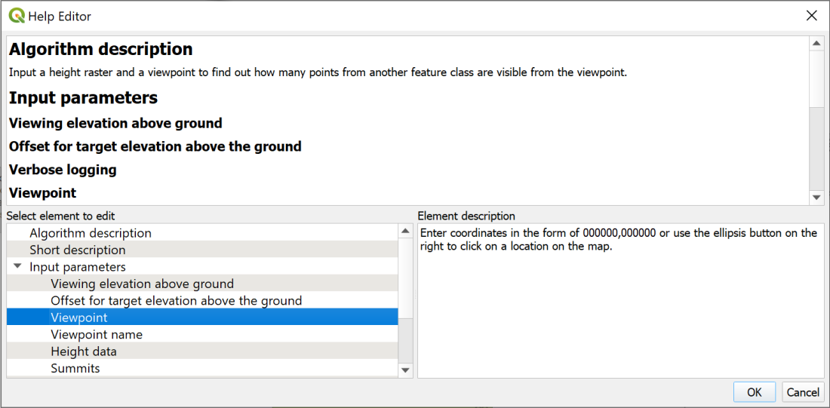

The Help Editor. Select an element and type in the help that you wish your users to be able to see.

* When you’ve typed in help click OK to save it.

 **Run your model and look at the help.**

Now open your model as if you are going to run it (you can do this from within the Model Designer) and have a look at how your help appears.

If you can’t see it you may need to click on a small black arrow at the top right of the window.

Note that your comments don’t appear in this view, just the help that you’ve created.

You don’t need to actually run your model now, unless you want to!

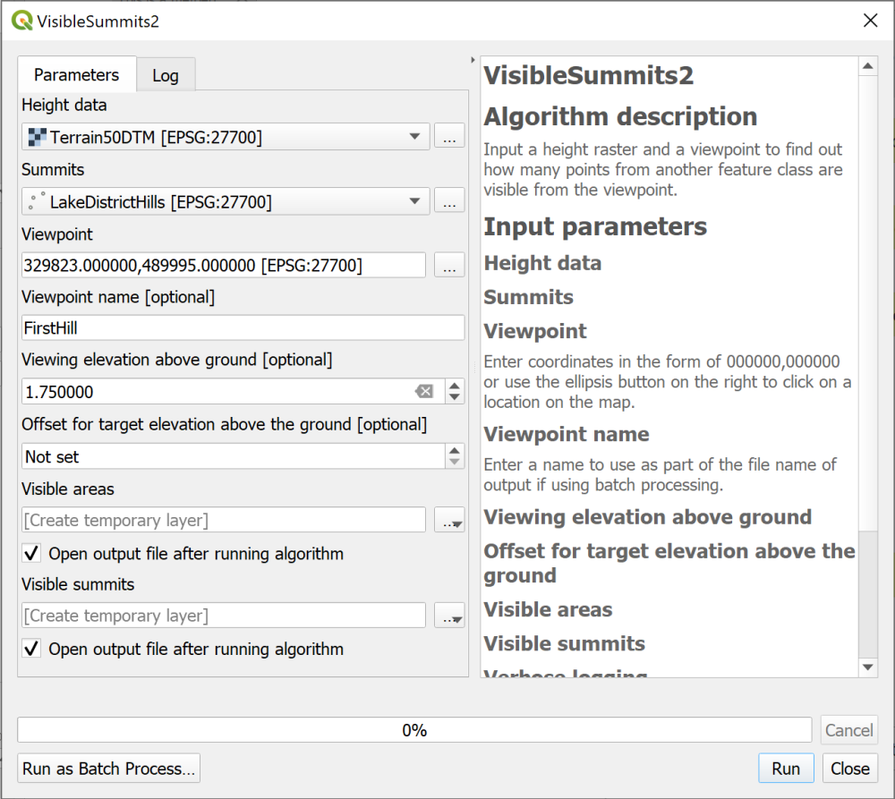

The model dialog showing the help that your users will see.

* You can close the run dialog now.

 **Add help to your model**

Add any further help to your model that you think will be useful.

## Exporting your graphical model

Sometimes it is useful to have a copy of your model as an image file. It shows the process that you’ve used and also serves as a reminder to you of the tools and data that you used.

 **Exporting a graphical model in QGIS.**

This video clip can be found in the module area of [Minerva](https://minerva.leeds.ac.uk) or in the [full list of video clips](https://cgordon-gis.github.io/videoclips.htm).

### Exporting as an image or pdf

QGIS gives you the choice of three formats for exporting your model, Image, PDF or SVG.

* If you export as Image you’ll be able to include it in a Word or PowerPoint document, or open it in an image editor on your computer.
* PDF is better if you just want to be able to open it on your computer.
* SVG is a vector format which will open in the Inkscape vector editing program and can then be edited.

To export your graphical model:

* Either use the menu at Model > Export and choose the option you want to use.
* Or use the buttons on the toolbar, and again choose the option you want to use. (Remember you will get tooltips when you hover over buttons in QGIS.)

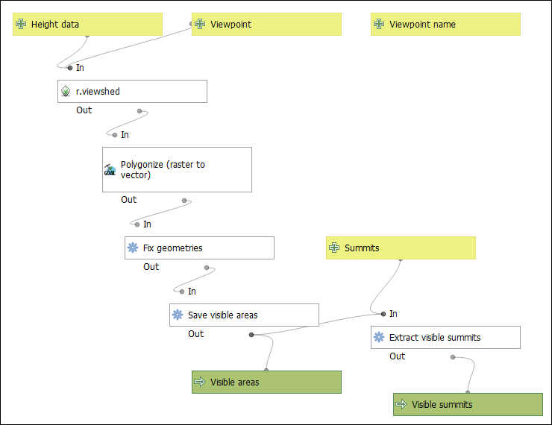

The model exported as an image file.

### Exporting your model as a python script

You’ll notice that there is a fourth export option - Export as Script Algorithm... or Export as Python Script... depending on whether you use the menu or the buttons.

* Click on the Export as Script Algorithm... button on the toolbar

A window should open which contains the python code for your model.

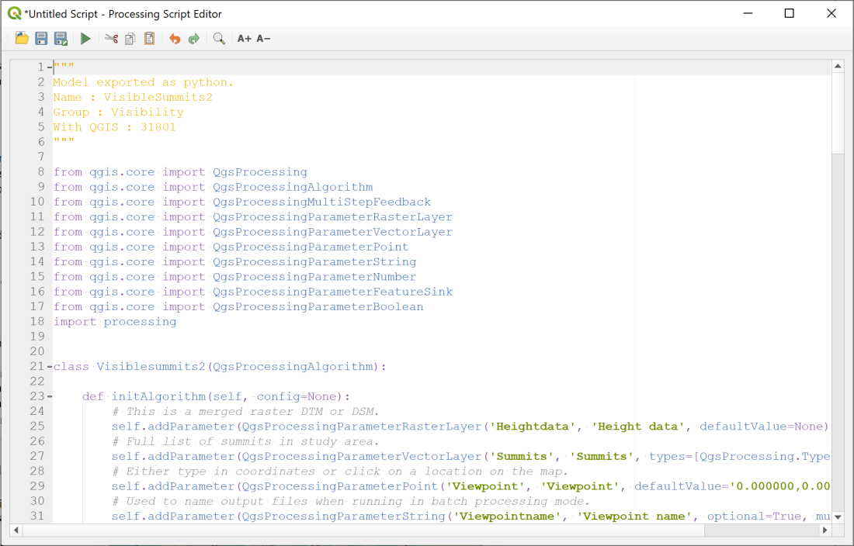

The python code behind your graphical model. This was opened using the button on the toolbar.

You can now use the Save button at the top of the window to save your code to a Python file which can then be opened in a text editor such as TextEdit on Mac or Notepad++ on Windows.

Alternatively use the menu to Model > Export > Export as Python Script... and save the file straightaway.

 **Have a look at the Python Script.**

Have a look at the Python script you have exported, either in the Processing Script Editor or in a text editor. Can you pick out the input and the algorithms that you added? How are the outputs passed from one algorithm to the next?

Note also that any comments that you added to your model are added as comments to the python script.

## Python in QGIS

I’m not going to cover Python here, but there is a very good introduction available online called [PyQGIS 101: Introduction to Python programming for non-programmers](https://anitagraser.com/pyqgis-101-introduction-to-qgis-python-programming-for-non-programmers/).

## Final output for this chapter

The output for this chapter is a model rather than a map. The data that you have produced would create a map very similar to the one at the end of the Elevation models 2 chapter.

Instead export your final model as an image file using the instructions above, and upload that to your GIS portfolio. If you upload it before the next class I will provide brief feedback on your work.

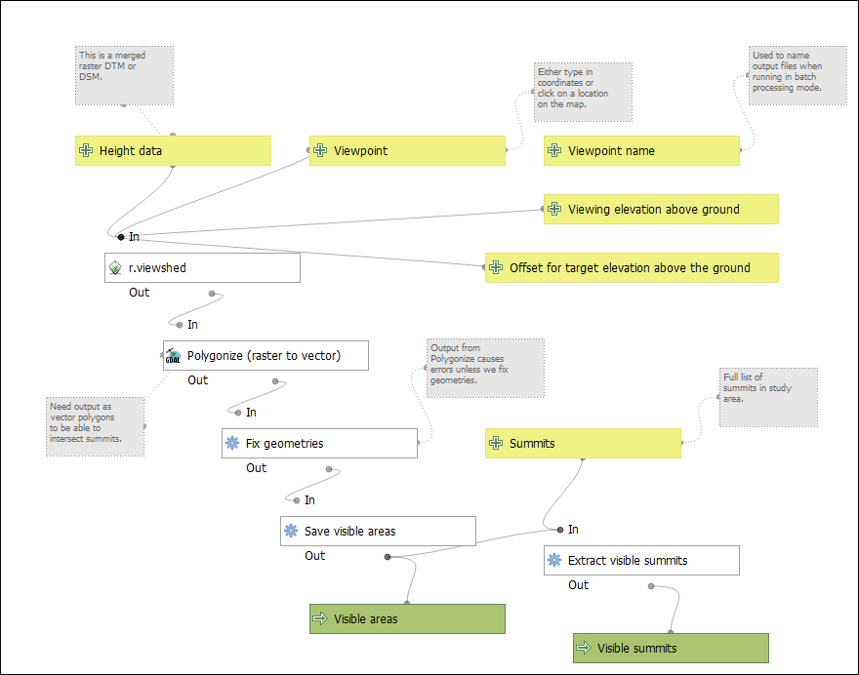

Possible final model from this chapter. You can move the elements around on the canvas to neaten up the presentation.

## Recommended reading for graphical models and batch processing

### Graphical models

* [QGIS User Guide information on graphical modeler](https://docs.qgis.org/latest/en/docs/user_manual/processing/modeler.html).
* [Automating GIS workflows with QGIS](https://courses.spatialthoughts.com/automating-gis-workflows.html) - full course from Spatial Thoughts, includes graphical models.
* [Advanced QGIS expressions and modelling](https://spatialthoughts.com/2020/11/26/spatial-homogeneity-testing-qgis/) - also Spatial Thoughts.
* [QGIS Open Courseware tutorial on using the graphical modeler](https://courses.gisopencourseware.org/mod/book/view.php?id=56). [Video tutorial to go with written course](https://youtu.be/BKdJMGXgOzg).

### Batch processing

* [Batch processing using Processing framework](https://www.qgistutorials.com/en/docs/3/batch_processing.html) - QGIS Tutorials

### Python

* [PyQGIS 101](https://anitagraser.com/pyqgis-101-introduction-to-qgis-python-programming-for-non-programmers/) - a basic introduction to using python in QGIS from Anita Graser (Underdark).

# Viewing your data in 3D

Last Modified: 16 Mar 22, 17:03:27

The background to viewing your data in 3D will be covered in the lecture segment at the beginning of the class, and the presentation and any other supporting materials will be available in Minerva. The lecture segment should help you to understand **why** you are doing these exercises. If you still aren’t sure, please ask [Clare](mailto:c.e.gordon@leeds.ac.uk).

## Learning outcomes

When you have completed this section of the workbook you should be able to

* demonstrate how to import height data in to GIS
* display a map in 3D to aid the interpretation of your data
* extrude vector data for 3D display based on a value from the attribute table

## Introduction

Once you have created features and data in GIS you can view the map in 3D and see how your data relates to other features. Being able to view landscapes or data in 3D can sometimes make relationships more obvious.

You’ll be able to export 3D views and profiles from QGIS to include in other reports and layouts.

## Data to download

For this chapter I have created a project which contains all the data that you will need to complete the exercises.

* Download ThreeD_Q.zip from Minerva.
* Unzip the folder to your GIS folder. You should have a folder called ThreeD_Q which contains a qgz file and multiple folders of data.
* Open ThreeD.qgz in QGIS. It should look something like the image below. Most of the layers in the layers panel are not visible.

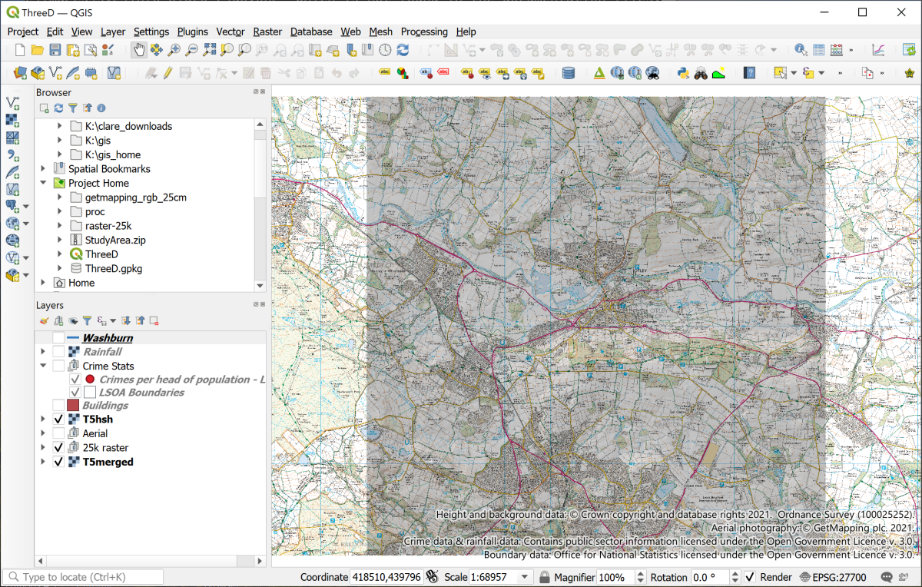

The initial project when you first open it.

You’ve used most of these data layers before in previous chapters but to save time I’ve set the project up this time.

## Creating a profile graph

QGIS enables you to draw a profile graph across your map using z values in your raster surface files or heights above sea-level. You have both an elevation layer and a rainfall surface on your map so you can try both of types of surface.

There is a plugin called the Profile Tool which is very simple to use, but which has limitations. If you would like to try that then you’ll probably find it pretty easy to use. Instead, for these exercises, I’ll take you through how to use a plugin called qProf. This allows us to have control over the x and y axes, and to export the graph in such a way that it is possible to display it properly on a layout.

* You’ll need to install the qProf tool plugin by going to Plugins > Plugin Manager in the same way as you [installed the QuickMapServices plugin](/gps/#installing-qgis-plugin-to-display-a-background-map).

Don’t worry that the description of this tool talks about plotting geological data, you’ll be using it without doing that.

* To open qProf go to Plugins > qProf > qProf.

The qProf tool window should open to the right of your map area.

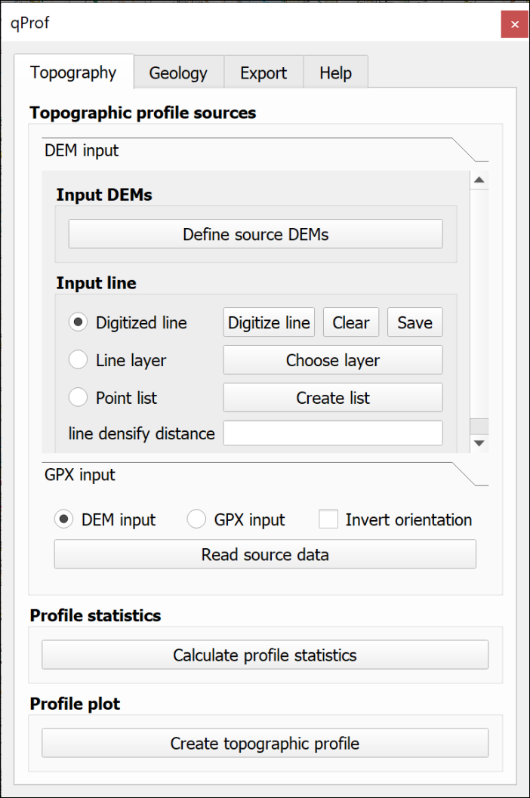

The qProf window.

 **Creating a profile graph in QGIS.**

This video clip can be found in the module area of [Minerva](https://minerva.leeds.ac.uk) or in the [full list of video clips](https://cgordon-gis.github.io/videoclips.htm).

The first thing you need to do is select the layer that contains your z or height data.

* Check that the Topography tab is selected at the top.
* Click on the button to Define source DEMs
* From the list select T5merged, or your height layer, and click OK.

Next you need to define the input line, i.e. the line of your profile. We’ll start by using a temporary, or Digitized line.

* Check that the T5hsh layer is visible on your map - this shows the extent of the height layer.
* Make sure that Digitized line is checked on the qProf dialog, then click on the Digitize line button.
* You are given brief instructions. Click OK when you’ve read them, then on your map:
  + left-click on the top left of the visible hillshade layer
  + left-click on the bottom right of the visible hillshade layer
  + right-click somewhere on the map to stop drawing the line

You should end up with a red line across your map.

Now you can generate the profile.

* First make sure that DEM input is checked, then click on the Read source data button. Hopefully you’ll get a message saying Data profile read.
* Next click on Calculate profile statistics. You should get a small window full of numbers. Close this, it shows that qProf has successfully created points at regular intervals along the line and assigned a height to them from the DEM.
* Then click the Create topographic profile button. You’ll get a Topographic plot parameters window at this stage.
  + Set vertical exaggeration to 3 for now so that you can see what is going on - you can set it higher if you particularly want to show the shape of the land, but for scientific purposes you will usually need to set it to the real-world exaggeration, which is 1.
  + Leave the Plot z max value as whatever qPlot has calculated.
  + As this is an inland area in West Yorkshire it is very unlikely that the minimum height will be less than sea-level, so set Plot z min value to 0.
  + If you want to change the colour of your line you can click on Elevation line visibility and colours, then on the colour patch. Change the colour if required then click on OK.

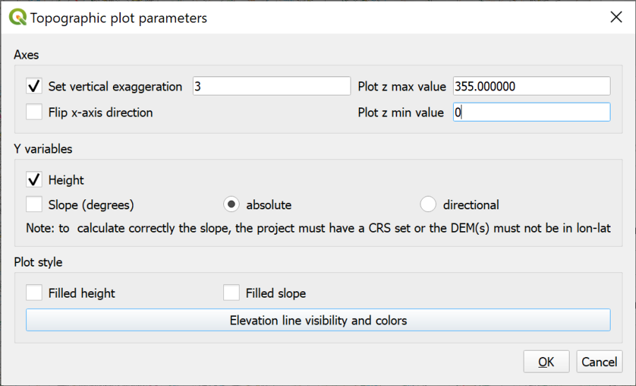

Filling in the Topographic Plot Parameters. Particularly note the vertical exaggeration.

* Now click on OK to generate the profile. A simple profile window should open.

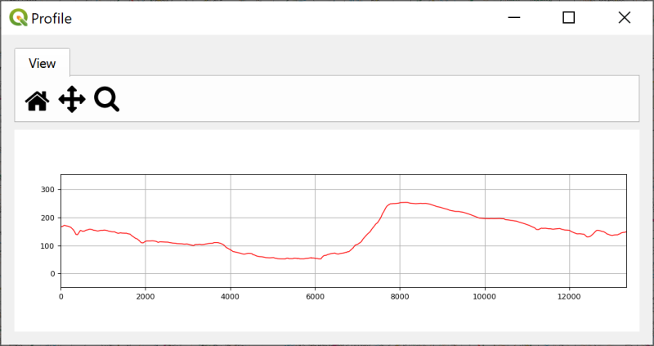

The generated profile. You can enlarge the window to make the profile larger.

 **Experiment by drawing different lines**

Click on Digitize line again and try drawing a few different lines across your map in any direction you fancy and see what the terrain is like. You’ll need to click on all three buttons in the lower part of the tool again.

* The x axis shows the distance in map units, which in this case will be metres. You can check this in the project properties if you need to.
* The y axis shows the values of your chosen “surface”. In this case the DTM. Again, this is map units so for this map is in metres.
* Note that if you have set the vertical exaggeration to anything except 1 the x and the y axes will not be in proportion to each other. Also note that if you follow the instructions further on for adding a profile to a layout, this won’t make any difference as it will end up to scale anyway.

### Adding a second profile to the same graph

It is possible to add multiple layers to provide z values for the same profile graph.

* You also have a rainfall layer on your map. This shows the total rainfall for the area in 2016.
* Click on the rainfall layer in the Layers panel, then click on Define source DEMs on the qProf tool panel.
* Tick next to both T5merged and Rainfall2016 then OK
* Digitize a line from top left to bottom right of the hillshade.
* Click on the Read source data, Calculate profile statistics and Create topographic profile buttons again, this time setting the rainfall as a blue line.

The output should look something like the image below. Changing the colour of one of the lines makes it simpler to remember which is which.

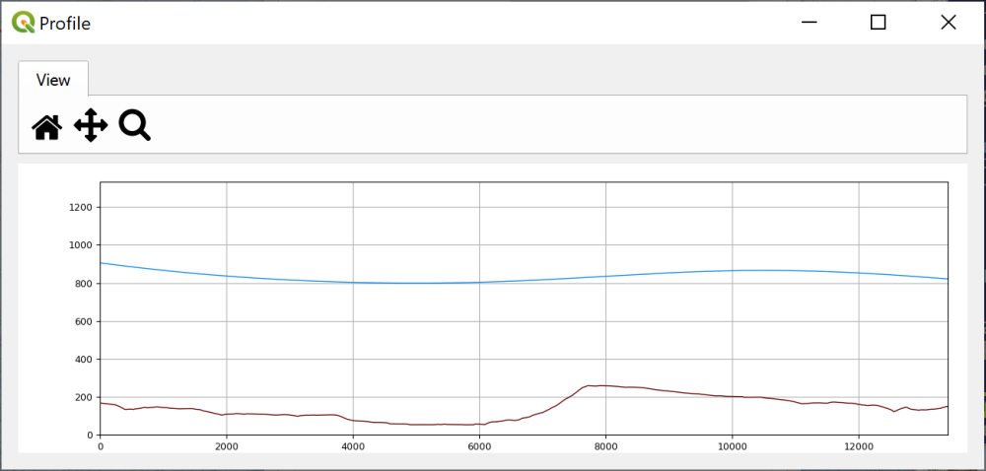

The Profile tool panel with two elevation layers set - terrain in brown and rainfall in blue.

Unfortunately it isn’t possible to edit the *y* axes independently so that you have the two profiles on different scales. If you want to do this you would probably need to export the profile graph as svg format, open it in Inkscape or another graphics editor, and make the changes there.

* When you’ve finished experimenting just close the qProf tool panel - this will clear the settings that you’ve been using.

### Using a feature class for the line on the map

So far you’ve only used a temporary line on the map for the line of the profile. When you close your map this line will disappear. If you are going to include the profile on the map layout you also need to show the line of the profile on the map. To do this you can create a feature class and digitise a line across the map. It is also possible to use an existing line feature, such as a river or a road, to create the profile and we’ll do that now.

* Reopen the qProf Tool again in the same way as before.
* Add the T5merged layer as the Input DEM
* Make sure you have a feature class containing a line feature in the Layers panel - on this map you have a layer called Washburn which includes a single line feature showing the course of the River Washburn. Turn this on now and have a look for it on the map. Remember that you can Zoom to layer to pinpoint where it is on the map.
* Under Input line click to check next to Line layer
* Click on the Choose layer button.
* The Input line layer: will be Washburn.

As there is only one line in this feature class you don’t need to worry about the other settings.

* Click OK
* Click on the Read source data, Calculate profile statistics and Create topographic profile buttons again to generate the profile. Set vertical exaggeration to 5 and Plot z min value to 0.

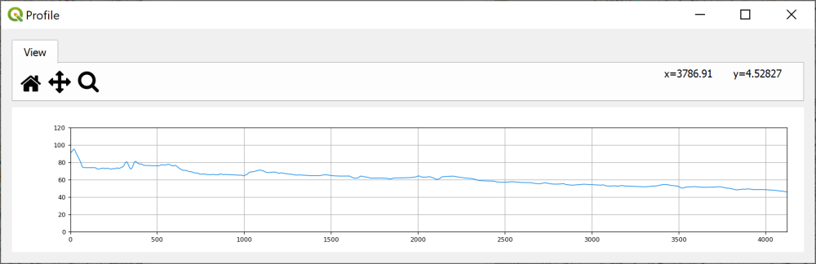

The topographic profile of the River Washburn.

 **Checking the data**

Have a look at the profile graph. Does this look as you think it should do for a river? If not, why do you think this might be?

### Saving the profile graph

You can save your profile graph as an image to add to other work, e.g. in Word or PowerPoint.

* Click on the Export tab at the top of the qProf panel
* Click on the Figure button.
* You can change the size of the image and various other parameters here
* Click on Choose to navigate to where you want to save the graph and give it a name. For now give the file name an extension of .tif to save the output as an image.
* Click on Save then OK to actually save it.
* For now keep the qProf dialog open - you’ll use the same profile for the next section.

The resulting tif file can be added to reports or map layouts, but see below.

 **Have a look at the output**

Find your saved profile png file in your file explorer and open it to have a look at it. It should open in your computers default graphics editing or viewing program.

Check that it looks as you would expect from what you could see in the qProf tool.

This output is fairly basic. It simply gives you the profile without any labels, titles etc.. If you are going to include a profile graph on a map layout or in a report you will need to annotate it with titles, labels etc.

One way to add annotations is to export the figure as .svg format, open the file in an editor, such as Inkscape [33] and add the annotations there.

If you are going to include your profile on a QGIS layout then there is an alternative which I’ll show you below.

### Adding annotation to a profile graph

Sometimes producing certain output in GIS can involve looking for alternative ways to do something or use particular techniques. This is a prime example. Using the qProf tool it is possible to export the data in a way that allows you to plot the profile as a line on a map. This then opens out the possibility of including it on a layout and using grids to add the axes, labels to add the title, and a key.

 **Do you need to do this section now?**

If you don’t need to do this right now I’d suggest missing out this section as it is quite long. Go straight on to the section on viewing 3D topography in QGIS, you can always come back to this section if you need it later.

If you do need to do this now the instructions below cover exporting the data from qprof, then importing it to QGIS so that you can set up the profile. There are some ideas for how to annotate and style your profile graph, but use the layout techniques that you’ve already covered too.

 **Using profile data to display a profile graph on a layout in QGIS.**

This video clip can be found in the module area of [Minerva](https://minerva.leeds.ac.uk) or in the [full list of video clips](https://cgordon-gis.github.io/videoclips.htm).

#### Exporting a csv file with the profile data

* If you don’t already have qProf set up to show a profile for the River Washburn then follow the instructions above again so that you have.
* On the Export tab click on the button to export Topographic profile data.
* Under Profile sources click next to Single DEM and make sure that T5merged is selected [34]
* Under Output format select csv
* Click on the three dots button to set the location and name for the Output file
* Click OK

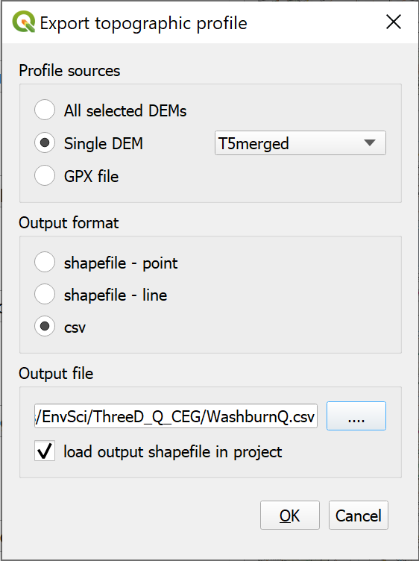

The settings to export the topographic profile as a csv file.

* You can close the qProf window now.
* Open your new csv file in a spreadsheet program or text editor to see what it contains. You’ll see that it’s an awful lot of numbers!

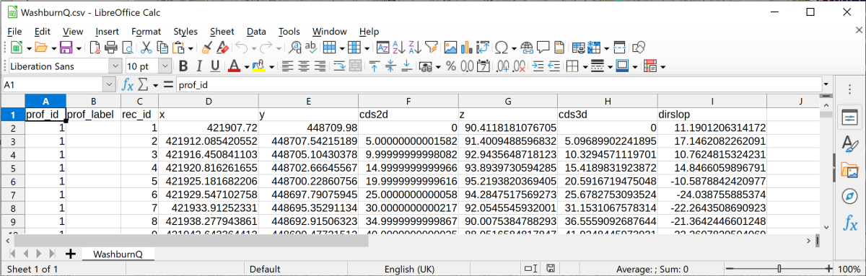

The csv file containing the data for your profile graph.

You should recognise the x and y fields as being the grid coordinates. The cds2d column gives the distance along the y axis from 0, or the start of the line. The z column gives the height at that point on the profile taken from the original DEM data.

* Close the spreadsheet or text editor without making any changes.
* Return to your map in QGIS.

#### Adding the csv profile data to a map

You need to add the csv file to your map as data, but we don’t actually want it to appear in the same position as the rest of the map so we won’t be using the grid coordinates.

* Remember when you added the Lake District summit points to the Lake District map, you installed the Spreadsheet Layers plugin. You can use that again this time to add the csv profile to your map.
* Add the new csv file as your File name and give your output Layer name a name that will mean something to you.
* Tick the Geometry box and check that the Reference system is set to EPSG:27700
* This is where what we do needs to differ. Instead of setting the X field and Y field as geographic coordinates use:
  + cds2d as the X field
  + z as the Y field
* Click on OK to add your points as a virtual layer (.vrt).

You won’t be able to see the new layer, but right-click on it in the Layers Panel and Zoom to layer. Now you should be able to see a line of dots across your map. The data has been added at about 0,0 on the British National Grid, which is fine for our purposes. You’ll also notice that any vertical exaggeration is no longer present. This is now at a vertical exaggeration of 1.

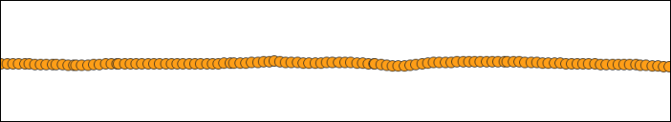

The points making up your profile.

#### Converting the profile points to a single line

The next stage is to convert that row of points to a single line.

* In the Processing toolbox search for Points to Path
* The Input point layer is the imported csv points, e.g. WashburnQ in my example.
* The Order field is the order the points need to be linked together in. For this it should be prof_id, or something similar which is probably the first field.
* Under Paths give your output line a name - you can save it in the project geopackage.
* Click Run to create the line.

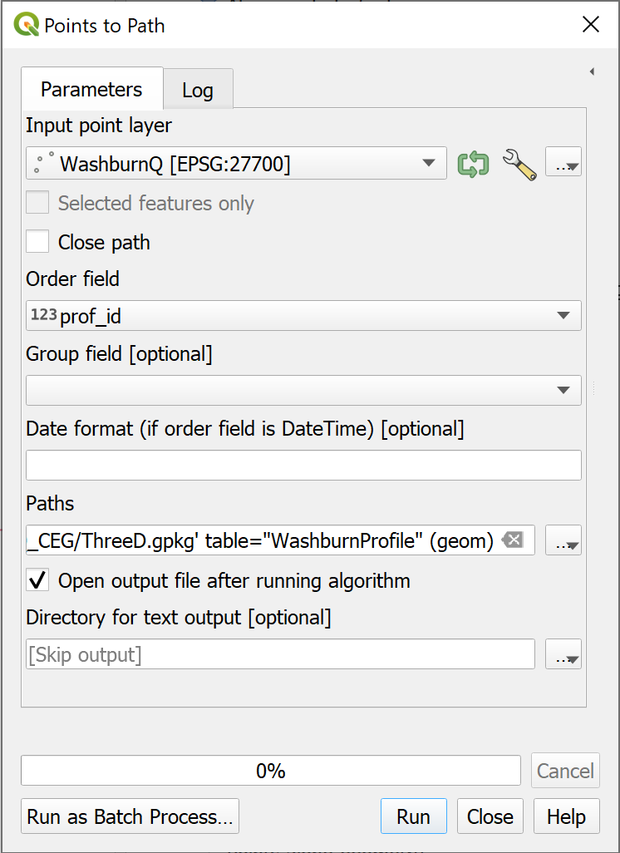

The Points to Path tool to convert the points to a single line.

You can turn off and remove the profile points now, and you should be left with a line across the map window. You can now style this in whatever way you wish to in exactly the same way you would style any other vector layer.

#### Creating a profile on a map layout

Now we come to setting up the profile on a layout in QGIS.

* Make sure that you have done Zoom to layer to the Profile layer in map view
* Open either your existing layout, or a new layout.
* Add a new map in the usual way. It should show your profile. Set the scale and size so that the profile shows as you wish it to. If you want it to match your main map, set both to the same scale.

##### Adding labels and a grid

Experiment with the usual map elements to see how you can annotate your profile graph.

* To add labels to the axes and lines on the graph add a grid to the window in the usual way.
* You can set the grid interval in the usual way. For a section setting it to 100 metre intervals may work best, but experiment to see what works best for you.
* You can Draw Coordinates on just the axes that you want to.
* Use the Extents on the Item properties for the map to control the lengths of the axes. For example, you can set Y min to 0 to set the scale to start at sea-level.
* Use the Add labels button to add a title and axis labels.
* Don’t forget to Lock layers on the Item Properties to prevent the profile from being changed when you move to other layers.

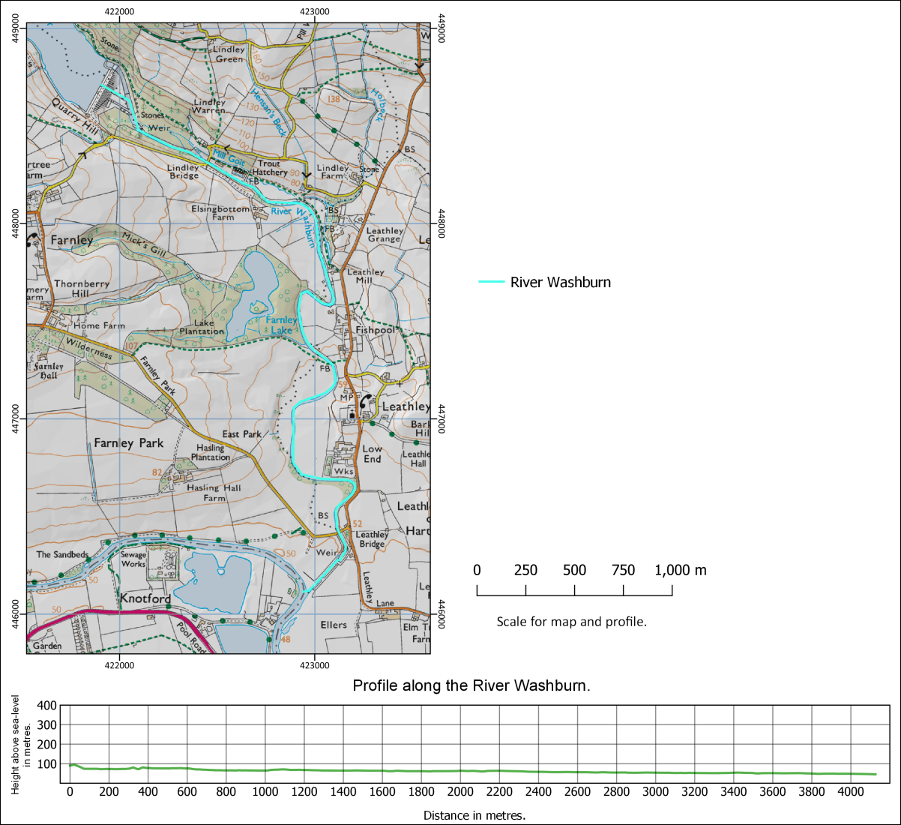

A map and profile created within a layout in QGIS. Note that if you set up the profile this way it is simple to set the map and profile to the same scale.

## Viewing 3D topography in QGIS

Sometimes being able to view your data in relation to the land surface can really help you to interpret it. QGIS has a plugin which is an effective and simple way of allowing you to do this.

Recently QGIS has gained an inbuilt 3D Map viewer. It is being actively developed at the moment and the version in 3.18 of QGIS has more functionality than the version in 3.16, but for now the plugin I show you below is more reliable. The inbuilt 3D viewer is worth keeping an eye on in future, though.

If you want to try the inbuilt 3D Map Viewer there is more information in the [QGIS Desktop User Guide](https://docs.qgis.org/3.16/en/docs/user_manual/introduction/qgis_gui.html#d-map-view).

QGIS has a plugin which gives more options for viewing your data in 3D, including extruding vector layers and exporting a view as a web page. It is worth installing this and trying it out and that’s the version I’m going to show you now.

### Installing the Qgis2threejs plugin

You can install the Qgis2threejs plugin in the same way you’ve used for other plugins.

* Open the plugin manager by going to Plugins > Manage and install plugins
* Go to the Not installed tab and search for Qgis2threejs then install the plugin

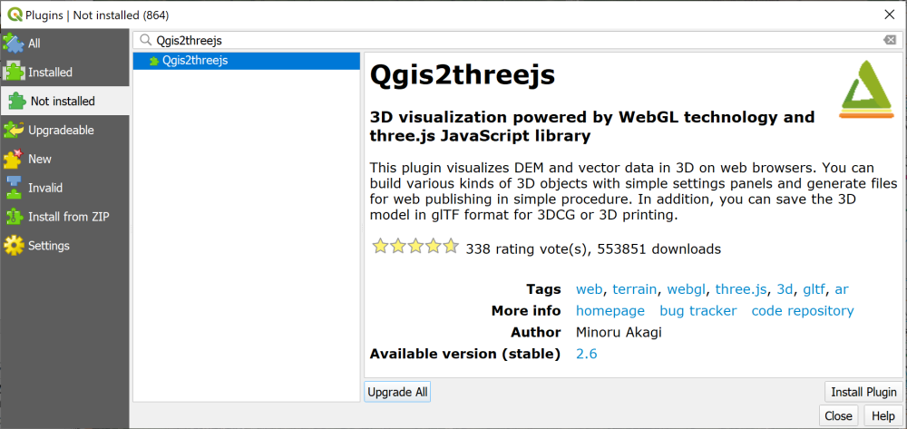

Installing the Qgis2threejs plugin.

### Creating a 3D view

 **Warning**

Note that if you have already run the QGIS internal 3D viewer you will need to close it, then close QGIS completely and reopen your project before you run the Qgis2threejs plugin.

To open the plugin

* Either click on the new button on the toolbar (a triangle symbol)

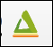

The Qgis2threejs button on the toolbar.

* Or go to Web > Qgis2threejs > Qgis2threejs Exporter on the menu bar.

 **Viewing a map in 3D with the Qgis2threejs plugin.**

This video clip can be found in the module area of [Minerva](https://minerva.leeds.ac.uk) or in the [full list of video clips](https://cgordon-gis.github.io/videoclips.htm).

The window that opens will have a blank main window and a list of your layers on the left.

* Under the DEM heading in the layers on the left click to put a tick next the to T5merged layer.

Your map should appear and should already be shown as a 3D view with any layers that you have visible on your main map, visible on this one too.

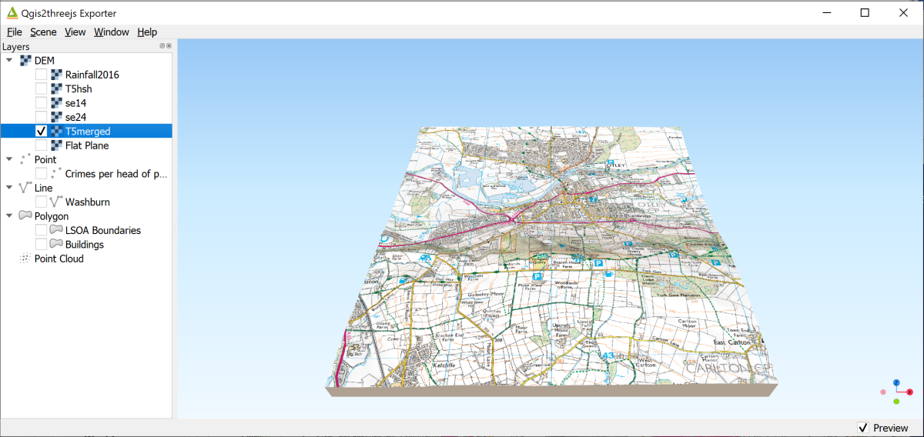

The Qgis2threejs exporter showing the ticked DEM layer on the left and the map in a 3D view on the right.

* Use your mouse to navigate in the scene. The mouse wheel will let you zoom in and out. If you click on the map you get a pop-up menu with the coordinates at that point and an option to zoom in to that point or orbit around it (press Esc to stop orbiting!). Just have a go…
* You can also use the navigation tool at the bottom right of the 3D map view - if it isn’t visible go to View > Widgets > Navigation widget and put a tick in the box next to it. It’s a bit limited but try cilcking on one of the dots to see what happens.

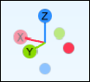

The navigation widget showing the orientation of the main axes.

* Press F5 (reset) to get back to the original view.
* To change the vertical exaggeration go to Scene > Scene settings.... Set the Vertical exaggeration to 3.0 and click Apply to see what happens. Use this setting with care - for a scientific map it’s usually best to stay at 1.0 vertical exaggeration which is the same as the real world.

### The DEM settings

There are other settings that you can experiment with.

* Right-click on the DEM layer (T5merged) in the left-hand panel.
* Click on Properties

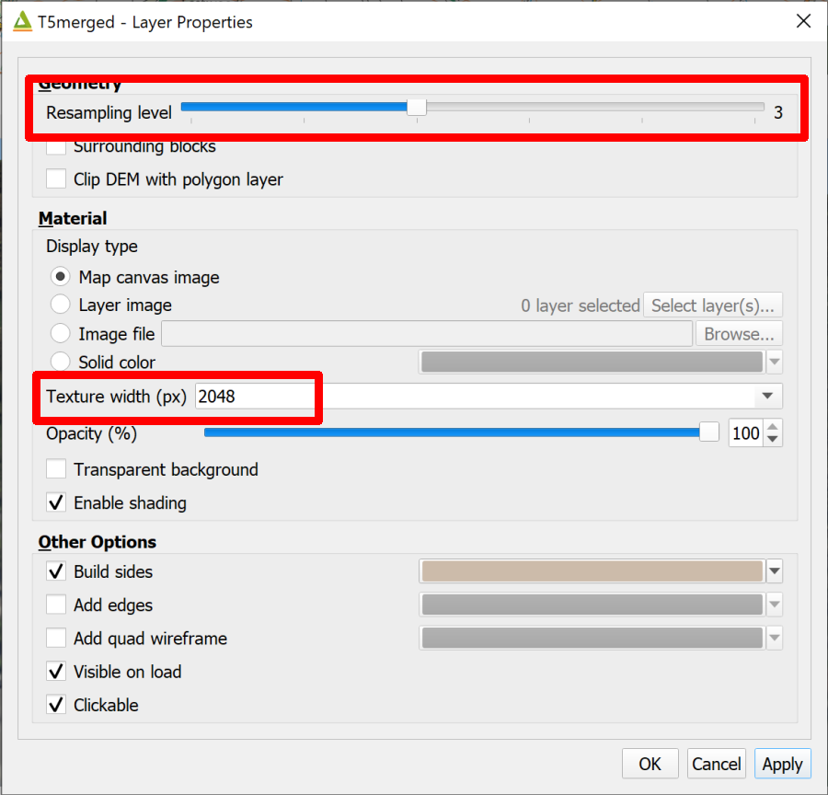

The DEM Properties panel showing the alterations you can make to the output quality.

Some of the settings here control the quality of the output image.

* Raising the Resampling level increases how much of the data from the original DEM QGIS uses to render the 3D effect. Raise with care - the higher the setting the longer it will take the 3D view to draw.
* If you zoom into the 3D map the map that is being displayed may not look particularly good quality. To increase the quality you can increase the setting for the Texture width (px).
  + Try typing 2048 into the box, click Apply and have another look at the map view.
  + Again be careful how high you set this - higher numbers will make the 3D view take longer to draw. The quality will also be limited by the quality of the original image.

 **Drape the aerial photography on the 3D view**

Close the 3D window to go back to your main map and turn on the group called Aerial in the Layers panel.

Now reopen Qgis2threejs.

Again, have a look around the 3D map. Aerial photographs can look very effective viewed in 3D, though there can be odd effects when, for example, buildings are flat. We’ll do something about this soon!

### Exporting an image

Once you have a view that shows your data in a way that will enhance the interpretation, you can export it as an image. The image can then be included in reports and map layouts.

From within the Qgis2threejs window:

* File > Save scene as... > Image (.png)
* You can change the output size here if you wish, then click on Save
* Browse to where you wish to save the image and give it a name, then click on Save.

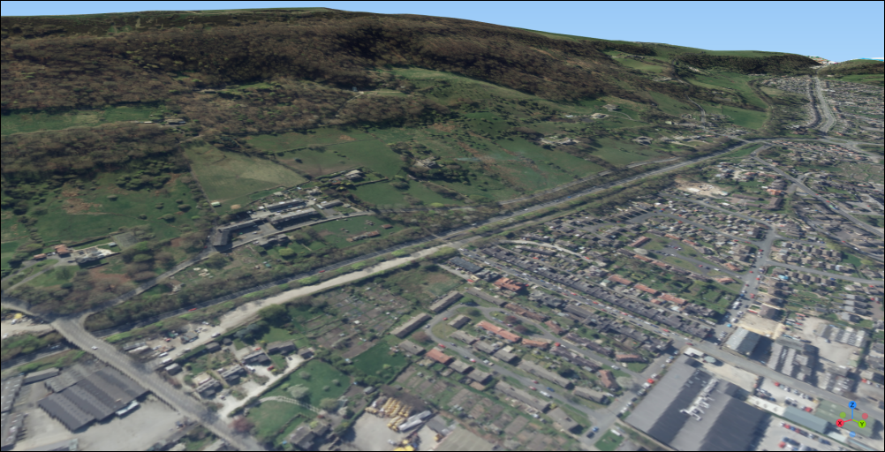

A view of Otley Chevin exported as an image from Qgis2threejs.

### Saving a 3D map as an interactive web page

One of the fun things about Qgis2threejs is that you can export the 3D map in a way that can be interactively viewed by anyone with an up to date web browser. In fact, this was the original main point of this plugin.

* Go to File > Export to Web...
* Next to Output Directory click on Browse... to browse to the folder where you want to save the web output. I’d suggest you make a new folder within the project folder and call it something like Output.
* Leave the HTML Filename as index.html
* If you wish, enter a Page Title which briefly says what your map shows.
* Tick next to Enable the Viewer to Run Locally
* Then click on Export

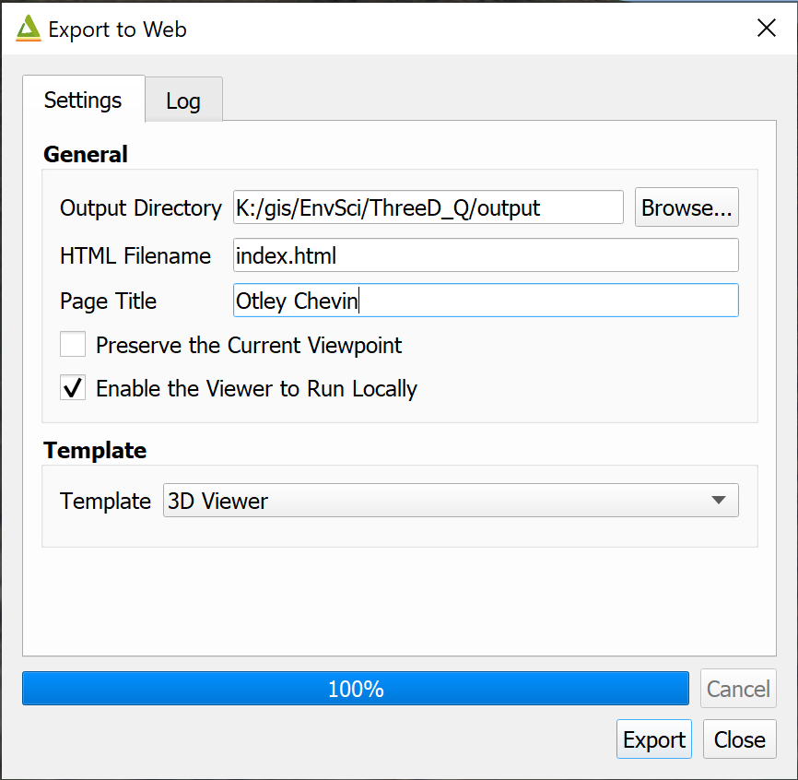

The Export to Web settings.

Once you’ve done this a set of new files will appear in the folder that you selected, and you’ll see the Log which gives you a list of directories as links.

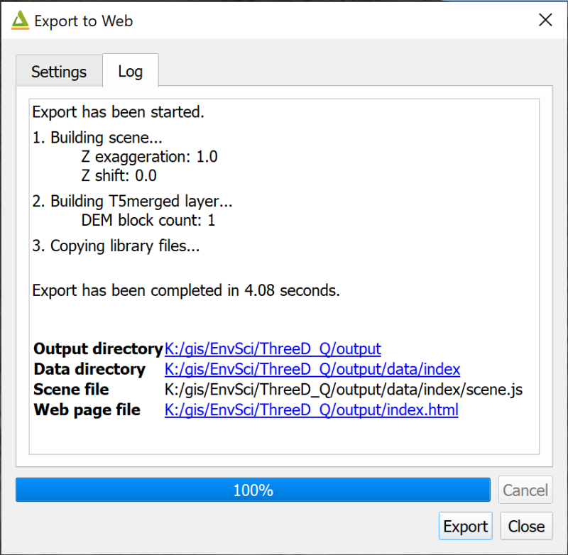

The Log for Export to Web showing the output folders as clickable links.

Depending on your default web browser, you should be able to click on the link next to Web page file to open a view which looks very like the one you have in QGIS.

You can also double-click on the index.html file in the folder.

You can share this with people who don’t have GIS by giving them the whole folder of files and telling them to click on index.html. Do be aware that the data included in these is still liable to copyright, though. In particular data from Digimap shouldn’t be shared with anyone who isn’t a member of UK Higher Education and signed up to the Digimap terms and conditions.

### Extruding vector layers

So far we’re just showing the map canvas in 3D laid on top of a terrain layer. It is also possible to “extrude” vector layers in the 3D viewer. A popular use for this is to extrude building polygons, but you can also use this as a way to display your data. We’ll look at a couple of examples here. Firstly showing a 3D view of crime data for this area, then to show building height.

#### Extruding numerical point data

These instructions will also work for lines and polygons.

 **Extruding data in a 3D view in the Qgis2threejs plugin.**

This video clip can be found in the module area of [Minerva](https://minerva.leeds.ac.uk) or in the [full list of video clips](https://cgordon-gis.github.io/videoclips.htm).

* Close the Qgis2threejs Exporter to go back to your main map.
* In the main map turn off the Aerial layer so that the 25k raster is visible again.
* Make the Crime Stats group visible.

This shows similar data to that used in the vector data analysis chapter, but for Otley rather than Leeds. The data has been processed to show number of crimes per head of population for January 2021 according to Lower Super Output Areas (LSOAs). You should be able to see the red dots which are the centre of each LSOA with the crime figures as the label.

* Reopen the Qgis2threejs plugin. The view should look similar to your main map.
* Tick the box next to Crimes per head of population in the left-hand panel
* Then right-click on the layer to go to the Properties
* Fill in the properties as follows:
  + Set the Object type to Cylinder - you can experiment if you wish, but this seems to be the best option for this data.
  + The Z coordinate mode should be set to Relative to "T5merged" layer - otherwise the extruded shapes would either be floating above the ground or partially buried.
  + Altitude should remain as 0
  + Change Radius to 30
  + The Height is the key property - click on the E button at the end of the line and use the Expression editor to enter round("Crimes_per_pop" * 10000, 2). The numbers involved are very small, so multiplying by 10,000 means that the differences become visible when extruded in map units.
  + To label in 3D click next to Export attributes then set the Label field to Crimes_per_pop and Label height to Relative.
* Click on Apply and have a look at your scene. At this stage you can make any changes you wish so that the differences in your data are clear.

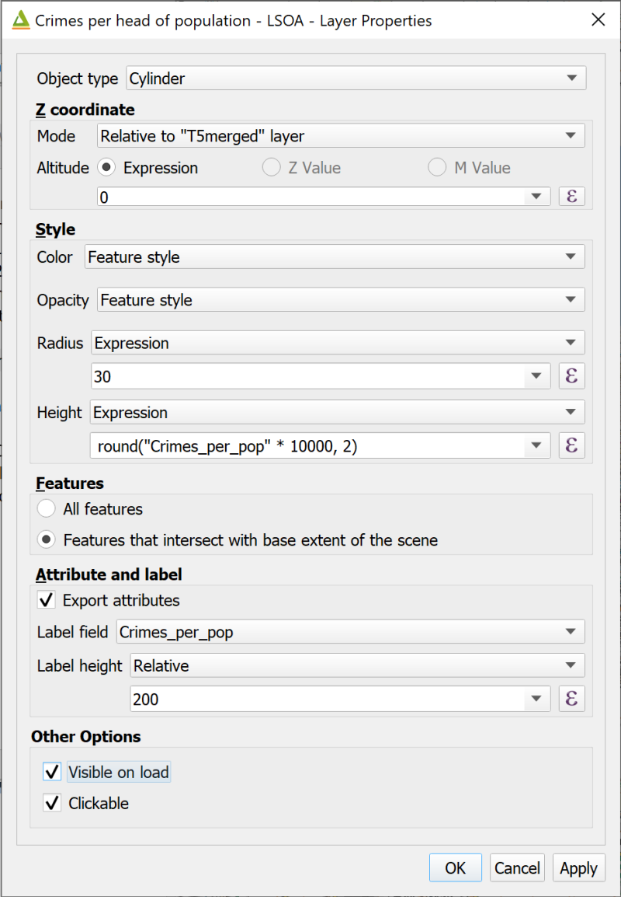

Filling in the layer properties to extrude the crime data.

The end result should show the points in the LSOAs with the higher crime rates as taller symbols. Have a look at your scene from various angles and note how the labels, which have “leader lines” attaching them to the symbols, move so that they are always facing the viewer.

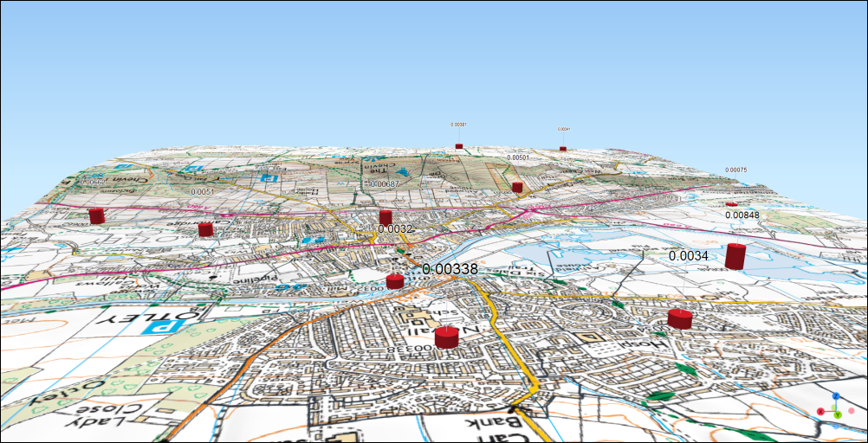

The extruded crime symbols showing the differing heights and the labels.

The point styles and label styles reflect those in your main map, so you can change those if you wish to change how t in your main maphe 3D symbols look.

 **Changing the point style**

Try changing the style of the points to Graduated > colour in your main map and look at how that appears in the 3D view.

If you think this helps with the interpretation of the data then keep it like this.

#### Extruding building data

At the moment the buildings are flat on the terrain, whether shown as the 25k raster background map or the aerial photographs. If you have building height attributes in a feature class you can also extrude the buildings to give an impression of the urban environment.

The Buildings layer that I have provided in the project is taken from the [Ordnance Survey MasterMap Topography Layer - Building Height attribute data](https://www.ordnancesurvey.co.uk/business-government/tools-support/mastermap-topography-support). Details of how to use the data for your own areas is available in the pdf linked from that link.

* In your main map make the Buildings layer visible. So far this is just showing the footprint of each surveyed building. This doesn’t have to be visible for you to extrude the data as the 3D settings are separate.
* Open the attribute table of the Buildings layer and have a look at the columns.

In particular have a look at the numerical attributes towards the right-hand side. Some start Abs... for absolute - these are building heights above sea-level. As we have the DTM in our project it makes more sense to use one of the heights which starts Rel... for relative, i.e. to the height of the terrain at that point.

We’ll use the RelHMax attribute to extrude the buildings on our map.

* Close the attribute table and open the 3D view again.
* Put a tick in the box next to Buildings in the Layers panel and untick the crime data.
* Right-click on Buildings and go to Properties

Filling in the properties dialog is very similar to what we did with the crime data, but this time do the following:

* Set Object type to Extruded
* The Mode is Relative to "T5merged" layer
* Height should be set to Expression then drop down the box underneath and select the height field - RelHMax. Note that this has to be a numerical field.
* Next to Edge color select Feature style
* Click on OK to view the 3D buildings.

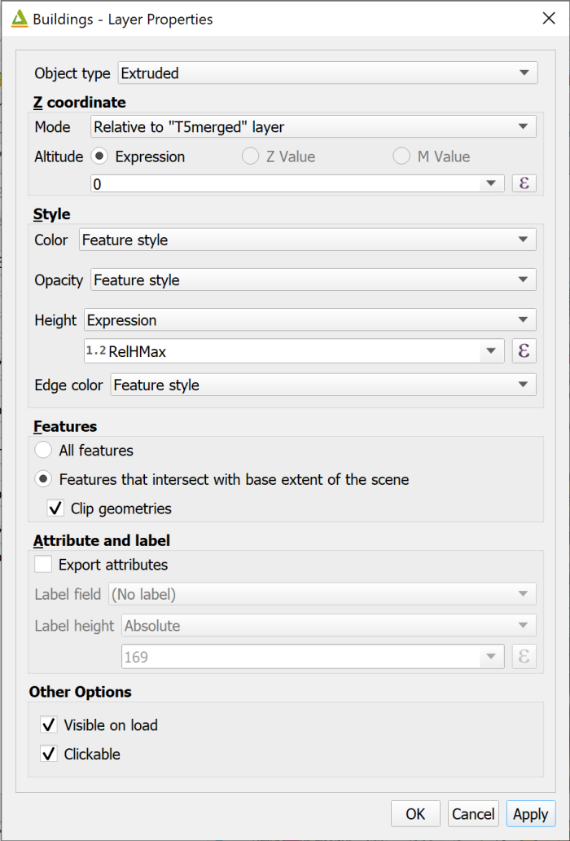

Settings for extruding buildings.

If you zoom in on your map you should be able to see that the buildings have been styled as 3D “boxes” according to the maximum heights.

Note that it can take QGIS quite a while to draw all the buildings, so be patient.

You can change the fill and outline colours in the main map to change how the buildings look in the 3D view. The buildings do look rather odd in close-up because of the lack of features such as doors and windows!

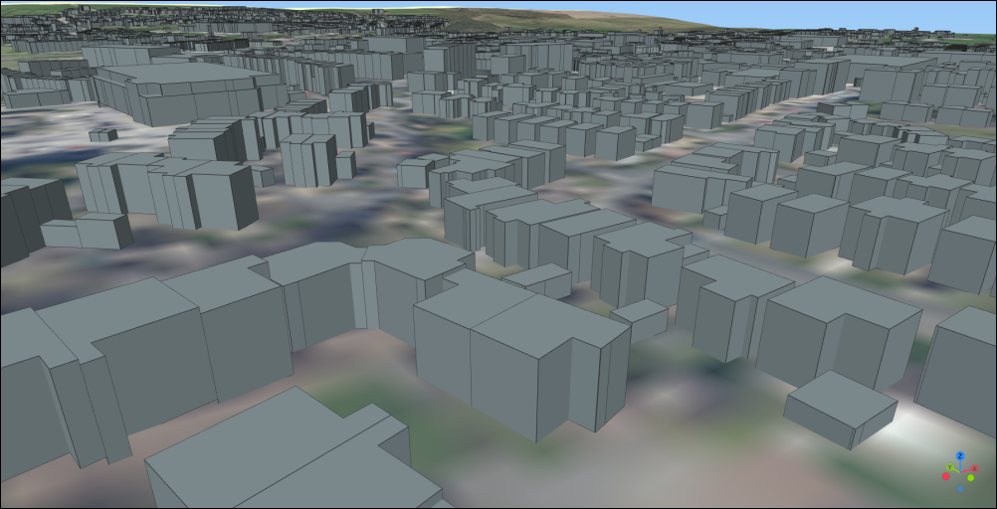

The extruded buildings.

Otley doesn’t have any particularly tall buildings, but if you have the building height data for a city such as London you can really see the scale of the skyscrapers.

## Final output for this chapter

The output for this chapter can be a series of profiles and three dimensional views of Otley and Otley Chevin.

Try creating a layout in QGIS which includes the “flat” map, a profile from north to south across the hill just to the south of Otley. This is Otley Chevin. Don’t forget to include a line on the map showing where the profile refers to. You can also include separate three dimensional views of Otley Chevin, the crime figures, and the extruded buildings.

You’ll need to export the profile and the 3D views as images to include them in your layout.

Export your layout as pdf or an image file and upload it to your GIS portfolio. Alternatively upload the exported images separately. If you upload your output in the next week or so I will provide brief feedback on your work.

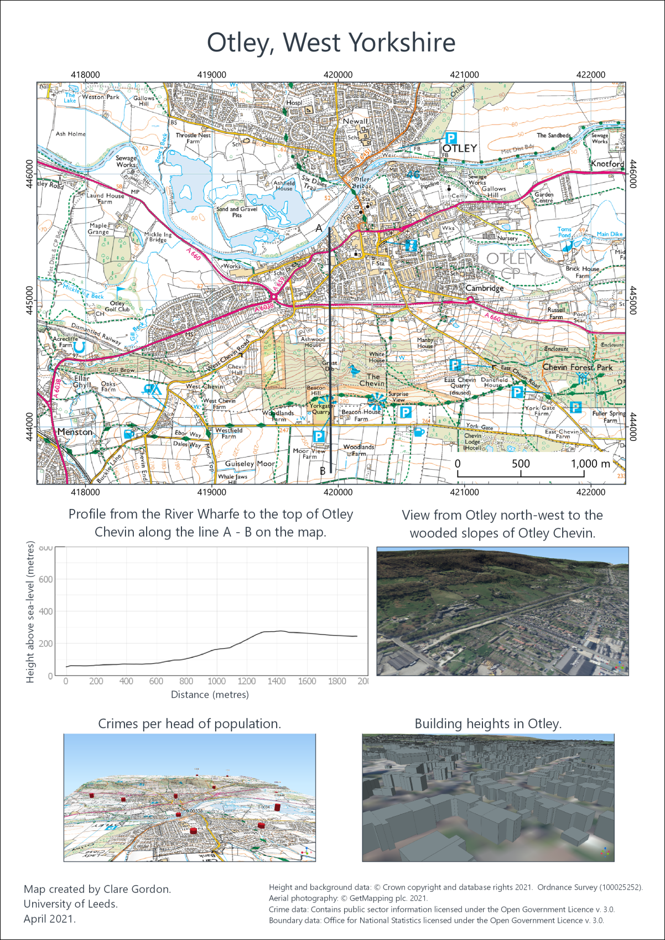

Example of final layout for this chapter. You can also output individual images or profiles.

## Recommended reading: Elevation and 3D mapping

The general books in the module reading list[35] include sections on elevation and 3D mapping.

* For a quick overview look at Darkes (2017) - pages 46-47 look at Relief.
* Heywood (2011) has a section on Modelling the Third Dimension on pages 99-100.
* Longley (2015) covers User Interation and Representation in 2.5-D and 3-D on pages 282-284.

### Further information

* For a video on the qProf plugin see [Topographic Profile Graphs with qProf in QGIS](https://youtu.be/oRZDm5UYtYA) on YouTube.
* If you want to find out more about Qgis2threejs see the [tutorial by Alasdair Rae](http://www.statsmapsnpix.com/2018/11/how-to-create-interactive-3d-landscape.html).

1. 7-zip is also open-source so if you want to install a copy on your own Windows computer you can - just download it from the [7-zip webpage](https://www.7-zip.org/).
2. Note that these instructions are for Windows, if you are on a Mac or Linux computer you will still need to unzip the files, but I don’t have access to one of these to write any specific instructions.
3. Later in the course you will need to run GRASS processing tools and will have to open the version of QGIS with GRASS to be able to do that.
4. Setting the save paths to relative instead of absolute means that if the drive letter changes, or you work on a different machine, QGIS still looks for the data in the same **relative** location compared to the map, rather than expecting them to still be on the original machine.
5. More information about the [Open Government Licence](http://www.nationalarchives.gov.uk/doc/open-government-licence/) is available on the National Archives web site.
6. The reading list is available in Minerva and also from the University Library by searching for SOEE2650 on the [reading list page](http://lib5.leeds.ac.uk/rlists/index.php).
7. The reading list is available in Minerva and also from the University Library by searching for SOEE2650 on the [reading list page](http://lib5.leeds.ac.uk/rlists/index.php).
8. **Metadata** can be described as “data about data”. A commonly quoted example is a library catalogue, which holds data about books.
9. If you want to find out more about coordinate systems and projections have a look at Heywood (2011) pp. 44-51 for a general introduction.
10. The reading list is available in Minerva and from the [library](http://lib5.leeds.ac.uk/rlists/index.php) (search for the number of this module).
11. This data was downloaded from Aerial Digimap.
12. If you’ve lost Chancellors Court in your map remember that you have the StudyArea layer in your map from the downloaded data. You can Zoom to Layer on that to get back to the right area.
13. The reading list is available in Minerva and from the [library](http://lib5.leeds.ac.uk/rlists/index.php) (search for the number of this module).
14. You can ignore the other files with extensions such as .xml and .gml in the same folder. Make sure you keep them with the .asc files, though. These files hold other information about the data which the GIS program uses itself.
15. Possible text editors include TextEdit on Mac and NotePad on Windows. If you want a better text editor then try [Notepad++](https://notepad-plus-plus.org/) on Windows.
16. Page accessed 10th December 2021.
17. The reading list is available in Minerva and from the [library](http://lib5.leeds.ac.uk/rlists/index.php) (search for the number of this module).
18. If you’re not sure who Julia Bradbury is have a look at the [Julia Bradbury Walks page](https://theoutdoorguide.co.uk/walks/julia-bradbury-walks/) on The Outdoor Guide. You can find several walks in the Lake District there.
19. If you no longer have a copy of the map that you have been instructed to use it doesn’t really matter. Either use a different map that you have created, or download the map from the week 1 class and use that instead. It isn’t the map itself that is important for these exercises, but having a layout with data on it so that you can try things out.
20. Page last visited: 30th March 2022.
21. If you are not a Geology student but would like to learn how to use Inkscape for drawing and for finishing maps please contact [Clare Gordon](mailto:C.E.Gordon@leeds.ac.uk) or go to [Clare’s downloads](https://cgordon-gis.github.io/downloads.htm) to obtain a copy of the exercises as interactive worksheets.
22. Available in Minerva and via the [University Library reading list page](http://lib5.leeds.ac.uk/rlists/) - just search for the module number.
23. The story [Mytholmroyd and Hebden Bridge hit by flooding](https://www.bbc.co.uk/news/uk-england-leeds-18768291) on the BBC news pages shows videos and images of the flooding.
24. If you want to find out more about the GeoTiff format try the article [GeoTIFF - a standard image file format for GIS applications](https://www.geospatialworld.net/article/geotiff-a-standard-image-file-format-for-gis-applications/).
25. Data downloaded from <http://www.metoffice.gov.uk/climatechange/science/monitoring/ukcp09/download/index.html> and edited to show only data for 2016. May 2019.
26. The reading list is available in Minerva and from the [library](http://lib5.leeds.ac.uk/rlists/index.php) (search for the number of this module).
27. Find more information about the census on the [website of the Office for National Statistics](https://www.ons.gov.uk/census).
28. Note that administrative boundaries do tend to change between each census so you do need to make sure that you download the right set for your census data.
29. The reading list is available in Minerva and from the [library](http://lib5.leeds.ac.uk/rlists/index.php) (search for the number of this module).
30. The reading list is available in Minerva and from the [library](http://lib5.leeds.ac.uk/rlists/index.php) (search for the number of this module).
31. For example, see Zoccali, P., Malacrinò, A., Campolo, O., Laudani, F., Algeri, G.M., Giunti, G., Strano, C.P., Benelli, G., Palmeri, V. 2017. A novel GIS-based approach to assess beekeeping suitability of Mediterranean lands, *Saudi Journal of Biological Sciences*, Volume 24(5), pp. 1045-1050. DOI: [10.1016/j.sjbs.2017.01.062](https://dx.doi.org/10.1016/j.sjbs.2017.01.062)
32. The reading list is available in Minerva and from the [library](http://lib5.leeds.ac.uk/rlists/index.php) (search for the number of this module).
33. [Inkscape](https://inkscape.org) is open source and freely available to download and install on Windows, Mac and Linux. If you want to learn how to use it I have created [Interactive Inkscape Worksheets](https://cgordon-gis.github.io/downloads.htm#heading_toc_j_2) which can be downloaded from my website.
34. If you want to show two lines it may be best to export them as separate csv files so it’s more flexible when you set up the layout.
35. Reading list available from Minerva and from the module catalogue.